CHANGE REQUEST
Meeting:* | ARC TP32
Source:* | BeiXu，Huawei，Echo.xubei@huawei.com
Date:* | 2017-11-07
Contact:* | BeiXu，Huawei，Echo.xubei@huawei.com
Reason for Change/s:* | Add new feature about 3GPP MBMS for Multicast-Group.
CR against: Release* | <Release3>
CR against: WI* | Active < WI-0031 - Optimized Group-based Operation >  MNT Maintenace / < Work Item number(optional)>  STE Small Technical Enhancements / < Work Item number (optional)>  Only ONE of the above shall be ticked
CR against: TS/TR* | TS-0001-Functional_Architecture-V3_7_0
Clauses/Sub Clauses*
Type of change: * | Editorial change  Bug Fix or Correction  Change to existing feature or functionality  New feature or functionality  Only ONE of the above shall be ticked
Post Freeze checking:* | This CR contains only essential changes and corrections? YES NO  This CR may break backwards compatibility with the last approved version of the TS? YES NO  This CR is a mirror CR? YES if YES, please indicate the document number of the original CR: <Document Number) : NO
Template Version:27 May 2015 (Dot not modify)

oneM2M Notice
The document to which this cover statement is attached is submitted to oneM2M. Participation in, or attendance at, any activity of oneM2M, constitutes acceptance of and agreement to be bound by terms of the Working Procedures and the Partnership Agreement, including the Intellectual Property Rights (IPR) Principles Governing oneM2M Work found in Annex 1 of the Partnership Agreement.
GUIDELINES for Change Requests:
Provide an informative introduction containing the problem(s) being solved, and a summary list of proposals.
Each CR should contain changes related to only one particular issue/problem.
In case of a correction, and the change apply to previous releases, a separated “mirror CR” should be posted at the same time of this CR
Follow the principle of completeness, where all changes related to the issue or problem within a deliverable are simultaneously proposed to be made E.g. A change impacting 5 tables should not only include a proposal to change only 3 tables. Includes any changes to references, definitions, and acronyms in the same deliverable.
Follow the drafting rules.
All pictures must be editable.
Check spelling and grammar to the extent practicable.
Use Change bars for modifications.
The change should include the current and surrounding clauses to clearly show where a change is located and to provide technical context of the proposed change. Additions of complete sections need not show surrounding clauses as long as the proposed section number clearly shows where the new section is proposed to be located.
Multiple changes in a single CR shall be clearly separated by horizontal lines with embedded text such as, start of change 1, end of change 1, start of new clause, end of new clause.
When subsequent changes are made to content of a CR, then the accepted version should not show changes over changes. The accepted version of the CR should only show changes relative to the baseline approved text.

Introduction
Update the procedure based on the comments.
-----------------------Start of change 1-------------------------------------------

9.6.44 Resource Type localMulticastGroup
The <localMulticastGroup> resource is used by a member hosting CSE to indicate that this CSE is a member of a multicast group. <localMulticastGroup> is created as the child resource of the <CSEBase> resource. And there may be multiple <localMulticastGroup> resources under the same <CSEBase>.

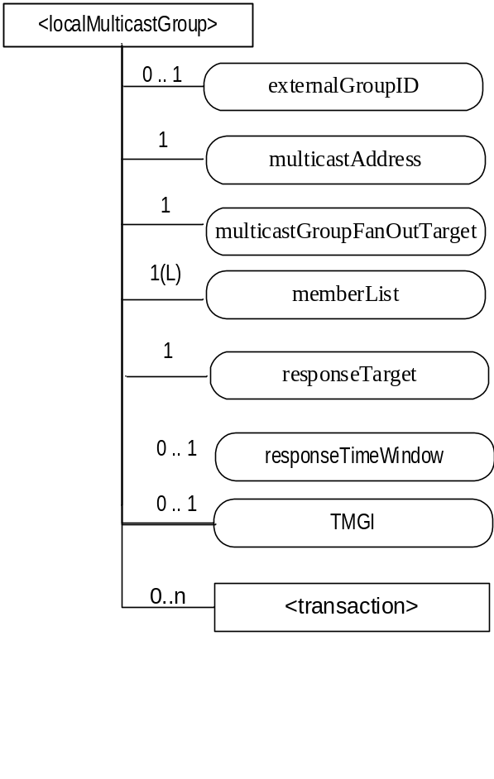
Figure 9.6.44-1: Structure of <localMulticastGroup> resource
The <localMulticastGroup> resource shall contain the child resources specified in table 9.6.44-1.
Table 9.6.44-1: Child resources of <localMulticastGroup> resource
Child Resources of <localMulticastGroup> | Child Resource Type | Multiplicity | Description
[variable] | <transcaction> | 0..n | See clause 9.6.48

The <localMulticastGroup> resource shall contain the attributes specified in table 9.6.44-2.
Table 9.6.44-2: Attributes of <localMulticastGroup> resource
Attributes of < localMulticastGroup > | Multiplicity | RW/  RO/  WO | Description | < localMulticastGroupAnnc> Attributes
resourceType | 1 | RO | See clause 9.6.1.3. | NA
resourceID | 1 | RO | See clause 9.6.1.3. | NA
resourceName | 1 | WO | See clause 9.6.1.3. | NA
parentID | 1 | RO | See clause 9.6.1.3. | NA
creationTime | 1 | RO | See clause 9.6.1.3. | NA
lastModifiedTime | 1 | RO | See clause 9.6.1.3. | NA
expirationTime | 1 | RW | See clause 9.6.1.3. | MA
accessControlPolicyIDs | 0..1 (L) | RW | See clause 9.6.1.3. | MA
labels | 0..1 (L) | RW | See clause 9.6.1.3. | MA
dynamicAuthorizationConsultationIDs | 0..1 (L) | RW | See clause 9.6.1.3. | OA
announceTo | 0..1(L) | RW | See clause 9.6.1.3. | NA
announcedAttribute | 0..1(L) | RW | See clause 9.6.1.3. | NA
externalGroupID | 0..1 | RW | It is the External-Group-ID as specified in 3GPP TS23.682 [i.14] clause 4.6.3. It is the globally unique ID exposed by the underlying network that is mapped to an internally used identifier for a specific group related services. | NA
multicastAddress | 1 | RW | The multicast address of the multicast group that the member hosting CSE joins. | NA
multicastGroupFanoutTarget | 1 | RW | The target of the fanout request received by the member hosting CSE.  It is a virtual identifier allocated by the group hosting CSE corresponding to the access paths (i.e. ResourceIDs that may be different) of the member resources on the member hosting CSE. | NA
memberList | 1(L) | RW | List of local member resourceIDs in the multicast group which are hosted on the same member hosting CSE. | NA
responseTarget | 1 | RW | Indicates the target that the multicast member hosting CSE sends the notification to when finishing the operation in the multicast message from the group hosting CSE. The default value should be the CSE-ID of the group hosting CSE. | NA

-----------------------End of change 1---------------------------------------------

-----------------------Start of change 2---------------------------------------------

10.2.7.13 Multicast Group Management Procedures
In case the multicast mechanism is used to fan-out group operations to members, the group hosting CSE shall maintain the necessary information pertaining to the multicast group(s) that belong to the addressed group, such as the mapping relationship between the member resources and the multicast address(es) and the target URI(s) in the fan out requests.
For each multicast group of a <group> resource, there may be multiple records of Multicast Group Information. The group hosting CSE should manage and index the multiple records by internal identifier for each Multicast Group Information. The definition of the internal identifier is out of scope of this specification. The group hosting CSE shall maintain the information as specified in table 10.2.7.13-1.
Table 10.2.7.13-1: Multicast Group Information managed by group hosting CSE
Information | Multiplicity | Description
groupID | 1 | Indicates the <group> resource identifier which the Multicaste Group Information belongs to.
multicastType | 1 | Indicates the underlying networks multicast capability of the group members, the value shall be one of the following:  - 3GPP_MBMS_group,  - IP_mulicast_group.
externalGroupID | 0..1 | If the multicastType is 3GPP_MBMS_group, the externalGroupID is the External-Group-ID as specified in 3GPP TS23.682[i.14] clause 4.6.3
multicastAddress | 1 | The multicast address is allocated to the members in the memberList and shared by the members of this multicast group. The allocation of multicast address is configured by the group hosting CSE locally. The procedure of multicast address assignment is specified in RFC 5771[11] and RFC 2375[12].
multicastGroupFanoutTarget | 1 | Used as the target URI of the fan out request sending to the members.  It is a virtual identifier allocated by the group hosting CSE corresponding to the access paths (i.e. Resource-IDs, which may be different) of the member resources on the member hosting CSEs.
memberList | 1(L) | List of all member resourceIDs in the multicast group. Each member resourceID corresponds to a member resource.
groupServiceServerAddress | 0..1 | It is used only when the multicastType is 3GPP_MBMS_group, and it is the address of 3GPP group service server (e.g. SCEF);

-----------------------End of change 2---------------------------------------------

-----------------------Start of change 3---------------------------------------------

10.2.7.13.1 Multicast Group Information and <localMulticastGroup> Creation Procedures

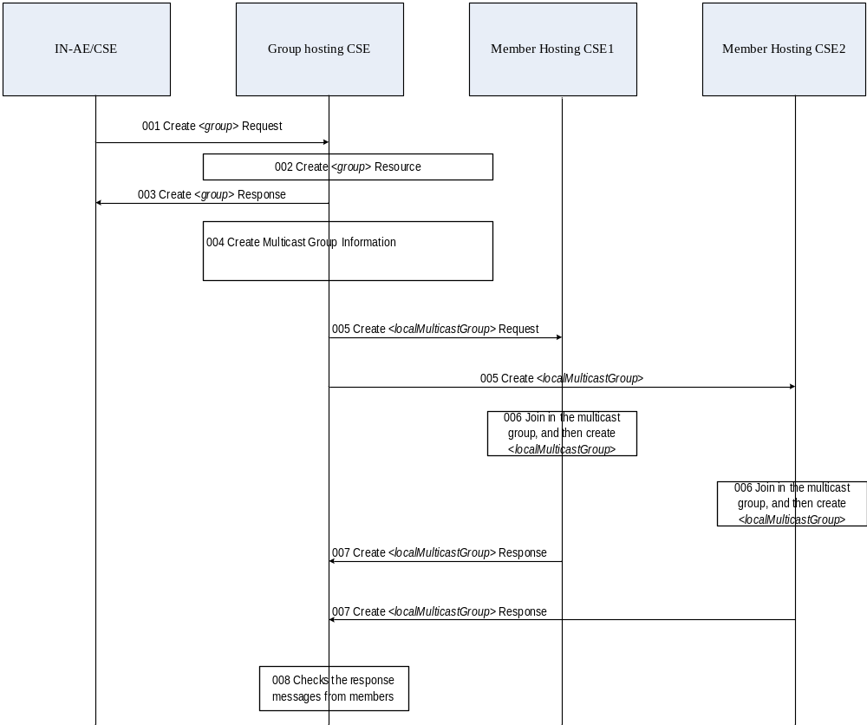

Figure 10.2.7.13.1-1: Multicast Group Information and <localMulticastGroup> creation procedures
Figure 10.2.7.13.1-1 illustrates how the Multicast Group Information and <localMulticastGroup> resource works on the group Hosting CSE and the group members Hosting CSEs.
001: The IN-AE/CSE sends a group resource creation request to the group Hosting CSE which includes member resource identifier list.
For example, member resources m11, m12, m21 and m22 are respectively located on two M2M devices ASN-CSE1 and ASN-CSE2. The resource identifiers are:
m11: /d1.example.org/xx1/aa
m12:/d1.example.org/yy1/bb
m21: /d2.example.org/xx2/cc
m22: /d2.example.org/yy2/dd
002: The group Hosting CSE creates the group resource as requested.
003: The group Hosting CSE returns the group creation response to IN-AE/CSE
004: The group Hosting CSE retrieves multicast capability of all member Hosting CSEs and determines whether it is necessary to create a multicast group. If no member hosting CSE supports multicast capability or no more than one member Hosting CSEs support the same multicast capability, no multicast procedure is eligible.
If at least two member Hosting CSEs support the same multicast capability, the group Hosting CSE determines to create multicast group, and performs all the actions: assign the multicast type based on the multicast capability, and allocate multicast address and multicast address type to the member resources of the multicast group. For a guide to an allocation scheme of IPv4 and IPv6 multicast address spaces, reference may be made to standard documents such as [RFC 3171] and [RFC 4291].
- If the multicastType is 3GPP_MBMS_group, and the member hosting CSEs have the same externalGroupID, the group Hosting CSE shall allocate the externalGroupID based on the externalGroupIDs of the member hosting CSEs and set the group hosting CSE resourceID as the responseTarget, set the memberList as in the request, allocate a virtual fanout universal identifier for multicastGroupFanoutTarget according to the member resource identifiers, and establish the mapping relationship between virtual fanout universal identifier and member resource identifiers. Step 5-7 are only used for creation procedure in case of IP_multicast_group.
- Editor’s note: More details of creating 3GPP MBMS group is for further study.
- If the multicastType is IP_multicast_group, the group Hosting CSE shall set the memberList as in the request, allocate a virtual fanout universal identifier for multicastGroupFanoutTarget according to the member resource identifiers, establish the mapping relationship between virtual fanout universal identifier and member resource identifiers and set the group hosting CSE resourceID as the responseTarget.
  - Note1:The current group based multicast can only be used when member hosting CSE and Group Hosting CSE have direct registration relationship. For example, the group Hosting CSE residing on IN-CSE can create multicast group for member Hosting CSE residing on MN-CSE, and can not create multicast group for member Hosting CSE residing on ASN-CSE which registers to the MN-CSE.
  - Note2:The current group based multicast can only be applied between CSEs, multicast to ADN is FFS
  - Note3: The externalGroupID which is pre-provisioned in operator network. The service provider and the operator should negotiate the mapping between externalGroupID and resourceID of <CSEBase> before pre-provision.
The group Hosting CSE establishes a mapping relationship between the multicast address and the fanout target according to the member resource identifiers on the member hosting CSE. The multicastGroupFanoutTarget should be set to /{groupHostingCSE-ID}/{fanout-segment}. The multicastGroupFanoutTarget should be uniquely assigned by the group Hosting CSE.
In this example, the Multicast Group Information is illustrated in figure 10.2.7.13.1-2.

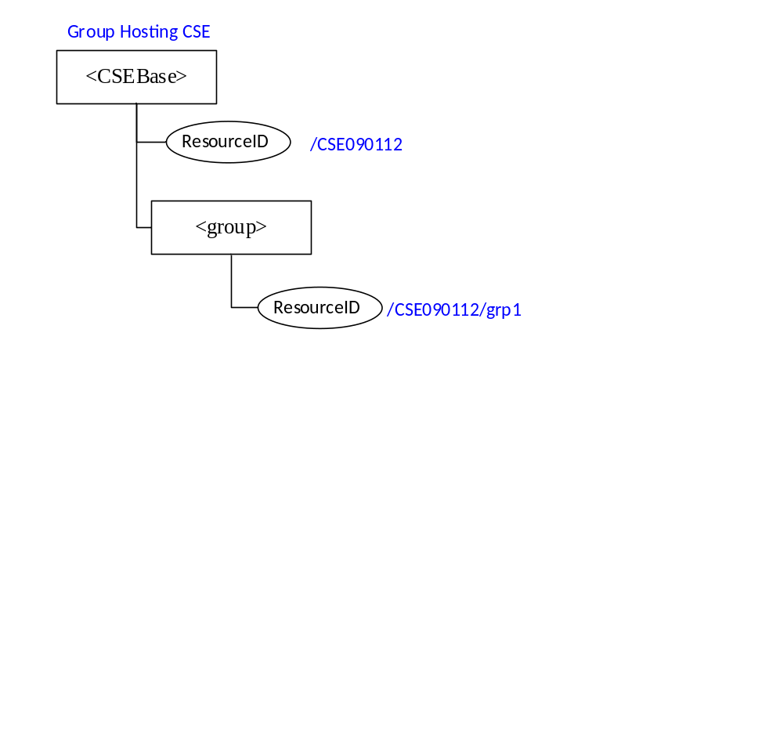
Figure 10.2.7.13.1-2: Multicast Group Information
005: The group Hosting CSE sends <localMulticastGroup> creation request which carries a mapping relationship between the virtual identifier multicastGroupFanoutTarget and the member resources to the member Hosting CSEs to advertise them to join the multicast group corresponding to the multicast address in unicast mode. In this example, the group Hosting CSE should send two group advertisement messages to the members.
006: The member Hosting CSEs receive the creation request and use a multicast management protocol such as MLD or IGMP to join the multicast group corresponding to the multicast address indicated in the multicast group advertisement.
The member Hosting CSEs create the < localMulticastGroup > after successfully joining the multicast group and store a mapping relationship between the virtual identifier and the multicast address, and a mapping relationship between the member list and the multicast address.
In this example, the both ASN-CSE1 and ASN-CSE2 create one <localMulticastGroup> resource to record to which multicast group its local member resources have joined.

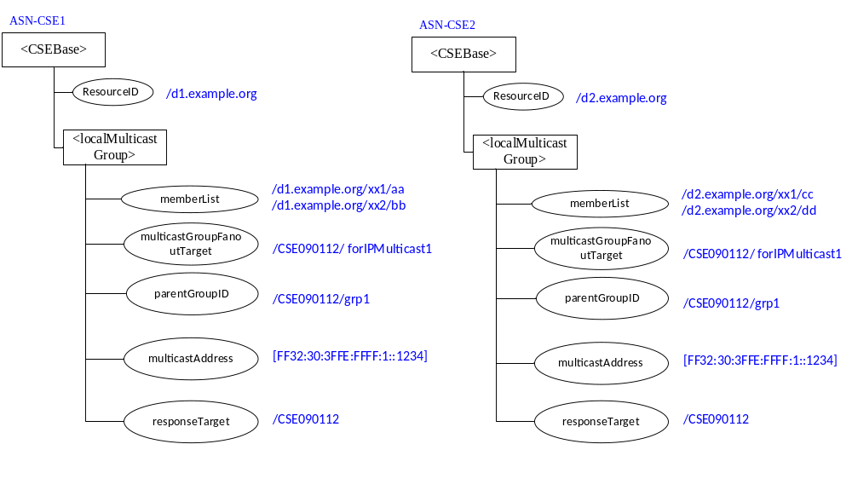
Figure 10.2.7.13.1-3: <localMulticastGroup> resource in member Hosting CSE

007: The members Hosting CSEs send the response to group Hosting CSE.
008: The group Hosting CSE checks the response messages from member Hosting CSEs, if there are at least two members responded successfully, the group Hosting CSE shall create the Multicast Group Information locally.
As a result, the group Hosting CSE may create one or more Multicast Group Information according to the member resources of the group resource created by IN-AE/CSE.

10.2.7.13.2 Multicast Group member Fan out Procedures
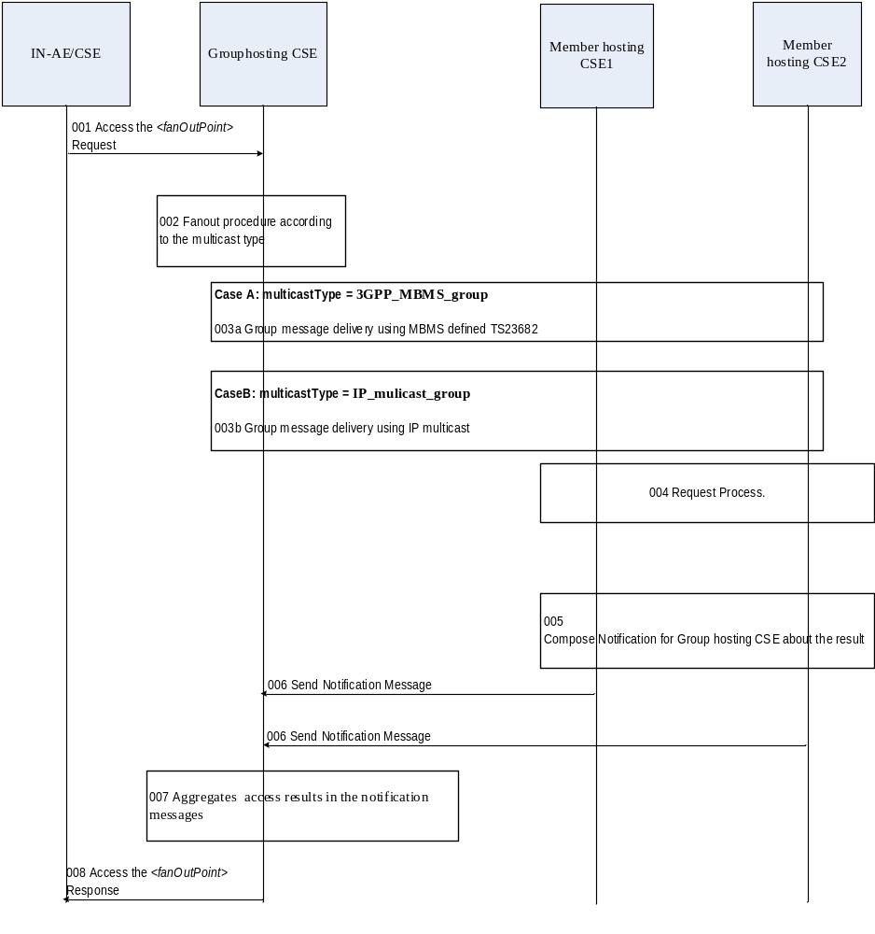
Figure 10.2.7.13.2-1: Multicast Group Information fan out procedures
001: The IN-AE/CSE sends an access <fanOutPoint> request carrying the group resource identifier for accessing member resources to group Hosting CSE.
002: The group Hosting CSE checks whether there is Multicast Group Information, according to the group resource identifier. If the group has Multicast Group Information, check the multicast type:
Case A): The multicast type is 3GPP_MBMS_group.
- 003a The group hosting CSE gets the externalGroupID based on the multicast group resource identifier , then send request message to the group service Server(eg.SCEF) to perform TMGI allocation and Group Message request of the 3GPP MBMS group message procedure, as specified in 3GPP TS 23.682 [i.14] and 3GPP TS 23.468 [i.34].
Case B): The multicast type is IP_multicast_group.
- 003b: The group hosting CSE sends the member resource access request to the member hosting CSEs in multicast mode according to the multicast address of the multicast group, which includes the multicastGroupFanoutTarget as the fan out target address corresponding to the member resource in the group resource, the Response Type should be nonBlockingRequestAsynch.
004: The member Hosting CSE receives from the multicast address a member resource access request, which carries the virtual fan out target matching the multicastGroupFanoutTarget of a <localMulticastGroup> resource that contains the same multicast address. It determines that the local member resource identifiers as the final targets of the request by the mapping relationship between the memberList and multicastGroupFanoutTarget in the <localMulticastGroup> resource, then replaces the multicastGroupFanoutTarget with the determined member resource identifiers and executes the operation indicated by the resource access request.
The member Hosting CSEs shall not return any Acknowledgement when receiving the message from the multicast address.
Editor’s Note: Further contribution is expected to change the basic procedures not to send any response (ACK) back to the Originator inTS-0001. And it should be reflected into TS-0004..
005: The member Hosting CSEs composes the notification for Group hosting CSE about the access result: set To value to the responseTarget of <localMulticastGroup> resource.
006: The member Hosting CSEs send the notification including the access results to the Group hosting CSE.
007: The group Hosting CSE aggregates the group member resource access results in the notification messages from member Hosting CSE.
The group Hosting CSE shall not return any response after parsing the Notification message content which is response message to the multicast request.
Editor Note: Further contribution is expected to change the basic procedures not to send any response (ACK) back to the Originator inTS-0001. And it should be reflected into TS-0004.
.008: The group Hosting CSE returns the aggregated group member resource access result to the IN-AE/CSE.

-----------------------End of change 3---------------------------------------------

CHECK LIST
- Does this change request include an informative introduction containing the problem(s) being solved, and a summary list of proposals.?
- Does this CR contain changes related to only one particular issue/problem?
- Have any mirror crs been posted?
- Does this change request make all the changes necessary to address the issue or problem? E.g. A change impacting 5 tables should not only include a proposal to change only 3 tables. Includes any changes to references, definitions, and acronyms in the same deliverable?
- Does this change request follow the drafting rules?
- Are all pictures editable?
- Have you checked the spelling and grammar?
- Have you used change bars for all modifications?
- Does the change include the current and surrounding clauses to clearly show where a change is located and to provide technical context of the proposed change? (Additions of complete sections need not show surrounding clauses as long as the proposed section number clearly shows where the new section is proposed to be located.)
- Are multiple changes in this CR clearly separated by horizontal lines with embedded text such as, start of change 1, end of change 1, start of new clause, end of new clause.?

