CHANGE REQUEST
Meeting ID:* | ARC 33
Source:* | Yuan Tao, CNICG, taoyuan@cnicg.cn;  Dale Seed, Convida, Seed.Dale@convidawireless.com;  Ye Tian, CNIC, tianye@cnic.cn;  Yang Liu, CAICT, liuyang1@ritt.cn.
Date:* | 2018-01-15
7Reason for Change/s:* | TR-0044 clean up
CR against: Release* | Release 3
CR against: WI* | Active <WI 0069>  MNT maintenance / < Work Item number(optional)>  Is this a mirror CR? Yes No  mirror CR number: (Note to Rapporteur - use latest agreed revision)  STE Small Technical Enhancements / < Work Item number (optional)>  Only ONE of the above shall be ticked
CR against: TS/TR* | TR-0044 Version 0.0.1
Clauses * | 2, 5, 6, 7, 8.1
Type of change: * | Editorial change  Bug Fix or Correction  Change to existing feature or functionality  New feature or functionality  Only ONE of the above shall be ticked
Impacted other TS/TR(s) | <TS/TR number>, <Version Number>, and <Description on which aspect should be reflected in this TS/TR>
Post Freeze checking:* | This CR contains only essential changes and corrections? YES NO  This CR may break backwards compatibility with the last approved version of the TS? YES NO
Template Version: January 2017 (Do not modify)

oneM2M Notice
The document to which this cover statement is attached is submitted to oneM2M. Participation in, or attendance at, any activity of oneM2M, constitutes acceptance of and agreement to be bound by terms of the Working Procedures and the Partnership Agreement, including the Intellectual Property Rights (IPR) Principles Governing oneM2M Work found in Annex 1 of the Partnership Agreement.
GUIDELINES for Change Requests:
Provide an informative introduction containing the problem(s) being solved, and a summary list of proposals.
Each CR should contain changes related to only one particular issue/problem.
In case of a correction, and the change apply to previous releases, a separate “mirror CR” should be posted at the same time of this CR
Mirror CR: applies only when the text, including clause numbering are exactly the same.
Companion CR: applies when the change means the same but the baselines differ in some way (e.g. clause number).
Follow the principle of completeness, where all changes related to the issue or problem within a deliverable are simultaneously proposed to be made E.g. A change impacting 5 tables should not only include a proposal to change only 3 tables. Includes any changes to references, definitions, and acronyms in the same deliverable.
Follow the drafting rules.
All pictures must be editable.
Check spelling and grammar to the extent practicable.
Use Change bars for modifications.
The change should include the current and surrounding clauses to clearly show where a change is located and to provide technical context of the proposed change. Additions of complete clauses need not show surrounding clauses as long as the proposed clause number clearly shows where the new clause is proposed to be located.
Multiple changes in a single CR shall be clearly separated by horizontal lines with embedded text such as, start of change 1, end of change 1, start of new clause, end of new clause.
When subsequent changes are made to content of a CR, then the accepted version should not show changes over changes. The accepted version of the CR should only show changes relative to the baseline approved text.

Introduction
This contribution provides corrections to TR-0044 as follows:
In change 1: Add the references.
In all editorial changes:
- Attempted to simply the description of functionalities and scenarios, make things clearer.
- Maintained the consistency of terminology.
- Replace the normative word “may”.
- Corrected general spelling and grammar.

----------------------- Start of change 1 -----------------------

2 References
The following text block applies.
References are either specific (identified by date of publication and/or edition number or version number) or non-specific. For specific references, only the cited version applies. For non-specific references, the latest version of the referenced document (including any amendments) applies.

2.1 Normative references
As a Technical Report (TR) is entirely informative it shall not list normative references.
The following referenced documents are necessary for the application of the present document.

[1] oneM2M TS-0001: "Functional Architecture".
[2] EPCglobal Inc. Object Name Service (ONS) V.2.0.1. 2012.
[3] EPCglobal Inc. EPC Tag Data Standard 1.6.2011.
[4] RFC 3652 Handle system protocol (ver 2.1) specification.
[5] ISO/IEC. ISO/IEC 9834-1 Information technology – Open Systems Interconnection – Procedures for the operation of OSI Registration Authorities: General procedures and top arcs of the International Object Identifier tree.
[6] ITU-T X.oid-res | ISO/IEC 29168. Information technology – Open Systems Interconnection – Object Identifier Resolution System.

2.2 Informative references
Clause 2.2 shall only contain informative references which are cited in the document itself.
The following referenced documents are not necessary for the application of the present document but they assist the user with regard to a particular subject area.
[i.1] oneM2M Drafting Rules (http://www.onem2m.org/images/files/oneM2M-Drafting-Rules.pdf)
[i.2] Ubiquitous Code: ucode, 930-S101-1.A0.10/UID-00010
[i.3] Ubiquitous ID Architecture, 910-S002-0.00.24 / UID-CO00002-0.00.24

----------------------- End of change 1 -----------------------

----------------------- Start of change 2 -----------------------

5 Introduction to Heterogeneous Identification Service

5.1 Concept of IoT identifier

5.1.1 Overview
An IoT identifier is used for uniquely identifying a physical entity or logical entity in a given context. The underlying networks or applications can control and manage an entity, as well as retrieve, transmit and exchange the relevant information by the identifier.
According to the different identified objects, scenarios, and technology characteristics, the identifier can be classified into three categories: tangible identifier, communication identifier, and application identifier.

5.1.2 Tangible identifier
A tangible identifier is used for uniquely identifying a physical entity (e.g. cup, human being, room, etc) not having network connectivity. The tangible identifier is generally coded within a carrier, and the carrier is attached to the physical entity, so as that the tangible identifier can be read by other entities. The carrier types include barcodes (e.g. 1D barcode, 2D barcode), RFID and others (e.g. Network card, cellphone).
The common scenario of the usage of the tangible identifier is to retrieve the physical entity related information, and the tangible identifier is not used for communicating or addressing.

5.1.3 Communication identifier
A communication identifier is used for uniquely identifying a network node with communication capabilities (terminal, RFID reader, sensor, network device). Some example formats include E.164 number and IP address. The communication identifier can be a relative or absolute address that it is used for communicating or addressing and establishing network connection to the identified object.

5.1.4 Application identifier
An application identifier is used for identifying the services in the application layer or service layer, logical entities and objects. For example, service access code or domain name. Some example formats include URI and URL.

5.2 Concept of identification service

5.2.1 Introduction
An IoT identification service supports the mapping, management, maintenance, discovery, and retrieval of identifier related information.

5.2.2 Identification registration
Identification registration represents the procedures of establishment of mappings between different identifiers, as well as the establishment of an identifier and its related information.

5.2.3 Identification resolution
Identification resolution represents the procedures of resolving the associated identifier or information according to the mapping between the different identifiers (e.g. tangible identifier, communication identifier and application identifier), as well as the identifier and its related information, for example, the lookups are implemented by DNS, ONS, handle system and so on.

5.2.4 Identification discovery
Identification discovery represents the procedures of discovering all the related identifiers or information in large and complex resources, according to the mapping between the different identifiers (e.g. tangible identifier, communication identifier and application identifier), as well as the identifier and its related information. Commonly, more than one result will be retrieved.

5.2.4 Identification maintenance
Identification maintenance represents the procedures of deletion and update of different identifiers, their related information and mappings between the different identifiers.

5.3 Requirements of Heterogeneous Identification Service
The IoT identifier is not globally unified due to political, commercial reasons, and due to different kinds of IoT ID standards defining their own identifiers. Currently, the mainstream IoT identifier standards include “Electronic Product Code (EPC)”, “Object Identifier (OID)”, “Handle Identifier”, “ubiquitous code (ucode)”, “Mobile RFID Code (mCode)” and so on. Different application verticals adopt different IoT standards and deploy different IoT identification technologies. As a result, there exists incompatibility between different IoT identification technologies.
The heterogeneous identification service supports interworking various identification systems, and allowing them to co-exist within one another

----------------------- End of change 2 -----------------------

----------------------- Start of change 3 -----------------------

6 Introduction on Existing Technologies
Editor’s Note: The clause describes various identifier technologies and identifier resolution technologies.

6.1 Overview
There are many existing mechanisms for identification, naming by assigning unique identifiers to various physical/virtual entities (e.g., devices, users, processes, data, services, applications, etc.). The identification system also includes the resolution mechanisms to resolve its corresponding identification type, and some of resolution mechanisms are not implemented based on DNS infrastructure.

6.2 Electronic Product Code (EPC)
EPC has its origins at Auto-ID Center of the Massachusetts Institute of Technology (MIT) since 1998. In 2003, the Auto-ID Center became EPCglobal, and all relevant studies, business, and management about EPC were transferred to GS1 US®. GS1 US® is Founded in 1973, and it is a not-for-profit information standards organization. Currently, GS1 US® has more than 300,000 members, and GS1 Standards are the most widely-used supply chain standards in the world.
A fundamental principle of the EPCglobal Network Architecture is the assignment of a unique identifier for physical objects, loads, locations, assets, and other entities whose use is to be tracked. The EPC has a series of code fields, it uses an 8-bits “Header Value” field to identify specific encoding scheme, such as SSCC, SGTIN, SGLN, GRAI, etc. Taking the “SGTIN” code as an example, the overall structure is shown in Figure 6.1.1-1. A company applies its own “CompanyPrefix” from GS1, and then it assigns the “Item Reference &Indicator Digit” and “Serial Number” fields for each item-level product. In information systems, an EPC is a Uniform Resource Identifier (URI) that is in text format. EPC is not restricted to data carriers.
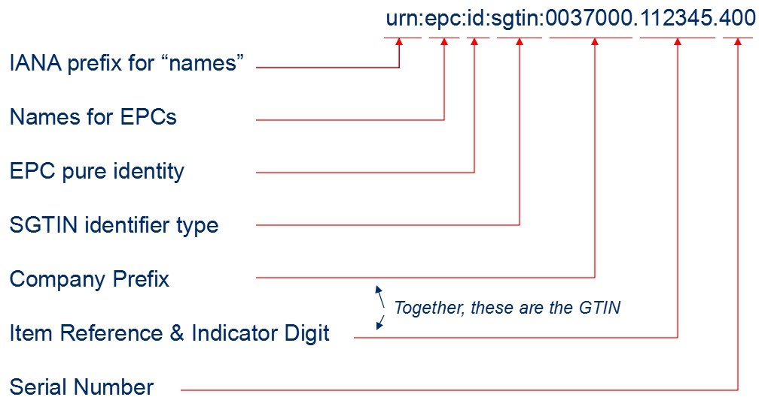
Figure 6.1.1-1 The overall structure of an EPC

EPCglobal network architecture is comprised of ONS (Object Name Service), and EPCIS (EPC information service). ONS is designed for resolving information associated with a EPC identifier, which means other identification types can not be recognized and resolved by the system. ONS uses the Domain Name System (DNS) infrastructure and implementation, thus the item’s EPC identifier must be converted into a format that DNS can understand, which is the typical, “dot” delimited, left-to-right form of all domain names, so as to accomplish the identification resolution, and then retrieving the information about the item. The resolution procedure is shown in Figure 6.1.1-2, and the detailed illustrations are as follows:

Figure 6.1.1-2 ONS resolution procedures
- A EPC identifier is read from a barcode or an RFID tag using an appropriate reader.
- The reader sends that sequence of data to an ONS application.
- The ONS application extracts the desired GS1 Identification Key type and the GS1 Identification
Key itself from the data. For example, a contained GTIN is 50614141322607.
- The ONS application sends the GS1 Identification Key type, the GS1 Identification Key itself,
and the optional codes that are the client language code and client country code to the ONS client. For
example, it is configured to operate in English in Canada: en|ca|gtin|50614141322607.
- The ONS client converts the GS1 Identification Key type and the GS1 Identification Key into an
appropriate FQDN as a DNS query, implementing “dot” delimited and left-to-right form. For example, 5.0.6.2.2.3.1.4.1.4.1.6.0.gtin.gs1.id.onsepc.com.
- The DNS infrastructure responds with service types and associated data, for example, the URLs point to one or more EPCIS.
- The ONS client extracts the service type and the service data and sends it to the ONS application.
- The application interprets the data and communicates the EPCIS server according to the resolved URL.

6.3 Handle Identifier
The Handle System was originally developed at CNRI (The corporation for National Research Initiatives). Each handle identifier is globally unique within the context of the Handle System. It consists of two parts: naming authority (prefix) and local name (suffix), and the structure is as followed:
<Handle> ::= <Handle Naming Authority> "/" <Handle Local Name>
The naming authority and local name are separated by the ASCII character "/". The naming authorities are defined in a hierarchical tree structure, the root and nodes of the tree are separated by the ASCII character ".".
For example, "10.1045/january99-bearman" is a handle identifier for an article. Its naming authority is "10.1045", thereinto “10” is the root naming authority, and “1045” is the subordinate naming authority. Its local name is "january99-bearman".
The Handle System defines a hierarchical service model. The Global Handle Registry (GHR) is at the top level, which can be used to manage any handle namespace, and the Local Handle Services (LHS) is at the lower level, which can be used to manage any handle namespace.
A typical handle resolution procedure is shown in Figure 6.1.2, and the detailed illustrations are as follows:
- The client sends a query to Global Handle Registry to resolve the handle “10.123/456”.
- The Global Handle Registry returns the service information of the Local Handle Service A that is responsible for the handles under the naming authority “10.123”.
- The client sends a query to the Local Handle Service A to resolve the handle “10.123/456”.
- The Local Handle Service A resolves the handle, and then responses the result.
Figure 6.1.2 Handle system resolution procedures

6.4 Ubiquitous Code (ucode)
ucode is supported by the uID center, which is a non-profit organisation based in Japan. A ucode is an identifier based on an encoding strategy to uniquely identify individual “objects”, “places” and “concepts” in the real world. "Objects" include tangible objects (e.g. industrial products, agricultural crops) and intangible objects (e.g. Internet content, programs). “Places” include the real world features such as roads and buildings. “Concepts” include the relationships between "objects" and "places" and the information which can be the real world context.
The ucode consists of five fields: Version, Top Level Domain Code, Class Code, Second Level Domain Code, and Identification Code. The basic ucode width is 128 bits, and it can extend the width in 128-bit units. The structure is shown in the Table 6.1.2.
Table 6.1.2: the structure of ucode
 | version | TLD Code | Class Code | SDL Code | Identification Code
ucode-128 | 4bits | 16bits | 4bits | 20-40bits | 24-4bits

The version indicates a ucode version number. The Class Code indicates the boundary between the Second Level Domain Code (SLDc) and the Identification Code (ic). The TLD is a domain allocated to organizations authorized by Ubiquitous ID Center. The SLD is a domain allocated to organizations authorized by the TLD management organizations.
The ucode server architecture is a multilevel hierarchical structure. In the architecture, the ubiquitous communicator (UC) retrieves the ucode and then gets the information server address by ucodeRP (ucode resolution protocol), and accesses the information associated with the identified “objects/places” .
A typical ucodeRP resolution procedure is shown in Figure 6.1.2, and the detailed illustrations are as follows:
- UC captures a ucode from a tag.
- UC sends a request that containing the ucode to the ucode resolution server, and gets the location information (e.g. 192.168.1.1) of the ucode resolution server for managing a CC field.
- UC sends a request that containing the ucode to the ucode resolution server for managing a CC field and gets the location information (e.g. 192.168.2.1) of the ucode resolution server for managing an SLD.
- UC sends a request that containing the ucode to the ucode resolution server for managing an SLD and gets the location information (e.g. http://www.uidcenter.org/getinfo.cgi) of the information server.
- UC sends the ucode to the information server and gets content.

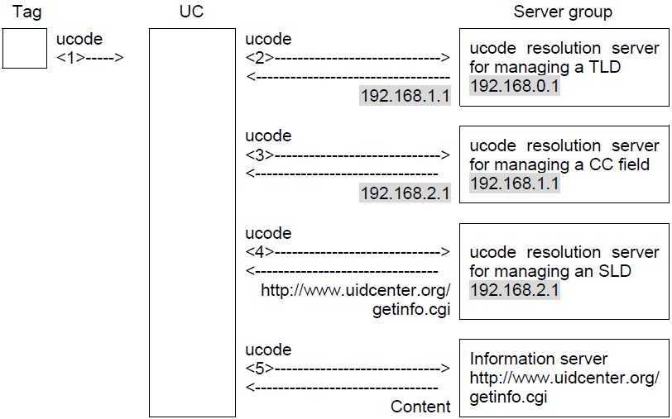
Figure 6.1.3 ucodeRP resolution procedures

6.5 Object Identifier (OID)
OID is jointly developed by both ISO/IEC and ITU-T. It is an encoding strategy and used to unambiguously identify an object (physical/virtual objects) uniquely in the global context. It ensures that the object can be addressed and managed absolutely.
OID uses a hierarchical tree structure. An OID consists of several segments called arcs which provide placeholders for identification and description in the hierarchical tree. In the OID tree, the first arc represents the organization code and is used to manage and allocate its corresponding lower arc. The first arc (nodes under the root) can be the value “itu-t (0)”, “iso (1)” and “joint-iso-itu-t (2)”, and the arcs from each node can be infinite. The OID structure is shown in the Figure. OID resolution system (ORS) is a DNS-based protocol.
Figure 6.1.4 the structure of OID

----------------------- End of change 3 -----------------------

----------------------- Start of change 4 -----------------------

7 Use cases analysis

7.1 Overview
A heterogeneous identification service is a common technology widely used in various IoT industries. For example, supply chain management and logistics, product traceability, and energy management.
There are three requirements related to the heterogeneous identification service that are not yet supported by the oneM2M system.
Requirement ID | Description | Release
OSR-111  See REQ-2017-0018R01 | The oneM2M system shall be able to support heterogeneous identification services, the recognition of external identification systems and converting an object identifier to a compatible identifier recognized by the oneM2M system.
The oneM2M system shall be able to support the traceability linking service which provides a mapping that relates a product identifier to product related traceability information.
Traceability information consists of:
  - Logs
  - Information on ID service nodes, such as:
    - servers that provide access to traceability information, and
    - devices (sensors and gateways) that gather traceability information
 | The oneM2M system shall be able to enable applications to retrieve the traceability information related to product identifiers.

Use case for heterogeneous identification service

7.2.1 Description
In an industrial internet environment, a physical entity (e.g. raw material, component, intermediate product and finished product ...) is given a unique tangible identifier via a labelling technology (e.g. RFID tag, barcode, etc.). The tangible identifier can aid a device (e.g. barcode reader) in identifying, monitoring, and proxying on behalf of a physical entity. The same physical entity can be assigned multiple tangible identifiers

based on various identification standards (e.g. EPC, OID, ucode) to allow different devices and applications compatible with the various identification standards to identify, monitor and proxy on behalf of the same physical entity.
To help manage the multiple tangible identifiers that is assigned to a physical entity, a M2M service platform supports a heterogeneous identification service. When it receives a request with a tangible identifier, the M2M service platform detects the standard which the tangible identifier is compliant to, and interworks with the corresponding resolution server to resolve the tangible identifier to a communication identifier (e.g. IP address, FQDN) of the device that interworks to the physical entity.

Actors
- M2M service platform -
- The entity that provides a heterogeneous identification service.
- Discovery application -
- The discovery request initiator (e.g. vendor, processor, operator, or third party).
- Device -
- The entity that interworks to the physical entity and reads its tangible identifier. It can be a sensor, actuator, RFID reader, or application server.
- Resolution server -
- The resolution server (e.g. ONS, Handle system) is an entity to resolve the tangible identifier of the physical entity to the communication identifier of the device that interworks to the physical entity.
- Physical entity -
- The physical entity does not have the capability to communicate with other entities. It is tagged with a tangible identifier which a device (e.g. RFID reader) can use to identify and record information about the physical entity.

Pre-conditions
The application registers to the M2M service platform. The M2M service platform supports a heterogenous identification service that interworks with one or more identification resolution servers.

Triggers
The application initiates a request to discover a physical entity via a tangible identifier.

Normal Flow

- The discovery application initiates a request to discover a physical entity via its tangible identifier such that it can find the communication identifier of the device that interworks to the physical entity.
- The M2M service platform receive the request from the discovery application, identifies the standards which the tangible identifier is compliant with.
- The M2M service platform sends a request to resolve the tangible identifier to a corresponding resolution server.
- The resolution server resolves the tangible identifier to the communication identifier of the device .
- The resolution server responds with the communication identifier of the device to the M2M service platform.
- The M2M service platform forwards the communication identifier to the discovery application.
- The discovery application sends a request to the device that is interworked to the physical entity and includes the tangible identifier of the physical entity.
- The device processes the request.
- The device responds with information about the physical entity to the discovery application.

Alternative flow
None

Post-conditions
None.

High Level Illustration

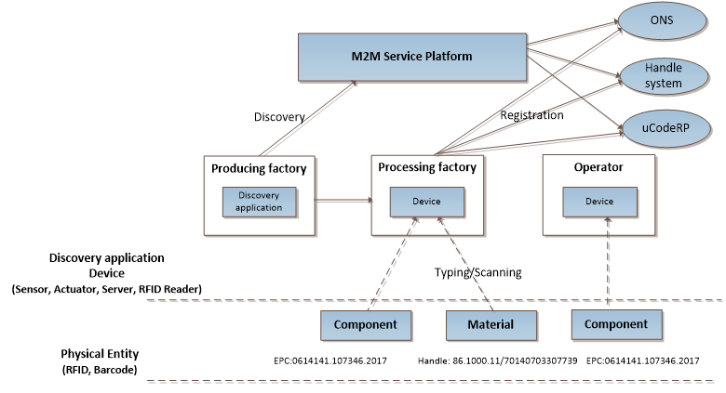

Potential requirements
- The oneM2M system shall be able to support heterogeneous identification services, the recognition of external identification systems and resolving a tangible identifier of a physical entity to a communication identifier of the device .

----------------------- End of change 4 -----------------------

----------------------- Start of change 5 -----------------------

8.1 Scenarios analysis based on oneM2M architecture

8.1.1 Creation of mapping information
A oneM2M AE captures the tangible identifier from tag attaching to a physical entity and also capture other related information (e.g. location, time). The creation procedures are shown in Figure 8.1.1-1.

Figure 8.1.1-1 Creation procedures
- AEs (AE1, AE2) capture the tangible identifiers and potentially other information (e.g. location, time) of the physical entities.
- 2. AEs optionally store the tangible identifiers, information (e.g. location, time) of the physical entities, identifier type, and the communication identifier of AE in the CSE. There are five possible combinations: 1) tangible identifier, information of the physical entity; 2) tangible identifier, communication identifier; 3) tangible identifier, information of the physical entity, identifier type; 4) tangible identifier, communication identifier, identifier type; 5) identifier type, communication identifier.

8.1.2 Discovery of identifiers related information
The application wants to discover the tangible identifier related information from the CSE that provides the heterogeneous service. There are two cases depicted as follows:
Case 1: the CSE4 maintains the tangible identifier related mapping information, the discovery procedures are shown in Figure 8.1.2-1.

Figure 8.1.2-1 discovery procedures for case 1

- The discovery application AE initiates a request to discover the device that interworks to a particular physical entity. The tangible identifier of the physical entity is included in the request.
- The CSE receives and processes the request. If the identifier type is not included in the request, the CSE can recognize the type of tangible identifier. The CSE resolves the tangible identifier to a communication identifier of the device that interworks to the physical entity .

- 3. The CSE forwards the discovery results to AE.

Case 2: the mapping information is not recorded on the queried CSE. The CSE will interwork with external identification resolution system(s) to assist with the identification resolution. The discovery procedure is shown in figure 8.1.2-2.

Figure 8.1.2-2 discovery procedures for case 2

- The discovery application AE initiates a request to discover the device that interworks to a particular physical entity. The tangible identifier of the physical entity is included in the request.
- The CSE receives the request. If the identifier type is not included in the request, the CSE can recognize the type of tangible identifier.
- The CSE sends the tangible identifier to the corresponding external resolution system (e.g. Handle system), and gets and resolution results from the resolution system. The results include the communication identifier of the device that interworks to the physical entity.
- 4. The CSE responds with the discovery results to AE.

----------------------- End of change 5 -----------------------

CHECK LIST
- Does this Change Request include an informative introduction containing the problem(s) being solved, and a summary list of proposals.?
- Does this CR contain changes related to only one particular issue/problem?
- Have any mirror CRs been posted?
- Does this Change Request make all the changes necessary to address the issue or problem? E.g. A change impacting 5 tables should not include a proposal to change only 3 tables?Does this Change Request follow the drafting rules?
- Are all pictures editable?
- Have you checked the spelling and grammar?
- Have you used change bars for all modifications?
- Does the change include the current and surrounding clauses to clearly show where a change is located and to provide technical context of the proposed change? (Additions of complete clauses need not show surrounding clauses as long as the proposed clause number clearly shows where the new clause is proposed to be located.)
- Are multiple changes in this CR clearly separated by horizontal lines with embedded text such as, start of change 1, end of change 1, start of new clause, end of new clause.?

