Input Contribution
Meeting ID* | ARC35
Title:* | ETSI ISG MEC Architecture and APIs for TR-0052
Source:* | Kenichi Yamamoto, KDDI, kc-yamamoto@kddi.com
Date:* | 2018-05-09
Input related to* | WI-0080 Edge and Fog Computing  TR-0052 V 0.1.0
Intended purpose of  document:* | Decision  Discussion  Information  Other <specify>
Impacted other TS/TR(s)
Decision requested or recommendation:* | Agree for inclusion in TR-0052
Template Version: January 2017 (Do not modify)

oneM2M Notice
The document to which this cover statement is attached is submitted to oneM2M. Participation in, or attendance at, any activity of oneM2M, constitutes acceptance of and agreement to be bound by terms of the Working Procedures and the Partnership Agreement, including the Intellectual Property Rights (IPR) Principles Governing oneM2M Work found in Annex 1 of the Partnership Agreement.

Introduction
This contribution provides ETSI ISG MEC Architecture and APIs for TR-0052.

---------------------- Start of change 1-------------------------------------------

Analysis Background
Editor’s Note: The section summarizes existing technologies of Edge and Fog Computing that can be used for providing the capability enablement in oneM2M. It also includes descriptions of the optimizations which Edge and Fog Computing are expected to provide to oneM2M implementations..

Overview
Editor’s Note: The section provides an overview of the technological landscape.

Existing Technologies
Editor’s Note: The section introduces existing technologies

6.2.x ETSI ISG MEC Architecture and APIs

6.2.x.1 Introduction
MEC provides IT and cloud-computing capabilities at the edge of the network in order to offer a service environment with ultra-low latency, high-bandwidth, and real time access to radio network. The enviroment can create new value-added services and expect to minimize the amount of processing required by cloud nodes and devices.
The MEC initiative is an Industry Specification Group (ISG) within ETSI. The purpose of the ISG is to create a standardized, open environment which will allow the efficient and seamless integrations of applications from vendors, service providers, and third-parties across multi-vendor edge computing platforms.
ISG MEC works on use cases, requirements, a reference architecture and corresponding API specifications. It published in July 2017 the first set of API specifications for application enablement in an Edge Computing node and for capability exposure to applications. The API specifications are first phase specifications, called MEC Phase 1.
In September 2016, ISG MEC changed the acronym MEC from “mobile edge computing” to “multi-access edge computing” to reflect the importance of addressing Wi-Fi and fixed-line in addition to 3GPP access technologies. This phase, known as MEC Phase 2, leverages on the industry acceptance of the Phase 1 specifications. Regarding the Phase 2 works in progress, see ETSI Work Programme [i.m].

6.2.x.2 MEC Framework and Reference Architecture
The MEC Framework shows the general entities involved for enabling the implementation of Mobile edge applications, defined in the GS (Group Specification) MEC 003 [i.b]. The Framework can be grouped into Networks level entity, Mobile edge host level and Mobile edge system level, see Figure 6.2.x.2-1.
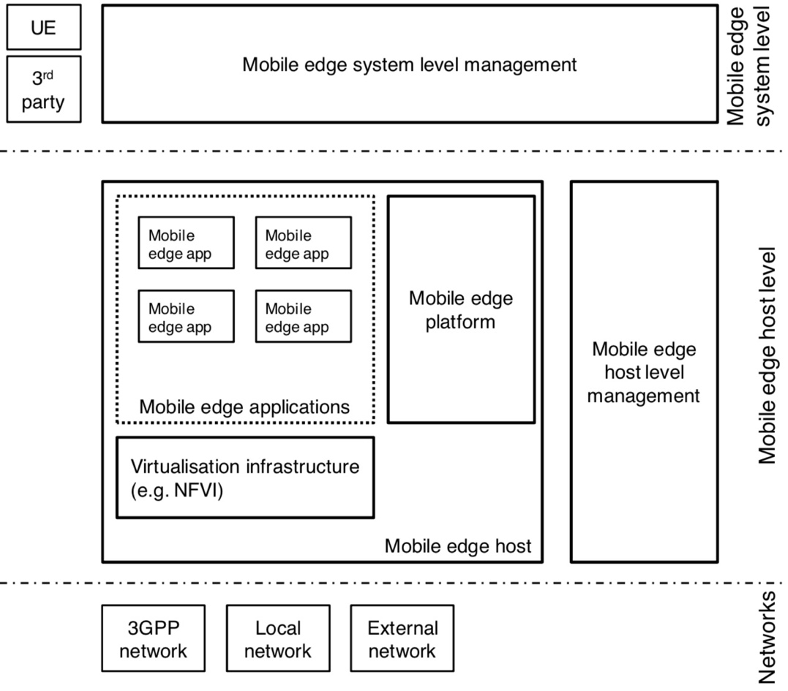
Figure 6.2.x.2-1: MEC framework [i.b]
Figure 6.2.x.2-2 illustrates the MEC reference architecture defined in the GS MEC 003 [i.b]. The reference architecture shows the functional elements that comprise MEC system and the reference points between them.
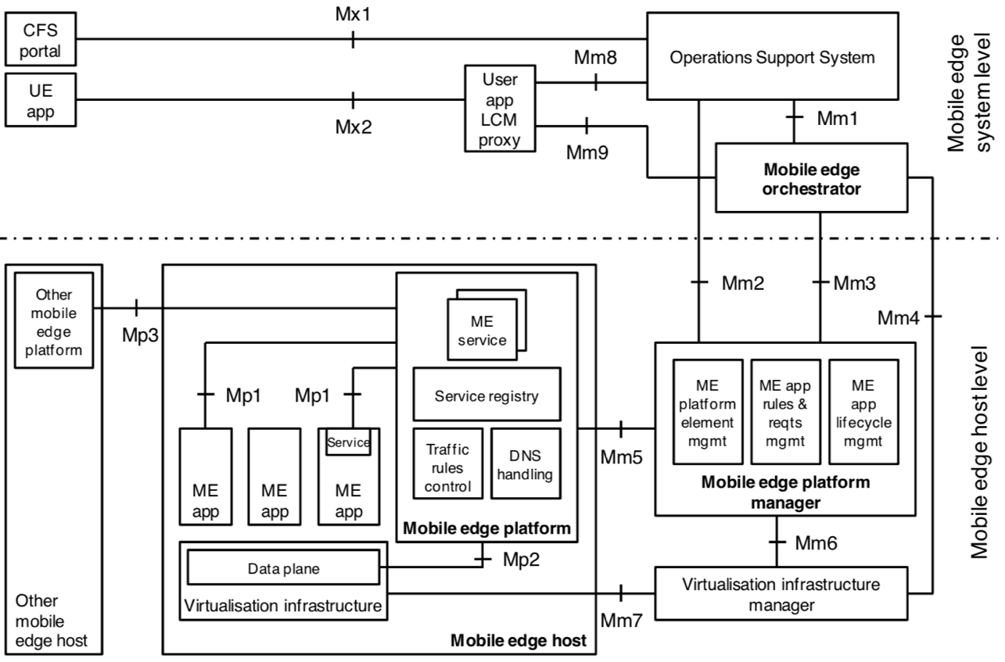
Figure 6.2.x.2-2: MEC reference architecture [i.b].
The reference architecture comprises mainly the following functions (those functions with reference points are further described in GS MEC 003 [i.b]):
Mobile edge host: The Mobile edge host comprises a Mobile edge platform, a Virtualisation infrastructure, and Mobile edge applications which provides compute, storage, and network resources for the mobile edge applications.
Mobile edge platform: The Mobile edge platform is the collection of essential functionality required to run Mobile edge applications and enable them to discover, advertise, consume, and offer mobile edge services via Mp1 reference point. It also communicates other Mobile edge host through the Mp3 reference when supported.
Mobile edge applications: The Mobile edge applications run as the virtual machines (VM) of the Mobile edge host. They interact with the Mobile edge platform to consume and provide mobile edge services via Mp1 reference point.
Virtualisation infrastructure: The Virtualisation infrastructure includes a data plane that executes the traffic rules received by the mobile edge platform, and routes the traffic among applications, services, DNS server/proxy, 3GPP network, local networks and external networks.
Virtualisation infrastructure manager: The Virtualisation infrastructure manager allocates, manages and releases the virtualized resources (compute, storage and networking) of the virtualisation infrastructure via Mm7 reference point. It also collects and reports performance and fault information about the virtualised resources.
Mobile edge platform manager: The Mobile edge platform manager manages the life cycle of applications, provides element management functions to the mobile edge platform and manages the application rules and requirements. It also receives fault reports and performance measurements from the virtualisation infrastructure manager.
Mobile edge orchestrator: The Mobile edge orchestrator is the core component of Mobile edge system level. It maintains an overview of the mobile edge system, on-boards of application packages, validates application rules and requirements, triggers application instantiation and termination, and selects appropriate mobile edge host(s).
OSS (Operations Support System): The OSS receives requests via the CFS (Customer Facing Service portal) portal and from UE applications for instantiation or termination of applications and communictes with the Mobile edge orchestrator via Mm1 reference point for further processing.
User application LCM proxy: The User application LCM (lifecycle management) proxy allows UE applications to request on-boarding, instantiation, termination of user applications via Mx2 reference point. It also authorizes requests from UE applications in the UE and interacts with the OSS via Mm8 reference point and the Mobile edge orchestrator via Mm9 reference point for further processing of these requests.

6.2.x.4 MEC API Specifications
ISG MEC defines a set of standardized APIs to support ege computing interoperability. The published API specifications comprise generic set of API design principles and patterns, management related APIs (platform management and application lifecycle management), application enablement API, service related APIs (Radio Network Information, Location, UE Identity, and Bandwidth Management), and UE application interface. Figure 6.2.x.4-1 shows the mapping between MEC API specifications and MEC reference architecture [i.l].
Figure 6.2.x.4-1: Mapping between MEC API specifications and MEC reference architecture [i.l]

6.2.x.4.1 Generic set of API design principles and patterns, “GS MEC 009” [i.c]
Generic set of API design principles and patterns is defined in GS MEC 009 [i.c]. It also specifies guidance for MEC API documentation. Compliance with these principles ensures consistency across APIs.

6.2.x.4.2 Platform management API, “GS MEC 010-1” [i.d]
Platform management API focuses on Mm2 reference point between the OSS and Mobile edge platform manager, defined in GS MEC 010-1 [i.d]. The API provides platform management related functionality, such as configuration management and fault management, using 3GPP specifications defined IRP (Integration Reference Point) [i.s], [i.t], [i.u], [i.v].

6.2.x.4.3 Application lifecycle management (LCM) API, “GS MEC 010-2” [i.e]
Application LCM API using Mm1 and Mm3 reference points is defined in GS MEC 010-2 [i.e]. Mm1 reference point between Mobile Edge Orchestrator and OSS is used for on-boarding application packages, triggering application instantiation and termination. Mm3 reference point between the Mobile edge orchestrator and the Mobile edge platform manager is used for the management of the application lifecycle, application rules and requirements, and keeping track of available mobile edge services.
Figure 6.2.x.4.3-1 illustrates the message flow of application instantiation. The OSS sends an instantiate application request to Mobile edge orchestrator via Mm1 (Step-1). Then Mobile edge orchestrator checks application instance configuration data, and authorizes the request via Mm3 (Step-2). The Mobile Edge Platform Manager communicates with Mobile edge platform and Virtualization infrastructure manager for resource allocation and configuration request of Traffic/DNS rules (Step-3,4,5 and 7 are not specified in GS MEC 010-2 [i.e]). The configutation (Step 6) between Mobile edge platform and Mobile edge application instance is specified in GS MEC 011 [i.f].
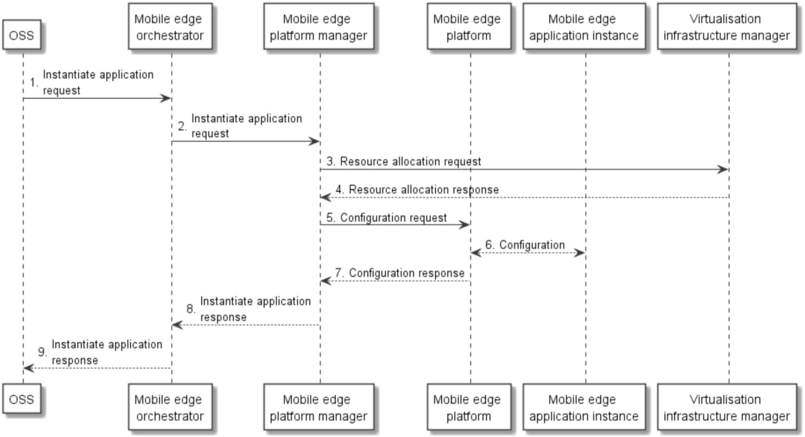
Figure 6.2.x.4.3-1: Application instantiation flow [i.e]

6.2.x.4.4 Application Enablement API, ”GS MEC 011” [i.f]
Application Enablement API is specified in GS MEC 012 [i.f] and supports the requirements in GS MEC 002 [i.a]. It focuses on Mp1 reference point between Mobile edge application and Mobile edge platform, which provides service related functionality, such as registration, discovery and service availability. It also provides other functionality, such as application start-up/termination, available transports, traffic rules (e.g. traffic filter per flow or packet and priority of traffic rule), DNS rules activation, and access to time of day information (e.g. NTP and PTP).

6.2.x.4.5 Radio Network Information service(RNIS) API, ”GS MEC 012” [i.g]
RNIS API is specified in GS MEC 012 [i.g] and supports the requirements in GS MEC 002 [i.a]. It provides radio network related information to Mobile edge application and Mobile edge platform in order to optimize the existing services and to provide new type of services that are based on up to date information on radio conditions. RNIS is discovered over the Mp1 reference point.
The information provided by RNIS classified as follow:
RAB (Radio Access Bearer) information: RNIS provides information on existing RAB, RAB establishment, RAB modification, and RAB release. The existing RAB information includes the information on users per cell such as:
- The identifiers of the cells (E-UTRAN cell global identifier [i.n]).
- The identifiers associated to UEs in the cells.
- The E-RAB information, based on E-RAB ID (identifying a radio access bearer for a particular UE) [i.n], QCI [i.r], and QoS (Maximum downlink/uplink E-RAB Bit Rate and guaranteed downlink/uplink E-RAB Bit Rate) [i.r].
PLMN(Public Land Mobile Network) information: It includes cell level PLMN information related to specific mobile edge application instance (e.g. E-UTRAN cell global identifier [i.n] and PLMN Identity [i.n]).
S1 bearer information: RNIS provides information on existing S1 bearer, S1 bearer establishment, modification and release. The information is used for optimizing the relocation of mobile edge applications, or uses the acquired information for managing the traffic rules for the related application instances. It contains following information: E-UTRAN cell global identifier [i.n], PLMN Identity [i.n], and S1 bearer information based on E-RAB ID [i.n] (identifying a S1 bearer for a specific UE), eNB transport layer address, eNB GTP-U TEID, S-GW transport layer address and S-GW GTP-U TEID.
Cell change information: It is sent by the RNIS to inform about the cell change of a UE. It includes the following information: handover status (e.g. in preparation, in execution, completed and rejected), E-UTRAN cell global identifier [i.n] and PLMN Identity [i.n] for the source/target cell.
UE measurement reports: RNIS provides UE measurement reports. The information includes as follow: E-UTRAN cell global identifier [i.n], PLMN Identity [i.n], triggers for the measurement report (e.g periodical or not available) [i.p], Reference Signal Received Power [i.o] and Reference Signal Received Quality [i.o] for the source cell and neighbouring cells.
UE timing advance: RNIS provides about the Timing Advance value received from the UE in order to ensure that uplink and downlink sub frames are synchronized at the eNB. It contains following information: E-UTRAN Cell Identity [i.n], PLMN Identity [i.n], and Timing Advance [i.o] .

6.2.x.4.6 Location service(LS) API, ”GS MEC 013” [i.h]
LS API is specified in GS MEC 013 [i.h] and supports the requirements in GS MEC 002 [i.a]. It provides the location related information to Mobile edge application and Mobile edge platform. LS supports the location retrieval mechanism, the location subscribe mechanism, the anonymous location report (e.g. for statistics collection), and the location information (UEs currently served by radio nodes, UEs which move in or out of particular location area, and a list of UEs in a particular location area). LS is registered and discovered over the Mp1 reference point.
LS leverages the Zonal Presence service described in SCF 084.07.01 [i.w] and in SCF 152.07.01 [i.x]. LS is accessible through the API defined in the Open Mobile Alliance (OMA) specification "RESTful Network API for Zonal Presence"[i.y]. In the specification, the Anonymous Customer Reference (ACR) [i.z] addresses user categories via the API and 3GPP Cell Identifiers defined in 3GPP TS.29.171 [i.q] can be mapped to the Access Point identifier of the OMA API [i.y].
The information provided by LS contains as follow (specified in OMA API [i.y]): address of user (e.g. 'acr' URI) currently on the access point, the identity of the access point the user is currently on, the identity of the zone the user is currently within, the geographical coordinates where the user is and contextual information of a user location (e.g. aisle, floor, room number, etc).

6.2.x.4.7 UE Identity service API, “GS MEC 014” [i.i]
UE Identity service API is specified in GS MEC 014 [i.i] and supports the requirements in GS MEC 002 [i.a]. The UE Identity feature is to allow UE specific traffic rules in the mobile edge system. Each UE is identified by a unique tag and the tag registration triggers the Mobile edge platform to activate the corresponding traffic rules. Mp1 reference point is used for the UE Identity functionality.

6.2.x.4.8 Bandwidth Management service (BWMS) API, “GS MEC 015” [i.j]
BWMS API is specified in GS MEC 015 [i.j] and supports the requirements in GS MEC 002 [i.a]. It enables registered applications to statically and/or dynamically register for specific bandwidth allocation (bandwidth size, bandwidth priority, or both) per session/application. BWMS is registered over Mp1 reference point.
The information provided by BWMS contains as follow: request type (application specific bandwidth allocation or session specific bandwidth allocation), indicating bandwidth allocation priority when dealing with several applications or sessions in parallel, size of bandwidth allocation, and the direction of the requested bandwidth allocation(downlink, uplink or symmetrical).

6.2.x.4.9 UE application interface, “GS MEC 016” [i.k]
UE application interface is specified in GS MEC 016 [i.k] and provides the LCM of the user applications API to support the requirements defined in GS MEC 002 [i.a]. It contains the request for the list of available user applications, the request for the user application instantiation, and the request for the user application termination over Mx2 reference point between the UE application in the UE and the user application LCM proxy.
The information provided by the request procedure for the list of available user application contains as follow: application name, application provider, application software version, descriptuion of application, characteristics of application, maximum memory size, maximum storage size, latency, required connection bandwidth, service continuity mode (required or not required), vendor specific information, and vendor identifier.

6.y.1 Technology x

-----------------------End of Change 1 ---------------------------------------------

-----------------------Start of Change 2 ---------------------------------------------

References
The following text block applies.
References are either specific (identified by date of publication and/or edition number or version number) or non- specific. For specific references, only the cited version applies. For non-specific references, the latest version of the referenced document (including any amendments) applies.

Normative references
Normative references are not applicable in the present document.

Informative references
Clause 2.2 shall only contain informative references which are cited in the document itself.
The following referenced documents are not necessary for the application of the present document but they assist the user with regard to a particular subject area.
[i.a] ETSI GS MEC 002 (V1.1.1): “Mobile Edge Computing (MEC); Technical Requirements”.
[i.b] ETSI GS MEC 003 (V1.1.1): “Mobile Edge Computing (MEC); Framework and Reference Architecture”.
[i.c] ETSI GS MEC 009 (V1.1.1): “Mobile Edge Computing (MEC); General principles for Mobile Edge Service APIs”.
[i.d] ETSI GS MEC 010-1 (V1.1.1): “Mobile Edge Computing (MEC); Mobile Edge Management; Part 1: System, host and platform management”.
[i.e] ETSI GS MEC 010-2 (V1.1.1): “Mobile Edge Computing (MEC); Mobile Edge Management; Part 2: Application lifecycle, rules and requirements management”.
[i.f] ETSI GS MEC 011 (V1.1.1): “Mobile Edge Computing (MEC); Mobile Edge Platform Application Enablement”.
[i.g] ETSI GS MEC 012 (V1.1.1): “Mobile Edge Computing (MEC); Radio Network Information API”.
[i.h] ETSI GS MEC 013 (V1.1.1): “Mobile Edge Computing (MEC); Location API”.
[i.i] ETSI GS MEC 014 (V1.1.1): “Mobile Edge Computing (MEC); UE Identity API”.
[i.j] ETSI GS MEC 015 (V1.1.1): “Mobile Edge Computing (MEC); Bandwidth Management API”.
[i.k] ETSI GS MEC 016 (V1.1.1): “Mobile Edge Computing (MEC); UE application interface”.
[i.l] NFV World Congress 2017 - Enabling the 5G Cloud.
(http://www.etsi.org/multi-access-edge-computing/mec-presentations-at-industry-events)
[i.m] ETSI Work Programme.
(https://portal.etsi.org/webapp/WorkProgram/SimpleSearch/QueryForm.asp)
[i.n] 3GPP TS 36.413: “LTE; Evolved Universal Terrestrial Radio Access Network (E-UTRAN); S1 Application Protocol (S1AP)”.
[i.o] 3GPP TS 36.214: "LTE; Evolved Universal Terrestrial Radio Access (E-UTRA); Physical layer; Measurements”.
[i.p] 3GPP TS 36.331:"LTE; Evolved Universal Terrestrial Radio Access (E-UTRA); Radio Resource Control (RRC); Protocol specification".
[i.q] 3GPP TS 29.171: "LTE; Location Services (LCS); LCS Application Protocol (LCS-AP) between the Mobile Management Entity (MME) and Evolved Serving Mobile Location Centre (E-SMLC); SLs interface”.
[i.r] 3GPP TS 23.401: “LTE; General Packet Radio Service (GPRS) enhancements for Evolved Universal Terrestrial Radio Access Network (E-UTRAN) access”.
[i.s] 3GPP TS 32.602: "Digital cellular telecommunications system (Phase 2+); Universal Mobile Telecommunications System (UMTS); LTE; Telecommunication management; Configuration Management(CM); Basic CM Integration Reference Point (IRP); Information Service (IS)".
[i.t] 3GPP TS 32.662: "Digital cellular telecommunications system (Phase 2+); Universal Mobile Telecommunications System (UMTS); LTE; Telecommunication management; Configuration Management (CM); Kernel CM Information Service (IS)".
[i.u] 3GPP TS 32.332: "Digital cellular telecommunications system (Phase 2+); Universal Mobile Telecommunications System (UMTS); LTE; Telecommunication management; Notification Log (NL) Integration Reference Point (IRP); Information Service (IS)".
[i.v] 3GPP TS 32.111-2: "Digital cellular telecommunications system (Phase 2+); Universal Mobile Telecommunications System (UMTS); LTE; Telecommunication management; Fault Management;Part 2: Alarm Integration Reference Point (IRP): Information Service (IS)".
[i.w] SCF 084.07.01: "Small cell zone services - RESTful bindings".
[i.x] SCF 152.07.01: "Small cell services API".
[i.y] OMA-TS-REST-NetAPI-ZonalPresence-V1-0-20160308-C: "RESTful Network API for Zonal Presence".
[i.z] OMA-TS-REST-NetAPI-ACR-V1-0-20151201-C: "RESTful Network API for Anonymous Customer Reference Management"

-----------------------End of Change 2 ---------------------------------------------

-----------------------Start of Change 3 ---------------------------------------------

Definitions, symbols and abbreviations
Delete from the above heading the word(s) which is/are not applicable.

Definitions

Symbols

Abbreviations
For the purposes of the present document, the [following] abbreviations [given in ... and the following] apply:
Abbreviation format
3GPP 3rd Generation Partnership Project
API Application Program Interface
BWMS Bandwidth Management service
eNB E-UTRAN NodeB
E-RAB E-UTRAN Radio Access Bearer
ETSI European Telecommunications Standards Institute
E-UTRAN Evolved UTRAN
GTP-U GPRS Tunnelling Protocol-User plane
IRP Integration Reference Point
LCM Life Cycle Management
LS Location Service
NTP Network Time Protocol
OMA Open Mobile Alliance
PLMN Public Land Mobile Network
PTP Precision Time Protocol
QCI Quality Class Indicator
QOS Quality of Service
RAB Radio Access Bearer
RNIS Radio Network Information Service
SCF Small Cell Forum
S-GW Serving Gateway
TEID Tunnel Endpoint Identifier
UE User Equipment

-----------------------End of Change 3 ---------------------------------------------

