CHANGE REQUEST
Meeting ID:* | ARC #35
Source:* | Preeti Rani(preetir@cdot.in), Suman Sheoran(ssheoran@cdot.in), Anupama Chopra(anupama@cdot.in)
Date:* | 2018-05-22
Reason for Change/s:* | Missing Location Request Flow
CR against: Release* | Release 2
CR against: WI* | Active <Work Item number>  MNT maintenance / < Work Item number(optional)>  Is this a mirror CR? Yes No  mirror CR number: ARC-2018-0133R01-MissingLocationRequestFlow_R3 (Note to Rapporteur - use latest agreed revision)  STE Small Technical Enhancements / < Work Item number (optional)>  Only ONE of the above shall be ticked
CR against: TS/TR* | TS-0001v2.19.0
Clauses * | 8.3.4 Location Request
Type of change: * | Editorial change  Bug Fix or Correction  Change to existing feature or functionality  New feature or functionality  Only ONE of the above shall be ticked
Impacted other TS/TR(s) | <TS/TR number>, <Version Number>, and <Description on which aspect should be reflected in this TS/TR>
Post Freeze checking:* | This CR contains only essential changes and corrections? YES NO  This CR may break backwards compatibility with the last approved version of the TS? YES NO
Template Version: January 2017 (Do not modify)

oneM2M Notice
The document to which this cover statement is attached is submitted to oneM2M. Participation in, or attendance at, any activity of oneM2M, constitutes acceptance of and agreement to be bound by terms of the Working Procedures and the Partnership Agreement, including the Intellectual Property Rights (IPR) Principles Governing oneM2M Work found in Annex 1 of the Partnership Agreement.
GUIDELINES for Change Requests:
Provide an informative introduction containing the problem(s) being solved, and a summary list of proposals.
Each CR should contain changes related to only one particular issue/problem.
In case of a correction, and the change apply to previous releases, a separate “mirror CR” should be posted at the same time of this CR
Mirror CR: applies only when the text, including clause numbering are exactly the same.
Companion CR: applies when the change means the same but the baselines differ in some way (e.g. clause number).
Follow the principle of completeness, where all changes related to the issue or problem within a deliverable are simultaneously proposed to be made E.g. A change impacting 5 tables should not only include a proposal to change only 3 tables. Includes any changes to references, definitions, and acronyms in the same deliverable.
Follow the drafting rules.
All pictures must be editable.
Check spelling and grammar to the extent practicable.
Use Change bars for modifications.
The change should include the current and surrounding clauses to clearly show where a change is located and to provide technical context of the proposed change. Additions of complete clauses need not show surrounding clauses as long as the proposed clause number clearly shows where the new clause is proposed to be located.
Multiple changes in a single CR shall be clearly separated by horizontal lines with embedded text such as, start of change 1, end of change 1, start of new clause, end of new clause.
When subsequent changes are made to content of a CR, then the accepted version should not show changes over changes. The accepted version of the CR should only show changes relative to the baseline approved text.

Introduction
The Location positioning procedure can be done by CSE or an NSE. Section 8.3.4 - Location Request of document TS-0001 only explains on of the general cases when location positioning procedure is done by CSE and does not include the other case. Thus it cannot be termed as a general location request.
Thus it is proposed to add the missing case of location positioning procedure done by NSE.
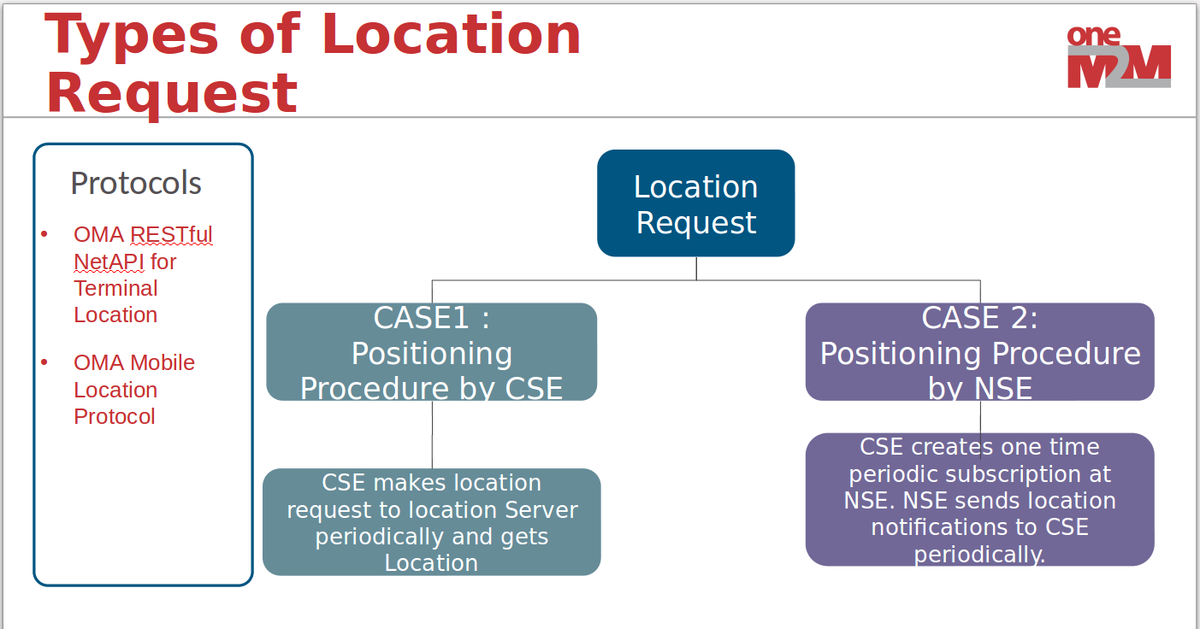

Case 1: TS-0001 Section 8.3.4: Periodic positioning procedure by CSE

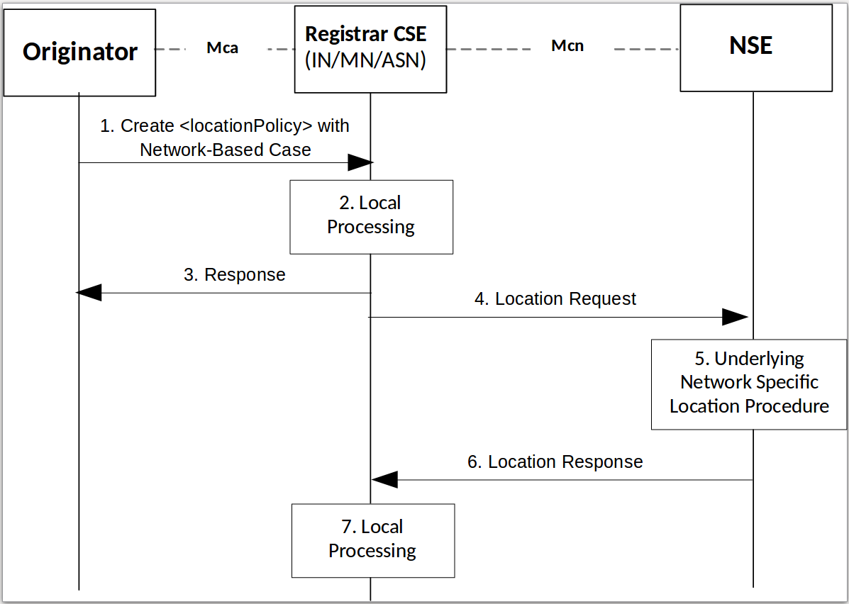

Case 2: Missing: Periodic location positioning procedure by NSE
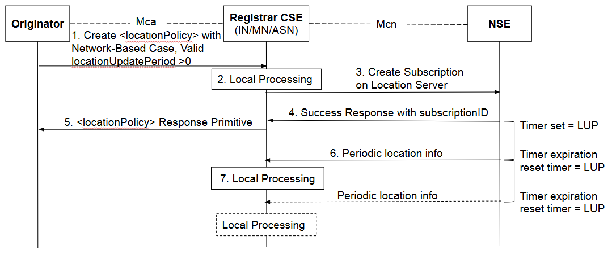

-----------------------Start of change 1-------------------------------------------

8.3.4 Location Request

8.3.4.1 Definition and Scope
Location Request is a means by which a CSE requests the geographical or physical location information of a target CSE or AE hosted in a M2M Node to the location server located in the Underlying Network over Mcn reference point. This clause describes only the case of location request when the attribute locationSource is set to Network Based.
The general location request to the location server can be done in two ways:
- Periodic location positioning procedure by CSE.
- Periodic location positioning procedure by NSE.

8.3.4.2 Periodic location positioning procedure by CSE
This procedure describes a scenario wherein an AE creates <locationPolicy> resource to obtain the location information of a target AE or CSE hosted in an M2M Node and CSE makes location request to the location server NSE periodically (if locationUpdatePeriod is greater than 0) or only on the retrieval of the latest child resource of the linked <container> resource, and the location server responses to the CSE with location information.

Figure 8.3.4.2: Periodic location positioning procedure by CSE
NOTE 1: Detailed descriptions for Step-1 to the Step-3 are described in the clause 10.2.11.1.
Step-1: Create <locationPolicy>
The Originator requests to CREATE <locationPolicy> resource at the Registrar CSE. The locationSource attribute of the <locationPolicy> resource shall be set to 'Network-Based' and the value for locationTargetID and locationServer attributes shall be set properly set for the Location Request.
Step-2: Local Processing for creating <locationPolicy> resource
After verifying the privileges and the given attributes, the Hosting CSE creates <container> resource where the actual location information is/are stored. Then the Hosting CSE shall create <locationPolicy> resource. The Hosting CSE shall maintain cross-reference between both resources: locationContainerID attribute for <locationPolicy> resource and locationID attribute for <container> resource.
Step-3: Response for creating <locationPolicy>
The Registrar CSE shall respond with a Response message.
Step-4: Location Request
The Registrar CSE issues Location Request to the selected Underlying Network. For doing this, the Registrar CSE shall transform the location configuration information received from the Originator into Location Request that is acceptable for the Underlying Network. For example, the Location Request can be one of existing location acquisition protocols such as OMA Mobile Location Protocol [Error: Reference source not found] or OMA RESTful NetAPI for Terminal Location [Error: Reference source not found]. Additionally, the Registrar CSE shall provide default values for other parameters (e.g. required quality of position) in the Location Request according to local policies.
NOTE 2: The Location Request can be triggered by the given conditions, e.g.:
1) When the locationUpdatePeriod attribute has expired, or if the locationUpdatePeriod attribute is not given from the Step-1.
2) The <locationPolicy> is created or updated.
3) The linked <container> has been retrieved.
4) If the attribute locationUpdatePeriod has multiple value and the Hosting CSE of the resource is the target device, the Hosting CSE of the resource may update the location update period by choosing one of the value within the list according to the local context information of the device (velocity, battery level, current range) and its pre-provisioned local policy which is out of scope of the specification. The Hosting CSE then issues Location Request with selected value as the update period. Then, if the value switches to another value, step-4, 5, 6, 7 shall be repeated using the new period.
Step-5: Performing Location Procedure
The Underlying Network specific procedures are performed. This may involve getting location information from the target device or the network node. These procedures are outside the scope of oneM2M specifications.
Step-6: Location Response
The NSE responds to the Registrar CSE with location information if the Registrar CSE is authorized. If not, the NSE sends an error code back to the Registrar CSE.
Step-7: Local Processing after Location Response
The received response shall be contained in the <container> resource that is related the <locationPolicy> resource.
NOTE 3: Please see the clause 10.2.11.2 for detail information.
NOTE 4: For notification regarding the location response towards the Originator, the subscription mechanism is used.

8.3.4.3 Periodic location positioning procedure by NSE
This procedure describes a scenario wherein an AE creates <locationPolicy> resource to obtain the location information of a target AE or CSE hosted in an M2M Node and CSE makes location request to create a subscription on the location server NSE to obtain location information in the form of notifications from the location server NSE, and the location server responses to the CSE with location information periodically.
Figure 8.3.4.3: Periodic location positioning procedure by NSE
NOTE 1: Detailed descriptions for Step-1 to the Step-3 are described in the clause 10.2.11.1.
Step-1: Create <locationPolicy>
The Originator requests to CREATE <locationPolicy> resource at the Registrar CSE. The locationSource attribute of the <locationPolicy> resource shall be set to 'Network-Based' and the value for locationTargetID and locationServer attributes shall be set properly set for the Location Request.
Step-2: Local Processing for creating <locationPolicy> resource
After verifying the privileges and the given attributes, the Hosting CSE creates <container> resource where the actual location information is/are stored. Then the Hosting CSE shall create <locationPolicy> resource. The Hosting CSE shall maintain cross-reference between both resources: locationContainerID attribute for <locationPolicy> resource and locationID attribute for <container> resource.
Step-3: Location request to location Server for creating Periodic location notifications subscription
The hosting CSE issues Location Request when the attribute locationUpdatePeriod provided in the <.LocationPolicy>request is a valid duration greater than 0.
The hosting CSE shall create periodic location notifications subscription to the selected Underlying Network.
The hosting CSE shall transform the location configuration information received from the Originator into Location Request that is acceptable for the Underlying Network. For example, the Location Request can be one of existing location acquisition protocols such as OMA Mobile Location Protocol [i.5] or OMA RESTful NetAPI for Terminal Location [i.6]. Additionally, the Registrar CSE shall provide default values for other parameters (e.g. required quality of position) in the Location Request according to local policies.
Step-4: Response from NSE for location request
Set attribute locationStatus = Not_Retrieved if NSE responds with a success status for subscription creation.
Not_Retrieved can mean that location data is not retrieved, current data is not provided (does not indicate an error, no attempt may have been made to get location yet).
Set attribute locationStatus = Error if subscription on the location Server could not be created due to an error.
Step-5: Response primitive for creating <locationPolicy>
The Registrar CSE shall respond to the originator with a Response primitive.

Step-6: Performing Location Procedure and location information response to CSE
The Underlying Network specific procedures are performed. These procedures are outside the scope of oneM2M specifications. The NSE responds to the Registrar CSE with location information if the Registrar CSE is authorized. If not, the NSE sends an error code back to the Registrar CSE.
Step-7: Local Processing after Location Response
The received response shall be contained in the <container> resource that is related the <locationPolicy> resource.
NOTE 3: Please see the clause 10.2.11.2 for detail information.
NOTE 4: For notification regarding the location response towards the Originator, the subscription mechanism is used.

-----------------------End of change 1---------------------------------------------

CHECK LIST
- Does this Change Request include an informative introduction containing the problem(s) being solved, and a summary list of proposals.?
- Does this CR contain changes related to only one particular issue/problem?
- Have any mirror CRs been posted?
- Does this Change Request make all the changes necessary to address the issue or problem? E.g. A change impacting 5 tables should not include a proposal to change only 3 tables?Does this Change Request follow the drafting rules?
- Are all pictures editable?
- Have you checked the spelling and grammar?
- Have you used change bars for all modifications?
- Does the change include the current and surrounding clauses to clearly show where a change is located and to provide technical context of the proposed change? (Additions of complete clauses need not show surrounding clauses as long as the proposed clause number clearly shows where the new clause is proposed to be located.)
- Are multiple changes in this CR clearly separated by horizontal lines with embedded text such as, start of change 1, end of change 1, start of new clause, end of new clause.?

