CHANGE REQUEST
Meeting ID:* | ARC 35
Source:* | Albert Zhao, BOE, zhaojunjie111@boe.com.cn  SeungMyeong JEONG, KETI, sm.jeong@keti.re.kr  Dale Seed, Convida, Seed.Dale@convidawireless.com
Date:* | 2018-5-23
Reason for Change/s:* | Update the locationID attribute from ‘RW’ to ‘RO’
CR against: Release* | Rel 2
CR against: WI* | Active <Work Item number>  MNT maintenance / < Work Item number(optional)>  Is this a mirror CR? Yes No  mirror CR number: ARC-2018-0153-container_locationID_attribute_correction_R3  STE Small Technical Enhancements / < Work Item number (optional)>  Only ONE of the above shall be ticked
CR against: TS/TR* | TS-0001 v2.19.0
Clauses * | 9.6.6
Type of change: * | Editorial change  Bug Fix or Correction  Change to existing feature or functionality  New feature or functionality  Only ONE of the above shall be ticked
Impacted other TS/TR(s) | <TS/TR number>, <Version Number>, and <Description on which aspect should be reflected in this TS/TR>
Post Freeze checking:* | This CR contains only essential changes and corrections? YES NO  This CR may break backwards compatibility with the last approved version of the TS? YES NO
Template Version: January 2017 (Do not modify)

oneM2M Notice
The document to which this cover statement is attached is submitted to oneM2M. Participation in, or attendance at, any activity of oneM2M, constitutes acceptance of and agreement to be bound by terms of the Working Procedures and the Partnership Agreement, including the Intellectual Property Rights (IPR) Principles Governing oneM2M Work found in Annex 1 of the Partnership Agreement.
GUIDELINES for Change Requests:
Provide an informative introduction containing the problem(s) being solved, and a summary list of proposals.
Each CR should contain changes related to only one particular issue/problem.
In case of a correction, and the change apply to previous releases, a separate “mirror CR” should be posted at the same time of this CR
Mirror CR: applies only when the text, including clause numbering are exactly the same.
Companion CR: applies when the change means the same but the baselines differ in some way (e.g. clause number).
Follow the principle of completeness, where all changes related to the issue or problem within a deliverable are simultaneously proposed to be made E.g. A change impacting 5 tables should not only include a proposal to change only 3 tables. Includes any changes to references, definitions, and acronyms in the same deliverable.
Follow the drafting rules.
All pictures must be editable.
Check spelling and grammar to the extent practicable.
Use Change bars for modifications.
The change should include the current and surrounding clauses to clearly show where a change is located and to provide technical context of the proposed change. Additions of complete clauses need not show surrounding clauses as long as the proposed clause number clearly shows where the new clause is proposed to be located.
Multiple changes in a single CR shall be clearly separated by horizontal lines with embedded text such as, start of change 1, end of change 1, start of new clause, end of new clause.
When subsequent changes are made to content of a CR, then the accepted version should not show changes over changes. The accepted version of the CR should only show changes relative to the baseline approved text.

Introduction
TS-0001 section 9.6.6 defines the container resource type which can be use to store location information. The <container> resource includes the locationID attribute which holds the ID of this <locationPolicy> resource.
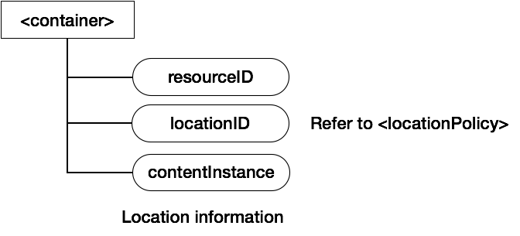
Section 10.2.9.2 define the create procedure for the <locationPolicy>. After receiver CSE recevices the Create <locationPolicy> request, the receiver will creates a <container> resource and a <locationPolicy> resource.
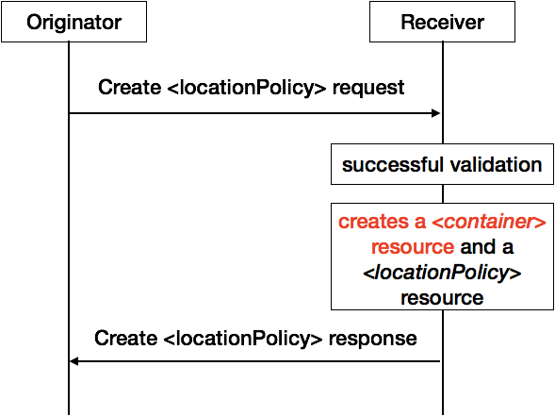
When the container is used to store location information, the <container> resource can only be created by Hosting CSE according to the create <locationPolicy> request, can not be created by originator using the create <container> request. So, form the perseptive of originator, the locationID attribute of <container> resource is RO, not RW.

-----------------------Start of change 1-------------------------------------------

9.6.6 Resource Type container
The <container> resource represents a container for data instances. It is used to share information with other entities and potentially to track the data. A <container> resource has no associated content. It has only attributes and child resources.
Figure 9.6.6-1: Structure of <container> resource
The <container> resource shall contain the child resources specified in table 9.6.6-1.
Table 9.6.6-1: Child resources of <container> resource
Child Resources of <container> | Child Resource Type | Multiplicity | Description | <containerAnnc> Child Resource Types
[variable] | <semanticDescriptor> | 0..n | See clause 9.6.30 | <semanticDescriptor>, <semanticDescriptorAnnc>
[variable] | <contentInstance> | 0..n | See clause 9.6.7 | <contentInstance>, <contentInstanceAnnc>
[variable] | <subscription> | 0..n | See clause 9.6.8 | <subscription>
[variable] | <container> | 0..n | See clause 9.6.6 | <container>  <containerAnnc>
[variable] | <flexContainer> | 0..n | See clause 9.6.35 | <flexContainer>  <flexContainerAnnc>
la | <latest> | 1 | See clause 9.6.27 | None
ol | <oldest> | 1 | See clause 9.6.28 | None

The <container> resource shall contain the attributes specified in table 9.6.6-2.
Table 9.6.6-2: Attribute of <container> resource
Attributes of  <container> | Multiplicity | RW/  RO/  WO | Description | <containerAnnc> Attributes
resourceType | 1 | RO | See clause 9.6.1.3. | NA
resourceID | 1 | RO | See clause 9.6.1.3. | NA
resourceName | 1 | WO | See clause 9.6.1.3. | NA
parentID | 1 | RO | See clause 9.6.1.3. | NA
expirationTime | 1 | RW | See clause 9.6.1.3. | MA
accessControlPolicyIDs | 0..1 (L) | RW | See clause 9.6.1.3. If no accessControlPolicyIDs value is configured, the accessControlPolicyIDs of the parent resource shall be applied for privilege checking. | MA
labels | 0..1 (L) | RW | See clause 9.6.1.3. | MA
creationTime | 1 | RO | See clause 9.6.1.3. | NA
lastModifiedTime | 1 | RO | See clause 9.6.1.3. | NA
stateTag | 1 | RO | See clause 9.6.1.3. | OA
announceTo | 0..1 (L) | RW | See clause 9.6.1.3. | NA
announcedAttribute | 0..1 (L) | RW | See clause 9.6.1.3. | NA
dynamicAuthorizationConsultationIDs | 0..1 (L) | RW | See clause 9.6.1.3. | OA
creator | 0..1 | RO | See clause 9.6.1.3. | NA
maxNrOfInstances | 0..1 | RW | Maximum number of direct child <contentInstance> resources in the <container> resource. | OA
maxByteSize | 0..1 | RW | Maximum size in bytes of data (i.e. content attribute of a <contentInstance> resource) that is allocated for the <container> resource for all direct child <contentInstance> resources in the <container> resource. | OA
maxInstanceAge | 0..1 | RW | Maximum age of a direct child <contentInstance> resource in the <container> resource. The value is expressed in seconds. | OA
currentNrOfInstances | 1 | RO | Current number of direct child <contentInstance> resource in the <container> resource. It is limited by the maxNrOfInstances.  The currentNrOfInstances attribute of the <container> resource shall be updated on successful creation or deletion of direct child <contentInstance> resource of <container> resource. | OA
currentByteSize | 1 | RO | Current size in bytes of data(i.e. content attribute of a <contentInstance> resource) stored in all direct child <contentInstance> resources of a <container> resource. This is the summation of contentSize attribute values of the <contentInstance> resources. It is limited by themaxByteSize. The currentByteSize attribute of the <container> resource shall be updated on successful creation of deletion of direct child <contentInstance> resource of <container> resource. | OA
locationID | 0..1 | RO | An ID of the resource where the attributes/policies that define how location information are obtained and managed. This attribute is defined only when the <container> resource is used for containing location information. | OA
ontologyRef | 0..1 | RW | A reference (URI) of the ontology used to represent the information that is stored in the child <contentInstance> resources of the present <container> resource (see note). | OA
disableRetrieval | 0..1 | RW | Boolean value to control RETRIE/UPDATE/DELETE operation on the child <contentInsance> resource.  When the value is set to 'TRUE', RETRIEVE/DELETE/UPDATE operations for child <contentInstance> shall be rejected at all times.  When the value is updated from 'TRUE' to 'FALSE', all existing <contentInstance> are deleted immediately.  When the value is set to 'FALSE', all operations are permitted on the <contentInstance> resource as per existing procedures. | OA
NOTE: The access to this URI is out of scope of oneM2M.

-----------------------End of change 1---------------------------------------------

CHECK LIST
- Does this Change Request include an informative introduction containing the problem(s) being solved, and a summary list of proposals.?
- Does this CR contain changes related to only one particular issue/problem?
- Have any mirror CRs been posted?
- Does this Change Request make all the changes necessary to address the issue or problem? E.g. A change impacting 5 tables should not include a proposal to change only 3 tables?Does this Change Request follow the drafting rules?
- Are all pictures editable?
- Have you checked the spelling and grammar?
- Have you used change bars for all modifications?
- Does the change include the current and surrounding clauses to clearly show where a change is located and to provide technical context of the proposed change? (Additions of complete clauses need not show surrounding clauses as long as the proposed clause number clearly shows where the new clause is proposed to be located.)
- Are multiple changes in this CR clearly separated by horizontal lines with embedded text such as, start of change 1, end of change 1, start of new clause, end of new clause.?

