

CHANGE REQUEST
Meeting:* | ARC TP35
Source:* | BeiXu，Huawei，Echo.xubei@huawei.com
Date:* | 2018-05-07
Contact:* | BeiXu，Huawei，Echo.xubei@huawei.com
Reason for Change/s:* | Create the new content of clause 6.
CR against: Release* | <Release4>
CR against: WI* | Active < WI-0082 - 3GPP V2X Interworking >  MNT Maintenace / < Work Item number(optional)>  STE Small Technical Enhancements / < Work Item number (optional)>  Only ONE of the above shall be ticked
CR against: TS/TR* | TR-0055-V0_0_1
Clauses/Sub Clauses*
Type of change: * | Editorial change  Bug Fix or Correction  Change to existing feature or functionality  New feature or functionality  Only ONE of the above shall be ticked
Post Freeze checking:* | This CR contains only essential changes and corrections? YES NO  This CR may break backwards compatibility with the last approved version of the TS? YES NO  This CR is a mirror CR? YES if YES, please indicate the document number of the original CR: <Document Number) : NO
Template Version:27 May 2015 (Dot not modify)

oneM2M Notice
The document to which this cover statement is attached is submitted to oneM2M. Participation in, or attendance at, any activity of oneM2M, constitutes acceptance of and agreement to be bound by terms of the Working Procedures and the Partnership Agreement, including the Intellectual Property Rights (IPR) Principles Governing oneM2M Work found in Annex 1 of the Partnership Agreement.
GUIDELINES for Change Requests:
Provide an informative introduction containing the problem(s) being solved, and a summary list of proposals.
Each CR should contain changes related to only one particular issue/problem.
In case of a correction, and the change apply to previous releases, a separated “mirror CR” should be posted at the same time of this CR
Follow the principle of completeness, where all changes related to the issue or problem within a deliverable are simultaneously proposed to be made E.g. A change impacting 5 tables should not only include a proposal to change only 3 tables. Includes any changes to references, definitions, and acronyms in the same deliverable.
Follow the drafting rules.
All pictures must be editable.
Check spelling and grammar to the extent practicable.
Use Change bars for modifications.
The change should include the current and surrounding clauses to clearly show where a change is located and to provide technical context of the proposed change. Additions of complete sections need not show surrounding clauses as long as the proposed section number clearly shows where the new section is proposed to be located.
Multiple changes in a single CR shall be clearly separated by horizontal lines with embedded text such as, start of change 1, end of change 1, start of new clause, end of new clause.
When subsequent changes are made to content of a CR, then the accepted version should not show changes over changes. The accepted version of the CR should only show changes relative to the baseline approved text.

Introduction
None.

-----------------------Start of change 1-------------------------------------------

7 Potential impact for interworking with oneM2M

7.1 oneM2M architecture impact: Field domain communication directly

Figure 7.1-1: 3GPP V2X PC5 mode
The “V2X Applications” hosted on the UE may be deployed as follows:
- Application only: UE could be ADN as of oneM2M entity
- Application and CSE: UE could be ASN or MN as of oneM2M entity
- CSE only: UE could be MN as of oneM2M entity
- Neither application nor CSE: UE could host a NoDN.
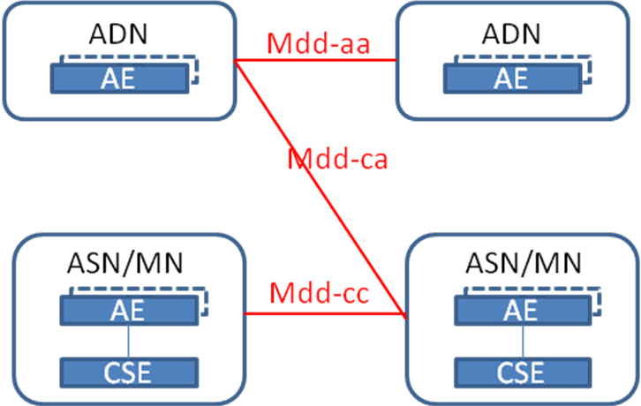
Figure 7.1-2: oneM2M interface mapping for 3GPP V2X PC5 mode
When oneM2M support 3GPP V2X Service PC5 mode, oneM2M shall support new reference point Mdd to support that the node in the field domain could communicate with other nodes,:
- When the UEs are ADNs, the interface is Mdd-aa.
- When the UEs are CSEs, the interface is Mdd-cc.
- When the UE are ADN and CSE, theinterface is Mdd-ca.
In oneM2M R4, CSE can only communicate with its registrar/register CSE via Mcc reference point. But the WI-0076 Lightweight oneM2M Services , AE is allowed to host its own oneM2M resources and support other operations than Notify. So oneM2M can support Mdd-aa firstly in release 4.

7.2 3GPP CIoT interworking impact
oneM2M has supported MBMS group in clause 7.7, location in clause 7.4.7 vi T8 reference point in TS-0026[5].oneM2M has supported OMA DM in TS-0005. oneM2M can reuse these function to support 3GPP V2X Service.
The Figure 7.2-1 shows the oneM2M and 3GPP interworking architecture which including 3GPP CIoT and 3GPP V2X Service at the same time. For oneM2M perspective, this architecture is simple and reasonable. But for 3GPP perspective, there shall be new requirements to support it.
The lines in pink are new requirements for 3GPP:
- SCEF shall support V4 reference point with HSS in the southbound interface;
- SCEF shall integragte 3GPP V2X AS partical function defined in 3GPP TR23.795 [3] and shall support new APIs to expose these functions via T8 interface;
Note: The 3GPP V2X Application Service is under process in 3GPP TR23.795[3].

Figure 7.2-1: 3GPP interworking architecture

-----------------------End of change 1-------------------------------------------

CHECK LIST
- Does this change request include an informative introduction containing the problem(s) being solved, and a summary list of proposals.
- Does this CR contain changes related to only one particular issue/problem?
- Have any mirror crs been posted?
- Does this change request make all the changes necessary to address the issue or problem? E.g. A change impacting 5 tables should not only include a proposal to change only 3 tables. Includes any changes to references, definitions, and acronyms in the same deliverable?
- Does this change request follow the drafting rules?
- Are all pictures editable?
- Have you checked the spelling and grammar?
- Have you used change bars for all modifications?
- Does the change include the current and surrounding clauses to clearly show where a change is located and to provide technical context of the proposed change? (Additions of complete sections need not show surrounding clauses as long as the proposed section number clearly shows where the new section is proposed to be located.)
- Are multiple changes in this CR clearly separated by horizontal lines with embedded text such as, start of change 1, end of change 1, start of new clause, end of new clause.?

