CHANGE REQUEST
Meeting ID:* | ARC#37
Source:* | Chengsui Lu, Hitachi, cslu@hitachi.cn  Miao Jiang, Hitachi, miaojiang@hitachi.cn
Date:* | 2018-09-10
Reason for Change/s:*
CR against: Release* | Release 2a
CR against: WI* | Active  MNT maintenance / < Work Item number(optional)>  Is this a mirror CR? Yes No  mirror CR number: (Note to Rapporteur - use latest agreed revision)  STE Small Technical Enhancements / < Work Item number (optional)>  Only ONE of the above shall be ticked
CR against: TS/TR* | TR-0018 V2.5.2
Clauses * | 10.3.1, 10.3.2, 10.3.4.1.1
Type of change: * | Editorial change  Bug Fix or Correction  Change to existing feature or functionality  New feature or functionality  Only ONE of the above shall be ticked
Impacted other TS/TR(s) | N/A
Post Freeze checking:* | This CR contains only essential changes and corrections? YES NO  This CR may break backwards compatibility with the last approved version of the TS? YES NO
Template Version: January 2017 (Do not modify)

oneM2M Notice
The document to which this cover statement is attached is submitted to oneM2M. Participation in, or attendance at, any activity of oneM2M, constitutes acceptance of and agreement to be bound by terms of the Working Procedures and the Partnership Agreement, including the Intellectual Property Rights (IPR) Principles Governing oneM2M Work found in Annex 1 of the Partnership Agreement.
GUIDELINES for Change Requests:
Provide an informative introduction containing the problem(s) being solved, and a summary list of proposals.
Each CR should contain changes related to only one particular issue/problem.
In case of a correction, and the change apply to previous releases, a separate “mirror CR” should be posted at the same time of this CR
Mirror CR: applies only when the text, including clause numbering are exactly the same.
Companion CR: applies when the change means the same but the baselines differ in some way (e.g. clause number).
Follow the principle of completeness, where all changes related to the issue or problem within a deliverable are simultaneously proposed to be made E.g. A change impacting 5 tables should not only include a proposal to change only 3 tables. Includes any changes to references, definitions, and acronyms in the same deliverable.
Follow the drafting rules.
All pictures must be editable.
Check spelling and grammar to the extent practicable.
Use Change bars for modifications.
The change should include the current and surrounding clauses to clearly show where a change is located and to provide technical context of the proposed change. Additions of complete clauses need not show surrounding clauses as long as the proposed clause number clearly shows where the new clause is proposed to be located.
Multiple changes in a single CR shall be clearly separated by horizontal lines with embedded text such as, start of change 1, end of change 1, start of new clause, end of new clause.
When subsequent changes are made to content of a CR, then the accepted version should not show changes over changes. The accepted version of the CR should only show changes relative to the baseline approved text.

Introduction
This contribution provides some editorial corrections on figure and texts in TR-0018.

-----------------------Start of Change 1-------------------------------------------

10.3.1 Introduction
This clause describes solutions for oneM2M and OPC UA interworking and provides,
- Functional architecture for interworking
- Resource model mapping
- Procedure mapping
Firstly functional architecture with main entities is described. Then possible resource model mappings are discussed. Next, procedure mapping is described, i.e. interaction between main entities e.g. discovery or registration, subscription and notification etc. This functional architecture and possible interworking solutions can address the defined interworking scenarios between oneM2M and OPC UA in clause 10.2.

10.3.2 Functional Architecture for Interworking
The OPC UA interworking scheme is based on IPE (Interworking Proxy Application Entity) which is a specialized AE for interworking. As depicted in Figure 10.3.2-1, the IPE is characterized by the support of a non-oneM2M reference point (OPC UA interface) and by mapping the non-oneM2M (OPC UA) data models to oneM2M resources exposed via the Mca reference point.

----------------------- End of Change 1-------------------------------------------

-----------------------Start of Change 2-------------------------------------------

10.3.4.1.1 Initialization
In the initialization stage, oneM2M IPE functionality will be installed on MN in the field domain or IN in the infrastructure domain. Figure 10.3.4.1.1-1 provides a possible initialization procedure of related entities involving MN-IPE. MN-IPE performs the registration with MN-CSE, and an oneM2M ASN-AE or ADN-AE registers through IN-CSE on the MN-CSE for communication with an OPC-UA device. The consequent discovery procedure is based on the initialization.

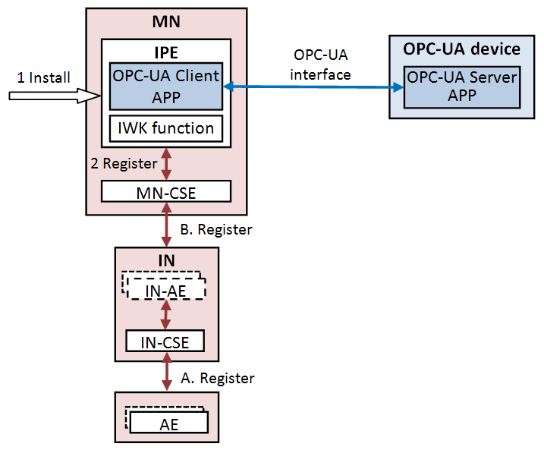
Figure 10.3.4.1.1-1 Initialization procedures

----------------------- End of Change 2-------------------------------------------

CHECK LIST
- Does this Change Request include an informative introduction containing the problem(s) being solved, and a summary list of proposals.?
- Does this CR contain changes related to only one particular issue/problem?
- Have any mirror CRs been posted?
- Does this Change Request make all the changes necessary to address the issue or problem? E.g. A change impacting 5 tables should not include a proposal to change only 3 tables?Does this Change Request follow the drafting rules?
- Are all pictures editable?
- Have you checked the spelling and grammar?
- Have you used change bars for all modifications?
- Does the change include the current and surrounding clauses to clearly show where a change is located and to provide technical context of the proposed change? (Additions of complete clauses need not show surrounding clauses as long as the proposed clause number clearly shows where the new clause is proposed to be located.)
- Are multiple changes in this CR clearly separated by horizontal lines with embedded text such as, start of change 1, end of change 1, start of new clause, end of new clause.?

