Input Contribution
Meeting ID* | ARC#38
Title:* | Architecture analysis for the new use cases and requirements with current oneM2M system
Source:* | TaeHyun KIM, SyncTechno Inc., thyun.kim@synctechno.com  SeungMyeong JEONG, KETI sm.jeong@keti.re.kr
Date:* | 2018-12-5
Input related to* | TR-0046 (Study on Public Warning Service Enabler)
Intended purpose of  document:* | Decision  Discussion  Information  Other <specify>
Impacted other TS/TR(s) | n/a
Decision requested or recommendation:* | Incorporate the text into TR-0046
Template Version: January 2017 (Do not modify)

oneM2M Notice
The document to which this cover statement is attached is submitted to oneM2M. Participation in, or attendance at, any activity of oneM2M, constitutes acceptance of and agreement to be bound by terms of the Working Procedures and the Partnership Agreement, including the Intellectual Property Rights (IPR) Principles Governing oneM2M Work found in Annex 1 of the Partnership Agreement.

Introduction
This contribution proposes a result of study for the public warning system on architecture analysis for the new use cases and requirements with current oneM2M system.

-----------------------Start of input 1-------------------------------------------

7. Architecture analysis for the new use cases and requirements with current oneM2M system

7.1 Introduction
The use cases of the IoT based public warning services are listed in Table 7.1-1.
Table 7.1-1: Use cases for the IoT Public Warning Service
Use case No. | Title | Description
1 | Public warning service triggered by external system | See clause Error: Reference source not found
Editor’s note: additional use cases are to be defined in clause 6 and listed here.

The following clauses derives possible architectures for oneM2M to support above use cases.

7.2 IoT Public Warning System Architectures

7.2.1 IoT PWS Architecture Type 1
Figure 7.2.1-1 depicts the first type of high level oneM2M architecture to enable the Public Warning Service. The M2M PWS Gateway is responsible for delivering the warning messages from the Integrated PWS System to M2M Devices through a M2M System. M2M devices can be connected directly to the M2M System via long range communication networks such as LPWA (Low Power Wide Area). Other devices which have only short range communication networks such as ZigBee, Bluetooth, etc., can be connected to the M2M System via home or factory gateways. Some of these devices are programmed to initiate performing special functions to react to emergencies upon receiving PWS messages.
In this type of architecture, the M2M PWS Gateway, which is depicted in Figure 7.2.1-1,acts as an ASN or a MN. A warning message which is generated by the Integrated PWS System contains both human readable and machine readable information. The M2M PWS Gateway extracts machine readable information from CAP messages in XML format to optimize (e.g. reduce message size, change data types) warning messages before deliver the warning message to the M2M System.

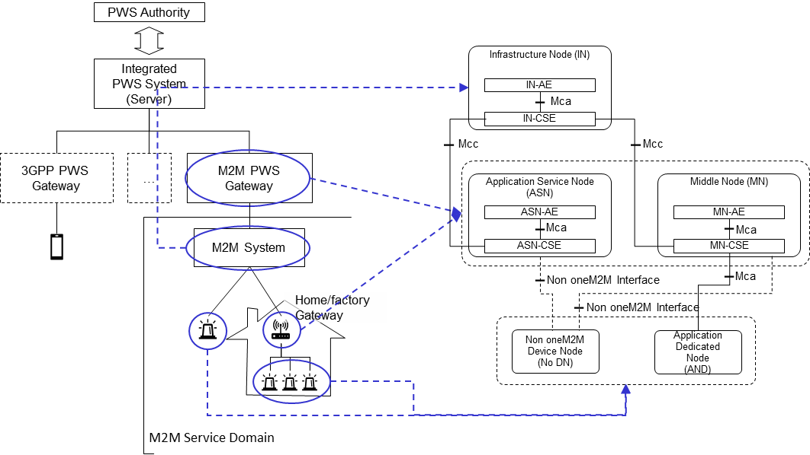
Figure 7.2.1-1 High Level Architecture Type 1 for IoT PWS Service

7.2.2 IoT PWS Architecture Type 2
Editor’s Note: this is TBD

-----------------------End of input 1---------------------------------------------

