INPUT CONTRIBUTION
Group Name:* | WG#5
Title:* | Semantic Home Control Use Case
Source:* | NEC (ETSI, TTC)
Contact: | Martin Bauer, NEC, martin.bauer@neclab.eu  Joerg Swetina, NEC, joerg.swetina@neclab.eu  Ataru Kobayashi, NEC, a-kobayashi@df.jp.nec.com
Date:* | 2014-02-19
Abstract:* | Updates to section 2.2, 5.2
Agenda Item:* | TBD
Work item(s): | oneM2M-WI-0005-Abstraction_&_Semantics_Capability_Enablement
Document(s)  Impacted* | oneM2M-TR-0007-Study_on_Abstraction_and_Semantics_Enablement  V0_6_0
Intended purpose of  document:* | Decision  Discussion  Information  Other <specify>
Decision requested or recommendation:* | Include text into section 2.2, 5.2

oneM2M Notice
The document to which this cover statement is attached is submitted to oneM2M. Participation in, or attendance at, any activity of oneM2M, constitutes acceptance of and agreement to be bound by terms of the Working Procedures and the Partnership Agreement, including the Intellectual Property Rights (IPR) Principles Governing oneM2M Work found in Annex 1 of the Partnership Agreement.

2.2 Informative references
The following referenced documents are not necessary for the application of the present document but they assist the user with regard to a particular subject area.
[i.1] ETSI TS 102 690: "Machine-to-Machine communication (M2M): Functional architecture".
[i.2] ETSI TR 101 584: "Machine-to-Machine communication (M2M): Study on Semantic support for M2M Data".
[i.3] Open Geospatial Consortium, http://www.opengeospatial.org/.
[i.4] Open Geospatial Consortium, Sensor Web Enablement DWG, http://www.opengeospatial.org/projects/groups/sensorwebdwg.
[i.5] Open Geospatial Consortium, Sensor Web Enablement architecture, August 2008.
[i.6] Open Geospatial Consortium, Observations and Measurements, Available at http://www.opengeospatial.org/standards/om.
[i.7] Open Geospatial Consortium, OpenGIS Sensor Model Language (SensorML), Available at http://www.opengeospatial.org/standards/sensorml.
[i.8] Open Geospatial Consortium, OpenGIS Transducer Markup Language (TML) Encoding Specification, Available at http://www.opengeospatial.org/standards/tml.
[i.9] Open Geospatial Consortium, Sensor Observation Service, Available at http://www.opengeospatial.org/standards/sos.
[i.10] Open Geospatial Consortium, Sensor Planning Service (SPS), Available at http://www.opengeospatial.org/standards/sps.
[i.11] Open Geospatial Consortium, Sensor Alert Service, Available at http://www.opengeospatial.org/standards/requests/44.
[i.12] W3C Semantic Sensor Network Incubator Group, http://www.w3.org/2005/Incubator/ssn/wiki/Main_Page.
[i.13] Open Geospatial Consortium, Sensor Web Interface for IoT SWG, http://www.opengeospatial.org/projects/groups/sweiotswg.
[i.14] Open Geospatial Consortium Best Practice, Semantic annotations in OGC standards, Available at http://www.opengeospatial.org/node/1790.
[i.15] Open Geospatial Consortium, Geography Markup Language, Available at http://www.opengeospatial.org/standards/gml.
[i.16] W3C Semantic Sensor Network Incubator Group, http://www.w3.org/2005/Incubator/ssn/wiki/Main_Page.
[i.17] Semantic Sensor Network XG Final Report, W3C Incubator Group Report 28 June 2011, http://www.w3.org/2005/Incubator/ssn/XGR-ssn/.
[i.18] Open Geospatial Consortium, OpenGIS Sensor Model Language (SensorML), Available at http://www.opengeospatial.org/standards/sensorml.
[i.19] Open Geospatial Consortium, http://www.opengeospatial.org/.
[i.20] Open Geospatial Consortium, Sensor Web Enablement DWG, http://www.opengeospatial.org/projects/groups/sensorwebdwg.
[i.21] SSN Suggested Key Ontology Intro Attributes, Available at http://www.w3.org/2005/Incubator/ssn/wiki/SSN_Suggested_Key_Ontology_Intro_Attributes.
[i.22] W3C Semantic Sensor Network Incubator Group, Semantic Sensor Network Ontology, Available at http://www.w3.org/2005/Incubator/ssn/ssnx/ssn.
[i.23] W3C Semantic Sensor Network Incubator Group, Semantic Sensor Network Ontology, Available at http://www.w3.org/2005/Incubator/ssn/wiki/SSN.
[i.24] DUL ssn, http://www.w3.org/2005/Incubator/ssn/wiki/DUL_ssn.
[i.25] oneM2M-TR-0001-UseCase: "oneM2M Use cases collection"
[i.26] W3C OWL Working Group, OWL 2 Web Ontology Language Document Overview, Available at http://www.w3.org/TR/owl2-overview/
[i.27] W3C SPARQL Working Group, SPARQL 1.1 Overview, Available at http://www.w3.org/TR/sparql11-overview/
[i.28] Jack Rusher, TripleStore, Semantic Web Advanced Development for Europe (SWAD-Europe), Workshop on Semantic Web Storage and Retrieval - Position Papers, Available at http://www.w3.org/2001/sw/Europe/events/20031113-storage/positions/rusher.html

5.2 Use Cases

5.2.1 General
Editors Note: The following other use cases from TR-0001 [i.25] also have semantic aspects and therefore should be referenced and potentially enhanced:
- Use Case on Devices, Virtual Devices and Things (see [i.25], Section 8.2)
- Semantic Device Plug and Play (see [i.25], Section 9.7)
- Vehicle Diagnostic & Maintenance Report (see [i.25], Section 10.1)

5.2.X Semantic Home Control
The Semantic Home Control use case has been described in the oneM2M Use cases collection (see [i.25], Section 9.6). The complete use case description will not be repeated here. Instead the semantic aspects of it will be detailed. This includes an example of how the semantic aspects could be modelled and how the use case could be realized on this basis.
In the use case, there are two applications, a building management system (BMS) and a home energy management system (HEMS). The BMS has knowledge about all structural elements of the building, i.e. the apartments, rooms, doors, windows, etc. as well as equipment installed in the house like heaters, air conditioning systems, etc. The HEMS configures itself for a given apartment based on the information available in the BMS. This means it has to find out about the rooms and the heaters and air conditioning systems deployed there in order to control the temperature in the apartment.
In the following, we give an example how the use case could semantically be modelled based on an OWL [i.26] ontology. The example is used to illustrate the semantic approach – it is not claimed to be complete and there are surely other modelling options.
Figure 5.A shows the semantic concepts of Thing Type, i.e. describing real world things, modelled as ontology concepts. The relation between buidling and apartment, i.e. hasApartment, and the relation between apartment and room, i.e. hasRoom, are modelled as object properties of the ontology and are shown as dashed arrows in Figure 5.A.
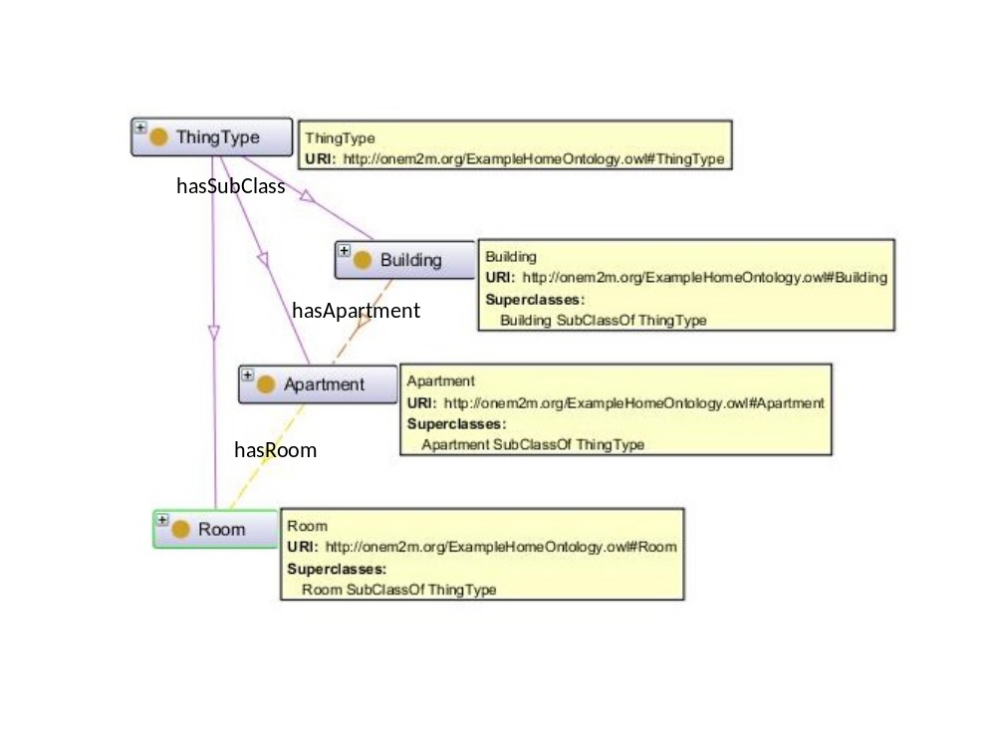
Figure 5.A Thing Types describing the structural elements of the building
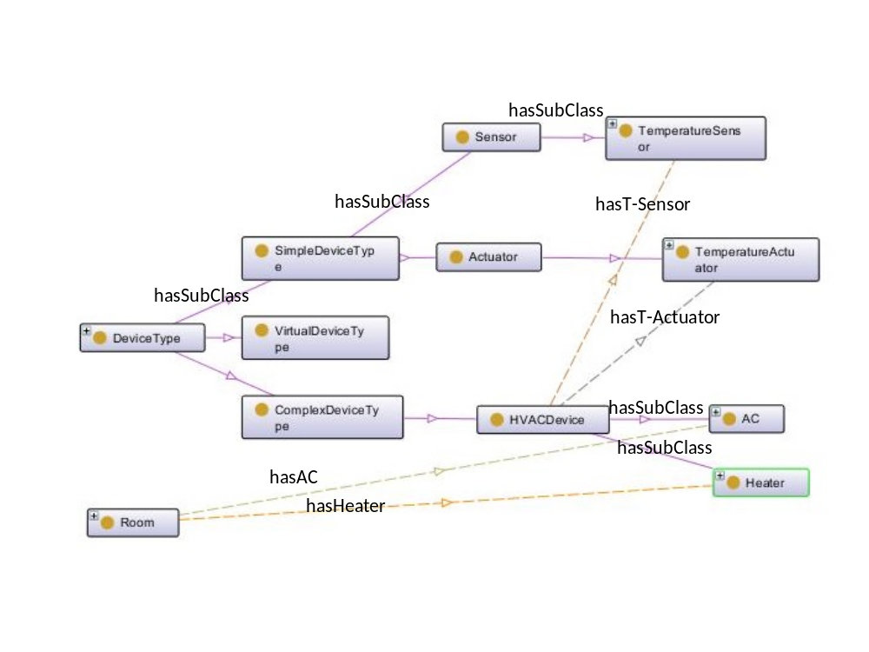
Figure 5.B Device Types describing the devices relevant for the HEMS
Figure 5.B shows the concepts of DeviceType, which are relevant for the HEMS. The Device Type has SimpleDeviceType, ComplexDeviceType and VirtualDeviceType as subclasses. A SimpleDeviceType can either be a Sensor or an Actuator. Relevant for HEMS are the TermperatureSensor and TemperatureActuator types. ComplexDeviceTypes represent more complex devices, which may contain simple devices. For the HEMS case, there are HVAC (heating, ventilation, air conditioning) devices, which contain temperature sensors and temperature actuators. The specific devices used are heaters and ACs (air conditioning systems). They inherit their relations to termperature sensors and actuators from the HVAC Device Type. VirtualDeviceTypes represent virtual devices, i.e. entities that can be accessed in the same way as real devices, but only consist of software. Virtual devices can be used to provide processed information, e.g. an average calculated from the output of a number of physical devices.
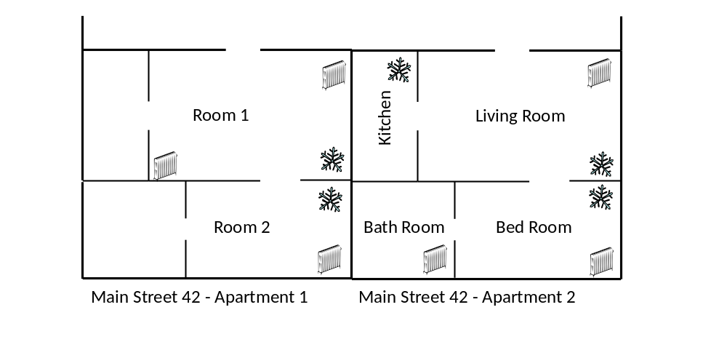Figure 5.C Visualization of example instances for HEMS use case.
Figure 5.C shows a visualization of example instances for the HEMS use case. Two apartments have been modelled with different levels of details. In Apartement 1 only the two main rooms are covered, whereas Apartment 2 provides the details for all the rooms. Icons also indicate which rooms where the heaters and ACs are installed.
Figure 5.D shows the ontology model corresponding to the visualization shown in Figure 5.C.
In addition to relationships among types it shows instantiation of the individual types (as “hasIndividual” relationship).
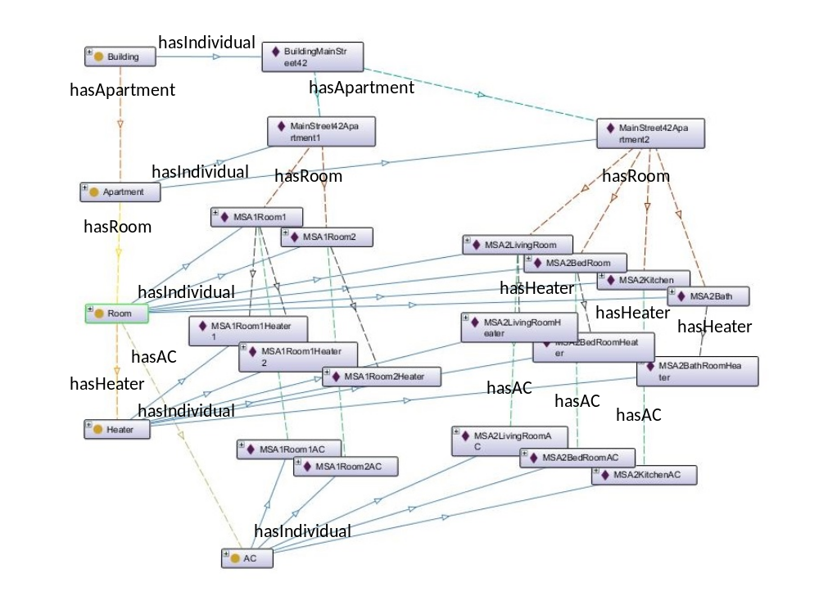
Figure 5.D Ontology model with instances
Given that the Ontology shown above is available in a triple store [i.28], the following SPARQL [i.27] queries can be executed to find the rooms and devices that the HEMS application needs in order to control the temperature in apartment 2 of building Main Street 42.

PREFIX home: <http://onem2m.org/ExampleHomeOntology.owl#>
SELECT ?room
WHERE { home:MainStreet42Apartment2 home:hasRoom ?room .
}

room
MSA2BedRoom
MSA2LivingRoom
MSA2Bath
MSA2Kitchen

With the following query, the heaters and ACs for the respective rooms can be found:

PREFIX home: <http://onem2m.org/ExampleHomeOntology.owl#>
SELECT ?room ?ac ?heater
WHERE { home:MainStreet42Apartment2 home:hasRoom ?room .
OPTIONAL { ?room home:hasAC ?ac }
OPTIONAL { ?room home:hasHeater ?heater }
}

room | ac | heater
MSA2BedRoom | MSA2BedRoomAC | MSA2BedRoomHeater
MSA2LivingRoom | MSA2LivingRoomAC | MSA2LivingRoomHeater
MSA2Bath |  | MSA2BathHeater
MSA2Kitchen | MSA2KitchenAC

Given the ACs and the Heaters, the respective temperature sensors and temperature actuators can be found, e.g.

PREFIX home: <http://onem2m.org/ExampleHomeOntology.owl#>
SELECT ?temp_sensor ?temp_actuator
WHERE { OPTIONAL { home:MSA2BedRoomHeater home:hasTemperatureSensor ?temp_sensor }
OPTIONAL { home:MSA2BedRoomHeater home:hasTemperatureActuator ?temp_actuator }
}

temp_sensor | temp_actuator
MSA2BedRoomHeaterTemperatureSensor | MSA2BedRoomHeaterTemperatureActuator

