Input contribution
Use case
Use Case Title:* | Use Case of Semantic Home Automation
Group Name:* | WG5
Source:* | Haier (CCSA)
Contact: | Jun Zhang, Haier, zhangjun@haierubic.com  Wenjun Ju, Haier, juwj@haier.com
Date:* | 2014-05-12
Abstract:* | This proposal provides the use case of home appliance control with semantic enablement capability.
Agenda Item:*
Work item(s): | oneM2M-WI-0005-Abstraction_&_Semantics_Capability_Enablement
Document(s)  Impacted* | oneM2M-TR-0007-Study_on_Abstraction_and_Semantics_Enablement  V0_6_0
Intended purpose of  document:* | Decision  Discussion  Information  Other <specify>
Decision requested or recommendation:* | Include the use case into section 5.2

oneM2M Notice
The document to which this cover statement is attached is submitted to oneM2M. Participation in, or attendance at, any activity of oneM2M, constitutes acceptance of and agreement to be bound by terms of the Working Procedures and the Partnership Agreement, including the Intellectual Property Rights (IPR) Principles Governing oneM2M Work found in Annex 1 of the Partnership Agreement.

5.2.x Title

Semantic Home Automation Control

5.2.x.1 Description

This use case demonstrates the semantic home automation control system. The system consists of home automation APP, smart household appliances, and M2M service platform as shown in the following figure.

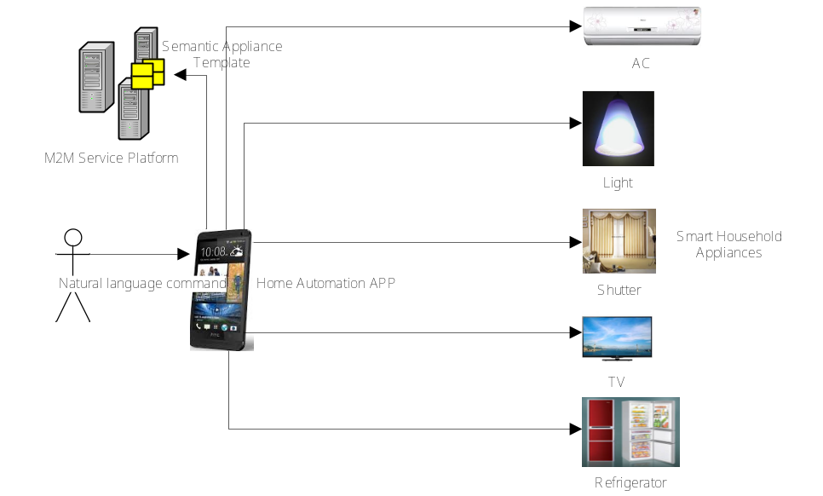

Figure 5.2.x.1 Semantic Home Automation Control Scenario

The user can install the home automation APP on the user device e.g. the smart mobile terminal. The user device with the installed the home automation APP can control smart household appliances including AC, light, shutter, AC, TV and refrigerator, etc. The various appliances information including e.g. appliance ID, appliance type, operation and data types, etc. can be modelled as SAT (semantic appliance template). The user sends control command in the form of natural language to the APP, e.g. by texting “tune the air conditioner in the living room to 22 centigrade”. The APP converts the natural language control command and generates e.g. SPARQL semantic query. The APP sends semantic query to the M2M service platform. In this use case, the M2M service platform provides the semantic functionalities with which semantic query can be executed to locate the desired appliance, i.e. AC in the living room, and get the appliance semantic information including, e.g. appliance ID, appliance type, operation and data types from the SAT (semantic appliance template).

The APP can then generate the appliance control command by using the appliance semantic information and send the appliance control command to the desired smart household appliance.

5.2.x.2 Source

Haier (CCSA)

5.2.x.3 Actors
- Home Automation APP: is an M2M application for home automation control
- M2M Service Platform: provides semantic appliance service for home automation control
- Smart Household Appliance: is the household appliance with remote control feature

5.2.x.4 Pre-conditions

The M2M service platform contains all the necessary information to manage the whole smart household appliances of the user if it is allowed. It in particular contains the details of the smart household appliances including the location of the appliances and their capabilities, etc.

The M2M service platform provides the semantic appliance control service which can parse a whole sentence and translate it to the SPARQL semantic query and the appliance control command.

The smart household appliance can interact with the M2M service platform which can send appliance control command to the appliance.

5.2.x.5 Triggers

None

5.2.x.6 Normal Flow

The following figure provides the basic flow of semantic home automation control.

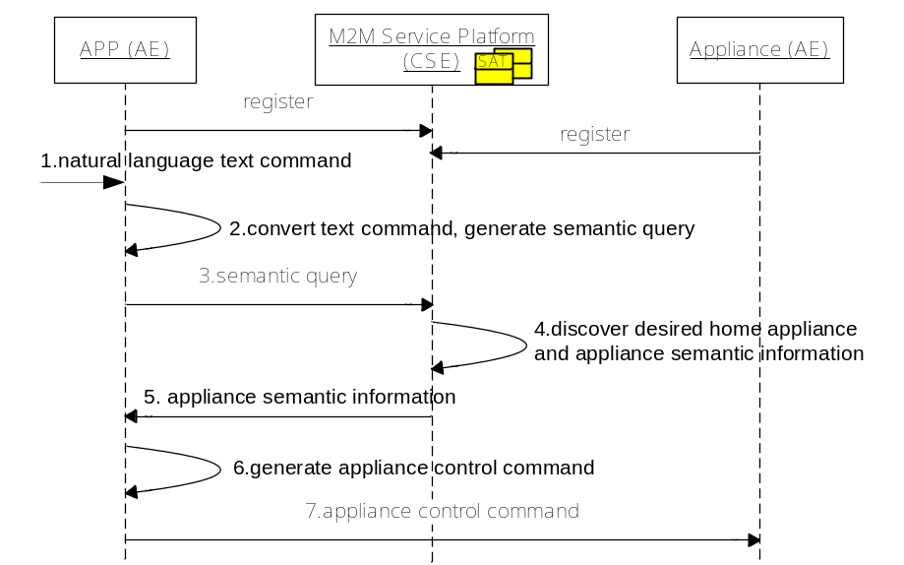

Figure 5.2.x.2 Semantic Automation Home Control Flow
- The APP receives the natural language control command, e.g. “tune the air conditioner in the living room to 22 centigrade”.
- The APP converts the natural language control command and generates semantic query e.g. SPARQL.
- The APP sends semantic query to the M2M service platform.
- The M2M service platform executes the semantic query to locate the desired appliance, i.e. AC in the living room, and get the appliance semantic information including e.g. appliance ID, appliance type, operation and data types from the appliance semantic description.
- The M2M service platform sends the appliance semantic information to the M2M APP.
- The M2M APP generates the appliance control command by using the appliance semantic information.
- The APP sends the appliance control command to the AC.

5.2.x.7 Post-conditions

None

5.2.x.8 High Level Illustration

This use case applies home automation ontology model for semantic information sharing. The following figure illustrates the logical view of ontology-based model to specify the semantic information of smart household appliances and their relationships.

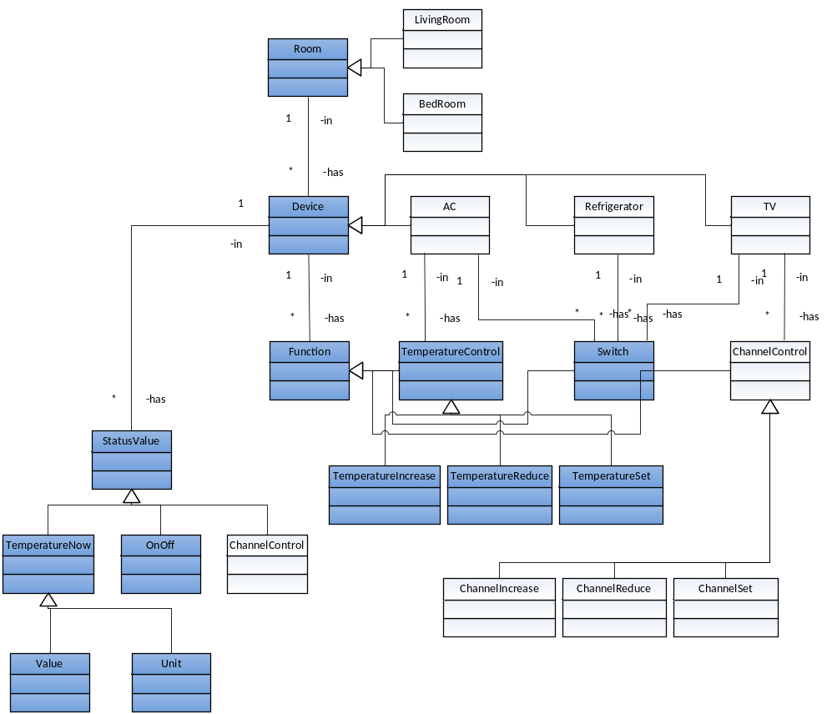

Figure 5.2.x.4 Home Automation Ontology Model

The basic information of this ontology model is described as follows.
- AC is an appliance which has there functions including controlling temperature (TemperatureControl) and switch (Switch).
- TemperatureControl function consists of three sub-functions including temperature increasing (TemperatureIncrease), temperature reducing (TemperatureReduce) and temperature setting (TemperatureSet).
- Switch function set the AC into working time running mode or out of working time running mode.
- TemperatureIncrease sub-function increases AC temperature.
- TemperatureReduce sub-function reduces AC temperature.
- TemperatureSet sub-function set AC temperature.
- StatusValue is a record to represent the current appliance status including current temperature (TemperatureNow), on-off state (OnOff) and current channel (ChannelControl).
- TemperatureNow is a status value to record the current temperaturewhich consists of value and unit.
- OnOff is a status value to decide the working time of the AC.

The following figure illustrates the instance of semantic home automation ontology according to the ontology-based model. Given the home automation ontology model, the APP can locate the desired appliance through semantic query.

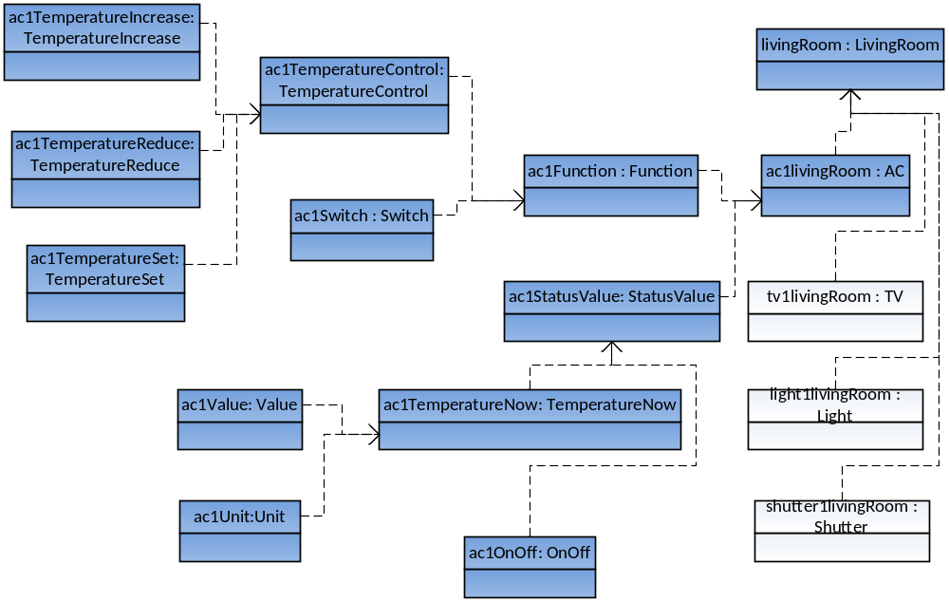 Figure 5.2.x.5 Home Ontology Model with AC Instances

5.2.3.9 Potential requirements

The M2M system shall be able to support semantic modelling device template for M2M devices (e.g. household appliance).

The M2M System shall support common ontology to model the semantic information of M2M devices and the real-world entities (e.g. rooms) that associate with M2M devices.

The M2M System shall support semantic query to enable the discovery of target M2M devices based on their semantic information.

