Input contribution
Use case
Use Case Title:* | Semantic smart building light control
Group Name:* | MAS WG5
Source:* | China Unicom
Contact: | Junling Mao (maojl11@chinaunicom.cn)  Peng Wang (wangpeng@chinaunicom.cn)  Changwei Hu (hucw5@chinaunicom.cn)  Xueqing Jia (jiaxq11@chinaunicom.cn)
Date:* | <2014-5-26>
Abstract:* | This contribution gives a use case named “semantic based smart building light control” to show potential semantic requirements.
Agenda Item:* | Tbd
Work item(s): | MAS
Document(s)  Impacted* | Study on Abstraction and Semantics Enablement TR0007
Intended purpose of  document:* | Decision  Discussion  Information  Other <specify>
Decision requested or recommendation:* | For discussions and adoption in the Abstraction and Semantics Technical Report

oneM2M Notice
The document to which this cover statement is attached is submitted to oneM2M. Participation in, or attendance at, any activity of oneM2M, constitutes acceptance of and agreement to be bound by terms of the Working Procedures and the Partnership Agreement, including the Intellectual Property Rights (IPR) Principles Governing oneM2M Work found in Annex 1 of the Partnership Agreement.

  - Title

Semantic smart building light control
  - Description

The smart building light control use case has been mentioned in the oneM2M use case collection (see[i.29]. section 6.1) from group management aspects. In this contribution, we describe the smart building light control use case from semantic aspects. The light control for one target room is given as an example.

In the use case, all the smart building appliances are connected with M2M gateway. M2M gateway and Smart building control center are connected with M2M platform. The light control application sends the semantic query request to the smart building control center to find the desired appliances.

In the following, we show how the use case could semantically be modelled based on OWL [i.26] ontology. There are two ontologies involved in this use case. One ontology is a basic M2M ontology named ontology A, which is referred by M2M gateway, M2M platform and Smart building Control centre. The other ontology is a specific ontology on light domain named ontology B, which is referred by light control application.

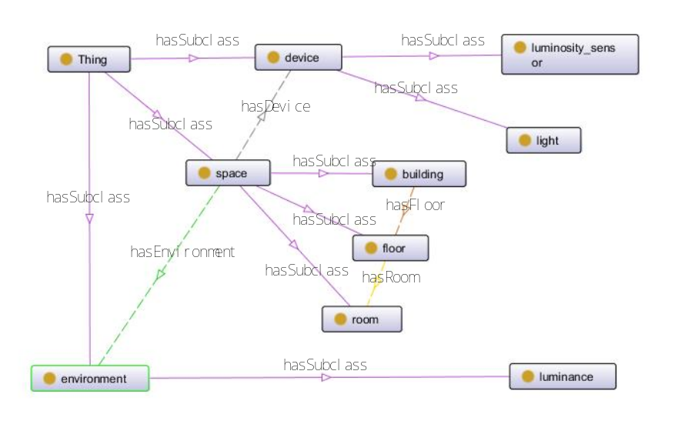

Fig.1 Class Concepts in ontology A

The class concepts in ontology A for this use case are described in Fig. 1, and the data properties model for class “light” and class “luminosity_sensor” in ontology A are described in Fig. 2. The class concepts in ontology B for this use case are described in Fig. 3. Some basic concepts in ontology B are referred from ontology A. The “brightness_adjustable_light” in ontology B is defined as the “light” which “brightness_adjustable” data property is “true”, the “led_light” and “fluorescent_light” in ontology B are defined as the “light” which “kind” are “led” and “fluorescent” respectively.

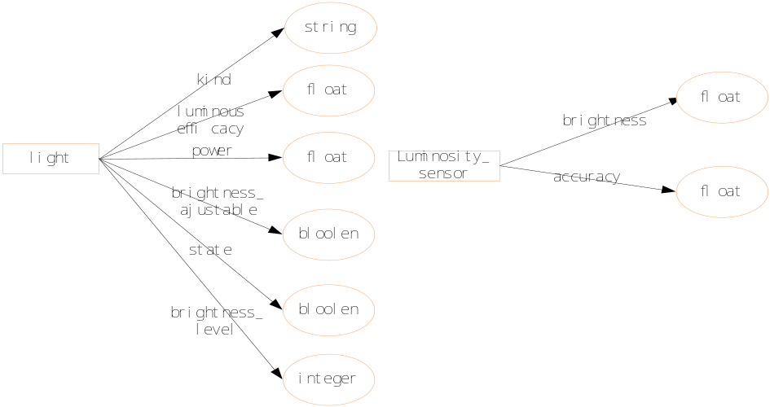

Fig. 2 data properties model in ontology A

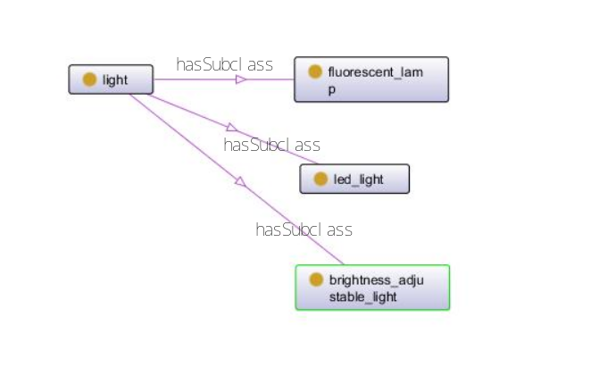

Fig. 3 Class related Concepts in ontology B

Examples of instances related to this use case are described in Fig. 4, where “type” means “instance of”.

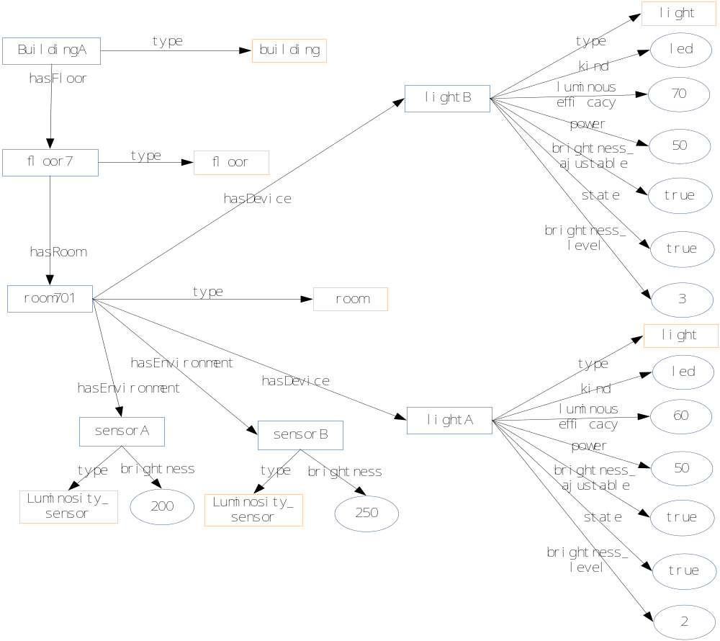

Fig. 4 Example of instances
  - Source (as applicable)

China Unicom
  - Actors (as applicable)

Light control application (developed by application provider)

Smart building Control centre (operated by smart building service operator)

M2M gateway (operated by underlying network operator)

M2M platform (operated by underlying network operator)

Smart building appliances (installed by smart building service operator)
  - Pre-conditions (if any)
- The Smart Building Service Provider establishes a business relationship with the M2M Service Provider so that the Smart building Control centre and Smart building appliances can use M2M gateway and M2M platform.
- All Smart building appliances are registered in smart building control centre.
  - Triggers (if any)
- Light control application intends to control the light to adjust the lumination conditions in target room (perhaps the motion sensor in that room detects that there are people entering that room).
  - Normal Flow (as applicable)
- Light control application sends semantic request to smart building control centre to find the target sensor in room701.
PREFIX building: <http://example.org /buildingOntology.owl#>
Select ?luminosity_sensor ?brightness
WHERE { building:room701 hasEnvironment ?luminosity_sensor.
?luminosity_sensor a building: luminosity.
?luminosity_sensor building:brightness ?brightness}
Given the Search results for the example in Fig. 4
luminosity_sensor | brightness
SensorA | 200
SensorB | 250

- Smart building Control centre return the URI of target luminosity sensor resources and the associated semantic information to light control application.
- Light control application send requests to smart building control centre to create the group of the returned resources and to subscribe the brightness data of created group.
- smart building control centre forward the group management requests to M2M platform and gateway.
- The brightness data is notified to light control application.
- Light control application finds that the brightness is a little lower than desired value , and intends to adjust the brightness of some lights instead of switching on more lights for power saving. The Led light is preferred, and the brightness level should be lower than the highest level 5. So light control application sends semantic query request to smart building control centre to find the target brightness_adjustable light.
PREFIX building: <http://example.org/buildingOntology.owl#>
PREFIX light:< http://example.org /lightOntology.owl#>
Select ?light ?brightness_level
WHERE { building:room701 hasDevice ?light.
?light a light: brightness_adjustable_light.
?light a light: led_light.
?light building:brightness_level ?brightness_level.
FILTER(?brightness_level < 5)}
Given the Search results for the example in Fig. 4
light | brightness_level
lightA | 2
lightB | 3

- Although the instances of “light” (e.g. “lightA” and “lightB”) are semantically annotated based on ontology A which do not indicate that they are instances of “brightness_adjustable light” and “led_light”, with the help of reasoning, smart building control centre can still correctly return the URI of target light resource and the associated semantic information.
- Light control application send requests to smart building control centre to create the group of the returned resource.
- smart building control centre forward the group management requests to M2M platform and gateway.
- The Light control application sends the requests to adjust the brightness level of created light group.
  - Post-conditions (if any)
  - High Level Illustration (as applicable)

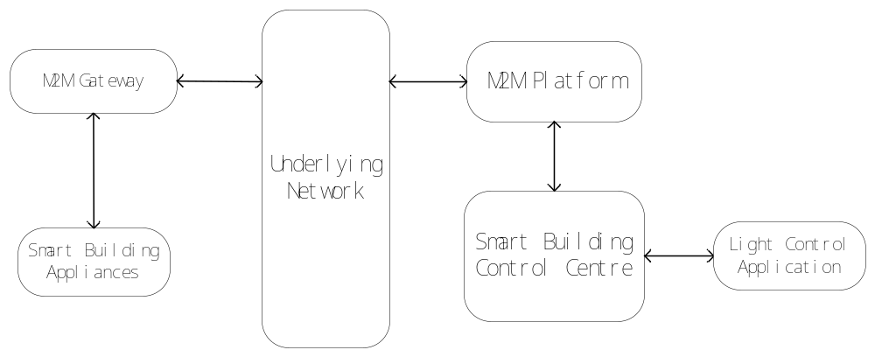

Potential requirements (as applicable)
- The M2M systems shall support the reasoning capability for deriving implicit knowledge from semantically annotated information according to referenced ontologies.

