Input contribution
Use case
Use Case Title:* | Semantic home care for smart aging use case
Group Name:* | WG5
Source:* | ZTE
Contact: | Qiuting Li, li.qiuting@zte.com.cn
Date:* | 2014-09-15
Abstract:* | This contribution proposes a semantic home care use case for refining potential requirements within the semantic enablement.
Agenda Item:*
Work item(s): | oneM2M-WI-0005-Abstraction_&_Semantics_Capability_Enablement
Document(s)  Impacted* | oneM2M-TR-0007-Study_on_Abstraction_and_Semantics_Enablement(New version)
Intended purpose of  document:* | Decision  Discussion  Information  Other <specify>
Decision requested or recommendation:* | Include the use case into Annex A.

oneM2M Notice
The document to which this cover statement is attached is submitted to oneM2M. Participation in, or attendance at, any activity of oneM2M, constitutes acceptance of and agreement to be bound by terms of the Working Procedures and the Partnership Agreement, including the Intellectual Property Rights (IPR) Principles Governing oneM2M Work found in Annex 1 of the Partnership Agreement.

Introduction

This contribution proposes a new use case about semantic home care for smart aging.

************************start of change****************************

A.X Semantic home care for smart aging

A.X.1 Description
Home care is a key part of smart aging, it provides elder’s health supervision service for taking care elder, tracking and monitoring rehabilitation care. In this use case, as shown in Figure A.Y, one elder wears/uses one or more professional monitoring devices which collect the daily/real-time data that reflect the elder’s health state, such as blood press, heartbeat, body temperature, pulse, blood sugar, position status etc. These data is sent to M2M platform via home gateway or cell phone. The home care applications/services provide the smart home care services based on semantic processing the collection data.

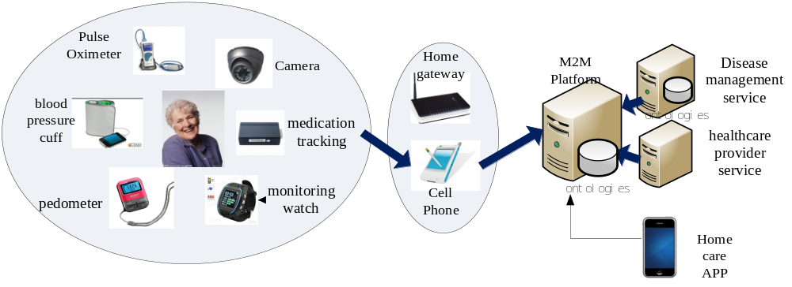
Figure A.Y
In this use case, M2M system defines ontologies for describing/associating the variant home care resources (e.g. entity, data) in the M2M platform, and annotates these resources with semantic information based on the defined ontologies.
For the different service levels, if M2M applications/services have strong capabilities, they can also define professional domain/application ontologies describe home care by themselves, and merge with the M2M system’s ontologies. M2M applications/services can also use self-defined ontologies or M2M system’s ontologies individually.
M2M system, M2M applications/services can automatically infer the collection data by semantic processing (include semantic annotation, reasoning, storage etc.), and then M2M applications/services provide elders customized home care services, e.g. comprehensive health evaluating for intervening/treating disease in early stage, emergency rescue, etc.

A.X.2 Source

ZTE

A.X.3 Actors
- Home care applications
- M2M platform
- Home care monitoring device, provided by service provider or application provider
- The third part system, provide customized/personal home care service, such as Disease management system.
- Home care users

A.X.4 Pre-conditions
- The monitoring devices register into the M2M platform that associates with the home care user.
- Home care applications/the third part systems have access rights for obtaining ontologies information.
- Home care applications/the third part systems can define ontologies and has the capability of merging with the ontologies defined in M2M system.

A.7.5 Triggers
- Home care application/the third part system establish elders’ files and want to collect elders’ data for providing home care service.

A.7.6 Normal Flow
- If home care application or the third part system self-defines ontologies, home care application/the third part system requests to query home care related ontologies information from the M2M platform, then merge the self-defined ontologies with M2M system responded ontologies information.
- Home care application/the third part system subscribes/queries the monitoring device data (include abnormal data) what reflects physical signs of elder in periodic or real time. When the M2M platform receives the data, it semantically processes the data based on M2M system ontologies and sends the processed results (e.g. annotated data, reasoning results) to home care application/the third part system
- Home care application/ the third part system semantically reprocesses the processed results from the M2M platform based on merged ontologies (e.g. analyzing/infering the processed result), and comes to a conclusion, such as keeping monitoring, calling the elder’s family.

A.X.7 Post-conditions
None

A.X.8 High Level Illustration
See Figure A.Y

A.X.9 Potential requirements
- The M2M System shall support publishing ontologies information which provided by M2M system.
****************************end of change ****************************

