Input contribution
Use case
Use Case Title:* | Air environment monitoring service
Group Name:* | WG5
Source:* | China Unicom (CCSA)
Contact: | <Junling Mao> , <China Unicom> , <maojl11@chinaunicom.cn>  <Peng Wang>, <China Unicom>, <wangpeng@chinaunicom.cn>  <Changwei Hu>, <China Unicom>, <hucw5@chinaunicom.cn>
Date:* | 2015.03.10
Abstract:* | This contribution gives a use case named “air environment monitoring service” to show potential requirements related to semantic mash-up.
Agenda Item:* | TBD
Work item(s): | oneM2M-WI-0005-Abstraction_&_Semantics_Capability_Enablement
Document(s)  Impacted* | oneM2M-TR-0007-Study_on_Abstraction_and_Semantics_Enablement
Intended purpose of  document:* | Decision  Discussion  Information  Other <specify>
Decision requested or recommendation:* | For discussions and adoption in the Abstraction and Semantics Technical Report.
Template Version:23 February 2015 (Dot not modify)

oneM2M Notice
The document to which this cover statement is attached is submitted to oneM2M. Participation in, or attendance at, any activity of oneM2M, constitutes acceptance of and agreement to be bound by terms of the Working Procedures and the Partnership Agreement, including the Intellectual Property Rights (IPR) Principles Governing oneM2M Work found in Annex 1 of the Partnership Agreement.

.1 Title
Air environment monitoring service

Description
Nowadays air quality is concerned by more and more people. Among various air quality related parameters, overall air pollution indexes are more attractive for most people compared with direct air pollution parameters (e.g. NO2, SO2, PM2.5). However, the overall air pollution index is generally calculated based on multiple air pollution parameters and cannot be directly measured by single device.
To facilitate the access of overall air pollution index, the use case of A.1 provides a feasible method for direct access to the overall air pollution index via creating the virtual resources by the mash-up of multiple resources related to direct air pollution parameters.
This use case extends the use case of A.1 with the emphasis on the sharing of the mash-up resources. As shown in Fig. 1, in this use case, there are two M2M platforms, M2M platform A and M2M platform B. M2M platform A is in charge of the city air environment monitoring devices, which may be a government infrastructure. M2M platform B provides the value-added air environment monitoring services to customers. But M2M platform B may be only in charge of some private air environment monitoring devices or even has none air environment monitoring devices. The air quality monitoring APP in use’s mobile phone requests M2M platform B for the overall air quality index. Then M2M platform B will forward the request to M2M platform A and get the returned results. Some additional processing (e.g. introducing the effect of the data from private air environment monitoring devices or using private algorithm to re-calculate the air quality index) will be made by M2M platform B before forwarding the results to user’s APP for providing value-added services.
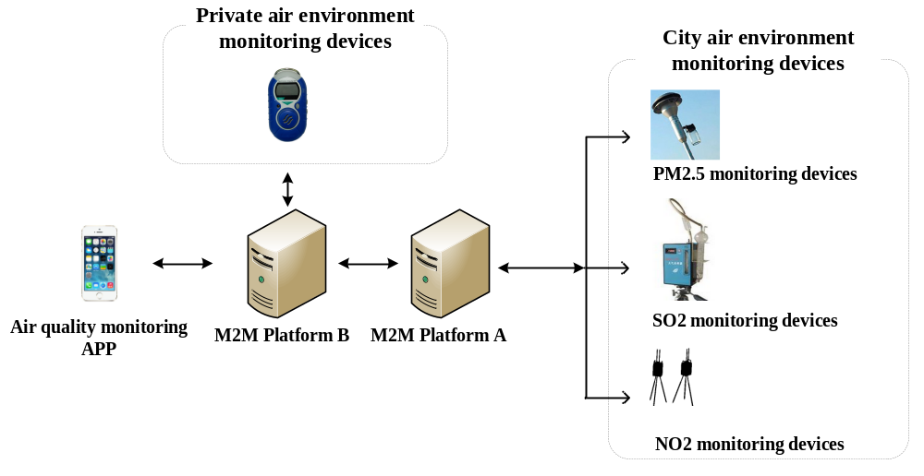
Fig.1 an example of air environment monitoring systems

Source
China Unicom

Actors
- Air quality monitoring APP
- M2M platform A ( hosted by government )
- M2M platform B
- City air environment monitoring devices ( hosted by government )
- Private air environment monitoring devices

Pre-conditions
City air environment monitoring devices are registered in M2M platform A.

Triggers
None

Normal Flow
Fig. 2 displays the flow diagram of the considered air environment monitoring system.
Step 0: the air quality monitoring APP and private air environment monitoring devices are registered in M2M platform B. City air environment monitoring devices are registered in M2M platform A.
Step 1: the air quality monitoring APP sends a request to M2M platform B for querying air quality index.
Step 2: M2M platform B checks that there are no matched resources in the CSE, and forward the request to M2M platform A.
Step 3: M2M platform A discovers a corresponding virtual resource created by a mash-up of multiple related air environment monitoring devices.
Step 4: M2M platform A returns the identifier of the corresponding virtual resource to M2M platform B.
Step 5: M2M platform B get the information of mash-up logic and the identifiers of the resources involved in the mash-up through the returned identifier.
Step 6: M2M platform B re-creates a virtual air quality resource by the mash-up of air quality related resources (including the related resources hosted by M2M platform B and the related resources hosted by M2M platform A) using private mash-up logic.
Step 7: M2M platform B returns the identifier of the created virtual air quality resource.
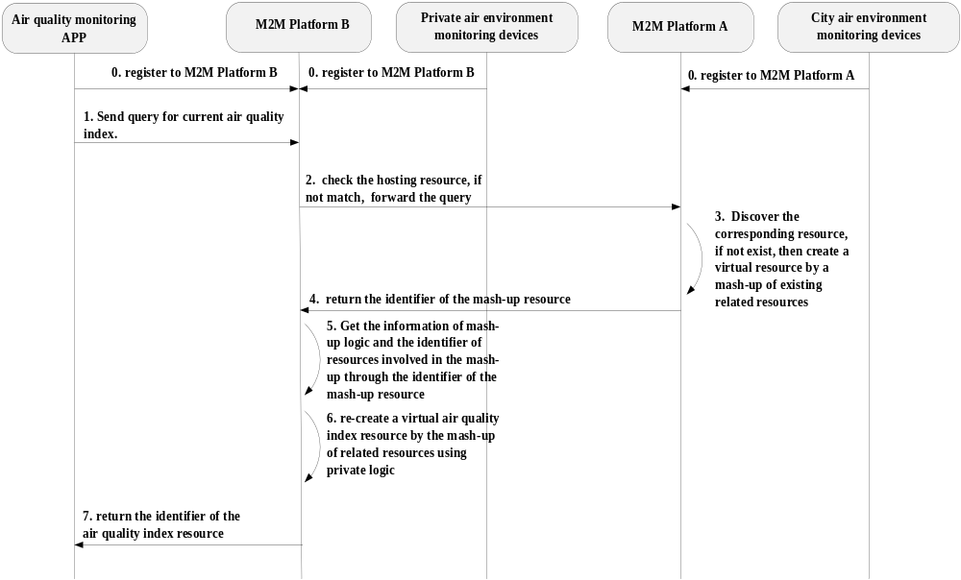
Fig. 2 High level flow diagram of the considered air environment monitoring system

Alternative flow
None

Post-conditions
None

High Level Illustration
See Fig. 1 in section 1.2.

Potential requirements
- The oneM2M system should support the capability for sharing the mash-up resources within a single M2M service provider domain.
- The oneM2M system should support the capability for sharing the mash-up resources across different M2M service provider domains.
- The oneM2M system should support the exposure of the mash-up service logic of mash-up resources.
- The oneM2M system should support the exposure of the identifiers or contents of the resources involved in the mash-up.

