CHANGE REQUEST
Meeting:* | MAS#19
Source:* | Dongjoo Kim (dongjoo7.kim@lge.com)
Date:* | 2015-08-31
Contact:* | Dongjoo Kim (dongjoo7.kim@lge.com)
Reason for Change/s:* | See the introduction below
CR against: Release* | Rel-2
CR against: WI* | Active <WI-0017 – Home Domain Enablement>  MNT Maintenace / < Work Item number(optional)>  STE Small Technical Enhancements / < Work Item number (optional)>  Only ONE of the above shall be ticked
CR against: TS/TR* | TR-0017 V0.5.0
Clauses/Sub Clauses* | 6
Type of change: * | Editorial change  Bug Fix or Correction  Change to existing feature or functionality  New feature or functionality  Only ONE of the above shall be ticked
Post Freeze checking:* | This CR contains only essential changes and corrections? YES NO  This CR may break backwards compatibility with the last approved version of the TS? YES NO  This CR is a mirror CR? YES if YES, please indicate the document number of the original CR: <Document Number) : NO
Template Version:27 May 2015 (Dot not modify)

oneM2M Notice
The document to which this cover statement is attached is submitted to oneM2M. Participation in, or attendance at, any activity of oneM2M, constitutes acceptance of and agreement to be bound by terms of the Working Procedures and the Partnership Agreement, including the Intellectual Property Rights (IPR) Principles Governing oneM2M Work found in Annex 1 of the Partnership Agreement.
GUIDELINES for Change Requests:
Provide an informative introduction containing the problem(s) being solved, and a summary list of proposals.
Each CR should contain changes related to only one particular issue/problem.
In case of a correction, and the change apply to previous releases, a separated “mirror CR” should be posted at the same time of this CR
Follow the principle of completeness, where all changes related to the issue or problem within a deliverable are simultaneously proposed to be made E.g. A change impacting 5 tables should not only include a proposal to change only 3 tables. Includes any changes to references, definitions, and acronyms in the same deliverable.
Follow the drafting rules.
All pictures must be editable.
Check spelling and grammar to the extent practicable.
Use Change bars for modifications.
The change should include the current and surrounding clauses to clearly show where a change is located and to provide technical context of the proposed change. Additions of complete sections need not show surrounding clauses as long as the proposed section number clearly shows where the new section is proposed to be located.
Multiple changes in a single CR shall be clearly separated by horizontal lines with embedded text such as, start of change 1, end of change 1, start of new clause, end of new clause.
When subsequent changes are made to content of a CR, then the accepted version should not show changes over changes. The accepted version of the CR should only show changes relative to the baseline approved text.

Introduction
This CR proposes a solution defining the dedicated new resource type to represent the abstract information model for home appliances in the CSEs of the oneM2M system.
The solution is made in accordance with the information model that is discussed in clause 5.3.2 of TR-0017.

-----------------------Start of change 1-------------------------------------------

6 Potential Representations in the oneM2M System

6.1 Introduction
This clause describes potentially how the developed abstract information model for a device could be represented in the CSEs of the oneM2M system.
The developed abstract information model for home appliances (see clause 5.3) shall be represented somehow as a resource within the oneM2M system. There could be several ways to do so, and they might have different features.
The following clauses describe potential ways of representation and provide the pros and cons of each solution for intercomparison which could then lead to the clause 7 conclusion.
6.2 Reresentation Using Dedicated Resource Types

6.2.1 New Resource Type appObj
This clause proposes a new resource type that can represent the oneM2M Information Model defined in the clause 5.3.2.
The <appObj> resource represents an application object that is exposed by an M2M Application to enable other M2M Applications to manipulate its object data (e.g., home appliance control data). Manipulation of the resource attributes are notified to the M2M Application then it can perform its application logics and return results. Those attributes to manipulate the application object are pre-defined so that the Originator application and the target application already share the control information and its data formats.
The <appObj> resource is a child resource of the <AE> resource. The target M2M application (e.g., which hosts home appliance control application) creates the resource under its <AE> resource and other M2M Applications discover and manipulates with the proper privileges.
Each instance of <appObj> resource is the instance of specializied <appObj> resource.
There are two approaches to define <appObj> resource type. They are one-level representation and two-level representation.

6.2.1.1 one-level <appObj>
All services including common service, shared services and device-specific services defined in clause 5.3.2 are represented as attributes of <appObj>. Common service that indicating basic properties of a device are directly mapped to attributes under <appObj>. And, shared services and device-specific services are mapped to [sharedChar] and [deviceSpecificChar] respectively because they are variable.

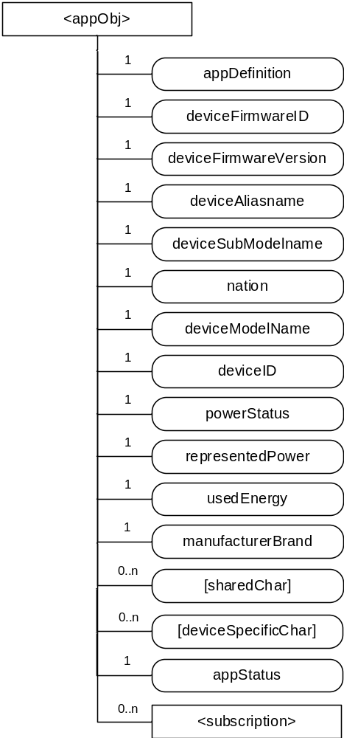
Figure 6.2.1.1-1. Structure of <appObj> resource
The <appObj> resource shall contain the child resources specified in table 6.2.1.1-1.
Table 6.2.1.1-1: Child resources of <appObj> resource
Child Resources of <appObj> | Child Resource Type | Multiplicity | Description | <appObjAnnc> Child Resource Types
[variable] | <subscription> | 0..n | See clause 9.6.8 in TS-0001 | <subscription>

The <appObj> resource shall contain the attributes specified in table 6.2.1-2.
Table 6.2.1.1-2: Attribute of <appObj> resource
Attributes of  <appObj> | Multiplicity | RW/  RO/  WO | Description | <appObjAnnc> Attributes
resourceType | 1 | RO | See clause 9.6.1.3 in TS-0001 | NA
resourceID | 1 | RO | See clause 9.6.1.3 in TS-0001 | MA
resourceName | 1 | WO | See clause 9.6.1.3 in TS-0001 | MA
parentID | 1 | RO | See clause 9.6.1.3 in TS-0001 | NA
expirationTime | 1 | RW | See clause 9.6.1.3 in TS-0001 | MA
accessControlPolicyIDs | 0..1 (L) | RW | See clause 9.6.1.3 in TS-0001 | MA
labels | 0..1 (L) | RW | See clause 9.6.1.3 in TS-0001 | MA
creationTime | 1 | RO | See clause 9.6.1.3 in TS-0001 | NA
lastModifiedTime | 1 | RO | See clause 9.6.1.3 in TS-0001 | NA
announceTo | 0..1 (L) | RW | See clause 9.6.1.3 in TS-0001 | NA
announcedAttribute | 0..1 (L) | RW | See clause 9.6.1.3 in TS-0001 | NA
appDefinition | 1 | WO | Definition of the application that is exposed by this resource (e.g., Washer). | MA
deviceFirmwareVersion | 1 | RW | See clause 5.3.2 | OA
deviceFirmwareID | 1 | RO | See clause 5.3.2 | OA
deviceType | 1 | RO | See clause 5.3.2 | OA
deviceAliasName | 1 | RW | See clause 5.3.2 | OA
deviceSubModelName | 1 | RO | See clause 5.3.2 | OA
nation | 1 | RO | See clause 5.3.2 | OA
deviceModelName | 1 | RO | See clause 5.3.2 | OA
deviceID | 1 | RO | See clause 5.3.2 | OA
powerStatus | 1 | RO | See clause 5.3.2 | OA
representedPower | 1 | RO | See clause 5.3.2 | OA
usedEnergy | 1 | RO | See clause 5.3.2 | OA
manufacturerBrand | 1 | RO | See clause 5.3.2 | OA
[sharedChar] | 0..n | RW | List of shared attributes which are defined per each specialized <appObj> resource. Specialized attributes can have characteristics or behaviors that are defined in oneM2M information model (see TS-000x) | OA
[deviceSpecificChar] | 0..n | RW | List of device-specific attributes with are defined per each specialized <appObj> resource.  Specialized attributes can have characteristics or behaviors that are defined in oneM2M information model (see TS-000x) | OA
appStatus | 1 | RO | Status information of the application which is represented as the parent <AE> resource (e.g., online, offline). | OA

Note: Some characteristics used for the common service such as deviceFirmwareVersion, deviceFirmwareID and deviceID are already defined in oneM2M system. So they can be represented in a different way using some kinds of linking attributes.

Example A. Resource washer (Specialization of one-level <appObj>)
The [washer] resource is used to share information regarding wahser. The [washer] is a specialization of the one level <appObj> resource.
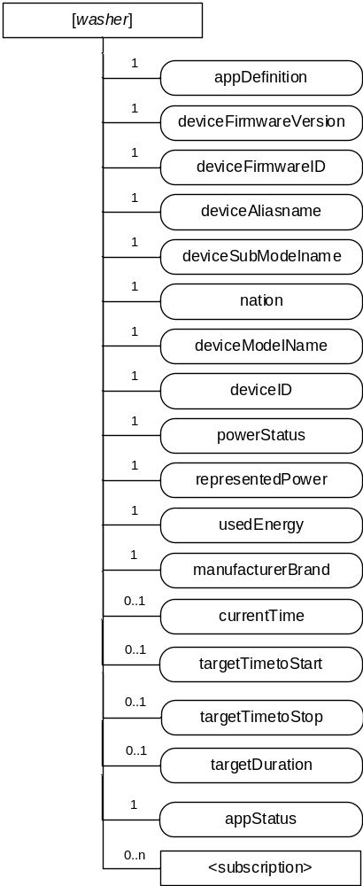
Figure 6.2.1.1-2. Structure of [washer] resource
The [washer] resource shall contain the child resource specified in table 6.2.1.3-3.
Table 6.2.1.3-3: Child resources of [washer] resource
Child Resources of <washer> | Child Resource Type | Multiplicity | Description | <appObjAnnc> Child Resource Types
[variable] | <subscription> | 0..n | See clause 9.6.8 in TS-0001 | <subscription>

The <washer> resource shall contain the attributes specified in table 6.2.1.3-4.
Table 6.2.1.3-4: Attribute of <washer> resource
Attributes of  <appObj> | Multiplicity | RW/  RO/  WO | Description
resourceType | 1 | RO | See clause 9.6.2.3. in TS-0001
resourceID | 1 | RO | See clause 9.6.2.3. in TS-0001
resourceName | 1 | WO | See clause 9.6.2.3. in TS-0001
parentID | 1 | RO | See clause 9.6.2.3. in TS-0001
expirationTime | 1 | RW | See clause 9.6.2.3. in TS-0001
accessControlPolicyIDs | 0..1 (L) | RW | See clause 9.6.2.3. in TS-0001
labels | 0..1 (L) | RW | See clause 9.6.2.3. in TS-0001
creationTime | 1 | RO | See clause 9.6.2.3. in TS-0001
lastModifiedTime | 1 | RO | See clause 9.6.2.3. in TS-0001
announceTo | 0..1 (L) | RW | See clause 9.6.2.3. in TS-0001
announcedAttribute | 0..1 (L) | RW | See clause 9.6.2.3. in TS-0001
appDefinition | 1 | WO | Definition of the application that is exposed by this resource (e.g., Washer).
deviceFirmware  Version | 1 | RO | Common, See table 5.3.2-1
deviceFirmwareID | 1 | RO | Common, See table 5.3.2-1
deviceType | 1 | RO | Common, See table 5.3.2-1
deviceAliasName | 1 | RO | Common, See table 5.3.2-1
deviceSubModelName | 1 | RO | Common, See table 5.3.2-1
nation | 1 | RO | Common, See table 5.3.2-1
deviceModelName | 1 | RO | Common, See table 5.3.2-1
deviceID | 1 | RO | Common, See table 5.3.2-1
powerStatus | 1 | RW | Common, See table 5.3.2-1
representedPower | 1 | RO | Common, See table 5.3.2-1
usedEnergy | 1 | RO | Common, See table 5.3.2-1
manufacturerBrand | 1 | RO | Common, See table 5.3.2-1
currentTime | 0..1 | RW | Current time
targetTimetoStart | 0..1 | RW | The time when the device is expected to start its operation
targetTimetoStop | 0..1 | RW | The time when the device is expected to stop its operation
targetDuration | 0..1 | RW | Target duration of the operation
appStatus | 1 | RO | Status information of the application which is represented as the parent <AE> resource (e.g., online, offline).

As a procedure example, the figure 6.2.1.1-3 illustrates how the [washer] resource works for controlling the device.
There are three players in the example. Remote Controller (AE) can control or monitor Washer device using [washer] resource which is located at the Gateway (Hosting CSE) and requested by Washer (AE)
Step-001: Washer (AE) requests AE registration to the Gateway (Hosting CSE)
Step-002: After checking authority using a Certificate or Service Subscription Profile, the Hosting CSE shall create <AE> resource under <CSEBase> resource.
Step-003: The Hosting CSE shall respond with reasonable parameters in Response message for <AE> Create operation.
Step-004: Washer (AE) requests for creating [washer] resource to the Gateway (Hosting CSE)
Step-005: If the request is from the creator of <AE>, the Hosting CSE shall create [washer] resource under <AE>. Otherwise, it rejects.
Step-006: The Hosting CSE shall respond with reasonable parameters in Response message for [washer] Create operation.
Step-007: Washer (AE) requests for creating <subscription> resource preparing to get a notification which will be regarded as a command to actuate the physical device.
Step-008: After checking privileges, the Hosting CSE shall create <subscription> resource under [washer].
Step-009: The Hosting CSE shall respond with reasonable parameters in Response message for <subscription> Create operation.
Step-010: The other AE that is Remote Controller requests to the Hosting CSE for discovery of [washer] resource with filter criteria.
Step-011: The Hosting CSE checks its authority, and generates the results that meet the filter criteria.
Step-012: The Hosting CSE shall respond with reasonable parameters including Content in Response message for Retrieve operation.
Step-013: The Remote Controller requests to update a particular attribute of [washer] resource with the ultimate purpose of controlling the physical device.
Step-014: Depending on the result of privilege check, the Hosting CSE performs the requested operation.
Step-015: The Hosting CSE shall respond with reasonable parameters in Response message for Update operation.
Step-016: According to the <subscription> created in the Step-008, the Hosting CSE shall send a Notification to the Washer (AE).
Step-017: The Washer shall physically operate functions. In this example, it turn on the device if the value of powerStatus attribute changed from zero to one.
Step-018: The Washer shall respond with reasonable parameters in Response message indicating its result and status. (e.g., Success or Failure / On or Off)
Step-019: The Hosting CSE shall forward the response from Step-018 to the Remote Controller (AE).
Step-020: The Remote Controller can see the success of failure and current status.
Step-021: The Remote Controller shall respond with reasonable parameters in Response message for Notify operation.
Note: In many other use cases, the remote controller (AE) can just retrieve the [washer] resource and its attributes. In other word, the [washer] resource may be used only for mornitoring.
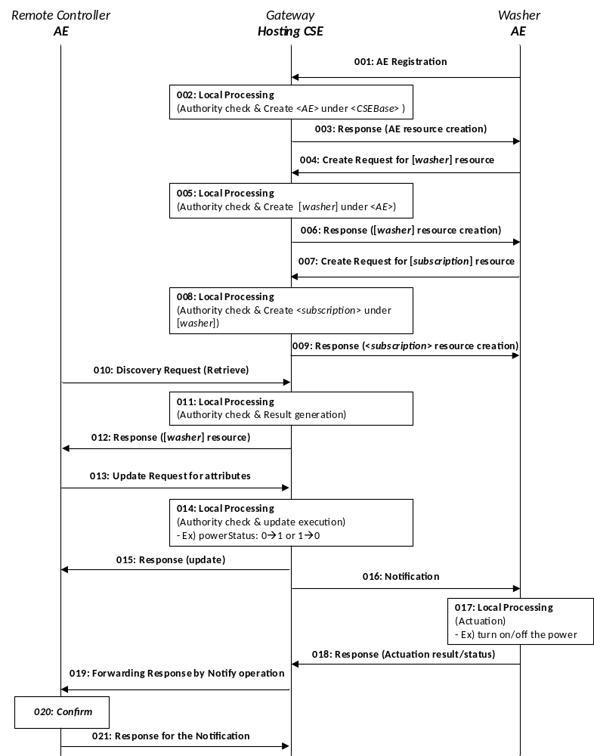
Figure 6.2.1.1-3. An example of [washer] procedure

6.2.1.2 two-level <appObj>
The first approach described in clause 6.2.1.1 is straightforward to implement. But, it is difficult to represent the relationships among services and shared attributes must be re-defined for each specializations everytime.
This clause describes the second approach introducing a new resource type <appService> which will be also specialized to specific services such as [timer], [spin] and etc.
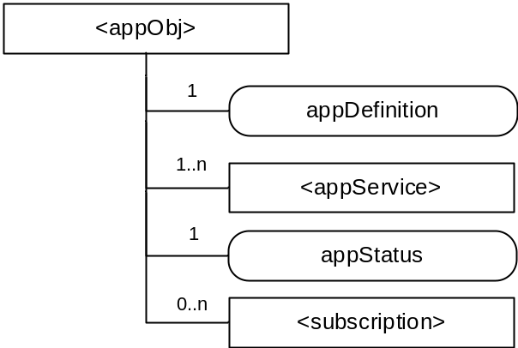
Figure 6.2.1.2-2. Structure of <appObj> resource
The <appObj> resource shall contain the child resources specified in table 6.2.1.2-1.
Table 6.2.1.2-1: Child resources of <appObj> resource
Child Resources of <appObj> | Child Resource Type | Multiplicity | Description | <appObjAnnc> Child Resource Types
[variable] | <appService> | 1..n | This resource provides capability to get information about common, shared or device-specific operational states of an appliance and to control an appliance with a specific set of commands linked to the appliance. | <appFuncAnnc>
[variable] | <subscription> | 0..n | See clause 9.6.8 in TS-0001 | <subscription>

The <appObj> resource shall contain the attributes specified in table 6.2.1.2-2.
Table 6.2.1.2-2: Attribute of <appObj> resource
Attributes of  <appObj> | Multiplicity | RW/  RO/  WO | Description | <appObjAnnc> Attributes
resourceType | 1 | RO | See clause 9.6.1.3 in TS-0001 | NA
resourceID | 1 | RO | See clause 9.6.1.3 in TS-0001 | MA
resourceName | 1 | WO | See clause 9.6.1.3 in TS-0001 | MA
parentID | 1 | RO | See clause 9.6.1.3 in TS-0001 | NA
expirationTime | 1 | RW | See clause 9.6.1.3 in TS-0001 | MA
accessControlPolicyIDs | 0..1 (L) | RW | See clause 9.6.1.3 in TS-0001 | MA
labels | 0..1 (L) | RW | See clause 9.6.1.3 in TS-0001 | MA
creationTime | 1 | RO | See clause 9.6.1.3 in TS-0001 | NA
lastModifiedTime | 1 | RO | See clause 9.6.1.3 in TS-0001 | NA
announceTo | 0..1 (L) | RW | See clause 9.6.1.3 in TS-0001 | NA
announcedAttribute | 0..1 (L) | RW | See clause 9.6.1.3 in TS-0001 | NA
appStatus | 1 | RO | Status information of the application which is represented as the parent <AE> resource (e.g., online, offline). | OA

The <appService> is a set of characteristics supporting a service and it is re-usable for multiple specializations of <appObj> resource.
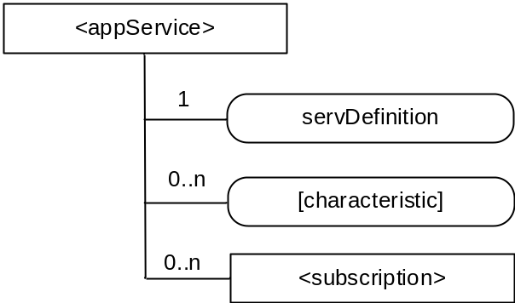
Figure 6.2.1.2-2. Structure of <appService> resource
The <appService> resource shall contain the child resources specified in table 6.2.1.2-3.
Table 6.2.1.2-3: Child resources of <appService> resource
Child Resources of <appObj> | Child Resource Type | Multiplicity | Description | <appObjAnnc> Child Resource Types
[variable] | <subscription> | 0..n | See clause 9.6.8 in TS-0001 | <subscription>

The <appObj> resource shall contain the attributes specified in table 6.2.1.2-4.
Table 6.2.1.2-4: Attribute of <appService> resource
Attributes of  <appObj> | Multiplicity | RW/  RO/  WO | Description | <appObjAnnc> Attributes
resourceType | 1 | RO | See clause 9.6.1.3 in TS-0001 | NA
resourceID | 1 | RO | See clause 9.6.1.3 in TS-0001 | MA
resourceName | 1 | WO | See clause 9.6.1.3 in TS-0001 | MA
parentID | 1 | RO | See clause 9.6.1.3 in TS-0001 | NA
expirationTime | 1 | RW | See clause 9.6.1.3 in TS-0001 | MA
accessControlPolicyIDs | 0..1 (L) | RW | See clause 9.6.1.3 in TS-0001 | MA
labels | 0..1 (L) | RW | See clause 9.6.1.3 in TS-0001 | MA
creationTime | 1 | RO | See clause 9.6.1.3 in TS-0001 | NA
lastModifiedTime | 1 | RO | See clause 9.6.1.3 in TS-0001 | NA
announceTo | 0..1 (L) | RW | See clause 9.6.1.3 in TS-0001 | NA
announcedAttribute | 0..1 (L) | RW | See clause 9.6.1.3 in TS-0001 | NA
servDefinition | 1 | WO | Definition of the service that is exposed by this resource (e.g., Common, Timer). | MA
[characteristic] | 0..n | RW | List of attributes which are defined per each specialized <appService> resource. Specialized attributes can have characteristics or behaviors that are defined in oneM2M information model (see TS-xxxx) | OA

The <appService> resource shall be specialized to particular services. The <appObj> resource must have at least one specialization of the <appService> resource for indicating its common properties.
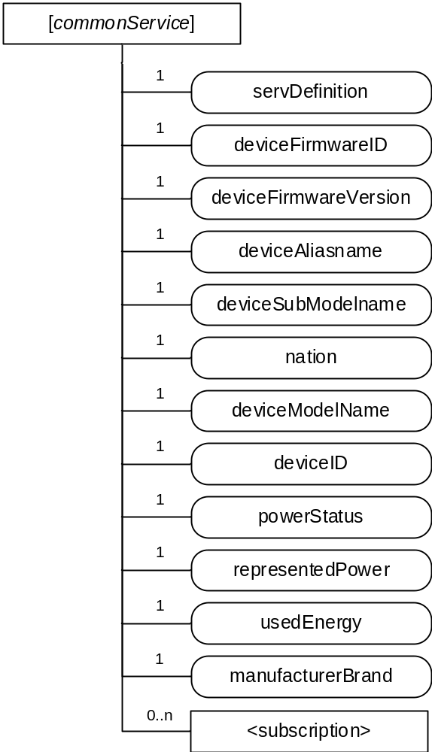
Figure 6.2.1.2-3. Structure of [commonService] resource
The [commonService] specialization of the <appService> resource shall contain the child resources specified in table 6.2.1.2-5.
Table 6.2.1.2-5: Child resources of [commonService] specialization
Child Resources of <appObj> | Child Resource Type | Multiplicity | Description | <appObjAnnc> Child Resource Types
[variable] | <subscription> | 0..n | See clause 9.6.8 in TS-0001 | <subscription>

The [commonService] specialization shall contain the attributes specified in table 6.2.1.2-6.
Table 6.2.1.2-6 Attribute of [commonService] specialization
Attributes of  <appObj> | Multiplicity | RW/  RO/  WO | Description | <appObjAnnc> Attributes
resourceType | 1 | RO | See clause 9.6.1.3 in TS-0001 | NA
resourceID | 1 | RO | See clause 9.6.1.3 in TS-0001 | MA
resourceName | 1 | WO | See clause 9.6.1.3 in TS-0001 | MA
parentID | 1 | RO | See clause 9.6.1.3 in TS-0001 | NA
expirationTime | 1 | RW | See clause 9.6.1.3 in TS-0001 | MA
accessControlPolicyIDs | 0..1 (L) | RW | See clause 9.6.1.3 in TS-0001 | MA
labels | 0..1 (L) | RW | See clause 9.6.1.3 in TS-0001 | MA
creationTime | 1 | RO | See clause 9.6.1.3 in TS-0001 | NA
lastModifiedTime | 1 | RO | See clause 9.6.1.3 in TS-0001 | NA
announceTo | 0..1 (L) | RW | See clause 9.6.1.3 in TS-0001 | NA
announcedAttribute | 0..1 (L) | RW | See clause 9.6.1.3 in TS-0001 | NA
servDefinition | 1 | WO | Definition of the application that is exposed by this resource (e.g., Washer). | MA
deviceFirmwareVersion | 1 | RW | See clause 5.3.2 | OA
deviceFirmwareID | 1 | RO | See clause 5.3.2 | OA
deviceType | 1 | RO | See clause 5.3.2 | OA
deviceAliasName | 1 | RW | See clause 5.3.2 | OA
deviceSubModelName | 1 | RO | See clause 5.3.2 | OA
nation | 1 | RO | See clause 5.3.2 | OA
deviceModelName | 1 | RO | See clause 5.3.2 | OA
deviceID | 1 | RO | See clause 5.3.2 | OA
powerStatus | 1 | RO | See clause 5.3.2 | OA
representedPower | 1 | RO | See clause 5.3.2 | OA
usedEnergy | 1 | RO | See clause 5.3.2 | OA
manufacturerBrand | 1 | RO | See clause 5.3.2 | OA

The <appObj> resource should have more specializations of the <appService> resource for indicating its characteristics and behaviors. For example, it can have a [timer] resource.
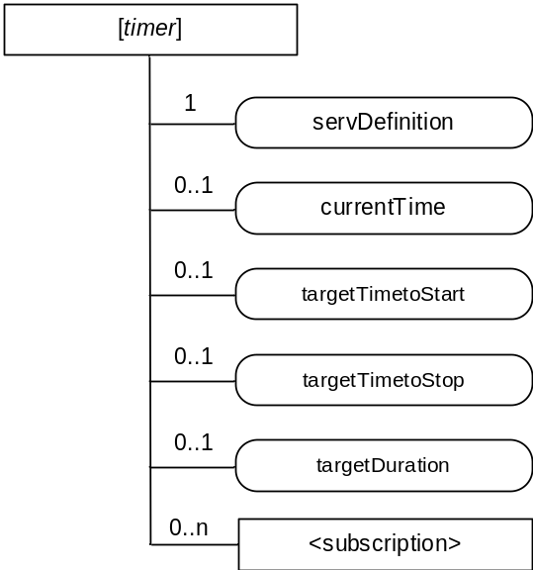
Figure 6.2.1.2-4. Structure of [timer] resource

The [timer] specialization of the <appService> resource shall contain the child resources specified in table 6.2.1.2-7.
Table 6.2.1.2-7: Child resources of [timer] specialization
Child Resources of <appObj> | Child Resource Type | Multiplicity | Description | <appObjAnnc> Child Resource Types
[variable] | <subscription> | 0..n | See clause 9.6.8 in TS-0001 | <subscription>

The [timer] specialization shall contain the attributes specified in table 6.2.1.2-8.
Table 6.2.1.2-8 Attribute of [timer] specialization
Attributes of  <appObj> | Multiplicity | RW/  RO/  WO | Description | <appObjAnnc> Attributes
resourceType | 1 | RO | See clause 9.6.1.3 in TS-0001 | NA
resourceID | 1 | RO | See clause 9.6.1.3 in TS-0001 | MA
resourceName | 1 | WO | See clause 9.6.1.3 in TS-0001 | MA
parentID | 1 | RO | See clause 9.6.1.3 in TS-0001 | NA
expirationTime | 1 | RW | See clause 9.6.1.3 in TS-0001 | MA
accessControlPolicyIDs | 0..1 (L) | RW | See clause 9.6.1.3 in TS-0001 | MA
labels | 0..1 (L) | RW | See clause 9.6.1.3 in TS-0001 | MA
creationTime | 1 | RO | See clause 9.6.1.3 in TS-0001 | NA
lastModifiedTime | 1 | RO | See clause 9.6.1.3 in TS-0001 | NA
announceTo | 0..1 (L) | RW | See clause 9.6.1.3 in TS-0001 | NA
announcedAttribute | 0..1 (L) | RW | See clause 9.6.1.3 in TS-0001 | NA
currentTime | 0..1 | RW | Current time | OA
targetTimetoStart | 0..1 | RW | The time when the device is expected to start its operation | OA
targetTimetoStop | 0..1 | RW | The time when the device is expected to stop its operation | OA
targetDuration | 0..1 | RW | Target duration of the operation | OA

Example B. Resource washer (Specialization of two-level <appObj>)
The [washer] resource is used to share information regarding wahser. The [washer] is a specialization of the two-level <appObj> resource.
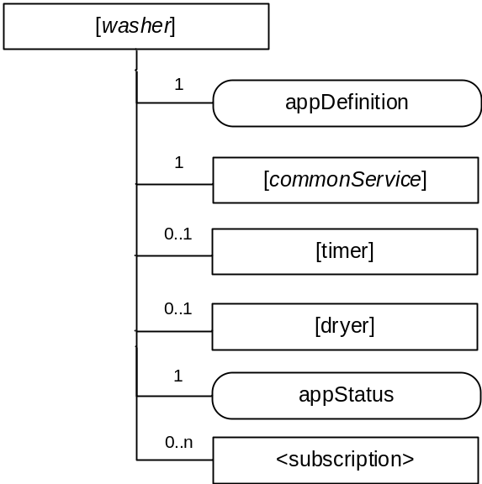
Figure 6.2.1.2-5. Structure of [washer] resource
The [washer] resource shall contain the child resource specified in table 6.2.1.2-9.
Table 6.2.1.2-9: Child resources of [washer] resource
Child Resources of <washer> | Child Resource Type | Multiplicity | Description | <appObjAnnc> Child Resource Types
commonService | <appService> as defined in the specialization of [commonService] (common service) | 1 | See figure 6.2.1.2-3 | <appServiceAnnc>
[variable] | <appService> as defined in the specialization of [timer] (shared service) | 0..1 | See figure 6.2.1.2-4 | <appServiceAnnc>
[variable] | <appService> as defined in the specialization of [dryer] (device specific service) | 0..1 | This resource describes a dryer function for a washer. | <appServiceAnnc>
[variable] | <subscription> | 0..n | See clause 9.6.8 in TS-0001 | <subscription>

The <washer> resource shall contain the attributes specified in table 6.2.1.2-10.
Table 6.2.1.2-10: Attribute of <washer> resource
Attributes of  <appObj> | Multiplicity | RW/  RO/  WO | Description
resourceType | 1 | RO | See clause 9.6.2.3. in TS-0001
resourceID | 1 | RO | See clause 9.6.2.3. in TS-0001
resourceName | 1 | WO | See clause 9.6.2.3. in TS-0001
parentID | 1 | RO | See clause 9.6.2.3. in TS-0001
expirationTime | 1 | RW | See clause 9.6.2.3. in TS-0001
accessControlPolicyIDs | 0..1 (L) | RW | See clause 9.6.2.3. in TS-0001
labels | 0..1 (L) | RW | See clause 9.6.2.3. in TS-0001
creationTime | 1 | RO | See clause 9.6.2.3. in TS-0001
lastModifiedTime | 1 | RO | See clause 9.6.2.3. in TS-0001
announceTo | 0..1 (L) | RW | See clause 9.6.2.3. in TS-0001
announcedAttribute | 0..1 (L) | RW | See clause 9.6.2.3. in TS-0001
appDefinition | 1 | WO | Definition of the application that is exposed by this resource (e.g., Washer).
appStatus | 1 | RO | Status information of the application which is represented as the parent <AE> resource (e.g., online, offline).

-----------------------End of change 1---------------------------------------------

