Input Contribution
Meeting ID* | MAS#33.1
Title:* | Information Model mapping between WoT TD and oneM2M BO
Source:* | Yongjing Zhang, zhangyongjing@huawei.com
Date:* | 2017-01-31
Input related to* | TR-0042 WoT Interworking
Intended purpose of  document:* | Decision  Discussion  Information  Other <specify>
Impacted other TS/TR(s) | n/a
Decision requested or recommendation:* | To be included in TR-0042
Template Version: January 2017 (Do not modify)

oneM2M Notice
The document to which this cover statement is attached is submitted to oneM2M. Participation in, or attendance at, any activity of oneM2M, constitutes acceptance of and agreement to be bound by terms of the Working Procedures and the Partnership Agreement, including the Intellectual Property Rights (IPR) Principles Governing oneM2M Work found in Annex 1 of the Partnership Agreement.

-----------------------Start of change 1-------------------------------------------

7.2 WoT Thing Description vs oneM2M Base Ontology
WoT TD [i.5] defines a limited set of vocabulary in terms of classes and its fields (i.e. properties). The collection of the classes and relations comprises the ontology of TD ‘Core Model’ as illustrated in Figure 7.2-1.
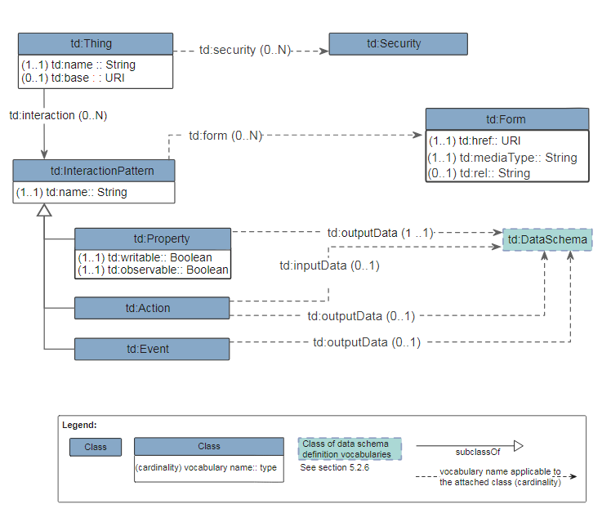
Figure 7.2-1 TD Core Model
WoT TD has less classes defined than oneM2M Base Ontology (BO) [i.7] in general, but has some specific classes and fields (properties) that are not directly mappable to oneM2M BO. Table 7.2-1 and Table 7.2-2 show the mapping relationships of the Classes and the Properties (both Object Properties and Data Properties) between WoT TD and oneM2M BO respectively.
Table 7.2-1: Class mapping between WoT TD and oneM2M BO
Class/Property in TD | Mapping relationship | Class/Property in BO | Note
td:Thing | owl:equivalentClass | oneM2M:Thing | a td:Thing can be a physical and/or virtual Thing
td:InteractionPattern | owl:subClassOf | oneM2M:Service | -
td:Property | owl:subClassOf* | oneM2M:ThingProperty  oneM2M:OutputDataPoint | a td:Property can be a static, non-functional property of a thing or a dynamic and functional (output) data point of a thing.
td:Action | owl:subClassOf | oneM2M:Operation | -
td:Event | owl:subClassOf | oneM2M:Operation | -
td:DataSchema | owl:subClassOf | oneM2M:Variable | td:DataSchema
td:Form | N/A | N/A | td:Form is to provide the metadata (e.g. URI, mediaType) for accessing a service (td:InteractionPattern) of a thing.  There is no direct mapping in oneM2M BO.
td:Security | owl:subClassOf | oneM2M:ThingProperty | There is no direct mapping in oneM2M BO, but security can be consider as a property of a thing.

Table 7.2-2: Property mapping between WoT TD and oneM2M BO
Class/Property in TD | Mapping relationship | Class/Property in BO | Note
td:name | owl:subPropertyOf*  (Note: the td:name of a td:InteractionPattern is not mappable) | oneM2M: hasThingAnnotation | td:name can be used to annotate the name of a thing or a interactionPattern, while oneM2M:hasThingAnnotation can only be used to annotate a thing but not for the name of a service.
td:security | owl:subPropertyOf | oneM2M:hasThingProperty | There is no direct mapping in oneM2M BO, but security can be consider as a property of a thing.
td:interaction | owl:subPropertyOf | oneM2M:hasService | -
td:outputData | owl:subPropertyOf | oneM2M:hasOutputData  oneM2M:hasOutput | If the domain class (subject) is a td:Property, it’s mapped to oneM2M:hasOutputData. If the domain class (subject) is a td:Action or td:Even, it’s mapped to oneM2M:hasOutput
td:inputData | owl:subPropertyOf | oneM2M:hasInput | -
td:observable | N/A | N/A | td:observable is to indicates whether a remote servient can subscribe to ("observe") a td:Property. There is no proper mapping in oneM2M BO.
td:writable | N/A | N/A | td:writable is to indicates whether whether a td:Property is writable or not. There is no proper mapping in oneM2M BO.
td:base | owl:subPropertyOf* | oneM2M:oneM2MTargetURI | td:base is the base URI of all local interactions. It may or may not be a oneM2M URI depending on whether the described thing is a oneM2M entity or not.
td:href | owl:subPropertyOf* | oneM2M:oneM2MTargetURI | td:href can be a relative URI based on the td:base URI or an absolute URI. It may or may not be a oneM2M URI depending on whether the described thing is a oneM2M entity or not.
td:mediaType | N/A | N/A | td:mediaType describes the IANA media type of the interaction pattern.  There is no proper mapping in oneM2M BO.
td:rel  Editor’s note: it’s not well defined in WoT yet. | N/A | N/A | td:rel Provides the expected result of performing the operation described by the td:Form.  There is no proper mapping in oneM2M BO.

NOTE: The mapping relationship with a ‘*’ mark in Table 7.2-1 represents a reversed relationship (from oneM2M BO to WoT TD).
According to the analysis above, it’s noticed that not all WoT TD classes and properties can be directly mapped to oneM2M BO. There may be information losing (e.g. td:Form) if the ‘Ontology-based Interworking’ mechanism defined in [i.8] is applied to the oneM2M-WoT interworking based on the ontology mapping to oneM2M BO.
Editor’s Note: Extension to oneM2M BO may need to be considered in order to better support the interworking with WoT. On the other hand, it’s ffs if all TD information requires to be mapped or not. td:Form metadata for accessing WoT services may be hidden by IPE, so no need to be mapped and exposed.

-----------------------End of change 1-------------------------------------------

-----------------------Start of change 2-------------------------------------------

2 References
References are either specific (identified by date of publication and/or edition number or version number) or non-specific. For specific references,only the cited version applies. For non-specific references, the latest version of the referenced document (including any amendments) applies.

2.1 Normative references
Not applicable.

2.2 Informative references
The following referenced documents are not necessary for the application of the present document but they assist the user with regard to a particular subject area.
- oneM2M Drafting Rules (http://member.onem2m.org/Static_pages/Others/Rules_Pages/oneM2M-Drafting-Rules-V1_0.doc)
- oneM2M TS-0001, Functional Architecture, v2.10.0, August 2016.
- Web of Things (WoT) Architecture, W3C Editor's Draft, May 4, 2017 (https://w3c.github.io/wot-architecture/)
- WoT Current Practices, Unofficial Draft, April 27, 2017 (http://w3c.github.io/wot/current-practices/wot-practices.html)
- Web of Things (WoT) Thing Description, W3C Editor's Draft 26 January 2018 (https://w3c.github.io/wot-thing-description/)
- oneM2M TS-0023, Home Appliances Information Model and Mapping, V2.0.1, July 7, 2017.
- oneM2M TS-0012, Base Ontology, v3.6.0, January 08, 2018.
- oneM2M TS-0030, Ontology based Interworking, v0.4.1, January 08, 2018

3 Definitions, symbols and abbreviations

3.1 Definitions
Clause numbering depends on applicability.
- A definition shall not take the form of, or contain, a requirement.
- The form of a definition shall be such that it can replace the term in context. Additional information shall be given only in the form of examples or notes (see below).
- The terms and definitions shall be presented in alphabetical order.
For the purposes of the present document, the [following] terms and definitions [given in ... and the following] apply:
Definition format
<defined term>: <definition>
If a definition is taken from an external source, use the format below where [N] identifies the external document which must be listed in Section 2 References.
<defined term>[N]: <definition>
example 1: text used to clarify abstract rules by applying them literally
NOTE: This may contain additional information.

3.2 Symbols
Clause numbering depends on applicability.
For the purposes of the present document, the [following] symbols [given in ... and the following] apply:
Symbol format
<symbol> <Explanation>
<2nd symbol> <2nd Explanation>
<3rd symbol> <3rd Explanation>

3.3 Abbreviations
Abbreviations should be ordered alphabetically.
Clause numbering depends on applicability.
For the purposes of the present document, the [following] abbreviations [given in ... and the following] apply:
Abbreviation format
AE Application Entity
API Application Program Interface
ASN Application Service Node
BO Base Ontology
CRUD Create, Retrieve, Update, Delete
CSE Common Service Entity
CSF Common Service Function
IG Interest Group
IN Infrastructure Node
IoT Internet of Things
IPE Interworking Proxy Entity
JSON-LD JavaScript Object Notation for Linked Data
MN Middle Node
RDF Resource Description Framework
ROA Resource-Oriented Architecture
SDT Smart Device Template
TD Thing Description
URI Uniform Resource Identifier
WG Working Group
WoT Web of Things

-----------------------End of change 2-------------------------------------------

