Input Contribution
Meeting ID* | MAS#34
Title:* | Information Model mapping between WoT TD and oneM2M BO
Source:* | Yongjing Zhang, zhangyongjing@huawei.com
Date:* | 2018-03-12
Input related to* | TR-0042 WoT Interworking
Intended purpose of  document:* | Decision  Discussion  Information  Other <specify>
Impacted other TS/TR(s) | n/a
Decision requested or recommendation:* | To be included in TR-0042
Template Version: January 2017 (Do not modify)

oneM2M Notice
The document to which this cover statement is attached is submitted to oneM2M. Participation in, or attendance at, any activity of oneM2M, constitutes acceptance of and agreement to be bound by terms of the Working Procedures and the Partnership Agreement, including the Intellectual Property Rights (IPR) Principles Governing oneM2M Work found in Annex 1 of the Partnership Agreement.

-----------------------Start of change 1-------------------------------------------

5.2.2 Overview of W3C WoT system

5.2.2.1 W3C WoT architecture
WoT functional architecture has been designed with three primary requirements [i.3]: flexibility by aiming to support a wide range of physical WoT devices, upper compatibility to current IoT standards and legacy IoT solutions, and security and privacy. In WoT system, the major functional entity is “WoT Servient” which is an entity consisting of a web client, a web server, and device control capabilities. A WoT Servient becomes a WoT Server if it only has a web server and device control capabilities, or a WoT client if it does not have a web server but a web client. Through a WoT Servient, IoT physical devices can be accessed, monitored, and controlled (e.g. to get their status and data values from those devices).
The general WoT Servient functional architecture as defined in [i.3] is presented in Figure 5.2.2.1-1. Servients communicate with each other through “WoT Interface”, a resource-oriented Web Application Program Interface (API). A Servient can be in client role (i.e., it only consumes other things), server role (i.e., it only exposes things and provides capabilities), or both. As defined in [i.5], “Thing” is the abstract concept of a physical entity that can either be a real-world artifact, such as a device, or a virtual entity that represents physicality, such as a room or group of devices. In general, a WoT Thing (e.g., a legacy device only providing proprietary interface) has an associated WoT Servient, which is the representation of this Thing in the WoT system, with which other WoT Servients can interact. Servients can also provide access to virtual things such as a collection of physical things (e.g., all lights in a room). In addition, Servients can be hosted in different places such as inside a smartphone, a local gateway, or the cloud.

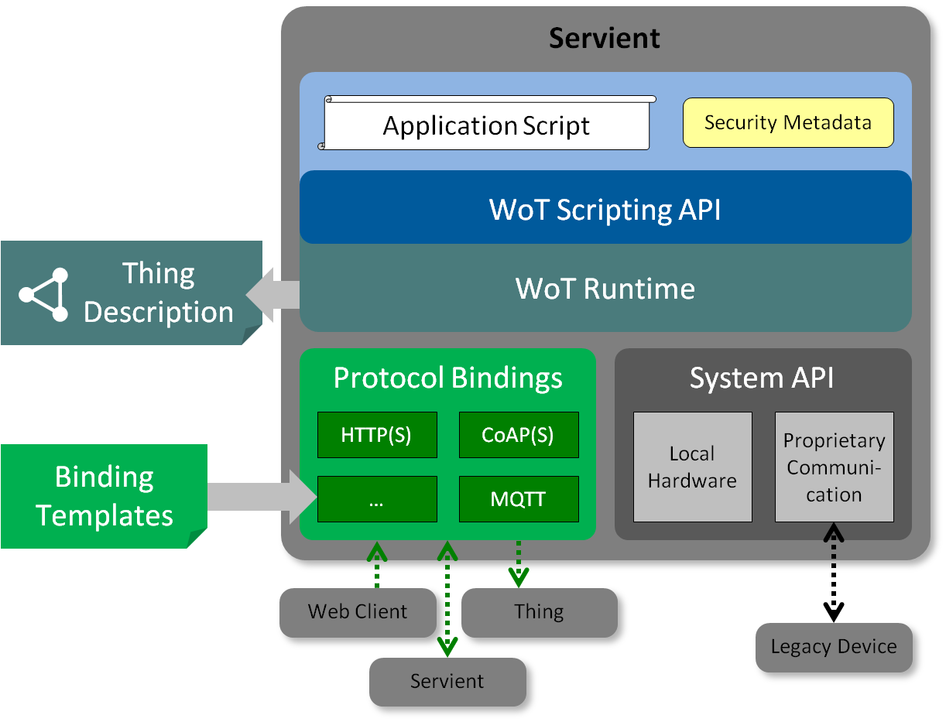
Figure 5.2.2.1-1: Functional Architecture of WoT Servient [i.3]
According to [i.3], the functionalities of several major modules of a WoT Servient are described below.
- Thing Description: Each WoT Thing is described by a WoT TD, which basically describes the semantics of a Thing as well as its WoT Interface. The TD must be acquired before it the Thing can be accessed and/or interested with. Things can provide their own TDs locally, but the TD can also be hosted externally (e.g. if there is not enough space on the thing/device). To ease TD discovery, TDs can be registered with a well-known TD Repository, where the TD for Things of interest can be queried. The Clause 5.2.2.2 gives more details about TD.
- Appication: The application logic of a WoT Thing (or technically a servient) can be implemented natively, for instance in the device firmware, which is expected to be common for very resource-constrained Things. Following the patterns in the Web, however, application logic should also be provided by scripts. This is supported through a scripting runtime environment—similar to the Web browser—that may be provided by a servient. App scripts implement application logic in a modular and portable way. It can access local hardware, locally connected legacy devices, and remote things through the WoT Interface.
- Script API: Portability of such scripts is ensured through a common Scripting API (i.e. Client API, Server API, Discovery API, and Proprietary API) that allows an application to discover things (via Discovery API), to consume things (via Client API), to expose things (via Server API), and/or to access/control the hardware physically attached to the servient (via Proprietary API). Scripting API is more like an internal API used by application scripts, while the WoT Interface is the external interaction interface between different WoT Servients.
- Protocol Binding: It supports binding Script API messages to different underlying protocols with various communication patterns such as push, pull, pub-sub and bi-directional messaging. After protocol binding, message will be transmitted over WoT interface from one WoT Servient to another WoT Servient. This will be realized by standardized Binding Template.
- Security and Privacy: Security and privacy features will be embedded in other modules like TD, Script API, Protocol Binding, etc. As a result, W3C WoT WG will not generate a standalone specification for security and privacy, but include security and privacy design in TD specification, Script API specification, and binding template specification.

W3C WoT WG does not specify Applicattion, but specifies Thing Description (TD), Script API, and Protocol Binding Template.
Editor’s note: all the description about WoT Architecture needs to be revisited/revised according to the latest version of W3C WoT before oneM2M publication. The “Security and Privacy” part may need to be removed.

5.2.2.2 WoT Thing Description (TD)
WoT TD is the key module to enable interactions between two WoT Servients, and plays a critical role in oneM2M-WoT interworking (e.g. mapping between W3C TD model and inforamtion models in oneM2M).
WoT TD can be considered as the entry point of a Thing (aka the index.html of the Thing). It consists of semantic metadata for the Thing itself, a narrow-waist interaction model with WoT's Properties, Actions, and Events, a semantic schema to make data models machine-understandable, and features for Web Linking to express relations among Things [i.5].

Currently WoT TD uses JSON-LD as its default serialisation format, while other formats (e.g. plain JSON) are also under investigation. Using JSON-LD implies the semantic layer capability of WoT TD, which follows the Linked Data and RDF practices in the Semantic Web [i.6] world. In fact, the core set of WoT TD consists of a limited set of vocabulary in terms of classes, its fields (i.e. properties) and relations, which comprises the ontology of TD ‘Core Model’ as illustrated in Figure 7.2-1 [i.5]. Detailed definintions and more examples can be found in [i.5].
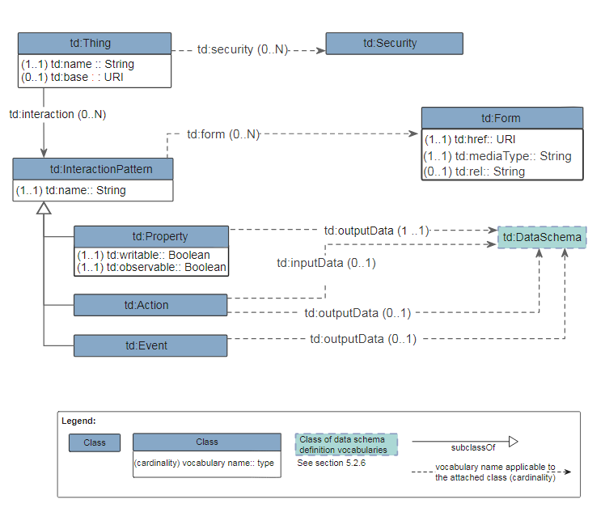
Figure 7.2-1 TD Core Model

Editor’s note: all the description about WoT TD needs to be revisited/revised according to the latest version of W3C WoT before oneM2M publication.

-----------------------End of change 1-------------------------------------------

-----------------------Start of change 2-------------------------------------------

7.2 WoT Thing Description vs oneM2M Base Ontology

WoT TD has less classes defined than oneM2M Base Ontology (BO) [i.8] in general, but has some specific classes and fields (properties) that are not directly mappable to oneM2M BO. Table 7.2-1 and Table 7.2-2 show the mapping relationships of the Classes and the Properties (both Object Properties and Data Properties) between WoT TD and oneM2M BO respectively.
Table 7.2-1: Class mapping between WoT TD and oneM2M BO
Class/Property in TD | Mapping relationship | Class/Property in BO | Note
td:Thing | owl:equivalentClass | oneM2M:Thing | a td:Thing can be a physical and/or virtual Thing
td:InteractionPattern | owl:subClassOf | oneM2M:Service | -
td:Property | owl:subClassOf* | oneM2M:ThingProperty  oneM2M:OutputDataPoint | a td:Property can be a static, non-functional property of a thing or a dynamic and functional (output) data point of a thing.
td:Action | owl:subClassOf | oneM2M:Operation | -
td:Event | owl:subClassOf | oneM2M:Operation | -
td:DataSchema | owl:subClassOf | oneM2M:Variable | td:DataSchema
td:Form | N/A | N/A | td:Form is to provide the metadata (e.g. URI, mediaType) for accessing a service (td:InteractionPattern) of a thing.  There is no direct mapping in oneM2M BO.
td:Security | owl:subClassOf | oneM2M:ThingProperty | There is no direct mapping in oneM2M BO, but security can be consider as a property of a thing.

Table 7.2-2: Property mapping between WoT TD and oneM2M BO
Class/Property in TD | Mapping relationship | Class/Property in BO | Note
td:name (of td:Thing) | owl:subPropertyOf | oneM2M: hasThingAnnotation | In the case that td:name is used to annotate the name of a thing, it can be mapped as a subProperty of oneM2M:hasThingAnnotation which can be used to annotate a thing in many ways including the name.
td:name (of td:InteractionPattern) | owl:subPropertyOf | oneM2M:hasOutputDataPoint | In the case that td:name is used to annotate the name of an instantiated td:InteractionPattern (which is mapped as a subclass of oneM2M:Service), it can be mapped as a subProperty of oneM2M: hasOutputDataPoint, which can link to a specialized oneM2M:OutputDataPoint that annotates the name of the oneM2M:Service.
td:security | owl:subPropertyOf | oneM2M:hasThingProperty | There is no direct mapping in oneM2M BO, but security can be consider as a property of a thing.
td:interaction | owl:subPropertyOf | oneM2M:hasService | -
td:outputData | owl:subPropertyOf | oneM2M:hasOutputData  oneM2M:hasOutput | If the domain class (subject) is a td:Property, it’s mapped to oneM2M:hasOutputData. If the domain class (subject) is a td:Action or td:Even, it’s mapped to oneM2M:hasOutput
td:inputData | owl:subPropertyOf | oneM2M:hasInput | -
td:observable | N/A | N/A | td:observable is to indicates whether a remote servient can subscribe to ("observe") a td:Property. There is no proper mapping in oneM2M BO.
td:writable | N/A | N/A | td:writable is to indicates whether whether a td:Property is writable or not. There is no proper mapping in oneM2M BO.
td:base | owl:subPropertyOf* | oneM2M:oneM2MTargetURI | td:base is the base URI of all local interactions. It may or may not be a oneM2M URI depending on whether the described thing is a oneM2M entity or not.
td:href | owl:subPropertyOf* | oneM2M:oneM2MTargetURI | td:href can be a relative URI based on the td:base URI or an absolute URI. It may or may not be a oneM2M URI depending on whether the described thing is a oneM2M entity or not.
td:mediaType | N/A | N/A | td:mediaType describes the IANA media type of the interaction pattern.  There is no proper mapping in oneM2M BO.
td:rel  Editor’s note: it’s not well defined in WoT yet. | N/A | N/A | td:rel Provides the expected result of performing the operation described by the td:Form.  There is no proper mapping in oneM2M BO.

NOTE: The mapping relationship with a ‘*’ mark in Table 7.2-1 represents a reversed relationship (from oneM2M BO to WoT TD).
According to the analysis above, it’s noticed that not all WoT TD classes and properties can be directly mapped to oneM2M BO. There may be information losing (e.g. td:Form) if the ‘Ontology-based Interworking’ mechanism defined in [i.9] is applied to the oneM2M-WoT interworking based on the ontology mapping to oneM2M BO.
Editor’s Note: mapping highlighted in yellow needs FFS before conclusion.
Editor’s Note: Extension to oneM2M BO may need to be considered in order to better support the interworking with WoT. On the other hand, it’s ffs if all TD information requires to be mapped or not. td:Form metadata for accessing WoT services may be hidden by IPE, so no need to be mapped and exposed.

-----------------------End of change 2-------------------------------------------

-----------------------Start of change 3-------------------------------------------

2 References
References are either specific (identified by date of publication and/or edition number or version number) or non-specific. For specific references,only the cited version applies. For non-specific references, the latest version of the referenced document (including any amendments) applies.

2.1 Normative references
Not applicable.

2.2 Informative references
The following referenced documents are not necessary for the application of the present document but they assist the user with regard to a particular subject area.
- oneM2M Drafting Rules (http://member.onem2m.org/Static_pages/Others/Rules_Pages/oneM2M-Drafting-Rules-V1_0.doc)
- oneM2M TS-0001, Functional Architecture, v2.10.0, August 2016.
- Web of Things (WoT) Architecture, W3C Editor's Draft, May 4, 2017 (https://w3c.github.io/wot-architecture/)

- Web of Things (WoT) Thing Description, W3C Editor's Draft 9th March 2018 (https://w3c.github.io/wot-thing-description/)
- World Wide Web Consortium (W3C), Semantic Web (https://www.w3.org/standards/semanticweb/)
- oneM2M TS-0023, Home Appliances Information Model and Mapping, V2.0.1, July 7, 2017.
- oneM2M TS-0012, Base Ontology, v3.6.0, January 08, 2018.
- oneM2M TS-0030, Ontology based Interworking, v0.4.1, January 08, 2018

Editor’s Note: All references (espeically those from WoT) should be updated before publication.

3 Definitions, symbols and abbreviations

3.1 Definitions
Clause numbering depends on applicability.
- A definition shall not take the form of, or contain, a requirement.
- The form of a definition shall be such that it can replace the term in context. Additional information shall be given only in the form of examples or notes (see below).
- The terms and definitions shall be presented in alphabetical order.
For the purposes of the present document, the [following] terms and definitions [given in ... and the following] apply:
Definition format
<defined term>: <definition>
If a definition is taken from an external source, use the format below where [N] identifies the external document which must be listed in Section 2 References.
<defined term>[N]: <definition>
example 1: text used to clarify abstract rules by applying them literally
NOTE: This may contain additional information.

3.2 Symbols
Clause numbering depends on applicability.
For the purposes of the present document, the [following] symbols [given in ... and the following] apply:
Symbol format
<symbol> <Explanation>
<2nd symbol> <2nd Explanation>
<3rd symbol> <3rd Explanation>

3.3 Abbreviations
Abbreviations should be ordered alphabetically.
Clause numbering depends on applicability.
For the purposes of the present document, the [following] abbreviations [given in ... and the following] apply:
Abbreviation format
AE Application Entity
API Application Program Interface
ASN Application Service Node
BO Base Ontology
CRUD Create, Retrieve, Update, Delete
CSE Common Service Entity
CSF Common Service Function
IG Interest Group
IN Infrastructure Node
IoT Internet of Things
IPE Interworking Proxy Entity
JSON JavaScript Object Notation
JSON-LD JavaScript Object Notation for Linked Data
MN Middle Node
RDF Resource Description Framework
ROA Resource-Oriented Architecture
SDT Smart Device Template
TD Thing Description
URI Uniform Resource Identifier
WG Working Group
WoT Web of Things

-----------------------End of change 3-------------------------------------------

