CHANGE REQUEST
Meeting ID:* | MAS #36
Source:* | Bareau Cyrille, Orange, cyrille.bareau@orange.com  Bonnardel Gregory, Orange, gbonnardel.ext@orange.com  Gharout Said, Orange, said.gharout@orange.com  Goluch Maciej, Orange, maciej.goluch@orange.com  Strzemecki Paweł, Orange, pawel.strzemecki2@orange.com
Date:* | 2018-07-19
Reason for Change/s:* | See the introduction below
CR against: Release* | REL 2
CR against: WI* | Active WI-0088  MNT maintenance / < Work Item number(optional)>  Is this a mirror CR? Yes No  mirror CR number: (Note to Rapporteur - use latest agreed revision)  STE Small Technical Enhancements / < Work Item number (optional)>  Only ONE of the above shall be ticked
CR against: TS/TR* | TS-0022 v2.3.1
Clauses * | 7
Type of change: * | Editorial change  Bug Fix or Correction  Change to existing feature or functionality  New feature or functionality  Only ONE of the above shall be ticked
Impacted other TS/TR(s) | <TS/TR number>, <Version Number>, and <Description on which aspect should be reflected in this TS/TR>
Post Freeze checking:* | This CR contains only essential changes and corrections? YES NO  This CR may break backwards compatibility with the last approved version of the TS? YES NO
Template Version: January 2017 (Do not modify)

oneM2M Notice
The document to which this cover statement is attached is submitted to oneM2M. Participation in, or attendance at, any activity of oneM2M, constitutes acceptance of and agreement to be bound by terms of the Working Procedures and the Partnership Agreement, including the Intellectual Property Rights (IPR) Principles Governing oneM2M Work found in Annex 1 of the Partnership Agreement.
GUIDELINES for Change Requests:
Provide an informative introduction containing the problem(s) being solved, and a summary list of proposals.
Each CR should contain changes related to only one particular issue/problem.
In case of a correction, and the change apply to previous releases, a separate “mirror CR” should be posted at the same time of this CR
Mirror CR: applies only when the text, including clause numbering are exactly the same.
Companion CR: applies when the change means the same but the baselines differ in some way (e.g. clause number).
Follow the principle of completeness, where all changes related to the issue or problem within a deliverable are simultaneously proposed to be made E.g. A change impacting 5 tables should not only include a proposal to change only 3 tables. Includes any changes to references, definitions, and acronyms in the same deliverable.
Follow the drafting rules.
All pictures must be editable.
Check spelling and grammar to the extent practicable.
Use Change bars for modifications.
The change should include the current and surrounding clauses to clearly show where a change is located and to provide technical context of the proposed change. Additions of complete clauses need not show surrounding clauses as long as the proposed clause number clearly shows where the new clause is proposed to be located.
Multiple changes in a single CR shall be clearly separated by horizontal lines with embedded text such as, start of change 1, end of change 1, start of new clause, end of new clause.
When subsequent changes are made to content of a CR, then the accepted version should not show changes over changes. The accepted version of the CR should only show changes relative to the baseline approved text.

Introduction
This CR brings new management object to provide handling of authentication by OAuth2 security protocol.
This mgmtObj can be used to provide support for configuration of and authentication to non-oneM2M node use case described in TR-0001 (see clause 12.21 in TR-0001) and provide support for SER-076 and CMR-0020 requirements described in TS-0002 (see clauses 6.4 and 6.7 in TS-0002).
Vendors can use different security protocols to authenticate applications to their devices or servers. One of possible choices is OAuth2 protocol. OAuth2Authentication mgmtObj is to store access and refresh token used to provide authentication in this protocol.
On the figure below you can find illustration of support for configuration of and authentication to non-oneM2M node use case. This CR is to provide resource to store authentication data obtained in non-oneM2M scope by Proxy API from Non-OneM2M Node. Data stored in this resource can be then used to authenticate User Application against vendor’s server to provide acces to Data stored on vendor’s server.
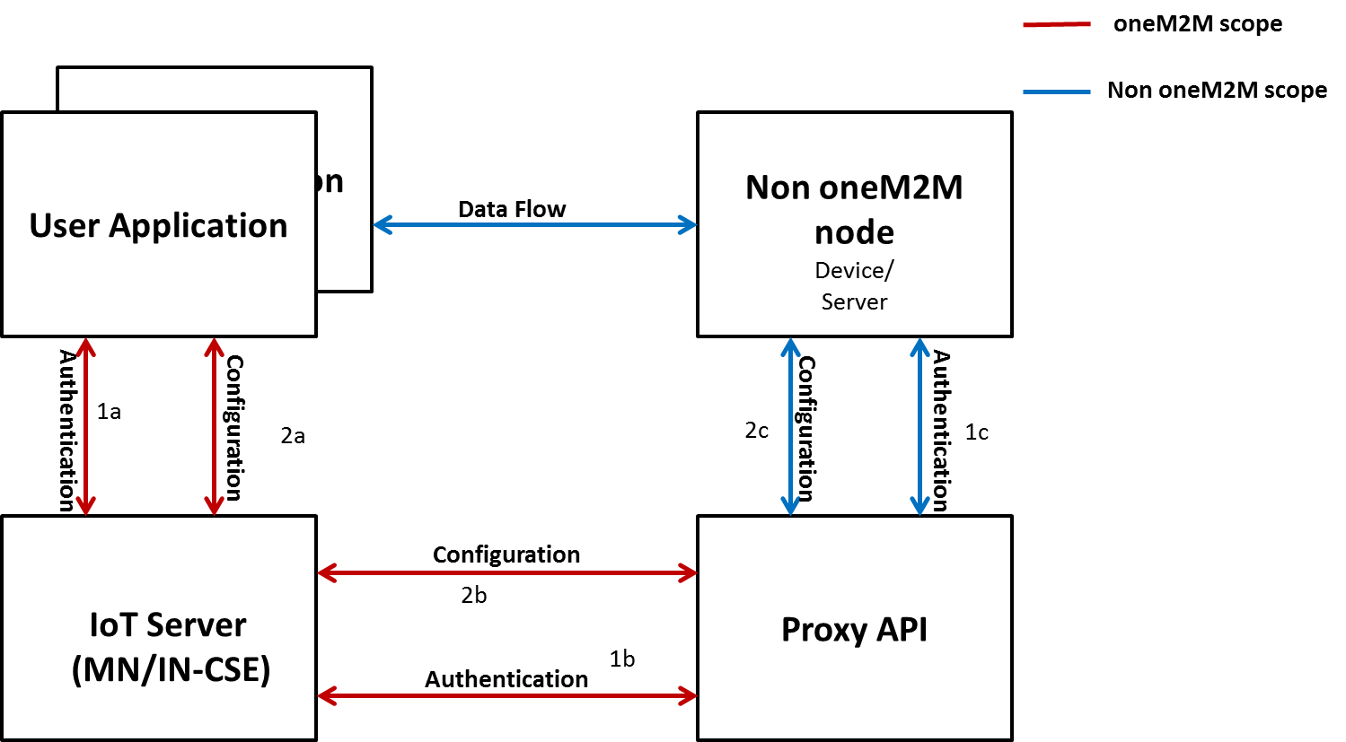
Illustration of support for configuration of and authentication to non-oneM2M node use case

According to the Figure 6.1-1 Architectural Aspects for Configuration of ASN/MN and ADN Nodes from clause 6.1 in TS-0022 (See below) OAuth2 Management Object shall be stored in CSE (IN-CSE or MN-CSE)
Architectural Aspects for Configuration of ASN/MN and ADN Nodes. See Figure 6.1-1 in TS-0022

R03: Previous version lacked of the definition of CRUD operations for [OAuth2Authentication] MO. This revision introduces this clause.
R04: Architectural aspects diagram added.

-----------------------Start of change 1-------------------------------------------

7.1.X Resource [OAuth2Authentication]
This specialization of <mgmtObj> is used to store access token and refresh token used in OAuth2 security protocol

Figure 7.1.X-1: Structure of [OAuth2Authentication] resource
The [OAuth2Authentication] resource shall contain the child resources specified in table 7.1.X-1.
Table 7.1.X-1: Child resources of [OAuth2Authentication] resource
Child Resources of [OAuth2Authentication] | Child Resource Type | Multiplicity | Description
[variable] | <subscription> | 0..n | See clause 9.6.8 of oneM2M TS-0001[2]

The [OAuth2Authentication] resource shall contain the attributes specified in table 7.1.X-2.
Table 7.1.X-2: Attributes of [OAuth2Authentication] resource
Attributes of  [wifi] | Multiplicity | RW/  RO/  WO | Description
resourceType | 1 | RO | See clause 9.6.1.3 of oneM2M TS-0001 [2].
resourceID | 1 | RO | See clause 9.6.1.3 of oneM2M TS-0001 [2].
resourceName | 1 | WO | See clause 9.6.1.3 of oneM2M TS-0001 [2].
parentID | 1 | RO | See clause 9.6.1.3 of oneM2M TS-0001 [2].
expirationTime | 1 | RW | See clause 9.6.1.3 of oneM2M TS-0001 [2].
accessControlPolicyIDs | 0..1 (L) | RW | See clause 9.6.1.3 of oneM2M TS-0001 [2].
creationTime | 1 | RO | See clause 9.6.1.3 of oneM2M TS-0001 [2].
lastModifiedTime | 1 | RO | See clause 9.6.1.3 of oneM2M TS-0001 [2].
labels | 0..1(L) | RW | See clause 9.6.1.3 of oneM2M TS-0001 [2].
mgmtDefinition | 1 | WO | See clause 9.6.15 of oneM2M TS-0001 [2]. This attribute shall have fixed value "OAuthAuthentication”.
objectIDs | 0..1 (L) | WO | See clause 9.6.15 of oneM2M TS-0001 [2].
objectPaths | 0..1 (L) | WO | See clause 9.6.15 of oneM2M TS-0001 [2].
description | 0..1 | RW | See clause 9.6.15 of oneM2M TS-0001 [2].
accessToken | 1 | RW | Indicates OAuth2 access token.
refreshToken | 1 | RW | Indicates OAuth2 refresh token.

-----------------------End of change 1---------------------------------------------

-----------------------Start of change 2---------------------------------------------

7.2.X.Resource [OAuth2Authentication]

7.2.X.1 Introduction
This specialization of <mgmtObj> is used to store access token and refresh token used in OAuth2 security protocol
Table 7.2.X.1-1: Data Type Definition of [OAuth2Authentication]
Data Type ID | File Name | Note
OAuth2 | DCFG-OAuth2-v2_0_0.xsd

Table 7.2.X.1-2: Resource specific attributes of [OAuth2Authentication]
Attribute Name | Request Optionality |  | Data Type | Default Value and Constraints
Attribute Name | Create | Update | Data Type | Default Value and Constraints
mgmtDefinition | M | NP | See clause 7.4.15 of oneM2M TS-0004 [4].
objectIDs | O | NP | See clause 7.4.15 of oneM2M TS-0004 [4].
objectPaths | O | NP | See clause 7.4.15 of oneM2M TS-0004 [4].
description | O | O | See clause 7.4.15 of oneM2M TS-0004 [4].
accessToken | M | O | xs:string
refreshToken | M | O | xs:string

Resource specific procedure on CRUD operations
When management is performed using technology specific protocols, the procedures defined in clause 7.4.15.2 on oneM2M TS-0004,'<mgmtObj> specific procedures' shall be used. There are no change from the generic procedures in clause 7.2.2 of oneM2M TS-0004 [Error: Reference source not found] for operations on this resource.

-----------------------End of change 2---------------------------------------------

CHECK LIST
- Does this Change Request include an informative introduction containing the problem(s) being solved, and a summary list of proposals.?
- Does this CR contain changes related to only one particular issue/problem?
- Have any mirror CRs been posted?
- Does this Change Request make all the changes necessary to address the issue or problem? E.g. A change impacting 5 tables should not include a proposal to change only 3 tables?Does this Change Request follow the drafting rules?
- Are all pictures editable?
- Have you checked the spelling and grammar?
- Have you used change bars for all modifications?
- Does the change include the current and surrounding clauses to clearly show where a change is located and to provide technical context of the proposed change? (Additions of complete clauses need not show surrounding clauses as long as the proposed clause number clearly shows where the new clause is proposed to be located.)
- Are multiple changes in this CR clearly separated by horizontal lines with embedded text such as, start of change 1, end of change 1, start of new clause, end of new clause.?

