Input Contribution
Meeting ID* | MAS#36
Title:* | Analysis of industrial domain information models
Source:* | Chengsui Lu, Hitachi, cslu@hitachi.cn  Miao Jiang, Hitachi, miaojiang@hitachi.cn
Uploaded Date:* | 2018-7-16
Document(s)  Impacted* | WI-0075 Industrial Domain Information Model Mapping & Semantics Support  TR-0049 Industrial Domain Information Model Mapping & Semantics Support
Intended purpose of  document:* | Decision  Discussion  Information  Other <specify>
Decision requested or recommendation:* | To agree on the analysis of OPC UA information model.
Template Version:23 February 2015 (Dot not modify)

oneM2M Notice
The document to which this cover statement is attached is submitted to oneM2M. Participation in, or attendance at, any activity of oneM2M, constitutes acceptance of and agreement to be bound by terms of the Working Procedures and the Partnership Agreement, including the Intellectual Property Rights (IPR) Principles Governing oneM2M Work found in Annex 1 of the Partnership Agreement.

2 References

2.2 Informative references

-----------------------Start of Change 1-------------------------------------------
[i.5] TR-0018-Industrial Domain Enablement v.3.0.0.
[i.6] OPC Unified Architecture for ISA-95 Common Object Model Companion Specification, Release 1.00, Oct 30th, 2013.
[i.7] OPC UA Information Model for AutomationML, Release 1.00.00, February 22, 2016.
[i.8] PLCopen and OPC Foundation: OPC UA Information Model for IEC 61131-3, Release 1.00, March 24, 2010

----------------------- End of Change 1-------------------------------------------

3.3 Abbreviations

-----------------------Start of Change 2-------------------------------------------
IM Information Model

----------------------- End of Change 2-------------------------------------------

7 Analysis of industrial domain information models
Editors’ note: This clause introduces IMs with usage for industry, analyzes each IM and provides gap analysis. Main contents include, an overall introduction of industrial domain IMs (mapping with architecture of factory and value chain integration), separate introductions and analysis of OPC-UA, ISA-95, AutomationML/ PLCopen and others IMs, and possibly further gap analysis.

-----------------------Start of Change 3-------------------------------------------

7.1 OPC-UA information model
OPC-UA Information Model (IM, a.k.a. data model) is introduced in the session 10.1.4 of TR-0018 “Industrial Domain Enablement” [i.5]. The following figure provides a summary of main OPC-UA IMs. Based on these IMs, OPC-UA holds companion specifications with ISA-95 [i.6], AutomationML [i.7], and PLCopen [i.8] to map to their IMs. Recently, OPC works with VDMA (Verband Deutscher Maschinen- und Anlagenbau, Mechanical Engineering Industry Association) to develop common IMs for machine vision and robotics.
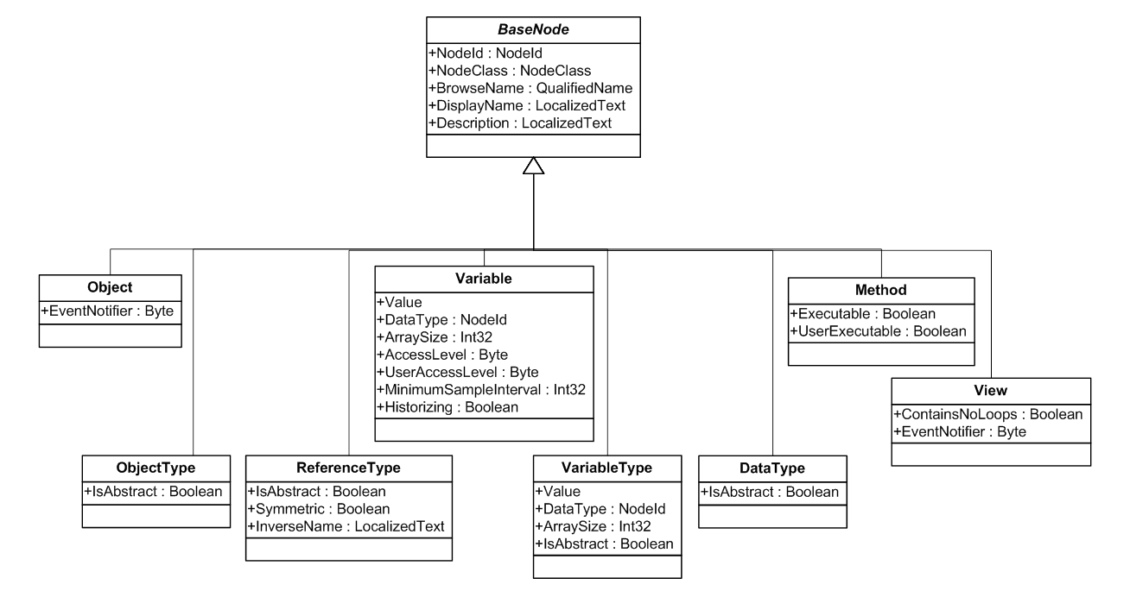
Figure 7.1-1: Summary of OPC-UA IM
A comparison between oneM2M and OPC UA with respect to their characters about information model is demonstrated in Table 7.1-1.
Table 7.1-1: Comparison of IMs of oneM2M and OPC UA System
 | oneM2M | OPC UA
Information models | SDT IM is supported in oneM2M. SDT is not restricted to be used specifically in the industrial domain, but also can be utilized in the vehicle domain for logistics, etc., for the potential integration of industrial value chains and the smart city applications.  TR-0018 session 10.3.3 [i.5] studies the mapping between OPC UA standard objects and oneM2M resources for interworking scenarios, but not other OPC UA IMs. | IM is supported in OPC UA and integrated with ISA-95, AutomationML, PLCopen, etc., in various industry sectors. OPC UA is extended for building automation, but still limited from logistics, and more verticals.
Semantic features | Semantic features (e.g. reasoning, semantic discovery, semantic validation, etc.) are supported in oneM2M using W3C OWL (Web Ontology Language). | Data described by OMG (Object Management Group) Unified Modeling Language (UML) in the OPC UA IM can be understood. However rich semantic features, such as reasoning as described in the PnP use case in Chapter 6, are not supported yet.

----------------------- End of Change 3-------------------------------------------

