CHANGE REQUEST
Meeting ID:* | MAS#37
Source:* | NTT
Date:* | 2018-09-17
Contact:* | Kei Harada(harada.kei@lab.ntt.co.jp), NTT,  Hiroyuki Maeomichi(maeomichi.hiroyuki@lab.ntt.co.jp), NTT,
Reason for Change/s:* | To add the information about J-ALERT
CR against: Release* | R4
CR against: WI* | Active < WI-0070 >  MNT maintenance / < Work Item number(optional)>  Is this a mirror CR? Yes No  mirror CR number: ARC-2018-0207  STE Small Technical Enhancements / < WI-0084>  Only ONE of the above shall be ticked
CR against: TS/TR* | TR-0046 V0.1.0
Clauses * | 5.5
Type of change: * | Editorial change  Bug Fix or Correction  Change to existing feature or functionality  New feature or functionality  Only ONE of the above shall be ticked
Impacted other TS/TR(s) | none
Post Freeze checking:* | This CR contains only essential changes and corrections? YES NO  This CR may break backwards compatibility with the last approved version of the TS? YES NO
Template Version: January 2017 (Do not modify)

oneM2M Notice
The document to which this cover statement is attached is submitted to oneM2M. Participation in, or attendance at, any activity of oneM2M, constitutes acceptance of and agreement to be bound by terms of the Working Procedures and the Partnership Agreement, including the Intellectual Property Rights (IPR) Principles Governing oneM2M Work found in Annex 1 of the Partnership Agreement.
GUIDELINES for Change Requests:
Provide an informative introduction containing the problem(s) being solved, and a summary list of proposals.
Each CR should contain changes related to only one particular issue/problem.
In case of a correction, and the change apply to previous releases, a separate “mirror CR” should be posted at the same time of this CR
Mirror CR: applies only when the text, including clause numbering are exactly the same.
Companion CR: applies when the change means the same but the baselines differ in some way (e.g. clause number).
Follow the principle of completeness, where all changes related to the issue or problem within a deliverable are simultaneously proposed to be made E.g. A change impacting 5 tables should not only include a proposal to change only 3 tables. Includes any changes to references, definitions, and acronyms in the same deliverable.
Follow the drafting rules.
All pictures must be editable.
Check spelling and grammar to the extent practicable.
Use Change bars for modifications.
The change should include the current and surrounding clauses to clearly show where a change is located and to provide technical context of the proposed change. Additions of complete clauses need not show surrounding clauses as long as the proposed clause number clearly shows where the new clause is proposed to be located.
Multiple changes in a single CR shall be clearly separated by horizontal lines with embedded text such as, start of change 1, end of change 1, start of new clause, end of new clause.
When subsequent changes are made to content of a CR, then the accepted version should not show changes over changes. The accepted version of the CR should only show changes relative to the baseline approved text.

Introduction

-----------------------Start of change 1-------------------------------------------

5.5 J-ALERT in Japan

5.5.1 J-ALERT
J-ALERT is the nationwide immediate aleat system in Japan. After many operation tests, it was put into use in February 2007.
Its biggest future is the concept of “Direct and immediate transmission from nation to citizen”. To realize this, J-ALERT uses multiple communication methods; which are satellite, Local Government Wide Area Network, wired telephone network and area mailing service provided by mobile phone companies.
Following kinds of information are notified with J-ALERT:
- Citizen protection information
  - Armed attack
  - Huge terrorism
  - Ballistic missile
- Disaster
  - Eathquake
  - Tsunami
  - Flood
  - Weather alert
  - Landslide
  - Tornado
  - Volcano
The Figure 5.5.1-1 shows the J-ALERT architecture.
When the disaster or matter of citizen protection occurs, Japan Meteorological Agency or Cabinet Secretariat sends the information to Fire and Disaster Management Agency transmission system at first. In case of the disaster, Japan Meteorological Agency sends to mobile phone companies at the same time.
Second, Fire and Disaster Management Agency transmission system sends the information to J-ALERT receivers via both satellite and Local Government Wide Area Network , here the latter is used for backup purpose. In case of the matter of citizen protection, Fire and Disaster Management Agency transmission system sends to mobile phone companies at the same time.
There are two differet routes as depicted the figure xx; the mobile phone company route and the municipality route.
In the mobile phone company route, when mobile phone companies gets information about the disaster or the matter of citizen protection, they directly and immediately sends these information to their users with Eathquake and Tsunami Warning System (ETWS). This is the mobile phone company’s route. The detail about ETWS is described in later clause.
In the municipality route, when J-ALERT receivers gets information about the disaster or the matter of citizen protection, they send these information to automatic activation devices.
Finally, automatic activation devices switch on end devices such as public address system, TVs, radios and Internet messages. This is the municipality route.
The number and location of each sending / receiving nodes are different. There are only two Fire and Disaster Management Agency transmission systems, the one covers East Lapan and another covers West Japan. J-ALERT receivers are located at every municipalities and Automatic activate machines are located at every end device location.
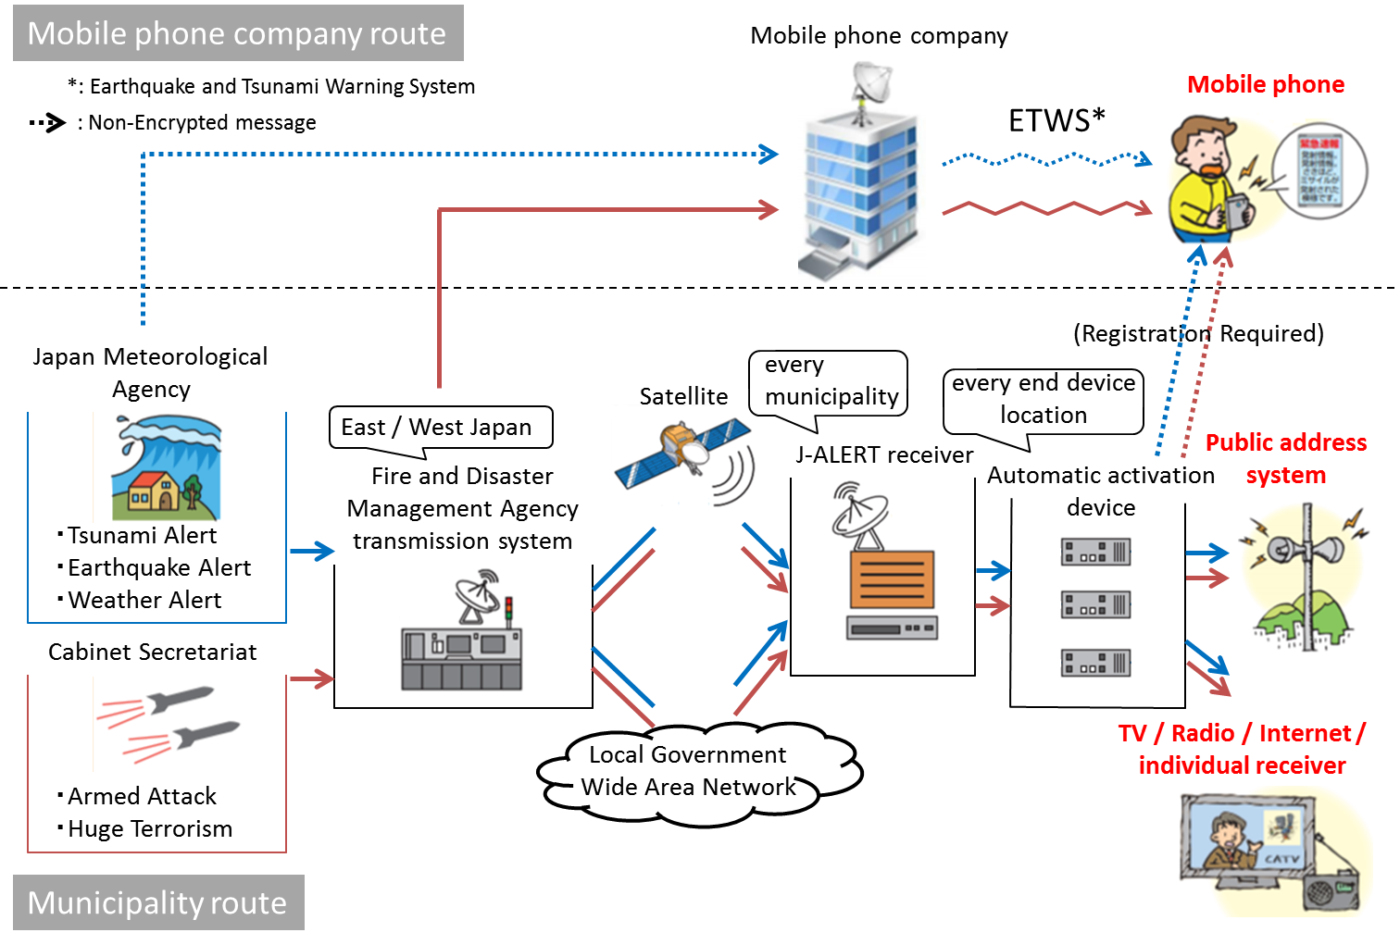
Figure 5.5.1-1. J-ALERT Architecture

5.5.2 ETWS
ETWS enable to broadcast disaster informations immediately to all mobile phone users. The ETWS communication is given the best priority among other communications, this means ETWS communication is not easily affected by congestion. When sending message with ETWS, there is no need to specify addressees, but the confirmation of message arrival is not performed.
The origin of ETWS is Cell Broadcast Service (CBS) specified at 3GPP for broadcasting of Short Message Service. Next, because of a lot of demand for the disaster information delivery, 3GPP specified Public Warning System (PWS) based on CBS. PWS covers from 2G to Long Term Evolution (LTE).
The requirement for PWS varied from area to area. In USA, users wanted not only disaster but also crime and accident information. On the other hand, In Japan, users wanted immediacy for the alert for eathquake and tsunami. Then, Commercial Mobile Alert System (CMAS) was developed for the requirement from the former, and ETWS was developed for the requirement from the latter.
5.5.3 Difference between J-ALERT and ETWS
As Figure 5.5.1-1 expression, ETWS is used only mobile phone company route in J-ALERT. Kinds of information delivered by J-ALERT and ETWS are completely same, but there is only one difference between J-ALERT and ETWS; only ETWS deliveries Non-encrypted message (the purple arrows in Figure 5.5.1-1).
When a disaster occures, Japan Meteorological Agency sends message to Fire and Disaster Management Agency transmission system and mobile phone companies. At this time, the former message is encrypted but the latter is not. Next, mobile phone companies sends message to users with ETWS, this message is not encrypted either.
However, other kind of messages delivered with ETWS are encrypted. When a matter of citizen protection occurs, Cabinet Secretariat sends message to Fire and Disaster Management Agency transmission system, then Fire and Disaster Management Agency transmission system sends message to J-ALERT receiver and mobile phone companies, after that, mobile phone companies sends message to users with ETWS like as the disaster case. The message delivered in this situation is encrypted even it travels via ETWS.
This encrypted or Non-encrypted difference makes mobile phone users a little confused because only Japanese mobile phone companies’ users can decode the message. Basically, J-ALERT message is encrypted and decoded by only Japanese devices, but exceptionally, disaster information delivered to mobile phone is Non-encrypted and everyone can read.
Table 5.5.3-1 wrapped up this difference. There is one condition including problem; When the matter of citizen protection occurs, you are using a Non-Japanese mobile phone. At this condition, you cannot get information with your phon, so Japanese Fire and Disaster Management Agency recommends installing some applications for notification.
Kind of Information | Receiver | Coded | Using ETWS | Readability
Citizen Protection | Mobile phone | ✓ | ✓ | Japanese or registered devices only
Citizen Protection | Fixed device | ✓ | × | Japanese devices only
Disaster | Mobile phone | both ✓ and × | ✓ | everyone
Disaster | Fixed device | ✓ | × | Japanese devices only
Table 5.5.3-1. Difference among J-ALERT messages

-----------------------End of change 1-------------------------------------------

