INPUT CONTRIBUTION
Group Name:* | M&P
Title:* | Proposed Process to obtain Needs/Services from 3rd Parties
Source:* | Shelby Kiewel, iconectiv, ATIS
Contact:
Date:* | <2014-12-12>
Abstract:* | At TP#14 the need for a oneM2M registry was identified. This contribution proposed a process which would allow oneM2M to contracting a 3rd party company to provide oneM2m with a Need or Service.
Agenda Item:*
Work item(s): | N/A
Document(s)  Impacted* | All
Intended purpose of  document:* | Decision  Discussion  Information  Other <specify>
Decision requested or recommendation:* | Obtain the services of a 3rd party to provide a oneM2M registry.

oneM2M Notice
The document to which this cover statement is attached is submitted to oneM2M. Participation in, or attendance at, any activity of oneM2M, constitutes acceptance of and agreement to be bound by terms of the Working Procedures and the Partnership Agreement, including the Intellectual Property Rights (IPR) Principles Governing oneM2M Work found in Annex 1 of the Partnership Agreement.
1 Introduction
The need for a oneM2M registry was identified during TP#14. oneM2M will need to contract with companies that can fulfil this need and provide the service identified. A general process is proposed to enable oneM2M to acquire a need or service from the industry.
The general process described is recommended to the Steering Committee in order to contract with 3rd party companies to provide any need or service that is beyond the scope of what oneM2M is capable or willing to fulfil.
2 Path Forward Recommendation
The follow process is recommended for contracting a 3rd party company to provide oneM2m with a Need or Service.
- A Need is identified by oneM2M. “Need” meaning a technical standard/report that oneM2M wishes to implement to advance its goals.
- The group/committee that identified the Need presents the need to the Steering Committee for consideration/implementation.
- The Steering Committee determines whether oneM2M should go forward with implementation of the Need. If the answer is “no”, then the process stops here.
- If the answer is “yes”, then the Steering Committee will adopt the Need as part of the oneM2M technical standard/report, notify the oneM2M membership and delegate responsibility for implementing the Need to a Partner (it is preferred to be a Partner Type 1).
- The Partner will investigate potential companies’ capability of supporting the given requirements expressed within the technical standard and/or technical report.
- The Partner will select and contract with a company to perform the Need.
- The Need will be developed by the 3rd party.
- The 3rd party will operate the solution to the Need.
- Partner (perhaps with the assistance of the selected company) will have supervisory oversight of this space to ensure industry implementation and compliance to the requirements contained within the technical standard/report.
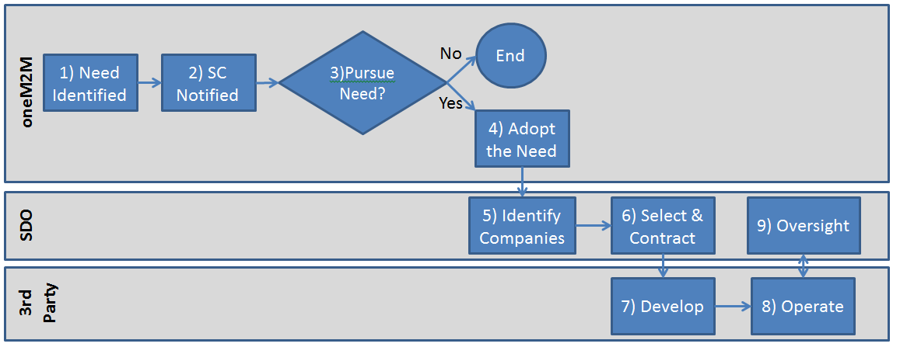
3 Conclusions
The proposed process would allow oneM2M to request and contract with 3rd parties to obtain identified Needs and Services as needed based on the technical standards/reports of the oneM2M Working Groups.

