INPUT CONTRIBUTION
Group Name:* | PRO#12.0
Title:* | CMDH procedures
Source:* | QUALCOMM Incorporated (TIA), LG Electronics
Contact: | Josef Blanz, jblanz@qti.qualcomm.com  Nobu Uchida, nuchida@qti.qualcomm.com  Hongbeom Ahn, hongbeom.ahn@lge.com
Date:* | 2014-07-29
Abstract:* | This contribution proposes CMDH procedures.
Agenda Item:* | Contribution
Work item(s): | WI 0009
Document(s)  Impacted* | oneM2M-TS-0004 Protocol Specification
Intended purpose of  document:* | Decision  Discussion  Information  Other <specify>
Decision requested or recommendation:* | Agree for inclusion in TS-0004

oneM2M Notice
The document to which this cover statement is attached is submitted to oneM2M. Participation in, or attendance at, any activity of oneM2M, constitutes acceptance of and agreement to be bound by terms of the Working Procedures and the Partnership Agreement, including the Intellectual Property Rights (IPR) Principles Governing oneM2M Work found in Annex 1 of the Partnership Agreement.

==================== Start of 1st text proposal =============================

oneM2M Procedures and oneM2M Resource Types

==================== End of 1st text proposal =============================

==================== Start of 2nd text proposal =============================

Description of Generic Procedures

Generic Request Procedure for Originator
A generic resource Request procedure shall be comprised of the following actions. Additional actions specific to individual procedures are listed in the respective sections by referencing these actions and providing additional steps.The Originator shall execute the following steps in order:
“Compose Request primitive”
“Send a Request to the Receiver CSE”
“Wait for Response primitive”
Request is blocking?
Process Response
“Retrieve result from <request> resource” in case of synchronous mode or
“Wait for result notification” in case of asynchronous mode
Yes

No

Start
“Wait for Response primitive”Finish
Figure 7.2.1.2.1-1: Generic procedure of Originator
Orig-1.0 “Compose Request primitive”: Please refer to clause Error: Reference source not found for details.
Orig-2.0 “Send a Request to the receiver CSE”: Please refer to clause Error: Reference source not found for details.
Orig-3.0 “Wait for Response primitive”: Please refer to clause Error: Reference source not found for details. If the Originator is using blocking communication, this step should be the last step of the Originator.
Orig-4.0 “Request is blocking?”: This step shall be operated after getting the Response primitive from step Oring-3.0 “Wait for Response primitive”. In this step, the Originator checks whether the request was blocking. If the request was blocking, it goes to step Orig-6.0 “Process Response” (TRUE branch). If the request was non-blocking, it goes to step Orig-5.0 “Retrieve result from the <request> resource” in case of synchronous non-blocking mode or to step Orig-5.1 “Wait for result notification” in case of asynchronous non-blocking mode (FALSE branch)..
Orig-5.0 “Retrieve result from the <request> resource”: See clause Error: Reference source not found for details.
Orig-5.1 “Wait for result notification”: See clause 7.2.2.1.X for details.
Orig-6.0 “Process Response”: the Originator processes the response.

Generic Primitive Processing Procedure for Receiver
The Receiver shall execute the steps contained in this clause in order.
Recv-0.0: In case of error while processing a Request primitive with a determined Originator in any of the steps below, the Receiver shall execute the following
Recv-0.0.0:"Create an unsuccessful Response" (refer to clause Error: Reference source not found for details)
Recv-0.0.1: In case the Request primitive was received in blocking mode "Send Response primitive" back to the Originator (refer to clause Error: Reference source not found for details). The corresponding Response Code shall be included in the Response primitive.
Recv-0.0.2:I n case the Request primitive was received in non-blocking mode but so far no Response primitive with Acknowledgement has been sent by the Receiver CSE: "Send Response primitive" back to the Registree/Registrar entity that sent the Request Primitive to the Receiver CSE (refer to clause Error: Reference source not found for details). The corresponding Response Code shall be included in the Response primitive.
Recv-0.0.3: In case the Request primitive was received in non-blocking synchronous mode and a Response primitive with Acknowledgement has already been sent by the Receiver CSE to the Registree/Registrar that sent the Request primitive to the Receiver CSE, i.e. a local <request> resource associated with the request has already been created: “Update <request> resource” (refer to clause 7.2.2.2.7 for details).
Recv-0.0.4: In case the Request primitive was received in non-blocking asynchronous mode and a Response primitive with Acknowledgement has already been sent by the Receiver CSE to the entity that sent the Request primitive to the Receiver CSE: “Send Response primitive via Notification” back to the Originator (see 7.2.2.2.X for details). If also a local <request> resource associated with the request has already been created: “Update <request> resource” (refer to clause 7.2.2.2.7 for details).
Recv-0.1: In case of an error while processing any other primitive – i.e. Request primitives where no Originator can be determined or Response primitives, the primitive shall be ignored.
“Check the syntax of received primitive”
Primitive type?
Local Response handling
procedure
Response

Request

Local Request handling procedure
Finish
Start
Response primitive with rs=ACK or primitive with to targeting receiver CSE itself, an AE registered with receiver CSE or a resource hosted on the receiver CSE?
Yes
“CMDH Processing”
No
Figure 7.2.1.2.2-2: Generic procedure of Receiver

Communication method?
Local operation handling
procedure
In case <request> resource type is supported, create local <request> resource
“Create Acknowledgement Response”
optional reference to <request>
“Send Response primitive”
Blocking

Non-Blocking

Local operation handling procedure
“Update <request> resource
if <request> is supported”
Finish
Start
“Send Response Primitive via Notification if asynchronous”
“Send Response primitive”

“Create a successful Response”

“Create a successful Response”

<request> supported?
synchronous?

“Send Response primitive”

“Create an unsuccessful Response”

Yes

No

Yes

No

Figure 7.2.1.2.2-2: Local Request handling procedure of Receiver

Is a request with same Req-ID and Originator pending on Receiver CSE?
Yes

No

Finish
Start
“Process Response”

“Send Response primitive”

“Update <request> resource”

Is a <request> resource with same Req-ID and Originator hosted on Receiver CSE?
Yes

“Close pending request“
Is to the Receiver CSE itself?
Yes

No

Ignore Primitive

Figure 7.2.1.2.2-3: Local Response handling procedure of Receiver

Recv-1.0 “Check the syntax of received message”: See clause Error: Reference source not found for details.
Recv-2.0 “Response primitive with rs being an ACK or primitive with to targeting receiver CSE itself, an AE registered with receiver CSE or a resource hosted on the receiver CSE?”: The Receiver CSE checks whether the primitive can be processed locally or needs to be forwarded to another CSE. If the primitive cannot be processed locally (No branch) the procedures for “CMDH Processing” according to Annex H shall be carried out. If the primitive can be processed locally (Yes branch), Step Recv-3.0 “Primitive Type?” shall be carried out next
Recv-3.0 “Primitive Type?”: The Receiver shall check whether the received primitive type is a Requst primitive or a Response Primitive. If the primitive is a Request primitive, Step 4.0 “Local Request Handling Processing” shall be carried out. If the primitive is a Response primitive, Step 5.0 “Local Response Handling Processing”

Recv-4.0 “Local Request Handling Procedure”:
Recv-4.1.0 “Communication method?”: The Receiver CSE checks whether a received request is blocking or non-blocking by using rt parameter (see detail in 8.1.2 of TS-0001 [6]). If the request is blocking, it goes to step Recv-4.2.0 “Blocking Local Request Procedure” (Blocking branch). If the request is non-blocking, it goes to step Recv-4.2.0 “Non-Blocking Local Request Procedure” (Non-blocking branch).
Recv-4.2.0 “Blocking Local Request Procedure”:
Recv-4.2.1 “Carry out local operation”: Carry out step Recv-6.0 “Local operation handling procedure”
Recv-4.2.2 “Create a successful Response”: Please refer to clause 7.2.2.3.11 for details.
Recv-4.2.2 “Send Response Primitive”: Please refer to clause 7.2.2.2.2 for details. Aafter this step, the procedure is terminated.
Recv-4.3.0 “Non-Blocking Local Request Processing”:
Recv-4.3.1 “<request> supported?”: If the Receiver CSE supports the <request> resource type continue with step Recv-4.3.5 “” (Yes branch). Otherwise (No branch) continue with step Recv-4.3.2 “synchronous?”
Recv-4.3.2 “synchronous?”: The Receiver CSE shall determine if the Request primitive is representing a synchronous non-blocking request. If the Request is a synchronous non-blocking Request (No branch) continue with step 4.3.3 “Create an unsuccessful Response”. If the Request is not a synchronous non-blocking Request (No branch) continue with step 4.3.5 “”.
Recv-4.3.3 “Create an unsuccessful Response”: Please refer to clause Error: Reference source not found for details.
Recv-4.3.4 “Send Response Primitive”: Please refer to clause 7.2.2.2.2 for details. Aafter this step, the procedure is terminated.
Recv-4.3.5 “In case <request> resource type is supported, create local <request> resource”: : In case the Receiver CSE supports <request> resource type, it shall create a local <request> resource that is associated with the processed Request. Please refer to clause Error: Reference source not found for details
Recv-4.3.6 “Create Acknowledgement Response with optional reference to <request>”: Create a Response primitive with an Acknowledgement response code. In case the Receiver CSE supports the <request> resource type, include a reference to the <request> resource that was created in the previous step. Please refer to clause Error: Reference source not found for details on creation of Acknowledgement Response.
Recv-4.3.7 “Send Response Primitive”: Please refer to clause 7.2.2.2.2 for details.
Recv-4.3.8 “Carry out local operation”: Carry out step Recv-6.0 “Local operation handling procedure”
Recv-4.3.9 “Create a successful Response”: Please refer to clause 7.2.2.3.11 for details.
Recv-4.3.10 “Update <request> resource if <request> is supported”: If the Receiver CSE supports the <request> resource type, update the <request> resource associated with this Request. Please refer to clause Error: Reference source not found for details on update of the <request> resource.
Recv-4.3.11 “Send Response Primitive via Notification if asynchronous”: If the Request was a non-blocking asynchronous request, send the Response via a Notification to the notification targets valid for this request. See clause TBD for details on sending Responses via notification.
Recv-4.3.12 terminate the procedure.
Recv-5.0 “Local Response Procedure”:
Recv-5.1.0 “Is a request with same Req-ID and Originator pending on Receiver CSE?”: The Receiver CSE checks if there is a pending open Request with the same Req-ID as in the Response primitive and with the same Originator. If that is the case (Yes branch) , continue with step Recv-5.1.1 “Is to the Receiver CSE itself?”. If that is not the case (No branch) , continue with step Recv-5.1.3 “”.
Recv-5.1.1 “Is to the Receiver CSE itself?”: If the “to” parameter is targeting the Receiver CSEitself, the Receiver CSE shall process the response, If the “to” parameter is targeting the Receiver CSEitself, the Receiver CSE shall carry out “Send Response Primitive”, please refer to clause 7.2.2.2.2 for details,
Recv-5.1.2 “Close pending Request”: The Receiver CSE shall close the associated pending request. The procedure terminates after this step.
Recv-5.1.3: “Is a <request> resource with same Req-ID and Originator hosted on Receiver CSE?”: The Receiver CSE checks if there is an existing <request> resource with the same Req-ID and with the same Originator as in the Response primitive. If that is the case, the Receiver CSE shall update the associated <request> resource, see clause Error: Reference source not found for details on update of the <request> resource. Otherwise ignore the Response primitive.
Recv-5.1.4 Terminate the procedure.

Start
“Check authorization of the Originator”
“Check validity of resource representation for the given resource type” in case of C U operations
“Check existence of the addressed resource or entity”
“Perform Create/Update/Retrieve/Delete/Notify operation is performed”
“Announce/De-announce the resource”
Finish
“Create a successful Response”
Figure 7.2.1.2.2-4: Local operation handling procedure
The above figure describes the generic procedure to handle a local operation.
Recv-6.0 “Local operation handling procedure”:

Recv-6.1 “Check existence of the addressed resource or entity”: Please refer to clause Error: Reference source not found for details.
Recv-6.3 “Check authorization of the Originator” : Please refer to clause (TBD) for details.
Recv-6.4 “Check validity of resource representation for the given resource type” : In case the requested operation is one out of Create or Update. Please refer to clause Error: Reference source not found and clause Error: Reference source not foundError: Reference source not found for details. Notify, Retreive or Delete ars not applicable for this step.
Recv-6.5 “Perform Create/Update/Retrieve/Delete/Notify operation” : The step represents five common operations which are “Create the resource”, “Retrieve the resource”, “Update the resource”, “Delete the resource” and “Notify re-targeting”. The procedure specified in the clause Error: Reference source not found Create the resource, Error: Reference source not found Update the resource, 7.2.2.3.6 Retrieve the resource, Error: Reference source not found Delete the resource or Error: Reference source not found Notify re-targeting is performed for the Create, Update, Retrieve, Delete, or Notify operation respectively.
Recv-6.6 “Announce/De-announce the resource”: The step represents two common operations which are “Announce the resource” and “De-announce the resource”. Please refer to clause Error: Reference source not found and clause Error: Reference source not found for details. Notify is not applicable for this step.

Editor’s Note: These procedures and steps are FFS. Steps are pointer to the common operation section in TS-0004

==================== End of first text proposal ===============================

=== Start of second text proposal (all new text, no revision marks) ============
- (Normative): CMDH Message Processing
  - Pre-Requisites
The scope of CMDH processing is to decide at which time and via which communication path to forward request or response messages from a receiver CSE to another CSE. A number of message parameters impact the CMDH processing. CMDH-related request message parameters are:
- ec: Event Category
- rqet: Request expiration time
- rset: Result expiration time
- oet: operation execution time
- rp: result persistence
- da: delivery aggregation

CMDH-related response message parameters are:
- ec: Event Category
  - ‘ec’ is needed for response messages as well since response messages can go over multiple hops and CMDH needs to know how to handle them.
- rset: Result expiration time
- da: delivery aggregation
  - When a request message was carried inside a <delivery> resource type, also the corresponding response message shall be carried in a <delivery> resource, i.e. the CSE requested to carry out an operation indicated in a request message that reaged that CSE via a <delivery> resource, shall also send the response within a <delivery> resource.

The details on how those parameters impact the CMDH processing are described in the next clauses.
In the following description it is assumed that the CSE behavior for CMDH processing is governed by CMDH policies that are represented by [cmdhPolicy] resources and their child resources which are effective for the respective CSE. If legacy device management technologies are used to provision these policies, the information represented by the effective [cmdhPolicy] resources and their child resources may not be available as oneM2M defined resources on the field nodes hosting the respective CSE. This CMDH related policy information may only be available in form of managed objects specific to the used device management technology. In that case the mapping from oneM2M specified [cmdhPolicy] resources and their child resources to equivalent objects of the deployed legacy device management technology shall be used to substitute the respective information contained in [cmdhPolicy] resources and their child resources in the description below. Therefore, whenever reference to [cmdhPolicy] resources, child resources thereof or any attributes of [cmdhPolicy] resources and their children are used in the description of CMDH processing below, they shall be read as a placeholder for the equivalent objects provided by legacy device management technologies on field nodes that are provisioned with such legacy device management technologies.
For a CSE that is processing request or response messages in CMDH, exactly one set of policies represented by a [cmdhPolicy] resource shall be active, as defined by the [activeCmdhPolicy] child resource of the <node> resource that represents the node which hosts the respective CSE. In case of field nodes that are managed via legacy device management technologies, the active CMDH policy can be represented by management objects of that device management technology. For the sake of simplicity, the term ‘active [cmdhPolicy]’ is used in this and the following clauses to refer to the active CMDH policy information even if no oneM2M specified resources are used to represent CMDH policies. Before any provisioning of CMDH policies has occurred, the ‘active [cmdhPolicy]’ and its corresponding managed objetcs defined for legacy device management technologies shall contain the specified default values as described in the [cdmhPolicy] specific procedures and procedures specific for all its child resources. For that reason, it can be assumed that information for an ‘active [cmdhPolicy]’ is always present on a CMDH capable CSE.
In addition, the active [cmdhPolicy] can have at least one or more [cmdhLimits] child resources and the active [cmdhPolicy] hosting CSE shall lookup all [cmdhLimits] child resources. If the attribute ‘requestContextNotification’ of any of found [cmdhLimits] resources is present and set to true, the CSE shall establish a subscription to the dynamic context information of the CSE defined in ‘requestContext’ attribute of the found [cmdhLimits] as well as subscription to this [cmdhLimits] resource for all AEs corresponding to the AE-ID or an App-ID appearing in the ‘requestOrigin’ attribute. The subscription(s) shall be established when the [cmdhPolicy] is provisioned or re-provisioned and any of found [cmdhLimits] child resource has the attribute ‘requestContextNotification’ that is set to true. Hence, both this policy establishment and changes of the context information and the [cmdhLimits] resource shall be notified to the respective AEs and the notification shall contain the limits for CMDH related parameter values defined in [cmdhLimits], context information and subscription reference ID. After this, the AEs received the notification shall send only allowed ‘ec’ messages if ‘ec’ is specified by the AEs.
  - CMDH Processing: Processing request or response messages requiring the Receiver CSE to forward information to another CSE
    - Applicability of CMDH processing
If a request or response message that is targeting an entity or a resource in the ‘to’ parameter that is not among any of
- the receiver CSE itself,
- an AE registered with the receiver CSE,
- a resource hosted on the receiver CSE,
and if the message is not a response message with an acknowledgement response code, the receiver CSE of that message needs to forward the message to another CSE via CMDH processing, see also the description in Clause 7.2.1.2. Description of Generic Procedures of this TS. For forwarding a message to the target CSE indicated by the ‘to’ parameter of the message, the receiver CSE shall determine to which CSE the message needs to be forwarded next. In the following clauses this CSE is referred to as the ‘next CSE’. CMDH processing shall be carried out as described in the following clauses.
    - Partitioning of CMDH processing
The CMDH processing consists of two parts:

- CMDH message validation: This includes message parameter pre-processing, deciding on acceptance for transporting the message, and buffering of messages.
This procedure defines how incoming request or response messages that need to be forwarded to other CSE(s) shall be pre-processed, how a decision on acceptance of the message for forwarding to another CSE shall be derived and how the messages shall be queued up before the actual forwarding can happen. Details of CMDH validation are defined in clause H.2.3. .
- CMDH message forwarding: This includes selecting buffered messages and communication path for forwarding the message to another CSE.
This procedure defines how to select among the messages buffered for forwarding to other CSEs the ones that need to be transported at a certain time and how to select an appropriate communication path for transporting the message(s). Details of CMDH message forwarding are defined in clause Error: Reference source not found.

CMDH message validation (Part A) will be carried out for each incoming new message for which CMDH processing is applicable.
If CMDH message validation is successful, the received message shall be queued up for the CMDH message forwarding process (Part B) including the associated ‘storagePriority’ value as defined in the applicable [cmdhBuffer] resource (see details in the CMDH message validation procedure).
If the queued message was a request message and it was done in non-blocking mode then:
- if the Receiver CSE supports the <request> resource type, it shall create a <request> resource representing the pending non-blocking request
- the Receiver CSE shall send an acknowledgement response message to the entity that sent the request message directly via Mca or Mcc to the receiver CSE indicating the acceptance of the request
- if the receiver CSE supports the <request> resource type it shall provide a reference to the created <request> resource in the cn parameter of the response.
After successful forwarding of such a request message, any incoming response message matching with the Request-ID and the Originator in the <request> resource shall be parsed to update the corresponding attributes of the <request> resource. In case a non-blocking synchronous request was forwarded successfully and a response with acknowledgement was received, it is the responsibility of the CSE that forwarded the message to periodically poll the status of the <request> resource created on the next CSE and update the locally created <request> resource accordingly. When the locally created <request> resource expires the hosting CSE can remove it. Details on <request> resource specific procedures for polling results are defined in clause 7.2.2.1.
If the queued message was a request message and it was done in blocking mode then memorize the open blocking request by storing its Request-ID and Originator and set a timer for a timeout until which a matching response message with the same Request-ID and Originator shall be received by the CSE processing this message. If no matching response is received when the timeout expires, the receiver CSE shall send a response message to the entity that sent the request to the Receiver CSE indicating unsuccessful processing of the request, unless the Receiver CSE and the Originator are the same. If Receiver CSE and Originator are the same, the Originator can decide internally whether to retry forwarding of the message.
If CMDH message validation is not successful, then the received message shall either get ignored – in case the received message is a response message – or a new unsuccessful response message shall be sent back to the entity that sent the message to the Receiver CSE – in case the received message is a request message and the Originator is not the Receiver CSE. If Receiver CSE and Originator are the same, the Originator can decide internally whether to create a new request message.
The CMDH message forwarding process (Part B) will handle all queued up messages that shall be forwarded to another CSE. This process shall always be carried out when messages are pending for forwarding to another CSE.
The flow of CMDH processing is depicted in the flowchart below:


    - CMDH message validation

In CMDH message validation, pre-processing of CMDH related parameters of a message for which CMDH-processing applies, deriving the decision on acceptance of a message and the buffering of that messages shall be carried out in line with the following steps. A summary of this processing is depicted in the flow chart at the end of this clause.
- Filling in missing CMDH-related parameters:

  - Determine the value that shall be used for the ‘ec’ parameter of the processed message
    - If the message contains an ‘ec’ parameter: Use the value of the ‘ec’ parameter provided in the message.
    - If the message does not contain an ‘ec’ parameter:
      - Lookup all [cmdhDefEcValue] child resources of the [cmdhDefaults] resource that is a child resource of the provisioned active [cmdhPolicy] resource.
      - If the message is a request message and any of the attributes ‘requestContext’, and ‘requestCharacteristics’ are present in the found [cmdhDefEcValue] resources, discard all [cmdhDefEcValue] resources from the list of found items for which the context conditions or the request characteristics at time of processing the request message are not met, respectively.
      - Among the remaining found [cmdhDefEcValue] resources do the following selection:
        - If present, select the [cmdhDefEcValue] resource containing the AE-ID in the list defined by the ‘requestOrigin’ attribute which matches with the ’fr’ parameter in case of a request message or with the ‘to’ parameter in case of a response message. If multiple [cmdhDefEcValue] resources match, select the one with the lowest value in the ‘order’ attribute. Continue processing with step 1.1.2.4
        - If present, select the [cmdhDefEcValue] resource containing the App-ID in the list defined by the ‘requestOrigin’ attribute which matches with the ’fr’ parameter in case of a request message or with the ‘to’ parameter in case of a response message. If multiple [cmdhDefEcValue] resources match, select the one with the lowest value in the ‘order’ attribute. Continue processing with step 1.1.2.4
        - If present, select the [cmdhDefEcValue] resource containing the string ‘localAE’ in the list defined by the ‘requestOrigin’ attribute in case of processing a message where the ’fr’ parameter is the AE-ID of an AE registered with the CSE processing this message. If multiple [cmdhDefEcValue] resources match, select the one with the lowest value in the ‘order’ attribute. Continue processing with step 1.1.2.4
        - If present, select the [cmdhDefEcValue] resource containing the string ‘thisCSE’ in the list defined by the ‘requestOrigin’ attribute in case of processing a message where the ’fr’ parameter is the CSE-ID of the CSE processing this message. If multiple [cmdhDefEcValue] resources match, select the one with the lowest value in the ‘order’ attribute. Continue processing with step 1.1.2.4
        - Select the [cmdhDefEcValue] resource containing the string ‘default’ in the list defined by the ‘requestOrigin’ attribute in case of processing a message where no other matches were found.
      - If a [cmdhDefEcValue] resource has been selected in steps 1.1.2.3.1 through 1.1.2.3.4: Use the value of the ‘defEcValue’ attribute of the selected [cmdhDefEcValue] resource as the value for the ‘ec’ parameter of the message. Else use the default value of ‘bestEffort’ for the ‘ec’ parameter of the message.
  - Filling in values that shall be used for the remaining CMDH-related parameters of messages
    - If the message contains any of the CMDH-related parameters ‘rqet’, ‘rset’, ‘oet’, ‘rp’: The provided values of the respective parameters in the message shall be used. No filling in is needed for those parameters. If any of the parameters ‘rqet’, ‘rset’, ‘oet’, ‘rp’ present in the message is represented with a duration, the receiving CSE shall translate the values of those parameters into absolute times by adding the duration to the originating timestamp in the ‘ot’ parameter of the message. This ‘ot’ parameter is an optional message parameter and in case it is not present in a message, it shall be filled in by the first receiving CSE of a message using the time when the message was received.
    - If the message parameter ‘ec’ has a value of ‘bestEffort’, use the following values for any missing CMDH-related parameters: For a request message use ‘rqet’ = ‘infinite’, ‘rset’ = ‘infinite’, ‘oet’ = ‘now’, ‘rp’ = ‘none’, ‘da’ = ON. For a response message use ‘rset’ = ‘infinite’, ‘da’ = ON. Continue with step 2.
    - If the message parameter ‘ec’ has a value of ‘immediate’, do not fill in any remaining missing CMDH-related parameters and continue with step 2.
    - For any of the missing CMDH-related parameters fill in values as follows:
      - Lookup all [cmdhEcDefParamValues] child resources of the [cmdhDefaults] resource that is a child resource of the provisioned active [cmdhPolicy] resource.
      - Among the found [cmdhEcDefParamValues] resources do the following selection:
        - If present, select the [cmdhEcDefParamValues] resource containing the value of the ‘ec’ parameter of the message in the list defined by the ‘applicableEventCategory’ attribute. If a match is found, continue processing with step 1.2.4.3
        - Select the [cmdhEcDefParamValues] resource that contains the string ‘default’ in the list defined by the ‘applicableEventCategory’.
      - Use the following attributes of the selected [cmdhEcDefParamValues] resource to fill in any missing CMDH-related message parameters: Fill in the value of the attribute ‘defaultRequestExpTime’ for the parameter ‘rqet’ if it is missing. Fill in the value of the attribute ‘defaultResultExpTime’ for the parameter ‘rset’ if it is missing. Fill in the value of the attribute ‘defaultOpExecTime’ for the parameter ‘oet’ if it is missing. Fill in the value of the attribute ‘defaultRespPersistence’ for the parameter ‘rp’ if it is missing. Fill in the value of the attribute ‘defaultDelAggregation’ for the parameter ‘da’ if it is missing.
- Compare CMDH parameters with allowed CMDH parameter limits:
Check if CMDH-related parameters effective for the message are with allowed limits.
  - Lookup all [cmdhLimits] child resources of the provisioned active [cmdhPolicy] resource.

  - If the message is a request message and any of the attributes ‘requestContext’, and ‘requestCharacteristics’ are present in the found [cmdhLimits] resources, discard all [cmdhLimits] resources from the list of found items for which the context conditions or the request characteristics at time of processing the request message are not met, respectively.
  - Among the remaining found [cmdhLimits] resources do the following selection:
    - If present, select the [cmdhLimits] resource(s) containing the AE-ID in the list defined by the ‘requestOrigin’ attribute which matches with the ’fr’ parameter in case of a request message or with the ‘to’ parameter in case of a response message. If multiple [cmdhLimits] resources match, select the one with the lowest value in the ‘order’ attribute. Continue processing with step 2.4
    - If present, select the [cmdhLimits] resource(s) containing the App-ID in the list defined by the ‘requestOrigin’ attribute which matches with the ’fr’ parameter in case of a request message or with the ‘to’ parameter in case of a response message. If multiple [cmdhLimits] resources match, select the one with the lowest value in the ‘order’ attribute. Continue processing with step 2.4
    - If present, select the [cmdhLimits] resource(s) containing the string ‘localAE’ in the list defined by the ‘requestOrigin’ attribute in case of processing a message where the ’fr’ parameter is the AE-ID of an AE registered with the CSE processing this message. If multiple [cmdhLimits] resources match, select the one with the lowest value in the ‘order’ attribute. Continue processing with step 1.1.2.4
    - If present, select the [cmdhLimits] resource(s) containing the string ‘thisCSE’ in the list defined by the ‘requestOrigin’ attribute in case of processing a message where the ’fr’ parameter is the CSE-ID of the CSE processing this message. If multiple [cmdhLimits] resources match, select the one with the lowest value in the ‘order’ attribute. Continue processing with step 2.4
    - Select the [cmdhLimits] resource containing the string ‘default’ in the list defined by the ‘requestOrigin’ attribute in case of processing a message where no other matches were found.
  - Validate if ‘ec’ parameter is within allowed range:
If the ‘ec’ parameter of the message is not within the list defined by the ‘limitsEventCategory’ attribute of the selected [cmdhLimits] resource, mark CMDH message validation for this message as not successful and exit CMDH message validation.
  - Validate if ‘rqet’ parameter is within allowed range:
If the ‘rqet’ parameter is present in the message and if it is not within the range defined by the ‘limitsRequestExpTime’ attribute of the selected [cmdhLimits] resource, mark CMDH message validation for this message as not successful and exit CMDH message validation.
  - Validate if ‘rset’ parameter is within allowed range:
If the ‘rset’ parameter is present in the message and if it is not within the range defined by the ‘limitsResultExpTime’ attribute of the selected [cmdhLimits] resource, mark CMDH message validation for this message as not successful and exit CMDH message validation.
  - Validate if ‘oet’ parameter is within allowed range:
If the ‘oet’ parameter is present in the message and if it is not within the range defined by the ‘limitsOpExecTime’ attribute of the selected [cmdhLimits] resource, mark CMDH message validation for this message as not successful and exit CMDH message validation.
  - Validate if ‘rp’ parameter is within allowed range:
If the ‘rp’ parameter is present in the message and if it is not within the range defined by the ‘limitsRespPersistence’ attribute of the selected [cmdhLimits] resource, mark CMDH message validation for this message as not successful and exit CMDH message validation.
  - Validate if ‘da’ parameter is within allowed range:
If the ‘da’ parameter is present in the message and if it is not within the list of allowed values defined by the ‘limitsDelAggregation’ attribute of the selected [cmdhLimits] resource, mark CMDH message validation for this message as not successful and exit CMDH message validation.
- Check if message complies with network access rules and buffer limits:
  - Check if ‘ec’ is ‘immediate’:
If the ‘ec’ parameter of the message is ‘immediate’ bypass any checks on buffering or access network usage rules. Mark the CMDH message validation for this message as successful and end CMDH message validation.
  - Check if delivering the message is possible within the boundaries of access network usage rules in CMDH policies:
    - Lookup all [cmdhNetworkAccessRules] child resources of the provisioned active [cmdhPolicy] resource.
    - Among the all found [cmdhNetworkAccessRules] resources do the following selection:
      - If present, select the [cmdhNetworkAccessRules] resource containing the value of the ‘ec’ parameter of the message in the list defined by the ‘applicableEventCategory’ attribute. If a match is found, continue processing with step 3.2.3
      - Select the [cmdhNetworkAccessRules] resource that contains the string ‘default’ in the list defined by the ‘applicableEventCategory’.
    - Lookup all [cmdhNwAccessRule] child resources of the selected [cmdhNetworkAccessRules] resource
    - Among the all found [cmdhNwAccessRule] resources find at least one for which the <schedule> child resource ‘allowedSchedule’ is allowing usage of the corresponding target network consistent with the ‘rqet’ parameter in case of a request message being processed or in line with the ‘rset’ parameter in case of a response message being processed. If no matching [cmdhNwAccessRule] resource is found, mark CMDH validation for this message as not successful due to lack of scheduling opportunities and end CMDH message validation. Otherwise continue.
  - Check if delivering the message is possible within the boundaries of buffer usage rules in CMDH policies:
    - Lookup all [cmdhBuffer] child resources of the provisioned active [cmdhPolicy] resource.
    - Among the all found [cmdhBuffer] resources do the following selection:
      - If present, select the [cmdhBuffer] resource containing the value of the ‘ec’ parameter of the message in the list defined by the ‘applicableEventCategory’ attribute. If a match is found, continue processing with step Error: Reference source not found
      - Select the [cmdhBuffer] resource that contains the string ‘default’ in the list defined by the ‘applicableEventCategory’.
    - Check if the amount of memory needed to buffer the message being validated in addition to the already buffered messages matching with the same buffer usage policy in the selected [cmdhBuffer] resource would exhaust the limit defined by the ‘maxBufferSize’ attribute of the selected [cmdhBuffer] resource or if the available memory for CMDH forwarding on the receiver CSE would get exhausted even when purging buffered messages with lower storage priority.
      - If the check is negative, mark the CMDH message validation for the message being validated as successful, assign the storage priority defined in the ‘storagePriority’ attribute of the selected [cmdhBuffer] resource to the validated message, and end CMDH message validation
      - If the check is positive, mark the CMDH message validation for the message being validated as not successful and end CMDH message validation.

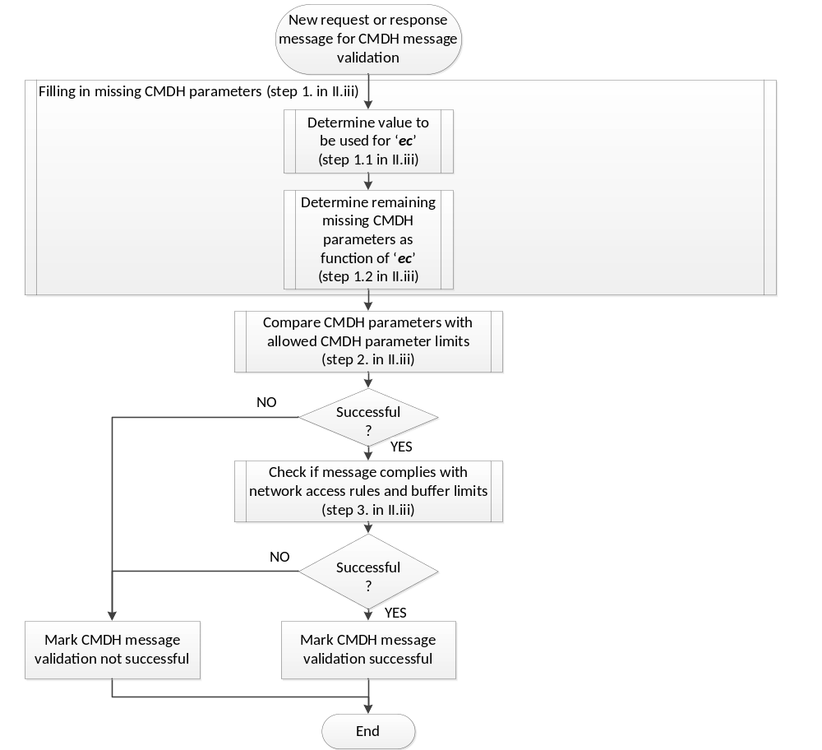
    - CMDH message forwarding
The high-level sequence of processing steps for the CMDH message forwarding process is depicted in the flow chart below. Note that this flow chart only represents the reference flow for implementing a standard compliant behavior. Other standard compliant implementations may be possible as long as the events defined below will result in the same normative message exchanges via reference points.
Occurrence of the following events shall trigger processing in the CMDH message forwarding:
- One or more new message(s) get(s) queued up for CMDH message forwarding
- Any of the underlying networks becomes usable for message forwarding due to transition(s) in allowed schedule(s) or due to establishing of availability of connectivity (e.g. cable plugged-in, coverage established)
- Any of the underlying networks becomes unusable for message forwarding due to transition(s) in allowed schedule(s) or due to loss of availability of connectivity (e.g. cable unplugged, coverage lost)
- Any message buffered for CMDH forwarding expires

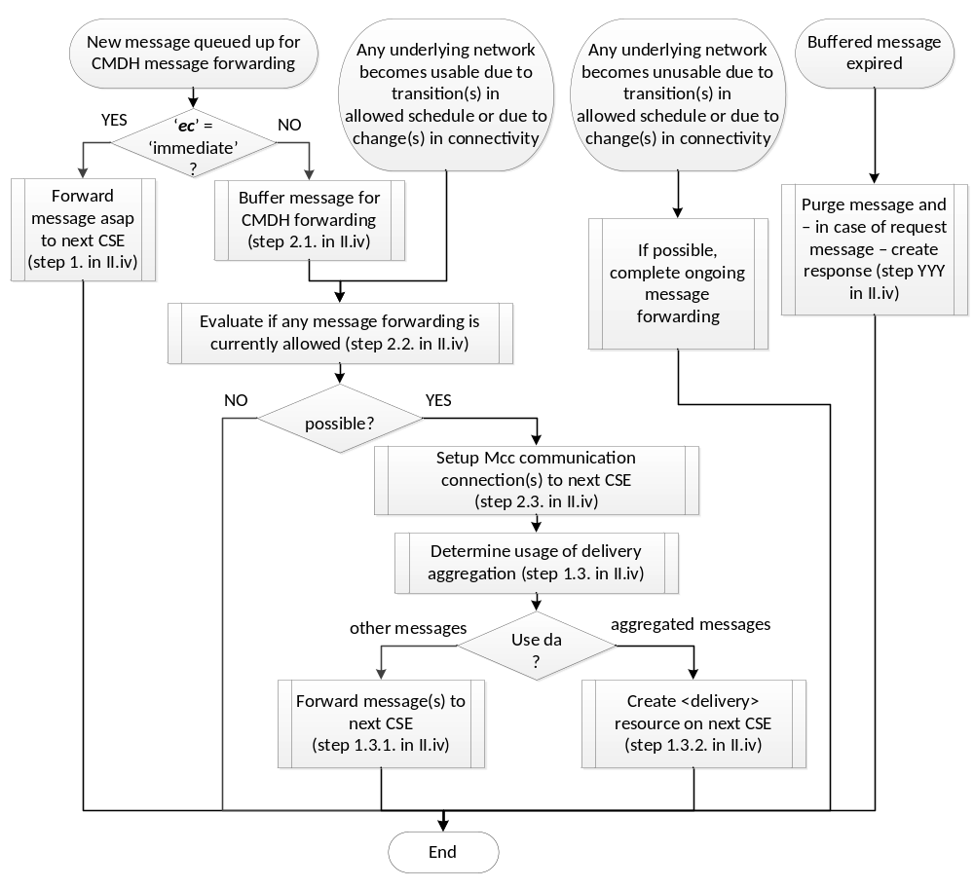

When a new message is getting queued up for CMDH message forwarding, carry out the following:
- If the ‘ec’ parameter of the messages has the value ‘immediate’:
Forward message as soon as possible to the next CSE. The processing in this situation is described by the flow chart in Figure 5 below.
  - If a Mcc communication connection to the next CSE for forwarding the message is already established, continue with step 1.3.
  - If no Mcc communication connection to the next CSE for forwarding the message is established pick one underlying network among all underlying networks that can provide communication to the next CSE and establish a Mcc communication connection to the next CSE in line with the rules outlined in clause H.2.5. . If establishment of a Mcc communication connection to the next CSE was not successful before the message expires, continue with step 1.4.
  - Determine whether delivery aggregation or forwarding of the message itself shall be used:
    - If the message contains a ‘da’ parameter set to the value ‘ON’, the Receiver CSE shall forward this message by creation of a <delivery> resource on the next CSE as outlined in clause 7.3.10. The receiver CSE can combine the forwarded message in the same <delivery> resource with other messages for which the ‘da’ parameter set to ‘ON’ and which need to be forwarded to the same target CSE.
    - If the message is not forwarded using a <delivery> resource, the receiver CSE shall forward the message as is to the next CSE via the established Mcc communication connection.
  - If the message could not be forwarded successfully to the next CSE before it expired (e.g. due to repeated unsuccessful attempts to establish a Mcc communication connection or due to the lack of usable underlying networks), the receiver CSE shall carry out the following:
    - If the message was a response message, ignore the message. End this cycle of CMDH message forwarding and wait for new triggering events.
    - If the message was a request message:
      - If the request was a blocking request:
Send a unsuccessful response to the pending blocking request with a matching Request-ID and Originator indicating the reason for failure and close the blocking request. End this cycle of CMDH message forwarding and wait for new triggering events.
      - If the request was a non-blocking request:
Update the associated <request> resource with matching Request-ID and Originator using an unsuccessful response code indicating the reason for failure. If the non-blocking request was made in asynchronous mode, send a notification with the unsuccessful response to the notification target(s) of the request. End this cycle of CMDH message forwarding and wait for new triggering events.
  - Else, i.e. if the message was forwarded successfully to the next CSE:
    - If the message was a response and the Receiver CSE has an open blocking request context with a matching Request-ID and matching Originator, mark the open blocking request as closed, end this cycle of CMDH message forwarding and wait for new triggering events.
    - If the message was a request message:
      - If the request was a blocking request:
Keep the context of the pending blocking request with matching Request-ID and matching Originator open and wait for an incoming response message with the same Request-ID and Originator. End this cycle of CMDH message forwarding and wait for new triggering events.
    - If the request was a non-blocking request:
Wait for a response to the forwarded request (e.g. response with acknowledgement or unsuccessful response). Update the associated <request> resource with the matching Request-ID and Originator using a response code that reflects the status of the forwarded request (e.g. accepted by next CSE, unsuccessful). If the next CSE responded with an unsuccessful response message and the request was in non-blocking asynchronous mode, send a notification request message to the Originator of the forwarded request containing the unsuccessful response of the next CSE. End this cycle of CMDH message forwarding and wait for new triggering events.
- Else, i.e. when the ‘ec’ parameter of the messages does not have the value ‘immediate’:
  - Buffer the message to be forwarded in the CMDH forwarding buffer:
The processing in this situation is described by the flow chart in Figure 5 below.
    - If the message is a request message and the ‘ec’ parameter of the messages has the value ‘latest’:
      - If the request message is a notification triggered by a subscription:
        - Find any buffered request message that is a notification triggered by a subscription with the same subscription reference.
      - Else, i.e. if the request message is not a notification triggered by a subscription:
        - Find any buffered request message that has the same values in the (‘fr’, ‘to’, ‘op’ ) parameters as the message being processed
      - If any request message was found in steps 2.1.1.1.1 or 2.1.1.2.1, purge the found message from the CMDH forwarding buffer.
    - If there is not enough memory available to buffer the message being processed in the CMDH forwarding buffer:
      - Find any buffered messages with storage priority values lower than the one assigned to the message being processed.
      - If any messages are found:
Purge enough messages among the found messages so that the message being processed can be buffered in the CMDH forwarding buffer. Messages which entered the buffer later shall be purged first. In case any request messages need to be purged, carry out the following:
        - In case of purging a non-blocking request messages:
Update the associated <request> resource with the same Request-ID as the purged request message with a status indicating unsuccessful completion. If the purged message was made in asynchronous mode, send a response to the notification target(s) of the pending non-blocking request
        - In case of purging a blocking request message:
Send a unsuccessful response to the open blocking request with the same Request-ID as in the purged request message and close the blocking request.
      - Due to the checking of sufficient memory in CMDH message forwarding buffer during CMDH message validation, there should be enough memory available to accommodate the message to be buffered at this point. If that is still not the case, then do the following:
        - In case the message to be buffered is a response message:
Ignore the message to be buffered. End this cycle of CMDH message forwarding and wait for new triggering events.
        - In case the message to be buffered is a non-blocking request message:
Update the associated <request> resource with the same Request-ID as the request message to be buffered with a status indicating unsuccessful completion. If the request message to be buffered was made in asynchronous mode, send a response to the notification target(s) of the pending non-blocking request. End this cycle of CMDH message forwarding and wait for new triggering events.
        - In case the message to be buffered is a blocking request message:
Respond with an unsuccessful response message to the open blocking request with the same Request-ID as in the request message to be buffered and close the blocking request. End this cycle of CMDH message forwarding and wait for new triggering events.
    - Store the message to be buffered with its assigned storage priority in the CMDH forwarding buffer. Include it in future evaluations for possible message forwarding.
  - Evaluate if any message forwarding is currently allowed:
    - For all buffered messages that are pending in CMDH message forwarding carry out the following evaluation steps:
      - Among all [cmdhNetworkAccessRules] child resources of the provisioned active [cmdhPolicy] resource do the following selection:
        - If present, select the [cmdhNetworkAccessRules] resource containing a value in the list defined by the ‘applicableEventCategory’ attribute that is equal to the value of the ‘ec’ parameter of the buffered message to be evaluated for forwarding. If a match is found, continue processing with step 2.2.1.2.
        - Select the [cmdhNetworkAccessRules] resource that contains the string ‘default’ in the list defined by the ‘applicableEventCategory’.
      - Lookup all [cmdhNwAccessRule] child resources of the selected [cmdhNetworkAccessRules] resource
      - If the attribute ‘otherConditions’ is present in any of the found [cmdhNwAccessRule] resources, discard all [cmdhNwAccessRule] resources from the list of found items for which the conditions expressed by ‘otherConditions’ at time of evaluation of the message for forwarding are not met, respectively.
      - Among the all remaining found [cmdhNwAccessRule] resources find those for which
- the <schedule> child resource ‘allowedSchedule’ is currently allowing usage of the corresponding target network, and
- for which the corresponding target network could be used to reach the next CSE for forwarding the message under evaluation.
If any allowed target network was found, memorize the message under evaluation as an allowed message and the allowed target network(s) for the message under evaluation and continue with the next evaluation of buffered messages
    - When all buffered messages have been evaluated, remove from the memorized list of allowed messages and their allowed target networks those target networks where the amount of data to be forwarded – accumulated over all allowed messages of the same event category – is less than the amount of data indicated in the ‘minReqVolume’ attribute of the corresponding [cmdhNwAccessRule] resource.
    - Remove any messages from the list of allowed messages for forwarding if no allowed target network is left for that message after the previous step.
  - Process messages allowed for forwarding to the next CSE:
If any messages can be forwarded, i.e. if any evaluation of step 2.2 was positive, apply the following steps:
    - Reuse already established Mcc communication connections or – if needed – establish new Mcc communication connection(s) so that all the messages that are allowed to be forwarded to their next CSE can be forwarded. Some messages may be allowed on the same target network. Follow the procedure outlined in clause H.2.5. for setting up a Mcc communication connection to another CSE via a particular target network. If no usable Mcc communication connection could be established for forwarding a particular allowed message before the message expires, execute step 1.4 in this clause above for that message.

    - For all messages allowed for forwarding and for which Mcc communication connections are established, apply steps 1.3 through 1.5 in this clause above.
  - Else, i.e. currently no message forwarding is allowed:
End this cycle of CMDH message forwarding and wait for new triggering events.
When any of the underlying networks becomes usable for message forwarding due to transition(s) in allowed schedule(s) or due to establishing of availability of connectivity (e.g. cable plugged-in, coverage established), carry out the processing above in this clause starting with step 2.2.

When any of the underlying networks becomes unusable for message forwarding due to transition(s) in allowed schedule(s) or due to loss of availability of connectivity (e.g. cable unplugged, coverage lost), complete – if at all possible – any ongoing message forwarding procedures. End this cycle of CMDH message forwarding and wait for new triggering events.

When any message buffered for CMDH forwarding expires, carry out step 1.4 in this clause above. End this cycle of CMDH message forwarding and wait for new triggering events.

Figure 5 Forwarding of messages with 'ec' = 'immediate'.
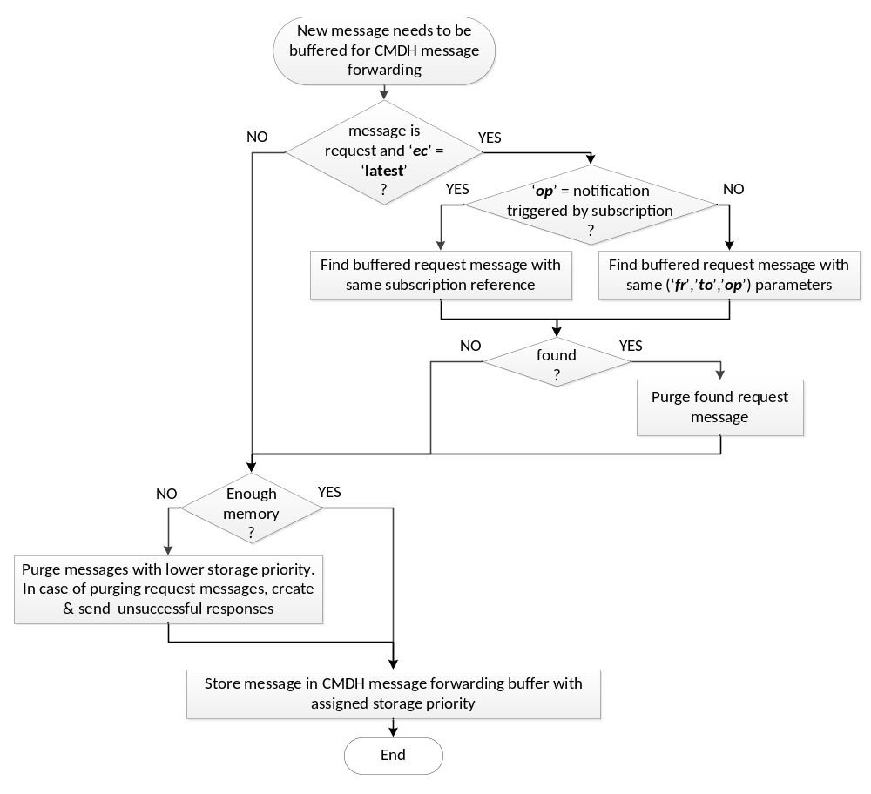
Figure 6 Buffering of messages for CMDH message forwarding.

    - Establishment of Mcc communication connection to another CSE
When a Mcc communication connection shall be established via a specific target network for forwarding a message of a specific event category indicated by the ‘ec’ parameter of the message, the process of establishing the Mcc communication connection shall be governed by values contained in the ‘backOffParameters’ attribute of the [cmdhNwAccessRule] resource that was used to evaluate whether the message was allowed to be forwarded, as defined in step 2.2 in the procedure outlined in clause H.2.4. .
When connectivity via the selected target network to reach the next CSE has not already been established for other reasons, then the CSE that is trying to forward a message buffered for CMDH message forwarding shall establish a new Mcc communication connection via the selected target network for transporting oneM2M messages to the next CSE via a new Mcc instance. This communication connection shall be established following the procedures for authentication and security association using TLS or DTLS as defined in TS-0003 [TBD] taking into account provisioned security settings. The protocol mapping for transporting oneM2M specified messages via this instance of Mcc shall be selected according to the capabilities of the two end-points of the Mcc instance.

If establishing the Mcc communication connection via the selected target network fails, a new attempt to establish that communication connection shall only be made after waiting for a back-off time according to the value given in the ‘back-off time’ component of the ‘backOffParameters’ attribute of the effective [cmdhNwAccessRule] resource.
When establishing the Mcc communication connection via the selected target network still fails, for each subsequent new attempt to establish the Mcc communication connection without any successful attempts in-between, the back-off time shall be increased by the value given in the ‘back-off time increment’ component of the ‘backOffParameters’ attribute of the effective [cmdhNwAccessRule] resource.
The back-off time for waiting before making any new attempt to establish the Mcc communication connection via the selected target network shall not exceed the value given by the ‘maximum back-off time’ component of the ‘backOffParameters’ attribute of the effective [cmdhNwAccessRule] resource.
When the next CSE is hosted on a node for which a usable Mcc communication connection for forwarding a message to the next CSE can only be established by the next CSE itself, device triggering mechanisms as defined in TS-0001 shall be used.
In case the next CSE can only be reached via communication connections originating from the node that hosts the next CSE, while it is capable of processing incoming oneM2M messages, it is assumed that such a CSE establishes a polling channel as defined in TS-0001 in order to effectively receive unsolicited oneM2M messages.

==================== End of second text proposal ============================

