CHANGE REQUEST
Meeting:* | PRO 19.0
Source:* | KT Corp. (TTA)
Date:* | 2015-08-27
Contact:* | Francisco Sang-Eon Kim (kim.sangeon@kt.com)
Reason for Change/s:* | Descriptioin to clearly understand for Generic procedure of Originator at section 7.1.2.1
CR against: Release* | Release 1
CR against: WI* | Active <Work Item number>  MNT Maintenace / < Work Item number(optional)>  STE Small Technical Enhancements / < Work Item number (optional)>  Only ONE of the above shall be ticked
CR against: TS/TR* | TS-0004-V1.2.0
Clauses/Sub Clauses* | 7.1.2.1
Type of change: * | Editorial change  Bug Fix or Correction  Change to existing feature or functionality  New feature or functionality  Only ONE of the above shall be ticked
Post Freeze checking:* | This CR contains only essential changes and corrections? YES NO  This CR is a mirror CR? YES NO if YES, please indicate the document number of the original CR:  <Document Number)<CR Number of the original CR to the current Release>
Template Version:23 February 2015 (Dot not modify)

oneM2M Notice
The document to which this cover statement is attached is submitted to oneM2M. Participation in, or attendance at, any activity of oneM2M, constitutes acceptance of and agreement to be bound by terms of the Working Procedures and the Partnership Agreement, including the Intellectual Property Rights (IPR) Principles Governing oneM2M Work found in Annex 1 of the Partnership Agreement.
GUIDELINES for Change Requests:
Provide an informative introduction containing the problem(s) being solved, and a summary list of proposals.
Each CR should contain changes related to only one particular issue/problem.
In case of a correction, and the change apply to previous releases, a separated “mirror CR” should be posted at the same time of this CR
Follow the principle of completeness, where all changes related to the issue or problem within a deliverable are simultaneously proposed to be made E.g. A change impacting 5 tables should not only include a proposal to change only 3 tables. Includes any changes to references, definitions, and acronyms in the same deliverable.
Follow the drafting rules.
All pictures must be editable.
Check spelling and grammar to the extent practicable.
Use Change bars for modifications.
The change should include the current and surrounding clauses to clearly show where a change is located and to provide technical context of the proposed change. Additions of complete sections need not show surrounding clauses as long as the proposed section number clearly shows where the new section is proposed to be located.
Multiple changes in a single CR shall be clearly separated by horizontal lines with embedded text such as, start of change 1, end of change 1, start of new clause, end of new clause.
When subsequent changes are made to content of a CR, then the accepted version should not show changes over changes. The accepted version of the CR should only show changes relative to the baseline approved text.

Introduction

Introduction
This contribution proposes to discriminate primitive, parameters of primitive and <resource> for generic procedures.
The rationale is that TS shall describe to clearly understand generic procedure, because current description has a little bit confusion e.g. “Communication Method?”, implicit parameters.
A bold types indicate primitives delimited with '“' and '”' e.g. “Request” and “Response”.
An italic types indicate parameters of primitives delimited with '“' and '”' e.g. “To”, “From”, “Operation”, “Response Type”, “Content”, etc.
A string containing resource type name delimited with '<' and '>' e.g. <resourceType> is used as an abbreviation referring to the type of a resource. For example the text "a <container> resource" could be used as an abbreviation for "a resource of type container".
The Orig-1.0 and Orig-2.0 are used “Request” primitive for clarification.
The Orig-3.0 is used “Response” primitive for clarification.
At Orig-4.0, an originator needs to decide “communication method” for which the “Response Type” parameter is used.
In case of ‘blockingRequest’ based on section 6.3.3.2.6 m2m:responseType, Orig-6.0 process “Response” primitive.
When a value of “Response Type” is nonBlockingRequestSynch, all exchange of information between Originator and Receiver CSE needs to be initiated by the Originator [section 8.2.2.2 in TS-0001]. Therefore, the Originator should send “Request” primitive at Orig-5.0. Operation parameter of “Request” primitive is RETRIEVE and Content parameter is <request> resource according to the 7.2.1.4.
Content parameter is optional for RETRIEVE operation as specified at section 8.1.2 in TS0001 v1.8.0.
After that, originator receives “Response” primitive from the Receiver CSE at Orig-5.1. The value of content parameter of the “Response” primitive is attributes and child resources of <request> resource.
At Orig-5.2, Originator checks whether the complete ot not based on operationResult attribute in <Request> resource for “Request” primitive which sent at Orig2-0. If the “Request” primitive is not completed at Receiver, the Originator retry Orig-5.0 later. Otherwise, when the “Request” primitive is completed at Receiver, the Originator process the results at Orig-6.0.
When a value of “Response Type” is nonBlockingRequestAsynch, Originator or other entities that need to know about the outcome of a “Request” are able to receive notification messages [section 8.2.2.2 in TS-0001].
Therefore, the Receiver should send “Request” primitive to the Origniator at Orig-7.0 when the Receiver completed processing. Operation parameter of “Request” primitive is NOTIFY and Create a “Response” primitive with “operation”=NOTIFY parameter at Orig-8.0
nonBlockingRequestAsync reviewed by Josef
nonBlockingRequestSync reviewed by Seungmyeong and Shingo
Nobu Uchida reviews and comments nonBlockingRequestAsync based on clause “7.4.1 Notification data object and procedures” in TS-0004.
This includes the results of the ad-hoc discussion during the PRO18.0 at Philadelphia.
Major results of ad-hoc discussion are:
- Orig3.0 and Orig4.0 is changed. Because Orig4.0 is preformed itself based on “Response Type” parameter. It does not need to wait response. The current flowchart can mislead to Orig4.0 based on Orig-3.0. The receiver primitive does not have “Response Type” parameter.
- In case of nonBlockingRequestSynch, Acknowledge is changed to Processing at Orig5.2
- Agreed with Qualcomm and LG electronics in principle.
Revision 3 is based on e-mail discussion after PRO18.1
- All step is described with quotation mark e.g.Orig-1.0: “Compose of a Request Primitive” instead of Orig-1.0: Compose of a Request Primitive
- The bold characters are not used for Request and Response primitive.
- However, parameters describes with italics to keep consistent with existing description of specification, e.g. Orig-4.0 in clause 7.1.2.1, Recv-2.0 in clause 7.1.2.2, Recv-6.1 in clause 7.1.2.2, , Recv-6.6.1 in clause 7.1.2.2, clause 7.2.1.2, clause 7.2.1.3, clause 7.2.2.1, clause 7.2.2.2, clause 7.2.2.6, clause 7.2.3.1, clause 7.2.3.2, clause 7.2.3.3, clause 7.2.3.4, cluse 7.2.3.5, clause 7.2.3.6, clause 7.2.3.7, clause 7.2.3.8, clause 7.2.3.9, clause 7.2.3.10, clause 7.2.3.11, clause 7.2.3.12, clause 7.2.3.13, clause 7.2.3.15, clause 7.2.3.16 clause 7.2.3.16.10, clause 7.2.3.16.11, clause 7.2.4.3, clause 7.3.7.2.3, clause 7.3.8.2.1, clause 7.3.10.2.1 and so on.
The 5th revision is based on e-mail discussion as follows
- Introduce op=N which stands for Operation=Notify and op=R stands for Operation=Retrieve.
- “If Response Type parameter does not exist, communication method is ‘blockingRequest’ as specified at clause 6.4.1.” is added at Orig-3.0
- A detailed description of Orig-4.0 is deleted and refers to related clause.

-----------------------Start of change 1-------------------------------------------

Generic resource request procedure for originator
A generic resource Request procedure shall be comprised of the following actions. Additional actions specific to individual procedures are listed in the respective sections by referencing these actions and providing additional steps. The Originator shall execute the following steps in order:
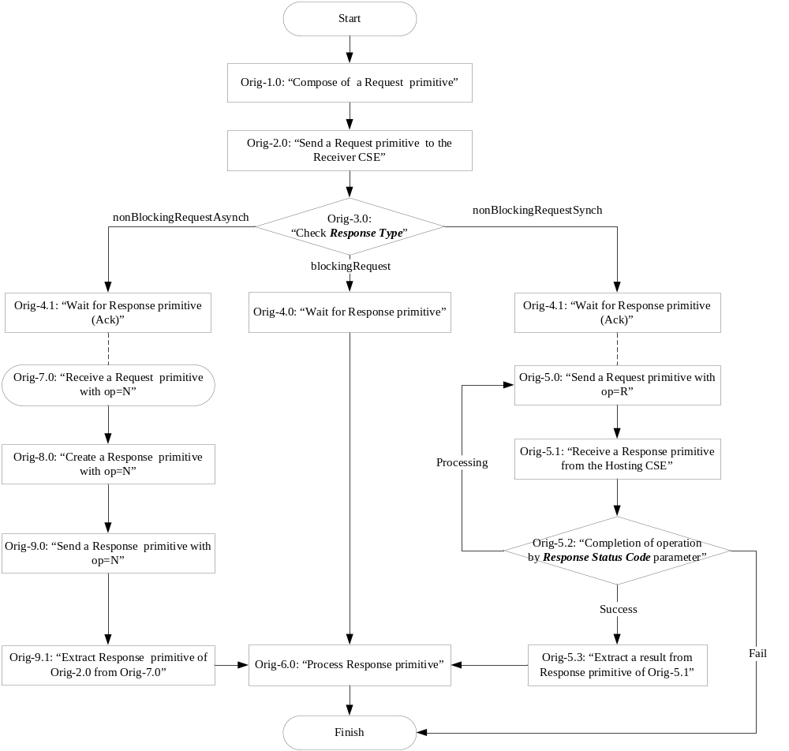Figure 7.1.2.1-1: Generic procedure of Originator
Figure 7.1.2.1-: Generic procedure of Originator
Orig-1.0 “Compose of a Request primitive”: Please refer to clause 7.2.1.1 for details.
Orig-2.0 “Send a Request primitive to the Receiver CSE”: The Request primitive shall be included mandatory parameters which are Operation, To, From and Request Identifier parameter. Please refer to clause Error: Reference source not found for details.

Orig-3.0 “Check Response Type”: In this step, the Originator checks communication method ether blockingRequest, nonBlockingRequestSynch or nonBlockingRequestAsynch by using Response Type parameter (see detail in clause 8.1.2 in the oneM2M TS-0001 Functional Architecture [Error: Reference source not found]). If Response Type parameter does not exist, communication method is ‘blockingRequest’ as specified at clause 6.4.1.
If the Response Type is blockingRequest it waits for Response primitive and goes to step Orig-4.0. If the Response Type is nonBlockingRequestSync, it waits for acknowledgement of Response primitive and goes to step Orig-4.1. If the Response Type is nonBlockingRequestAsynch, it waits for acknowledgement of Response primitive and goes to step Orig-4.1.
Orig-4.0 and Orig-4.1 “Wait for Response primitive”: Please refer to clause 7.2.1.3 for details.
Orig-5.0 “Send a Request primitive with op=R”: The Request primitive shall be included mandatory parameters which are Operation, To, From and Request Identifier parameter. See clause Error: Reference source not found for details.
Orig-5.1 “Receive a Response primitive from the Hosting CSE”: The Originator shall receive mandatory parameters which are Response Status Code, Request Identifier and Content parameter. A Request Identifier shall be identical to the Orig-5.0. An information of Content parameter is the result of the Orig-2.0 when the Receiver completed handling of Request primitive of Orig-2.0.
Orig-5.2 “Completion of operation by Response Status Code parameter”: When the Response Status Code is successful and Content parameter exists, it goes to Orig-5.3. When the Response Status Code is acknowledgment which indicates processing at the Receiver, it goes to Orig-5.0.
When the Response Status Code is error such as Originator error (4XXX) or Receiver error (5XXX) or Network error (6XXX) or absence of Content parameter, it goes to finish with error.
Orig-5.3 “Extract a result from Response primitive of Orig-5.1”: The information of operationResult attribute of the <request> resource in Content parameter from Orig-5.1 is extracted from Response primitive which is included Request Identifier, Response Status Code and optional Content parameter. The <request> resource shall be included mandatory attributes as specified in clause 9.6.12 [6]. The Request Identifier in operationResult attribute shall be identical of Orig-2.0

Orig-6.0 “Process Response primitive”: A Request Identifier shall be identical to the Orig-2.0. The Originator processes the results of the response.
Orig-7.0 “Receive a Request primitive with op=N”: The Originator receives Request primitive with mandatory parameters which are Operation, To, From, Request Identifier and Content parameter. An Operation parameter shall be Notify. A Content parameter is the notification information as specified in clause 7.4.1.1.

Orig-8.0 “Create a Response primitive with op=N”:The Originator creates Response primitive with mandatory parameters which are Response Status Code and Request Identifier parameter. A Request Identifier shall be identical to the Orig-7.0.

Orig-9.0 “Send a Response primitive with op=N”: The Response primitive which is created at Orig-8.0 shall be sent to the Receiver.
Please refer to clause Error: Reference source not found for details.

Orig-9.1 “Extract Response primitive of Orig-2.0 from Orig-7.0”: The information of operationResult attribute in <request> resource from Orig-7.0 in Response primitive is included Request Identifier, Response Status Code and optional Content parameters. The <request> resource shall be included mandatory attributes as specified in clause 9.6.12 [6]. The Request Identifier in operationResult attribute shall be identical of Orig-2.0

-----------------------End of change 1---------------------------------------------

-----------------------Start of change 2-------------------------------------------

Common operations

Originator actions

Compose request primitive
The originator shall compose a Request message that shall be mapped to a specific protocol.
The Request shall include mandatory parameters which is Operation, To, From and Request Identifier.
The Request may include the time related parameters which is Originating Timestamp, Request Expiration Timestamp, Result Expiration Timestamp and Operation Execution Time
The Request may include the other parameters as specified in ).
When including a resource representation in the request indication for create and update, the originator shall take into account the validation rules as specified in "Check validity for resource representation for create" and "Check validity for resource representation for update" respectively.
EXAMPLE: Any attributes marked with NP shall not be present in the resource representation for the corresponding request indication.

-----------------------End of change 2---------------------------------------------

-----------------------Start of change 3-------------------------------------------

Wait for response primitive
The originator shall wait for the Response primitive from the receiver that corresponds to the Request primitive that was sent by the originator. Correlation between the Request and the corresponding Response is handled by the transport layer or by Request Identifier parameter of the primitive.
If no Response primitive is received within a certain time, specified by server policy and/or by the underlying transport technology, this shall be handled as if a Response primitive with a Response Status Code indicating “REQUEST_TIMEOUT” error was received.

-----------------------End of change 3---------------------------------------------

CHECK LIST
- Does this change request include an informative introduction containing the problem(s) being solved, and a summary list of proposals.?
- Does this CR contain changes related to only one particular issue/problem?
- Have any mirror crs been posted?
- Does this change request make all the changes necessary to address the issue or problem? E.g. A change impacting 5 tables should not only include a proposal to change only 3 tables. Includes any changes to references, definitions, and acronyms in the same deliverable?
- Does this change request follow the drafting rules?
- Are all pictures editable?
- Have you checked the spelling and grammar?
- Have you used change bars for all modifications?
- Does the change include the current and surrounding clauses to clearly show where a change is located and to provide technical context of the proposed change? (Additions of complete sections need not show surrounding clauses as long as the proposed section number clearly shows where the new section is proposed to be located.)
- Are multiple changes in this CR clearly separated by horizontal lines with embedded text such as, start of change 1, end of change 1, start of new clause, end of new clause.?

