INPUT CONTRIBUTION
Group Name:* | REQ WG / ARC WG call
Title:* | M2M Functional Roles and related basic definitions
Source:* | Joerg Swetina, NEC, Joerg.swetina@neclab.eu
Contact:
Date:* | 2012-11-27
Abstract:* | This contribution provides a role model for functional roles in oneM2M. The intention is to introduce a terminology which shall be used for writing requirements.  Note, that the current document does _not_ yet introduce a full set of requirements  Additionally, it is proposed to add the role models as an introductory section of a requirements specification and the related definitions to a definitions section of the requirements document.
Agenda Item:* | Tbd
Work item(s): | Requirements
Document(s)  Impacted* | Requirement specification (number to be assigned)
Intended purpose of  document:* | Decision  Discussion  Information  Other <specify>
Decision requested or recommendation:* | Discussion and initial agreement for potential inclusion in the requirement TS at the TP2 meeting

oneM2M IPR STATEMENT
Participation in, or attendance at, any activity of oneM2M, constitutes acceptance of and agreement to be bound by all provisions of IPR policy of the admitting Partner Type 1 and permission that all communications and statements, oral or written, or other information disclosed or presented, and any translation or derivative thereof, may without compensation, and to the extent such participant or attendee may legally and freely grant such copyright rights, be distributed, published, and posted on oneM2M’s web site, in whole or in part, on a non-exclusive basis by oneM2M or oneM2M Partners Type 1 or their licensees or assignees, or as oneM2M SC directs.

1 Introduction
This contribution provides a role model for Functional roles in oneM2M. The intention is to agree that oneM2M will support such roles introduce a terminology which shall be used for writing requirements.
Note, that the current document does _not_ yet introduce a full set of requirements.
Additionally, it is proposed to add the role models as an introductory section of a requirements specification and the related definitions to a definitions section of the requirements document.
Definitions have been taken from various sources, some are new, some are modified. The change-marks indicate proposed changes to the original definitions.
  - Text for inclusion in a (non-normative) introductory section of the requirements specification
=================== begin text======================
The functional roles (entities) of the M2M ecosystem:
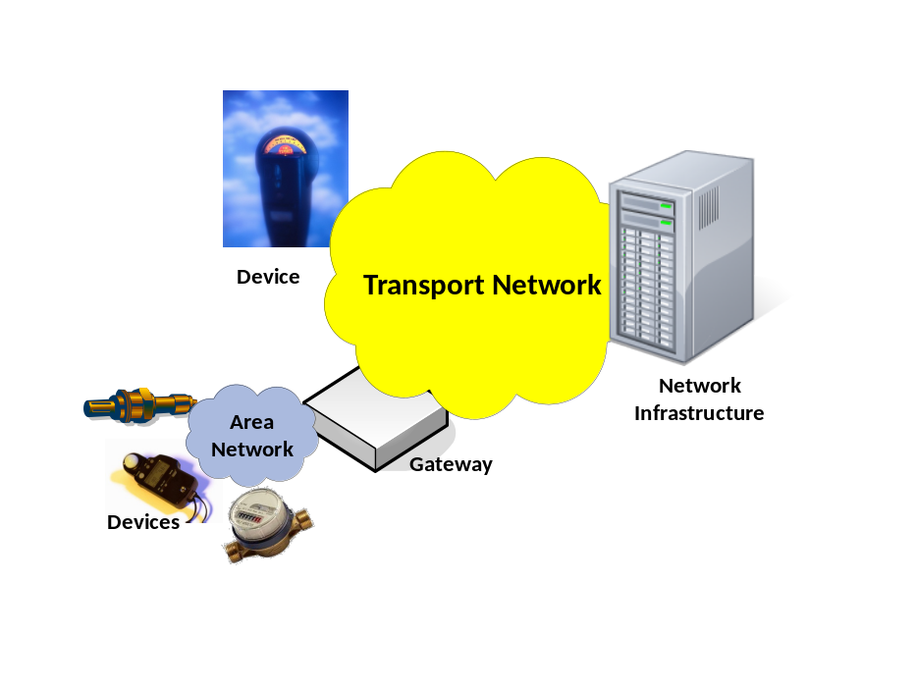
Role description
- The Device
- Physical device that provides functions (e.g. measurements, actuation) to implement the service logic of an M2M Solution
- A Device has communication capabilities to communicate over Transport Networks (WANs) and/or Area Networks (LANs) with other Devices, Gateways or Network Infrastructure.
- The Gateway
- Physical device that provides an Area Network to communicate with Devices to implement an M2M Solution
- A Gateway may provide additional functionalities (e.g. data concentration, device abstraction) to implement the service logic of an M2M Solution
- A Gateway has communication capabilities to communicate over Transport Networks (WANs) and Area Networks (LANs).
- The Network Infrastructure
- A (set of) physical devices that provide central functions of the service logic of an M2M Solution
- The Network Infrastructure has communication capabilities to communicate over Transport Networks (WANs)

=================== end text======================

  - Text for inclusion in a definitions section of the requirements specification
=================== begin text======================
Device: equipment that consists of a set actuators and sensors and that has embedded electronic computing and communication capability. A Device provides functions (e.g. measurements, actuation) to implement the service logic of an M2M Solution
[source: ETSI TR 102 725 V0.8.0]
Gateway: an equipment with electronic computing and communication capability aimed to translating, sharing and transferring information between two type of communicating entities, or aimed to perform some routing and multiplexing function between the two communicating entities.
[source: ETSI TR 102 725 V0.8.0]
Network Infrastructure: equipment (e.g. a set of physical devices) that provides central functions of the service logic of an M2M Solution and has the capability to communicate with Devices and/or Gateways.
[new]
Area Network: provides connectivity between Devices and Gateways.
[source: ETSI TR 102 725 V0.8.0]

================= maybe also needed ===================
M2M Device: a device that runs application(s) using M2M capabilities and network domain functions. A M2M device is made at least of one M2M Device Application and one M2M Communication Module. A M2M Device may contain one or more M2M Communication Module(s) and one or more M2M Device Application(s).
[source: ETSI TR 102 725 V0.8.0]
M2M Gateway: equipment using M2M Capabilities to ensure M2M Devices interworking and interconnected to the Network and Application Domain. The M2M Gateway may also run M2M applications. M2M Gateway functionality can be co-located with M2M Device(s).
[source: ETSI TR 102 725 V0.8.0]

=================== end text======================

