INPUT CONTRIBUTION
Group Name:* | WG1
Source:* | HUAWEI Technoligies Co., Ltd.
Format:*
Date:* | Dec 12, 2012
Contact:* | liangshuangjian@huawei.com  tianlinyi@huawei.com
Abstract:* | This contribution describes one use case:  - Vehicle Diagnostic & Maintenance Report
Agenda Item:*
Work item(s):
Document(s)
Impacted*
Intended purpose of  document:* | Decision  Discussion  Information  Other <specify>
Decision requested or recommendation:* | Approval

oneM2M IPR STATEMENT
“Participation in, or attendance at, any activity of oneM2M, constitutes acceptance of an agreement to be bound by all provisions of IPR policy of the admitting Partner Type 1 and permission that all communications and statements, oral or written, or other information disclosed or presented, and any translation or derivative thereof, may without compensation, and to the extent such participant or attendee may legally and freely grant such copyright rights, be distributed, published, and posted on oneM2M’s web site, in whole or in part, on a non-exclusive basis by oneM2M or oneM2M Partners Type 1 or their licensees or assignees, or as oneM2M SC directs.

  - Title

Vehicle Diagnostic & Maintenance Report
  - Description

The Vehicle Service Centre wants to help the vehicle owner to be aware of the status of the vehicle and remind them to maintain the vehicle in a timely manner to avoid any damages.

The Vehicle Service Centre needs to obtain and analyse data from the vehicle periodically. Based on the analysis result, it will notify to the vehicle owner showing what's going on with the vehicle together with some maintenance suggestions.
  - Source

HUAWEI Technologies Co., Ltd.
  - Actors

Vehicle Owner:

By reading the Vehicle Diagnostic & Maintenance Report sent from the Vehicle Service Centre, the vehicle owner will decide whether to maintain his/her vehicle.

Vehicle Service Centre:

It operates a service platform for diagnostics and maintenance of vehicles, performs the diagnostics data from the vehicle. It will also send vehicle Diagnostic & Maintenance Report together with maintenance suggestions to the vehicle owner.

Mobile Communication Network Operator:

As the transmission medium, it supports the network services between Vehicle Service Centre and Vehicle for the information transmission.

M2M Device:

It is embedded in a vehicle, which is used to send information to Vehicle Service Centre and implement diagnostics function from Vehicle Service Centre.
  - Pre-conditions (if any)
- The vehicle is pre-configured to report the diagnostics data collected from sensors within the vehicle periodically.
- The vehicle is already ignited.
  - Triggers (if any)
- None.
  - Normal Flow

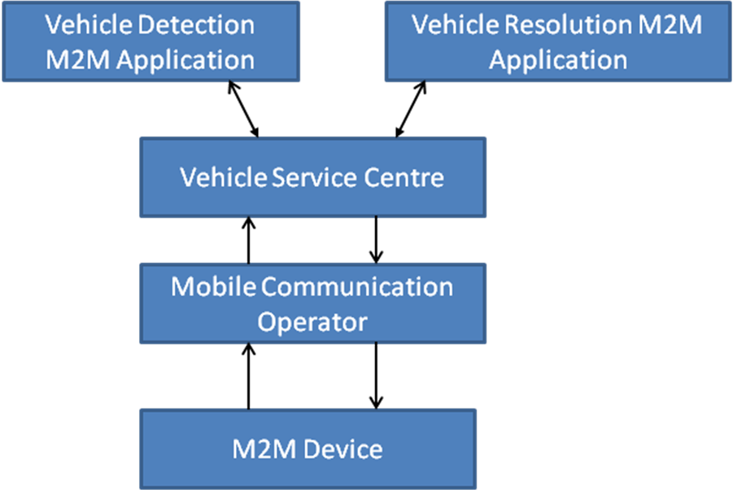

- The vehicle collects the diagnostics data from sensors within the vehicle and sends it to the Vehicle Service Centre. The diagnostics data includes information from Engine and Transmission System, Stability Control System, Air Bag System, Emission System, Antilock Brake System and so on. The information includes tyre pressure, odometer data, life of engine oil, engine and gear-box status, antilock braking system status etc.
- The Vehicle Service Centre sends the diagnostics data to the “Vehicle Detection M2M Application”. This M2M application analyzes the diagnostics data.
- The “Vehicle Detection M2M Application” finds that the Brake pads need to be replaced. It queries the maintenance services provided by “Vehicle Resolution M2M Application” and gets the information of the company who can provide the components.
- The “Vehicle Detection M2M Application” sends the Diagnostic & Maintenance Report to the vehicle owner together with the suggested component providers. .
- The vehicle owner will decide whether to maintain his/her vehicle based on the Diagnostic & Maintenance Report.
  - Post-conditions (if any)
- For normal flow, the vehicle owner maintains his/her vehicle according to the Diagnostic & Maintenance report in time.
  - High Level Illustration

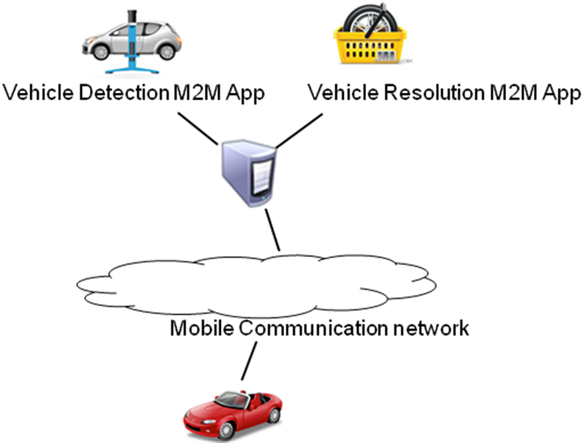
  - Potential requirements (as applicable)
- The M2M System shall allow the M2M Devices to send diagnostics data periodically to the M2M Application in the network domain.
- The M2M System shall allow the M2M Application to configure the notification interval in the M2M Devices.
- The M2M system shall support a mechanism to describe the syntax and semantics of the diagnostics data sent from the M2M Devices to the M2M Application in the network domain.

