Input contribution
Use case
Use Case Title:* | Smart Parking
Group Name:* | REQ
Source:* | LG Electronics
Contact: | Seungmyeong Jeong, LG Electronics, seungmyeong.jeong@lge.com
Date:* | 2013-Feb-18
Abstract:* | Smart parking helps finding empty parking spaces, paying parking fees, and even can make reservation for limited purposes.
Agenda Item:*
Work item(s):
Document(s)  Impacted* | Release 1 Use Case TR
Intended purpose of  document:* | Decision  Discussion  Information  Other <specify>
Decision requested or recommendation:* | Approval to incorporate this use case into oneM2M use case TR.

oneM2M IPR STATEMENT
“Participation in, or attendance at, any activity of oneM2M, constitutes acceptance of an agreement to be bound by all provisions of IPR policy of the admitting Partner Type 1 and permission that all communications and statements, oral or written, or other information disclosed or presented, and any translation or derivative thereof, may without compensation, and to the extent such participant or attendee may legally and freely grant such copyright rights, be distributed, published, and posted on oneM2M’s web site, in whole or in part, on a non-exclusive basis by oneM2M or oneM2M Partners Type 1 or their licensees or assignees, or as oneM2M SC directs.

  - Title

Smart Parking
  - Description

Smart parking helps one of the biggest problems on driving in urban areas; finding empty parking spaces and controlling illegal parking. Those parking spaces are wide spread and owned by different providers so that it is not easy to access at one place/time.

With smart parking service, drivers can easily find available parking spaces, pay parking fees and even can make reservations. Making parking reservations would be available for limited people such as VIPs or the disabled, since ordinary parking service needs to satisfy first-come-first-served rule.

In this use case, law enforcement authority is also included as an actor. This implies M2M technologies aims rightness/safety as well as convenience.
  - Source (as applicable)

LG Electronics
  - Actors (as applicable)

M2M Service Platform

This is a platform that interacts with M2M Gateways/Devices and M2M Application Service Providers.

Smartphone

This is a M2M Device acts as a car navigator and a wallet to pay parking fee by connecting parking meters.

On-street Parking Meter

This is a M2M Device installed near parking slots to charge drivers parking fees.

In-building Parking Sensor

This is a M2M Device with a small camera that can recognize a plate on cars, and is installed near disabled-only parking spaces.

Parking Provider

This is a M2M Application Service Provider who owns parking lots, in this use case there are two parking providers; in the mall and on street.

Billing Provider

This is a M2M Application Service Provider (e.g. credit card company) who provides billing service to M2M Users such as parking fee. When it issues a bill, coupons from M2M Application Service Providers are used as tokens for compensation schemes. They also can charge fines issued by police center on their bills.

Police Center

This is a law enforcement authority, one of M2M Application Service Providers, who charges fine to whom break laws.

User

This is a M2M service user who drives a car. In the second sub case, dedicated parking space, there are two users. One originally makes a reservation who is handicapped, and the other who illegally parks a car on disabled-only parking area.
  - Pre-conditions (if any)

See sub-case below.
  - Triggers (if any)

See sub-case below.
  - Normal Flow (as applicable)
    - Finding Space, Parking Car & Paying Bill

Pre-condition

User sets a destination as a shopping mall using the smartphone navigator, also checks availability of parking space in the building before or while driving.

Triggers

The car approaches near the destination.

Normal flow

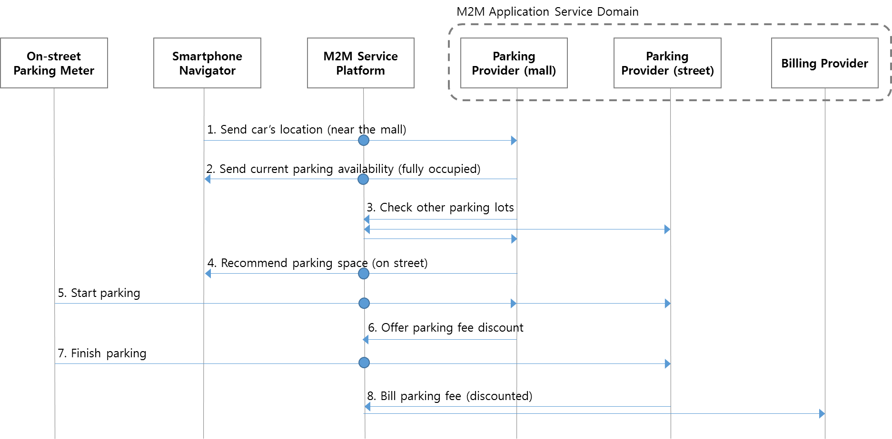

Figure 1
- Since the user set the mall as the destination before, when the user is near the mall, the navigator sends the location to the mall parking provider automatically.
- The mall parking provider informs the navigator that there’s no empty parking space now.
- Based on the car’s location, which is near the mall, the mall parking provider inquires availability of other parking spaces through M2M service platform.
- There are empty spaces on street, so the mall parking provider recommends that parking space.
- The user touches the smartphone on a parking meter to start parking. Then the street parking provider is noticed, and also the mall parking provider is.
- The mall parking provider offers discount coupon for parking outside as a compensation.
- The user touches the smartphone on the meter to finish parking.
- The street parking provider bills parking fee. The bill with discount coupon is sent to billing provider through M2M service platform.
    - Dedicated Parking Space

Pre-condition

Before driving, the user (user A) makes a parking reservation for a slot in a shopping mall, which is especially for the disabled. It is normally assured because there will be fines for illegal parking on this dedicated parking space

Triggers

None

Normal Flow

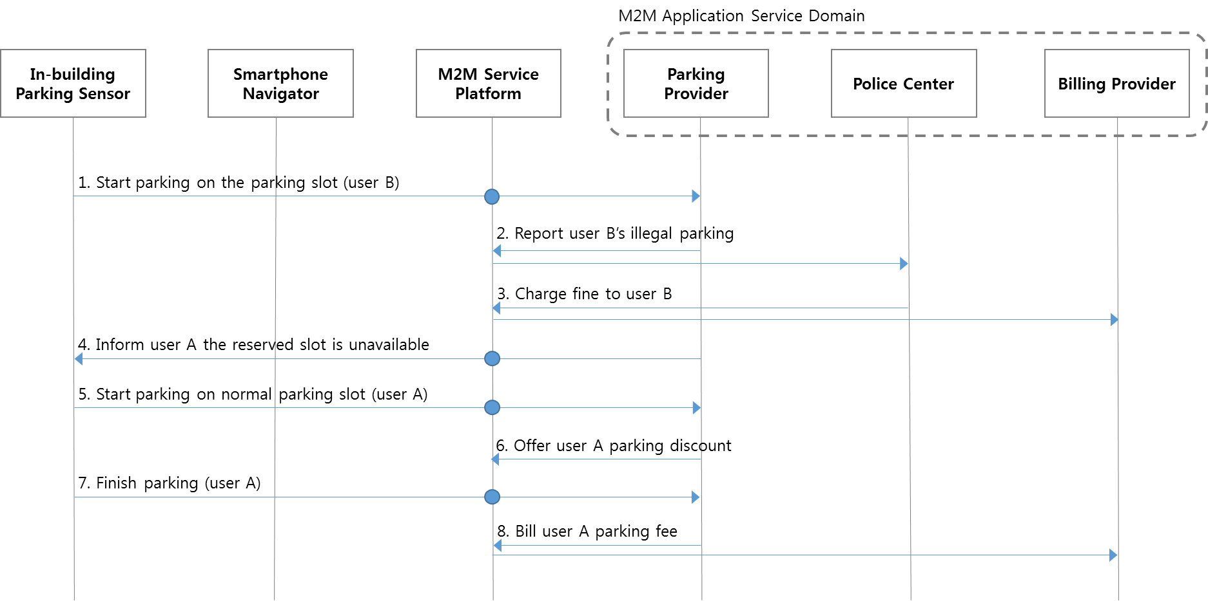

Figure 2-1
- The other user (user B) parks a car on the parking slot, which is already reserved by user A before.
- User B’s illegal parking on the disabled-only parking area is reported to police center.
- Police center charges fine on user B.
- User A approaches the mall and is noticed that reserved parking space is taken and only choice now is normal parking slots.
- User A parks on a normal parking slot instead of the reserved one.
- The parking provider offers parking discount coupon to the user A as a compensation.
- After shopping, user A leaves the building and finish parking.
- The parking provider bills parking fee for user A, adopting the parking coupon.
    - Dedicated Parking Space (alternative)

Pre-condition

Before driving, the user (user A) makes a parking reservation for a slot in a shopping mall, which is especially for the disabled. It is normally assured because there will be fines for illegal parking on this dedicated parking space

Triggers

None

Normal Flow

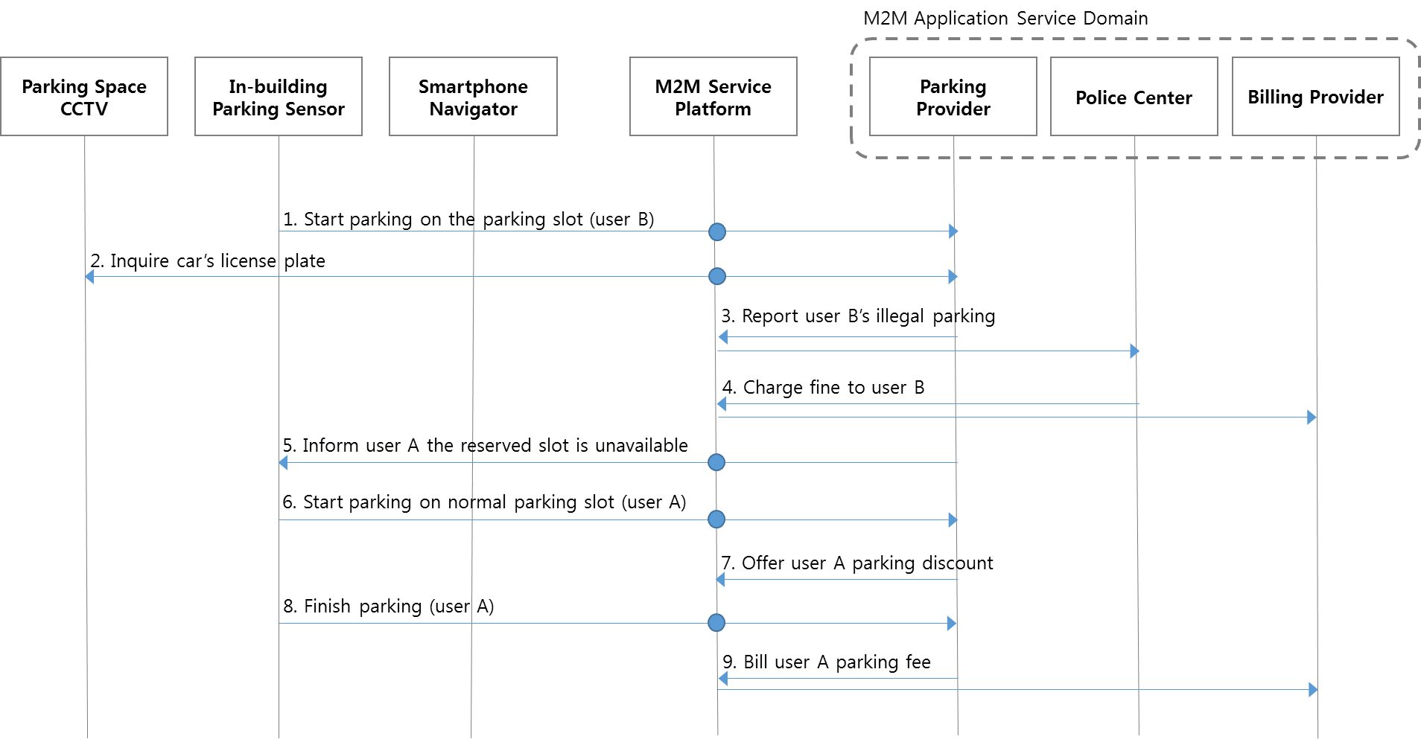

Figure 2-2
- The other user (user B) parks a car on the parking slot, which is already reserved by user A before.
- The mall parking provider inquires plate number of the car to a CCTV near the parking space.
- User B’s illegal parking on the disabled-only parking area is reported to police center.
- Police center charges fine on user B.
- User A approaches the mall and is noticed that reserved parking space is taken and only choice now is normal parking slots.
- User A parks on a normal parking slot instead of the reserved one.
- The parking provider offers parking discount coupon to the user A as a compensation.
- After shopping, user A leaves the building and finish parking.
- The parking provider bills parking fee for user A, adopting the parking coupon.

  - Post-conditions (if any)

  - High Level Illustration (as applicable)

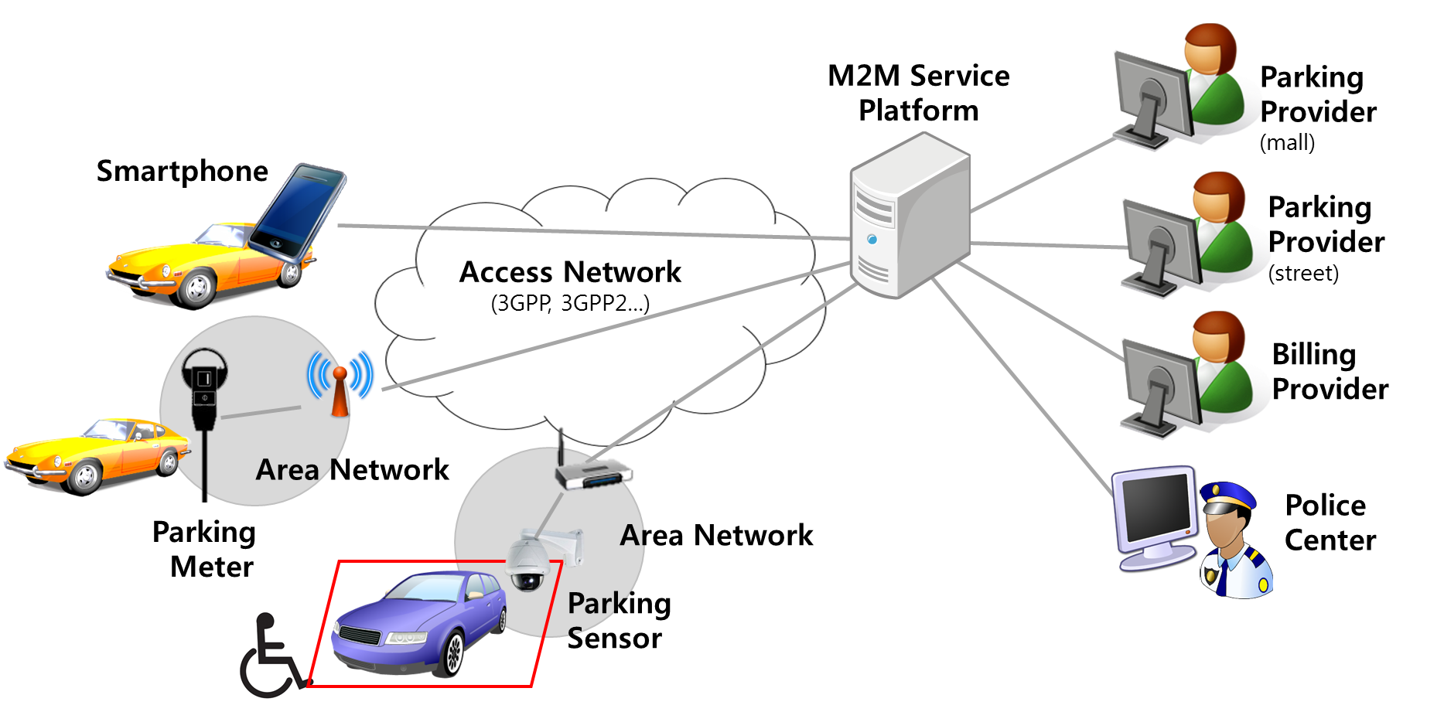
  - Potential requirements (as applicable)
- The M2M System shall support mechanisms to correlate charging data/records from different M2M Application Service Providers.
- The M2M System shall support triggering M2M Devices to report on-demand regarding collected data from other M2M Devices.

