INPUT CONTRIBUTION
Requirement
Group Name:* | WG1
Title:* | Requirements from “Computation and Analytics” Use Case
Source:* | KT(TTA)
Contact: | Wonseok Lee, KT, lee.wonseok@kt.com
Date:* | 2013-07-29
Abstract:* | This contribution contains another functional view and additional requirements from the Analytics Use Case accepted on 19 March (oneM2M-REQ-2012-0102R02)
Agenda Item:* | <Agenda item reference>
Work item(s): | Requirement
Document(s)  Impacted* | Requirements oneM2M-TS-0002
Intended purpose of  document:* | Decision  Discussion  Information  Other <specify>
Decision requested or recommendation:* | Inclusion of requirements

oneM2M Notice
The document to which this cover statement is attached is submitted to oneM2M. Participation in, or attendance at, any activity of oneM2M, constitutes acceptance of and agreement to be bound by terms of the Working Procedures and the Partnership Agreement, including the Intellectual Property Rights (IPR) Principles Governing oneM2M Work found in Annex 1 of the Partnership Agreement..
Introduction
Previously “Computation and Analytics” Use Case (oneM2M-REQ-2013-0102R03) is accepted and related requirements are proposed (oneM2M-REQ-2013-0157R06, oneM2M-REQ-2013-0370R01). In this document, we suggest another functional view and additional requirements of “Computation and Analytics” Use Case.
Discussion
We suggest another functional view as the figure below. In this figure, Remote Application is the application that request computation/analytics service and M2M Device is the devices that produce data (e.g. sensor data) and Compute/Analytics Application is the applications that are deployed and managed by the M2M System for data processing. In this figure, M2M Common Services is the common services provided by the M2M System.
In this functional view, an example process flow might be:
- Remote Application deploy compute/analytics application to M2M System as a Compute/Analytics Application using M2M Common Services.
- The Remote Application requests compute/analytics service for the specific group of M2M Devices with the identification information of the deployed Compute/Analytics Application.
- M2M System collect data of the given device group and deliver the device group data to the Compute/Analytics Application selected by the identification information.
- M2M System compute/analyse the collected data using the selected Compute/Analytics Application and transfer the computing/analysing results to the Remote Application.
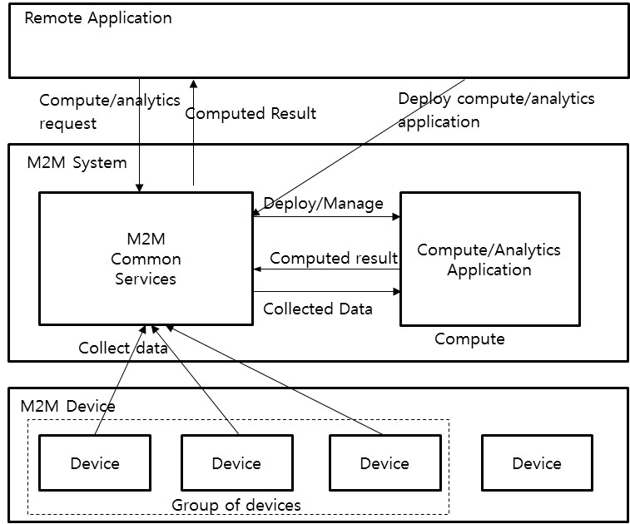
As described in this functional view, in addition to the previously proposed requirements in oneM2M-REQ-2013-0157R06 and oneM2M-REQ-2013-0370R01, data handling and delivery in grouped fashion is required. So we propose the following requirements.
We revised the initial requirements after the WG1 discussion on Tuesday (06-Aug-13).

Revised Requirement:
Requirement ID | Classification | Requirement Text
tbd | Overall System Requirement | The M2M System should enable the delivery of a requested data set as required by an M2M Application.
tbd | Overall System Requirement | The M2M System should provide mechanisms for subscriptions to sets of data. Notification should occurs following occurrence of requested criteria relative to sets of data.

