Input contribution
Use case
Use Case Title:* | Use cases of Electronic Toll Collection(ETC) service
Group Name:* | WG1
Source:* | ZTE
Contact: | Yingjie Hong; Rajesh Bhalla;
Date:* | 2014-03-28
Abstract:* | It includes a concrete use case, and a new requirement.
Agenda Item:*
Work item(s):
Document(s)
Impacted*
Intended purpose of  document:* | Decision  Discussion  Information  Other <specify>
Decision requested or recommendation:* | Approval

oneM2M IPR STATEMENT
“Participation in, or attendance at, any activity of oneM2M, constitutes acceptance of an agreement to be bound by all provisions of IPR policy of the admitting Partner Type 1 and permission that all communications and statements, oral or written, or other information disclosed or presented, and any translation or derivative thereof, may without compensation, and to the extent such participant or attendee may legally and freely grant such copyright rights, be distributed, published, and posted on oneM2M’s web site, in whole or in part, on a non-exclusive basis by oneM2M or oneM2M Partners Type 1 or their licensees or assignees, or as oneM2M SC directs.

  - Title

Use cases of Electronic Toll Collection(ETC) service.

  - Description

ETC aims to eliminate the delay on toll roads by collecting tolls electronically. ETC determines whether the cars passing are enrolled in the program, alerts enforcers for those that are not, and electronically debits the accounts of registered car owners without requiring them to stop.

  - Source

ZTE

  - Actors
- Vehicle Owner enroll a ETC service.
- On Board Unit(OBU) is a device used to store information such as identifier of vehicle, and do not have any direct communication interfaces to the ETC Service Platform.
- Road Side Unit(RSU) is a device which is an intermediate entity and is available to connect from OBU to a ETC Service Platform. The basic role is similar to the general M2M gateway, and it maybe have other functions(traffic light control, barrier control etc).
- ETC Service Platform is mainly in charge of collecting the information from OBU via RSU and information(location information etc) from RSU.
- ETC Service Provider provide its own M2M services for the user through the ETC Service Platform.

  - Pre-conditions
- Vehicle owner enrol his car to a ETC service.

  - Triggers

A vehicle equipped with OBU drive closely to a electronic road charging station which equipped with RSU.

  - Normal Flow

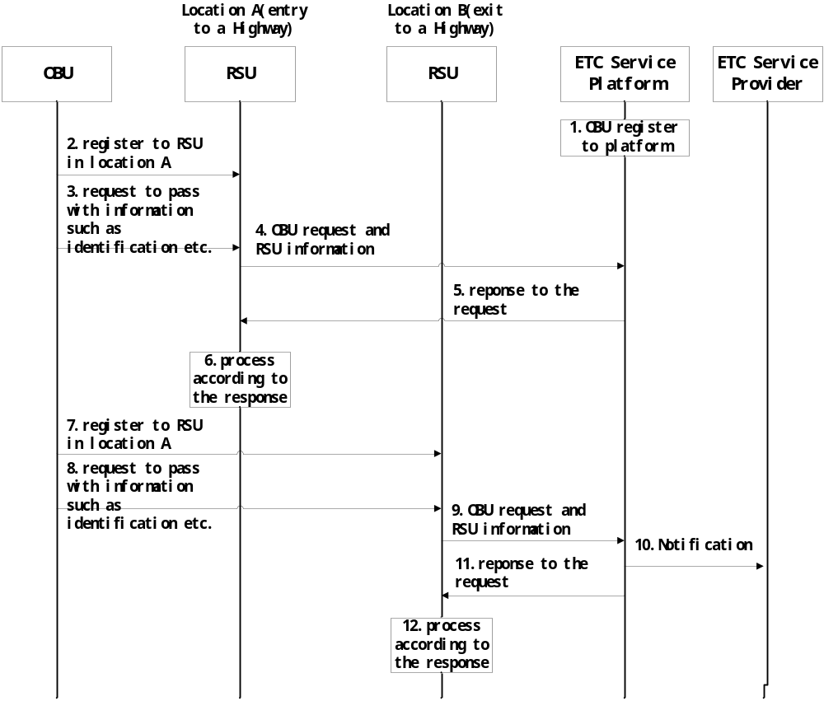
- Vehicle owner preliminarily join to ETC service and OBU register to the ETC Service Platform.
- When a vehicle go to a highway entrance(in location A), OBU register to the location A RSU.
- Vehicle send a request to ETC Service Platform via location A RSU asking for pass through.
- Location A RSU forward the request information and its related information e.g. location to Service Platform.
- Service Platform store and process the information, and response to location A RSU.
- Location A RSU decide whether vehicle can pass through according to the result from Service Platform.
- Then vehicle drives to the highway exit in location B, and OBU register to RSU in location B.
- Vehicle sent a request to ETC Service Platform via location B RSU asking for pass through.
- Location B RSU forward the request information and its related information e.g. location to Service Platform.
- Service Platform store and process the information, notify Service Provider of road toll.
- Service Platform response to location B RSU.
- Location B RSU decide whether vehicle can pass through according to the result from Service Platform.

  - Post-conditions (if any)

None

  - High Level Illustration (as applicable)

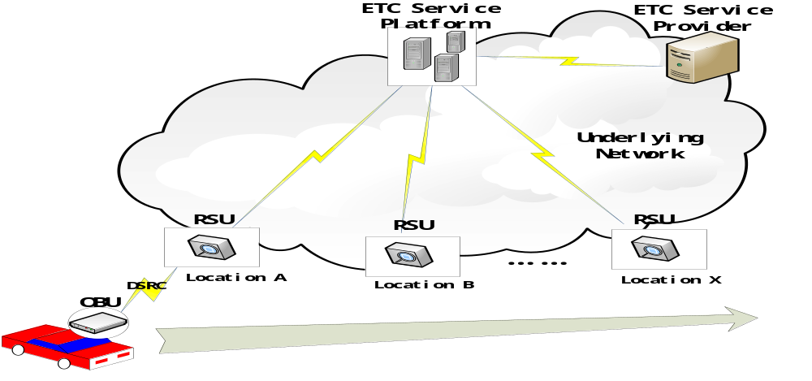

  - Potential requirements (as applicable)
  - M2M system shall provide the capability for support M2M entity multi-registrations.
  - M2M system shall provide a lightweight registration function and a lightweight registration resource for communication capability.

