Input contribution
Use case
Use Case Title:* | Use cases for Electronic Toll Collection (ETC) service
Group Name:* | WG1
Source:* | ZTE
Contact: | Yingjie Hong, hong.yingjie@zte.com.cn;  Rajesh Bhalla, rabhalla@ztetx.com;
Date:* | 2014-03-28
Abstract:* | Includes a Use Case on Electronic Toll Collection services and some associated requirements. This Use Case is suggested to be added to Transport Use Cases in section 10 of TR-001 v0.0.5
Agenda Item:*
Work item(s):
Document(s)
Impacted*
Intended purpose of  document:* | Decision  Discussion  Information  Other <specify>
Decision requested or recommendation:* | Approval of the Use Case.  Associated requirements shall be submitted separately for inclusion in Requirements TS.

oneM2M IPR STATEMENT
“Participation in, or attendance at, any activity of oneM2M, constitutes acceptance of an agreement to be bound by all provisions of IPR policy of the admitting Partner Type 1 and permission that all communications and statements, oral or written, or other information disclosed or presented, and any translation or derivative thereof, may without compensation, and to the extent such participant or attendee may legally and freely grant such copyright rights, be distributed, published, and posted on oneM2M’s web site, in whole or in part, on a non-exclusive basis by oneM2M or oneM2M Partners Type 1 or their licensees or assignees, or as oneM2M SC directs.

  - Title

Use cases for Electronic Toll Collection (ETC) service.

  - Description

ETC is an important part of Intelligent Transportation System (ITS). It is vigorously promoted in many countries.

ETC aims to eliminate the delay on toll roads by collecting tolls electronically. ETC determines whether the vehicles passing are enrolled in the program, alerts enforcers for those that are not, and electronically debits the accounts of registered vehicle owners without requiring them to stop.

In the ETC Use Case, On Board Unit (OBU) is a dedicated device located in the vehicle and it can communicate with the local RSUs only. Stated differently, the communication between OBU and ETC platform is via the RSUs. With a vehicle moving, the OBU would connect to the next RSU and release connection with the previous RSU. It is necessary for the OBU to 'register' with ETC Service Platform for receiving M2M system services. The term 'registration' here refers to an OBU having its contextual information available at the ETC Service Platform. Such registration information is for the duration of an OBU being subscribed to services from the ETC Service Platform. At the same time, OBU 'registers' with local RSUs also, as OBU connects to different RSUs. Such registration context at the RSUs is temporary, and gets released as the OBU moves out of the range of the RSU and connects to the next RSU. The OBU uses its connectivity with local RSUs for achieving communication with ETC Service Platform.

As regards the 'registration context' between the OBU and the ETC Service Platform, the contextual information needs to reflect the complete profile of the OBU at the ETC Service Platform. Such information can include OBU identity, credentials, service subscription information, payment history, account balance etc. This is referred to here as 'full registration'.

As regards the 'registration context' between the OBU and the RSU, such contextual information is a subset of the contextual information at the ETC Service Platform for the said OBU. The information in this subset needs to be sufficient for the RSU to indentify the OBU to the ETC Service Platform for the OBU to receive desired services without compromising any sensitive information to the RSU. This is referred to here as 'lightweight registration'

  - Source

ZTE

  - Actors
- Vehicle Owner enrolls for ETC service.
- On Board Unit (OBU) is a device used to store information such as identifier of the vehicle. The OBU typically does not communicate with the ETC Service Platform directly while receiving services. Direct communication between OBU and the ETC Service Platform may however be supported, out of band, for example for subscribing for ETC services.
- Road Side Unit (RSU) is a device which is an intermediate entity and is available to connect from OBU to the ETC Service Platform. Typical role of RSU can be similar to an M2M gateway, and it may provide other functions as well (e.g., traffic light control, barrier control etc).
- ETC Service Platform is responsible for collecting the information regarding the OBU via the RSU, including information such as location information from the RSU.
- ETC Service Provider provides its own M2M services for the user (OBU) through the ETC Service Platform.

  - Pre-conditions
- Vehicle owner enrols his/her vehicle for ETC services.
- All RSUs have their respective context (registration information) available at the ETC Service Platform.

  - Triggers

A vehicle equipped with OBU drives close to an electronic road charging station which equipped with RSU.

  - Normal Flow
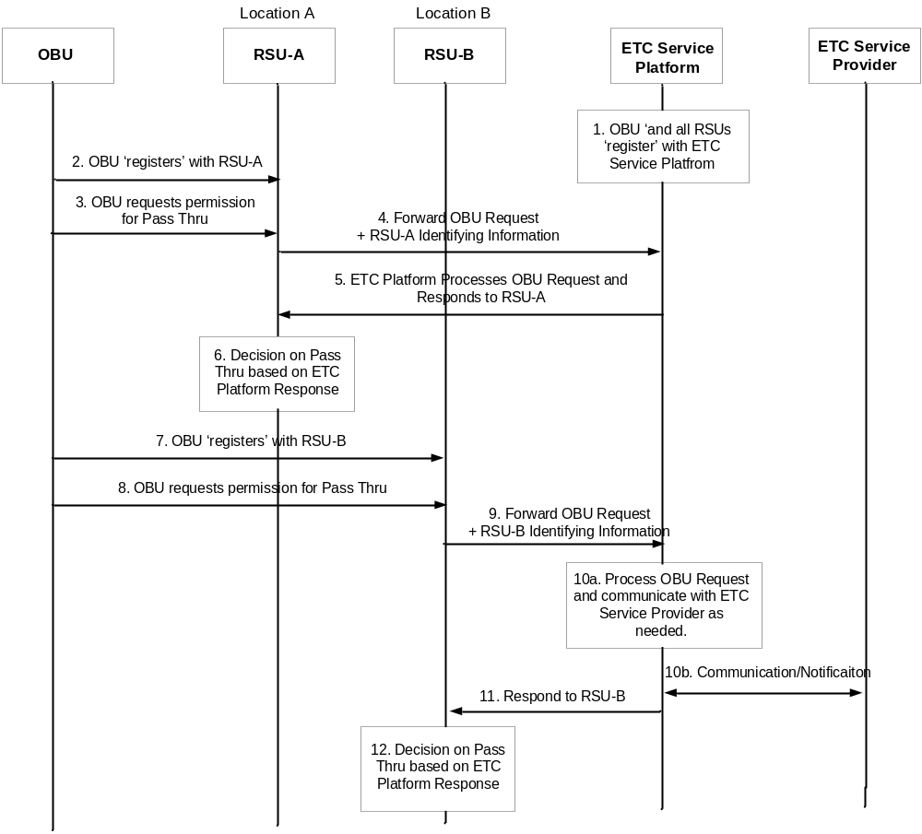

- Vehicle owner subscribes to ETC services and the OBU is 'registered' with the ETC Service Platform. All RSUs are also registered with the ETC Service Platform.

Note: The term 'registration' refers to communication and resulting contextual information of the registering entity at the registered entity.
- When the vehicle goes to a highway entrance (location A), OBU registers with RSU-A.
- The Vehicle (OBU) sends a request to ETC Service Platform via RSU-A asking for permission to pass through.
- RSU-A forwards the request from the OBU along with its own identifying information e.g. location information, to the ETC Service Platform.
- ETC Service Platform processes the request for the OBU, received from RSU-A, and responds to RSU-A. The processing at ETC Service Platform can include charging the 'toll' to OBU account and updating account balance etc., for the OBU. The response to RSU-A includes the recommended action for the OBU for pass through.
- RSU-A decides whether vehicle can pass through according to the response from the ETC Service Platform.
- The vehicle drives to the highway exit at location B, and OBU registers to RSU at location B (RSU-B).
- The vehicle sends a request to ETC Service Platform via RSU-B asking for permission for pass through.
- RSU-B forwards the request for the OBU along with its own information e.g. location information to the ETC Service Platform.
- ETC Service Platform processes the request for the OBU received from RSU-B. The processing at ETC Service Platform can include charging the 'toll' to OBU and updating account balance etc. for the OBU. The ETC Service Platform may communicate with the ETC Service Provider, as needed, while processing the request from the OBU.
- ETC Service Platform responds to RSU-B by including information such as the recommended action for the OBU to pass through.
- RSU-B decides whether vehicle can pass through according to the response from the ETC Service Platform.

  - Post-conditions (if any)

None

  - High Level Illustration (as applicable)

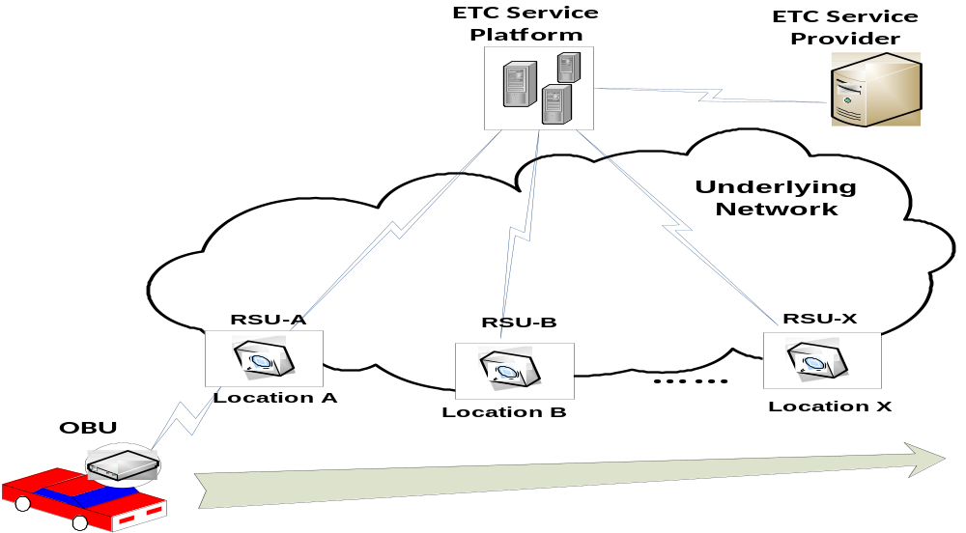

  - Potential requirements (as applicable)
  - TBD

-------------

