Input contribution
Use case
Use Case Title:* | Use cases for Triggering in Field Domain
Group Name:* | WG1
Source:* | Haier
Contact: | Yali Guo (guoyali@haierubic.com)
Date:* | 2014-05-30
Abstract:* | Propose to include the use case for field domain triggering in section 9 of TR 0001, when the device in not reachable by the gateway in field domain, the gateway could trigger the device to establish communication between the device and the gateway.
Agenda Item:*
Work item(s): | WI 0015 - oneM2M Use Case Continuation
Document(s)  Impacted* | Technical Specification TR 0001 - oneM2M Use Case Technical Report
Intended purpose of  document:* | Decision  Discussion  Information  Other <specify>
Decision requested or recommendation:* | Approval of the Use Case

oneM2M IPR STATEMENT
“Participation in, or attendance at, any activity of oneM2M, constitutes acceptance of an agreement to be bound by all provisions of IPR policy of the admitting Partner Type 1 and permission that all communications and statements, oral or written, or other information disclosed or presented, and any translation or derivative thereof, may without compensation, and to the extent such participant or attendee may legally and freely grant such copyright rights, be distributed, published, and posted on oneM2M’s web site, in whole or in part, on a non-exclusive basis by oneM2M or oneM2M Partners Type 1 or their licensees or assignees, or as oneM2M SC directs.

  - Title

Use case for Triggering in Field Domain.

  - Description

Smart Home is an important scenario that should be considered in OneM2M, in a general smart home scenario, home appliances such as air-conditioner, refrigerator, TV, etc. are managed by a home gateway, the home gateway connects to the infrastructure node which is provided by the service provider.

Most of the home appliances are not always power on, except the refrigerator. And for refrigerator, although it is always power on, but it may often shut off its wifi module, e.g. for power saving, when there’s no requirement to interact with the home gateway. This means the connection between a home appliance and the home gateway is often lost.

However, the user may want to control a home appliance through OneM2M system at any time, even when the communication connection between the home appliance and the home gateway is lost, e.g. the home appliance is power off or the home appliance has shut off its wifi module.

OneM2M has defined the triggering feature to wake up a device, to establish communication from the field domain towards the infrastructure domain when the device is not reachable by the infrastructure domain. However, the triggering feature defined in Rel-1 is only applicable to the devices or gateway which is directly registered to the infrastructure node.

But in the smart home scenario, the home gateway which is directly registered to the infrastructure node may always keep the connection with the infrastructure domain. The home appliances are registered to the home gateway, and the connection between the home appliance and the home gateway is often lost. When a user wants to control a home appliance which is not reachable by the home gateway, the field domain triggering is needed.

From our view, the smart home appliance could be assumed to support the infrared control, as people wants to control smart home appliances as well as traditional home appliances in their home. The smart home appliance also needs to support wifi to setup IP connection with home gateway in the OneM2M system.

So if the user wants to control a home appliance which is not reachable, e.g. the wifi module is shut off when the home appliance power off or sleep, the home gateway can use the infrared control to power on or wake up the home appliance, this will trigger the home appliance to restart its wifi module to establish communication from the home appliance towards the home gateway. Of course, the infrared control could also directly restart the wifi module in the home appliance.

After the communication between the home appliance and the home gateway is recovered, the home appliance is reachable and could be controlled by the user via OneM2M system.

  - Source

Haier

  - Actors
- User is one of the family members, which has privilege to control the home appliances in the home. User uses an application equipment to initiate the request to control a target home applicant in the home, and sends the request to the infrastructure node.
- Infrastructure node, which is an OneM2M Platform provide by a SP in the infrastructure domain.
- Home gateway is deployed in the field domain, used to manage the home appliances registered to the home gateway.
- Home appliance includes Air-conditioner, refrigerator, TV, etc. the home appliance uses wifi to setup IP connection between itself and the home gateway. The home appliance support more than communication protocols, e.g. wifi, infrared, Bluetooth, etc.

  - Pre-conditions

A smart air-conditioner registers its communication capability, e.g. wifi and infrared, to the home gateway. The home gateway and the AE are registered to the IN (Infrastructure Node). The IP connection between the gateway and the IN exists.
  - Triggers

None

  - Normal Flow
- The user powers off the air-conditioner and leaves home. Thus the IP connection between the air-conditioner and the home gateway is lost.
- After one day’s work, the user is on the road back home, he wants to power on the air-conditioner remotely, so the rooms will be in comfortable condition when he arrives home. The user uses his mobile phone as the application entity to send a request to the IN.
- IN forwards the request to the home gateway.
- After receiving the request from IN, Home gateway finds the IP connection between itself and the air-conditioner is lost, so it stores the received request locally.
- Home gateway tries to trigger the air-conditioner to be online. Home gateway knows the air-conditioner support both wifi and infrared communication methods, home gateway sends the infrared control command to the air-conditioner to power on the air-conditioner.
- After the air-conditioner power on, its wifi module establishes the IP communication towards the home gateway.
- Home gateway finds the air-conditioner is online, it forwards the request message locally stored to the air-conditioner.

  - Post-conditions (if any)

The user successfully controls the home appliance via OneM2M system.

  - High Level Illustration (as applicable)

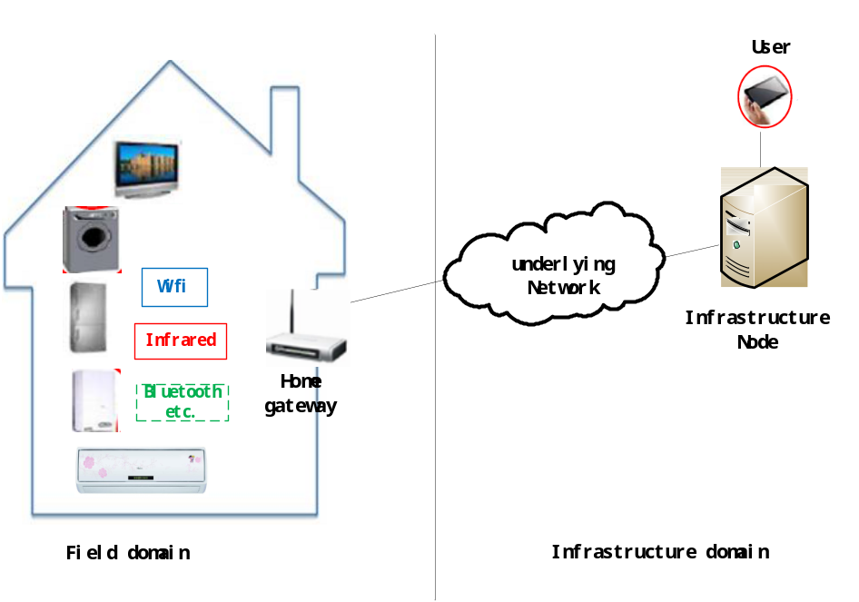

  - Potential requirements (as applicable)
- The M2M systems shall support the M2M device to register its communication capabilities to the M2M gateway.
- If the M2M device supports multiple communication channels, one of the communication channels could be used by the M2M system to trigger the setup of another communication channel in the field domain.

