Input contribution
Use case
Use Case Title:* | Use case for Device CachingRin Home Domain
Group Name:* | WG1
Source:* | KETI
Contact: | Sungchan Choi (csc@keti.re.kr)  Yong-Suk Park (yspark@keti.re.kr)  Jaeho Kim (jhkim@keti.re.kr)
Date:* | 2014-10-23
Abstract:* | Propose to include the use case for Home Domain Enablement TR.
Agenda Item:*
Work item(s): | WI 0017 – Home Domain Enablement
Document(s)  Impacted* | Technical Specification TR 0013 – Home Domain Enablement TR
Intended purpose of  document:* | Decision  Discussion  Information  Other <specify>
Decision requested or recommendation:* | Approval of the Use case for the Home Domain Enablement TR

oneM2M IPR STATEMENT
“Participation in, or attendance at, any activity of oneM2M, constitutes acceptance of an agreement to be bound by all provisions of IPR policy of the admitting Partner Type 1 and permission that all communications and statements, oral or written, or other information disclosed or presented, and any translation or derivative thereof, may without compensation, and to the extent such participant or attendee may legally and freely grant such copyright rights, be distributed, published, and posted on oneM2M’s web site, in whole or in part, on a non-exclusive basis by oneM2M or oneM2M Partners Type 1 or their licensees or assignees, or as oneM2M SC directs.

6.x Use case for Device Caching in Home Domain

6.x.1 Overview

56.x.1.1 Description

In home environments, various home appliances are used. Among the home appliances, some appliances such as fans, heaters, and air conditioners are only used during certain seasons of the year.

In oneM2M system, every device registers its information with the oneM2M system in order to receive oneM2M services. Therefore, when a device is powered on, the device needs to check whether it is registered with the oneM2M system or not.

For example, consider a scenario where an air conditioner is registered with a home gateway, and the home gateway is registered with a home server in infrastructure domain. Usually, the air conditioner is actively used in summer, rarely used in autumn, and never used in winter.

Through the registration process, each device can make use of the oneM2M functionality that is supported between M2M devices. However, the registration information for each device has a life time value. The value is a timer that indicates how long the information is valid in the registrar server or gateway. After the timer is expired, the registered information is deleted in the registrar server or gateway.

Therefore, when the air conditioner is actively used in summer, the registered information is frequently accessed and updated.

However, in winter, since the air conditioner is not used, the registered information of the air conditioner is not updated. As a consequence, the life time value is not updated and is expired, and the registered information regarding the air conditioner is removed from the oneM2M system.

In this situation, if the air conditioner is to be used again next summer, the air conditioner needs to register its information with the gateway or server again because the registration information was deleted. Hence, this kind of re-registration process can be an additional overhead to oneM2M system.

InAanother scenario, there are situations when an appliance installed in the home environment needs to be replaced due to faulty behavior. robably ch

In addition, under certain circumstances, a normal, working appliance may need to be replaced with a newer model because it is outdated. During replacement, the old device is de-registered, and the new device is registered with the oneM2M system. In this case, if the old device and new device are of the same model, it could be inefficient to delete and re-create the same or similar registration informationtnefficiency becausmation needs todeleere-created iyst

Therefore, when a home appliance is not used actively for a certain period of time or when a home appliance is replaced with a new appliance of the same model, the oneM2M system can improve its efficiency by supporting a caching mechanism for the registered information, instead of deleting and re-registering the same or similar information.

65.x.1.2 Source

KETI

65.x.1.3 Actors

Home appliances

are common, general home appliances, such as lighting, refrigerator, washing machine, etc. Specific home appliances are actively used duringin a cin seasons of the year onlyand ar. fan, air conditioner, heater, hot-air blower).

Home gateway

is a device which supports communication technology enabling each home appliance to be connected via Zigbee, Wifi, Bluetooth, etc. and each home appliance can register its information with the home gateway.

Home server

is a oneM2M platform provided by a service provider in the infrastructure domain. The home gateway registers its information with the home server.

65.x.1.4 Pre-condition

An air conditioner is registered with a home gateway, and it is actively used in the summer. The home gateway is registered with home server.

56.x.1.5 Triggers

None

56.x.1.6 Normal Flow

The air conditioner is rarely used in autumn and not used at all in winter. winter, the air conditioner is not used at all. Since the air conditioner is not used in winter, the air conditioner related registration information in the home gateway is not updated and not manipulated. This situation causes the life time value to be expired and then the registration information is deleted.

In this situation, if the home gateway andthe supports caching mechanism regarding its registered information, the information can be moved to a temporary repository. (Home server also supports caching mechanism regarding its registration information e.g. home gateway or home appliances directly registered with home server)

In this scenario, to support cache mechanism, the home gateway may move the resources regarding the air conditioneror example, the information to a cache-bin or the home .

When summer comes, the air conditioner is used again and starts running. At this time, the home gateway thebecomes aware ofre- the re-activation of the air conditioner and recovers the resources regarding the air conditioner from the cache-bin.

After restoring all cached information, the air conditioner provides oneM2M services by using the recovered registration information

56.x.1.7 Post-conditions

The air conditioner provides oneM2M services by using its registered information, and it also updates its resources. It runs normally as part of the oneM2M system.

56.x.1.8 High Level Illustration

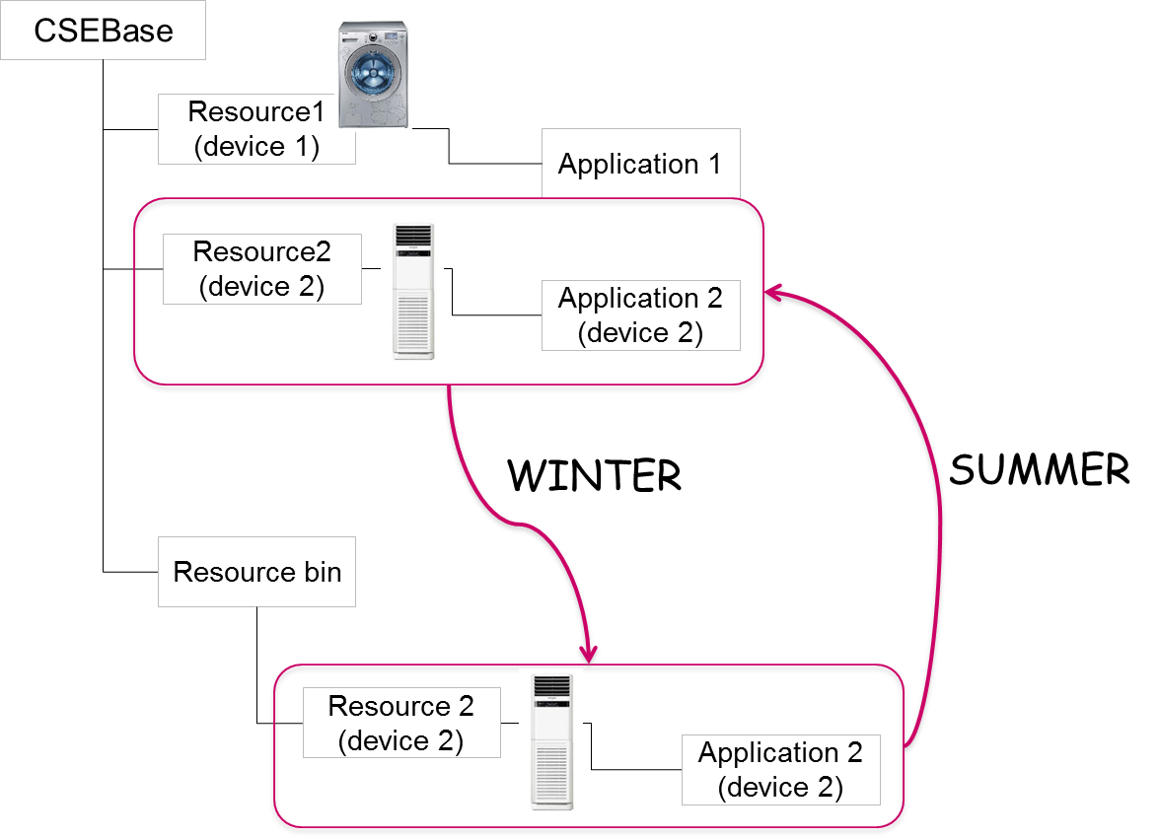

6.x.2 High Level Analysis

6.x.2.1 Functional Impacts

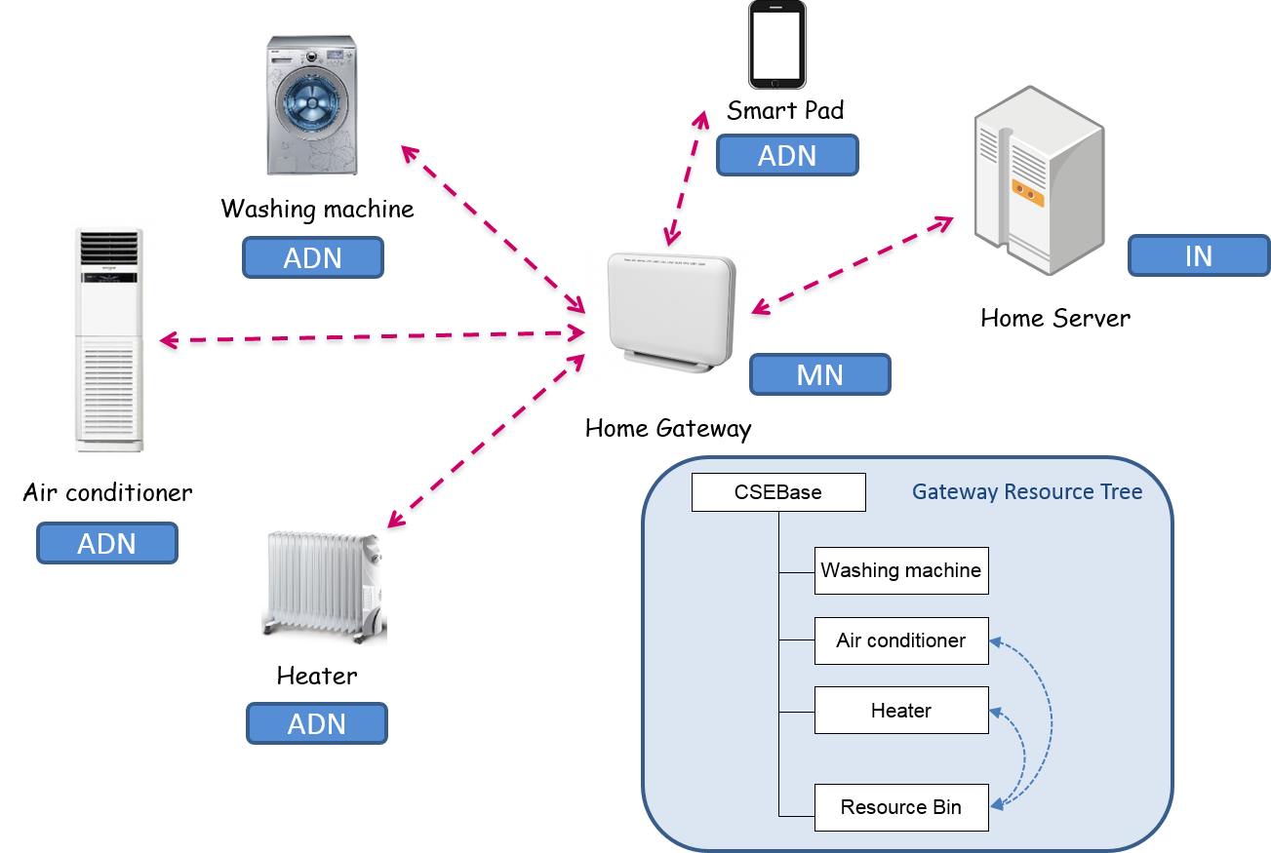

In oneM2M configurations, the washing machine, the air conditioner, and the heater can be interpreted as ADN (Application Dedicated Node). The home gateway and the home server can be interpreted as MN (Middle Node) and IN (Infrastructure Node), respectively.

Each home appliance needs to register its information with the home gateway. The relevant resources are created in the resource tree of the home gateway. When the registration resource can be created in the home gateway, the attribute value related with cache intention is set. (Registration).

The resource tree of the home gateway supports a cache bin structure which can be used for saving resources temporarily (Resource cache bin).

When the registered resources need to be deleted because the expiration timer is expired, the home gateway checks the attribute value representing cache intention. If the attribute value is set, the home gateway moves the registered information relevant to the air conditioner to the cache bin (Resource Caching).

When the air conditioner is used again, the home gateway recovers the relevant registered information from the cache bin (Resource Recovery).

6.x.2.2 High Level Information Flows

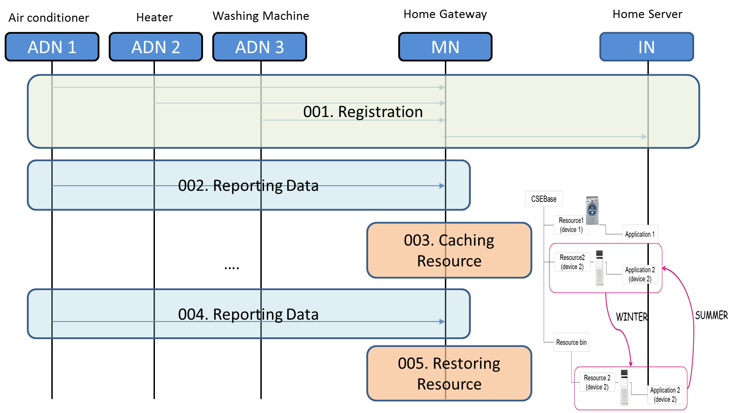

001: ADNs1, 2, and 3 register their respective information with MN. In addition, MN registers its information to the IN.

002: The air conditioner (ADN1) generates data and sends its data to the home gateway (MN). The resource regarding ADN1 in the MN is updated and refreshed.

003: The air conditioner is not used for some period of time (e.g. winter season). The MN detects this situation and caches the resources relevant to the air conditioner to its cache bin.

004: When the air conditioner (ADN1) is used again (e.g. summer season), the air conditioner sends its data to the home gateway (MN)

005: The home gateway (MN) detects that the air conditioner is active again and restores the resources relevant to the air conditioner (ADN1) from the cache bin.

56.x1.3. Potential requirements

The oneM2M system shall support resource caching of registered M2M Devices.

The oneM2M system shall support resource restoration of registered M2M Devices.

The oneM2M system shall support the decision mechanism about the registered M2M Devices need to be cache or not when the expiration timer regarding the resources is expired.

