Input contribution
Use case
Use Case Title:* | Use case for Conflict Management in Home Automation System
Group Name:* | WG1
Source:* | KETI
Contact: | Sungchan Choi (csc@keti.re.kr)  Yong-Suk Park (yspark@keti.re.kr)  Jaeho Kim (jhkim@keti.re.kr)
Date:* | 2014-10-23
Abstract:* | Proposes to include the use case for Home Domain Enablement TR.
Agenda Item:*
Work item(s): | WI 0017 – Home Domain Enablement
Document(s)  Impacted* | Technical Specification TR 0013 – Home Domain Enablement TR
Intended purpose of  document:* | Decision  Discussion  Information  Other <specify>
Decision requested or recommendation:* | Approval of the Use case for the Home Domain Enablement TR

oneM2M IPR STATEMENT
“Participation in, or attendance at, any activity of oneM2M, constitutes acceptance of an agreement to be bound by all provisions of IPR policy of the admitting Partner Type 1 and permission that all communications and statements, oral or written, or other information disclosed or presented, and any translation or derivative thereof, may without compensation, and to the extent such participant or attendee may legally and freely grant such copyright rights, be distributed, published, and posted on oneM2M’s web site, in whole or in part, on a non-exclusive basis by oneM2M or oneM2M Partners Type 1 or their licensees or assignees, or as oneM2M SC directs.

6.x Use case for Conflict management in Home Automation System

6.x.1 Overview

6.x.1.1 Description

Smart home service is usually provided using home automation system along with home monitoring system. For example, in the smart home system, the lights in a room turn on and off automatically as a person enters or leaves the room.

In home domain environment, there are various home appliances that are connected to a home gateway or a home server. Those home appliances can be managed and controlled through the home automation system/application.

For example, a smart home application can control a window blind at home according to the time of the day. Based on this rule, if it is sunset time, the window blind can be unfolded, and if it is sunrise time, the window blind can be folded. On the other hand, another smart home application may control the window blind based on the amount of the sunlight.

Situation may occur where one application is willing to pull down the window blind according to the time of the day and the other application is willing to draw up the window blind according to the amount of sunlight. This causes the following problem: which rule has priority over the other rule? This situation is referred to as conflict problem, and it could occur frequently in smart home systems.

The oneM2M gateway/server can manage a number of registered home appliances such as window blinds, doors, thermostats, sprinklers, etc. Each home appliance should be managed and controlled by the oneM2M gateway/server in a harmonized way, in order to provide users with comfortable home environments.

For example, let us consider a home automation system which includes sprinkler, temperature sensor, moisture sensor, water main valve controller, etc. Let’s suppose that a fire breaks out in the house, and the temperature sensor detects the fire. As soon as this situation occurs, the home automation system activates the sprinkler to extinguish the fire. However, if the sprinkler sprays water for some time, this causes the moisture sensor to detect flooding of the floor.

The information from the moisture sensor is regarded by the home automation system as flood conditions. The home automation system controls the water main to close. This causes the sprinkler not to work, and the house may be damaged by the fire. This kind of situation is not a desired situation in the home automation system. Therefore, when the home automation system is adapted in the oneM2M system, it should have some means to control home devices harmoniously.

6.x.1.2 Source

KETI

6.x.1.3 Actors

Home appliances

include temperature sensors, moisture sensors, sprinklers, water main pumps, refrigerators, washing machines, etc. Every home appliance needs to register its registration information with a home server.

Home gateway

enables each home appliance to be connected through Zigbee, Bluetooth, Wifi, etc. and delivers data from the home appliances to the home server. It manages the resources based on the registration information of the home appliances.

Home server

Is an oneM2M platform provided by a service provider in the infrastructure domain.

Smart Pad

is able to gather sensing information from sensor installed in home environments and is a controller for actuators in home.

Emergency system

Is a detection system regarding emergency situation and enables equipment and appliances to be controlled via the system

and resources

6.x.1.4 Pre-condition

Every home appliance is registered with a home gateway, and the home gateway is registered with the home server. Each home appliance is controlled via the home gateway from smart pad and emergency system. The home gateway or home server manages the resources of home appliances.

6.x.1.5 Triggers

None

6.x.1.6 Normal Flow

A fire breaks out in one of the rooms at home. In this situation, a temperature sensor detects the fire from one of the rooms.

Application in smart pad detects fire situation and control the sprinkler to be activated and spray water over the fire.

At this time, the floor of the room is getting flooded because of the water from sprinkler. A moisture sensor detects the water in the floor.

Application in smart pad detects water alarm and controls the water main valve to close.

Because the application in smart pad does not support the capability of conflict resolving function regarding control of resources in home automation system

However, emergency system supports the conflict resolving capability and the emergency systems send control message with high priority and then water main valve opens and sprinkler is activated again.

Application in smart pad detects the water main open and try to control the water main close but the priority of control message from application in smart pad is lower than emergency system and hence, the control message from the smart pad is ignored and water main valve open until the fire is extinguished.

6.x.1.7 Post-conditions

The fire is successfully extinguished, and home appliances are managed and controlled in a harmonious way.

6.x.1.8 High Level Illustration

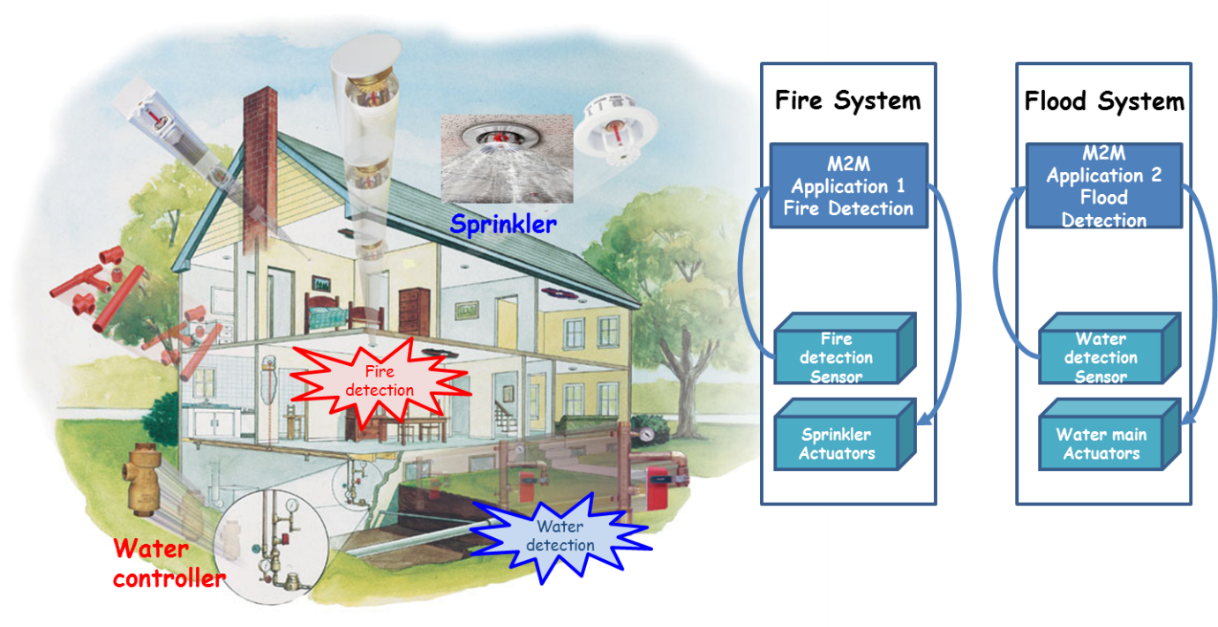

6.x.2 High Level Analysis

6.x.2.1 Functional Impacts

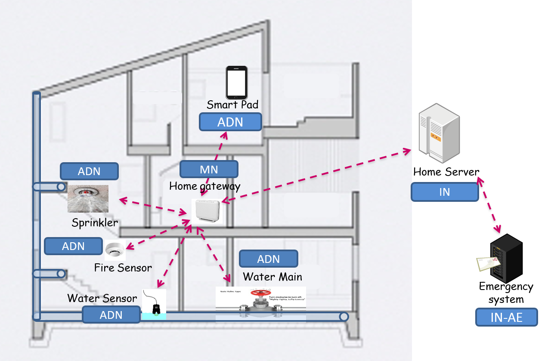

In oneM2M configurations, the sprinkler, the water main, the fire sensor, the water sensor, and the smart pad can be interpreted as ADNs (Application Dedicated Nodes). The home gateway and the home server can be interpreted as MN (Middle Node) and IN (Infrastructure Node). Emergency system can be interpreted as IN-AE.

Each device registers its information with the home gateway and the home gate way and emergency system are registered with home server (Registration).

The fire sensor and the water sensor report sensing information to the home gateway (Container creation, contentInstance creation).

The sprinkler and the water main are connected to the home gateway and can be actuated by device management technology via the home gateway (Device control/device status check).

The fire sensor sends information about fire detection in the room. The application in smart pad subscribed the fire sensor information and is notified with fire alarm. Using this information, the application in smart pad sends control message to activate the sprinkler (Device control based on sensing data).

The water sensor detects water in the floor, and this information is also notified to the application in smart pad. Using this information, the application in smart pad sends control message and this causes the water main to close (Device control based on sensing data).

The emergency system subscribed the resources in the gateway and is notified with deactivation of sprinkler and water main valve close. Since the emergency system supports conflict resolving capability and hence, send the control message with high priority to activate sprinkler and water main valve open before the fire is extinguished. (Priority-based resource control)

If oneM2M system support priority based resource control, the control message from emergency system is higher than the application in smart pad and hence the water main valve opens, and the sprinkler is activated again (Conflict management of control resources).

6.x.2.2 High Level Information Flows

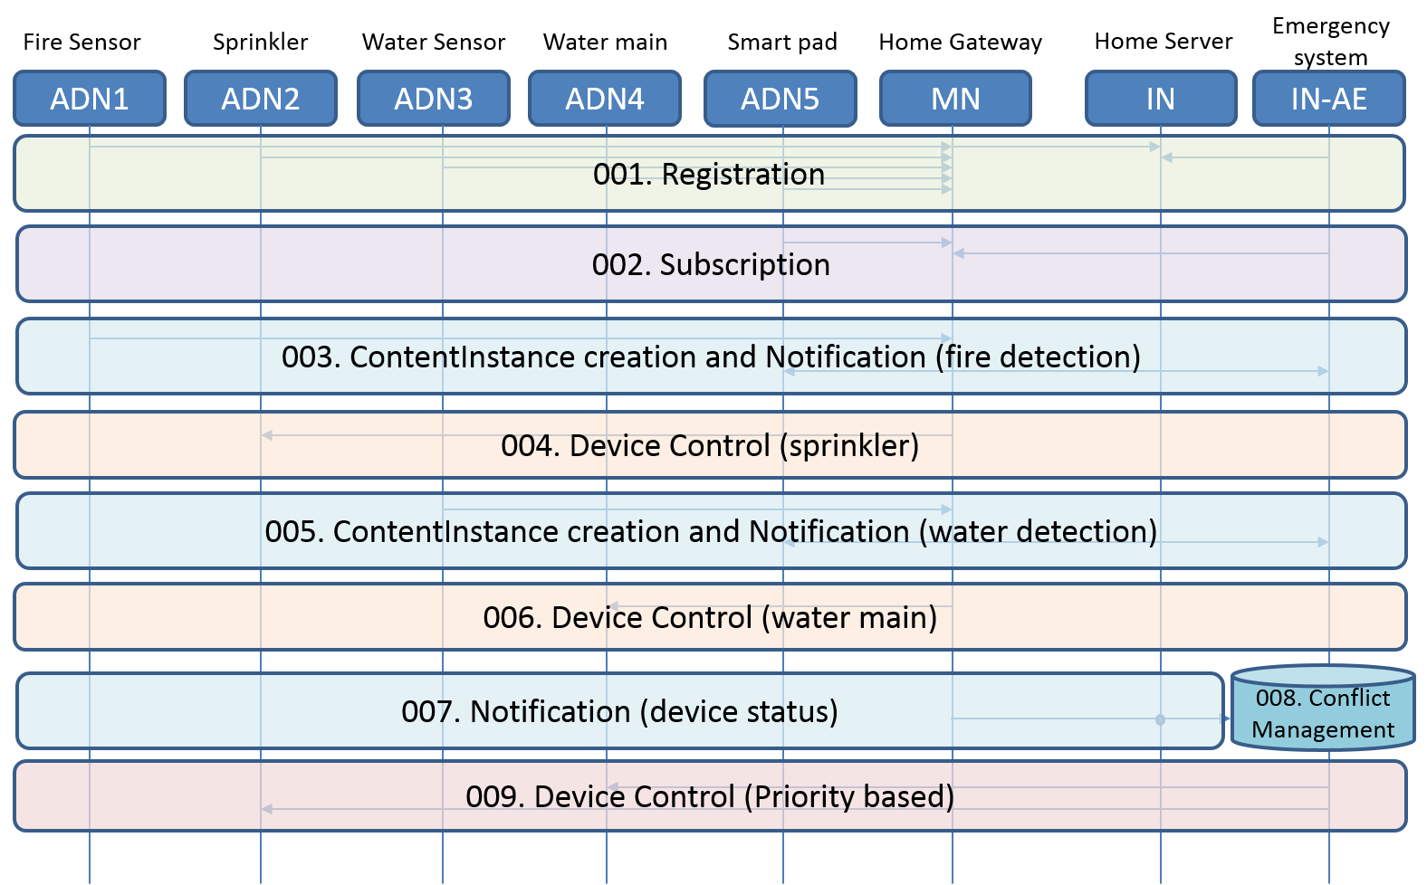

001: ADNs 1, 2, 3, 4, and 5 register their information with MN. MN is registered with IN and IN-AE also is registered with IN. ADNs 1 and 2 create container for their respective data in MN.

002: ADN5 and IN-AE create subscription resource in the MN in order to receive notification when new contentInstance is created.

003:

The fire sensor (ADN1) detects fire, generates sensing data, and delivers the data to MN. This leads to the delivery of notification message to ADN5 and IN-AE.

004: Based on the delivered information, i.e. fire detection, the application in smart pad sent control message to the MN and the sprinkler (ADN2) is activated and sprays water over the fire.

005: The water sensor (ADN3) detects water on the floor, generates sensing data, and delivers the data to MN. This leads to the delivery of notification message to ADN5 and IN-AE.

006: Based on the delivered information, i.e. water detection, the application in smart pad sent control message to the MN and the water main (ADN4) valve is closed. This causes deactivation of the sprinkler.

007: The fire sensor (ADN1) and the water sensor (ADN3) report their data to MN repeatedly. The status of sprinkler and water main valve is reported to the MN. This information can be delivered to the IN-AE which previously subscribed to resources in MN.

008: Based on the sensing data from both fire and water sensors and the status of the sprinkler and water main valve, the IN-AE recognizes a conflicting situation regarding device control and resolves the conflict

009: The emergency system (IN-AE) sends the control message with high priority. The MN receives this message and then the water main valve open and sprinkler is activated. The control message (i.e. water main close) from ADN5 can be ignored because the priority is lower than the emergency system.

6.x.3 Potential requirements

The oneM2M System shall provide a conflict resolution mechanism (e.g. priority and policy) when a number of applications access the resource regarding the same M2M device and control the M2M device at the same time.

