Input contribution
Use case
Use Case Title:* | Moving Field Domain Triggering use case from TR0001 to TR0013
Group Name:* | WG1
Source:* | Haier
Contact: | Zhang Jun, Haier,zhangjun@haierubic.com  Yali Guo, Haier, guoyali@haierubic.com
Date:* | 2015-01-12
Abstract:* | The Field Domain Triggering use case was approved at TP#11 (the doc num is REQ-2014-0447) in TR0001. After the approval of the Home Domain Enablement WID, according to the WG1 decision, this use case should also be captured in TR0013. This contribution moves the Field Domain Triggering use case from TR0001 to TR0013 and adds a new section “6.x.2 High Level Analysis” according to the TR0013 template.  R01: update the text of potential requirements based on the offline discussion
Agenda Item:* | TBD
Work item(s): | WI 0017 – Home Domain Enablement
Document(s)  Impacted* | TR 0013 – Home Domain Enablement Technical Report
Intended purpose of  document:* | Decision  Discussion  Information  Other <specify>
Decision requested or recommendation:* | Approval of the Use case for the Home Domain Enablement TR

oneM2M IPR STATEMENT
“Participation in, or attendance at, any activity of oneM2M, constitutes acceptance of an agreement to be bound by all provisions of IPR policy of the admitting Partner Type 1 and permission that all communications and statements, oral or written, or other information disclosed or presented, and any translation or derivative thereof, may without compensation, and to the extent such participant or attendee may legally and freely grant such copyright rights, be distributed, published, and posted on oneM2M’s web site, in whole or in part, on a non-exclusive basis by oneM2M or oneM2M Partners Type 1 or their licensees or assignees, or as oneM2M SC directs.

6.x Use case for Triggering in Field Domain

6.x.1 Overview

6.x.1.1 Description

Smart Home is an important scenario that should be considered in OneM2M, in a general smart home scenario, home appliances such as air-conditioner, refrigerator, TV, etc. are managed by a home gateway, the home gateway connects to the infrastructure node which is provided by the service provider.

Most of the home appliances are not always power on, except the refrigerator. And for refrigerator, although it is always power on, but it may often shut off its wifi module, e.g. for power saving, when there’s no requirement to interact with the home gateway. This means the connection between a home appliance and the home gateway is often lost.

However, the user may want to control a home appliance through OneM2M system at any time, even when the communication connection between the home appliance and the home gateway is lost, e.g. the home appliance is power off or the home appliance has shut off its wifi module.

OneM2M has defined the triggering feature to wake up a device, to establish communication from the field domain towards the infrastructure domain when the device is not reachable by the infrastructure domain. However, the triggering feature defined in Rel-1 is only applicable to the devices or gateway which is directly registered to the infrastructure node.

But in the smart home scenario, the home gateway which is directly registered to the infrastructure node may always keep the connection with the infrastructure domain. The home appliances are registered to the home gateway, and the connection between the home appliance and the home gateway is often lost. When a user wants to control a home appliance which is not reachable by the home gateway, the field domain triggering is needed.

From our view, the smart home appliance could be assumed to support the infrared control, as people wants to control smart home appliances as well as traditional home appliances in their home. The smart home appliance also needs to support wifi to setup IP connection with home gateway in the OneM2M system.

So if the user wants to control a home appliance which is not reachable, e.g. the wifi module is shut off when the home appliance power off or sleep, the home gateway can use the infrared control to power on or wake up the home appliance, this will trigger the home appliance to restart its wifi module to establish communication from the home appliance towards the home gateway. Of course, the infrared control could also directly restart the wifi module in the home appliance.

After the communication between the home appliance and the home gateway is recovered, the home appliance is reachable and could be controlled by the user via OneM2M system.

6.x.1.2 Source

Haier

6.x.1.3 Actors

User
is one of the family members, which has privilege to control the home appliances in the home. User uses an application equipment to initiate the request to control a target home applicant in the home, and sends the request to the infrastructure node.

Infrastructure node
which is an OneM2M Platform provide by a SP in the infrastructure domain.

Home gateway
is deployed in the field domain, used to manage the home appliances registered to the home gateway.

Home appliance
includes Air-conditioner, refrigerator, TV, etc. the home appliance uses wifi to setup IP connection between itself and the home gateway. The home appliance support more than communication protocols, e.g. wifi, infrared, Bluetooth, etc.

6.x.1.4 Pre-condition

A smart air-conditioner registers its communication capability, e.g. wifi and infrared, to the home gateway. The home gateway and the AE are registered to the IN (Infrastructure Node). The IP connection between the gateway and the IN exists. The infrastructure node configures the home gateway for the purpose of triggering devices behind the gateway.

6.x.1.5 Triggers

None

6.x.1.6 Normal Flow

The user powers off the air-conditioner and leaves home. Thus the IP connection between the air-conditioner and the home gateway is lost.

After one day’s work, the user is on the road back home, he wants to power on the air-conditioner remotely, so the rooms will be in comfortable condition when he arrives home. The user uses his mobile phone as the application entity to send a request to the IN.

IN forwards the request to the home gateway.

After receiving the request from IN, Home gateway finds the IP connection between itself and the air-conditioner is lost, so it stores the received request locally.

Home gateway tries to trigger the air-conditioner to be online. Home gateway knows the air-conditioner support both wifi and infrared communication methods, home gateway sends the infrared control command to the air-conditioner to power on the air-conditioner.

After the air-conditioner power on, its wifi module establishes the IP communication towards the home gateway.

Home gateway finds the air-conditioner is online, it forwards the request message locally stored to the air-conditioner.

6.x.1.7 Post-conditions
The user successfully controls the home appliance via OneM2M system.

6.x.1.8 High Level Illustration
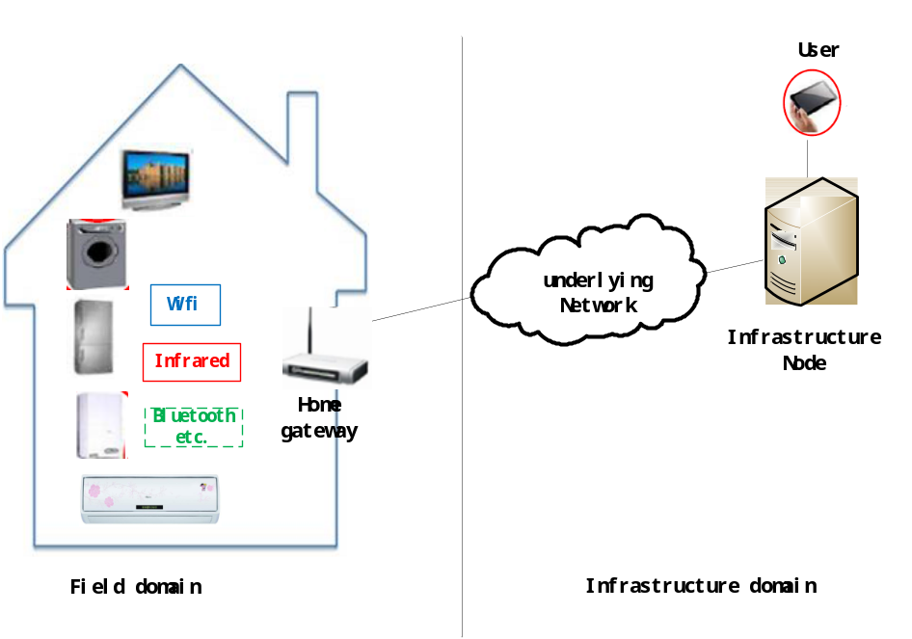

6.x.2 High Level Analysis

6.x.2.1 Functional Impacts

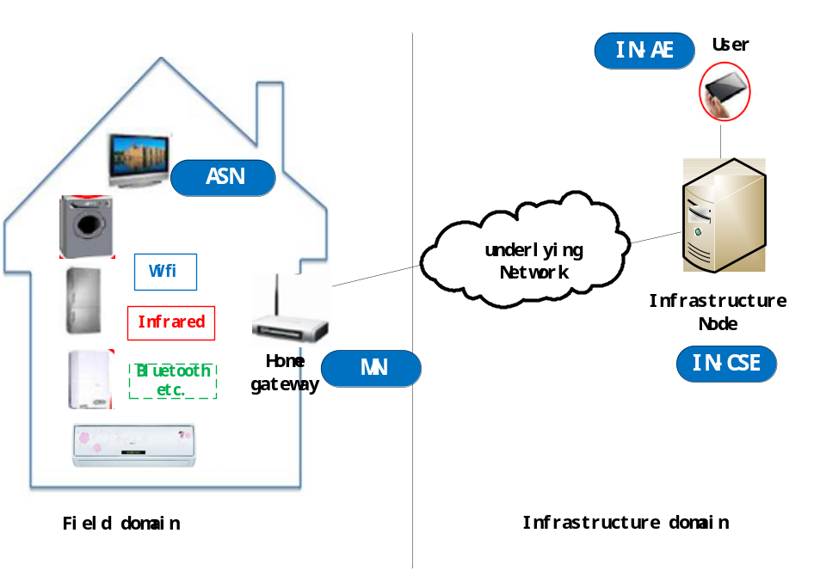

In oneM2M configurations, home appliances, for example the TV can be interpreted as the ASN (Application Service Node). The home gateway can be interpreted as the MN (Middle Node). The user device such as the user’s smart phone that is registered with the IN can be interpreted as the IN-AE (Infrastructure Node-AE). The cloud server can be interpreted as the IN (Infrastructure Node).

To enable this service, the IN configures the MN for the purpose of triggering devices behind the MN and the ASN should provide its communication capabilities to the MN. The communication capabilities include the information for example, supporting Infrared and the Infrared control code; supporting Wifi and the SSID; supporting SMS and the MSISDN.

The MN keeps the communication capabilities received from the ASN-CSE.

With the configurations of ASN triggering configured by the IN, when the MN receives the request to ASN, but the ASN is not online, the MN triggers the ASN to be online (e.g. by Infrared control) or ask the IN-CSE to trigger the ASN to be online (e.g. by SMS).

6.x.2.2 High Level Information Flows

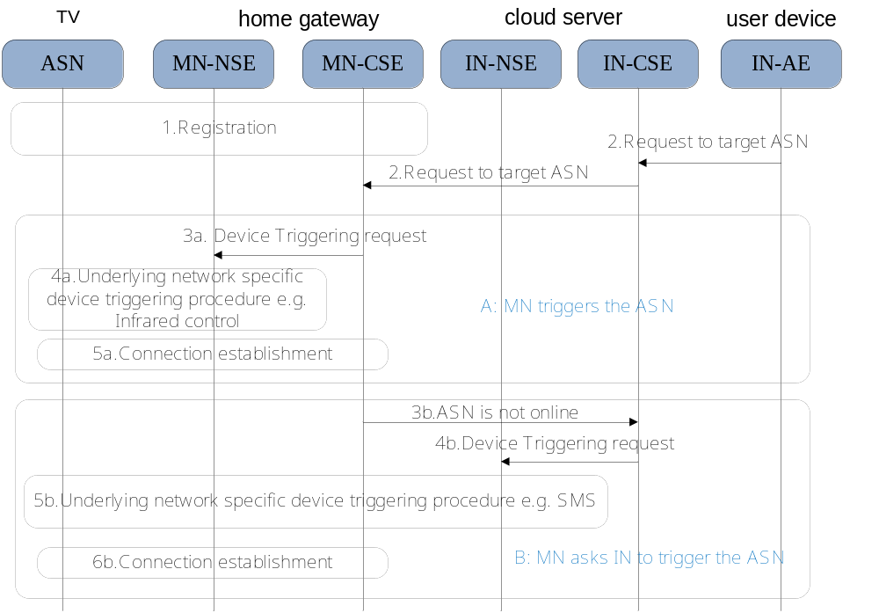

1. When the ASN registers with the MN successfully, the ASN provides its communication capabilities e.g., the information of supporting Infrared and the Infrared control code; supporting Wifi and the SSID; supporting SMS and the MSISDN, to the MN.

2. The MN receives a request towards the target ASN, but the ASN is not online.

3a. The MN determines it can trigger the ASN directly based on the configurations of ASN triggering configured by the IN. The MN-CSE sends the Device Triggering request to MN-NSE over Mcn.

4a. The MN-NSE performs underlying network specific device triggering procedure to trigger the ASN to setup IP connection with the MN-CSE. For example, the ASN supports both Wifi and Infrared control, but the Wifi connection is lost. The MN sends Infrared control command to control the ASN restart its Wifi module and reconnect to the MN again.

5a.The connection between the MN and the ASN is reestablished.

3b. Alternatively, when the ASN can’t be triggered by the MN, the MN can request the IN to trigger the ASN. The ASN’s communication capabilities may also be notified. One example of this scenario: the ASN supports both wifi and SMS, when the Wifi connection is lost, the MN requests the IN to trigger the ASN by SMS.

4b. The IN-CSE sends the Device Triggering request to the IN-NSE over Mcn.

5b. The IN-NSE performs underlying network specific device triggering procedure to trigger the ASN to setup IP connection with the MN-CSE. For example, the IN-NSE sends a SMS to control the ASN restart its Wifi module and reconnect to the MN again.

6b. The connection between the MN and the ASN is reestablished.

6.x.3 Potential Requirements

The M2M system shall provide mechanisms to communicate with M2M gateways for the purpose of triggering devices behind the gateway.

The M2M system shall support the M2M device to register its communication capabilities to the M2M gateway for the purpose of device triggering.

If the M2M device supports multiple communication channels, one of the communication channels could be used by the M2M system to trigger the setup of another communication channel in the field domain.

