Input contribution
Use case
Use Case Title:* | QoS/QoI monitoring in industrial domain
Group Name:* | WG1
Source:* | KETI (Sung-Chan Choi, Ting Miao, Minu Ryu, Jaeho Kim)  LGU+ (Michael HS. Yang)
Contact: | csc@keti.re.kr
Date:* | 2015-07-22
Abstract:* | Propose to include in TR-0018
Agenda Item:* | TBD
Work item(s): | WI 0028
Document(s)  Impacted* | TR 0018
Intended purpose of  document:* | Decision  Discussion  Information  Other <specify>
Decision requested or recommendation:* | <A concise statement of the decision required or the recommended action to be taken>
Template Version:23 February 2015 (Dot not modify)

oneM2M Notice
The document to which this cover statement is attached is submitted to oneM2M. Participation in, or attendance at, any activity of oneM2M, constitutes acceptance of and agreement to be bound by terms of the Working Procedures and the Partnership Agreement, including the Intellectual Property Rights (IPR) Principles Governing oneM2M Work found in Annex 1 of the Partnership Agreement.

Title
QoS/QoI monitoring in industrial domain

Description
In factories, a lot of data are generated from M2M devices (e.g. machines and program logic controllers) and the data are delivered to the M2M gateway via industrial bus system, e.g. Real-time Ethernet. In addition, factory management application can get factory status information through oneM2M Service platform (Infrastructure Node) which gathers data from M2M gateways located in each factory domain.
In local industrial communications, data packet transmission between M2M gateway and M2M devices has real-time transmission characteristic delivered over Ethernet-based communication system. However, for allowing remote mechanisms (remote supervisory, operation, service), Wide Area Networks is composed of broad and heterogeneous communication technologies, e.g. digital wireless telecommunication systems (GSM-based, UMTS-based), digital wired telecommunication systems (ISDN, DSL).
In this environment, M2M gateway can use various telecommunication system to send and receive data packet from oneM2M service platform. In addition, according to industrial application service types, it requires hard real-time data delivery, soft real-time data delivery or real-time not requiring data delivery when it comes to communication between M2M gateway and oneM2M service platform.
If quality of service (QoS) required from the application could not be guaranteed, this situation limits service scenarios in industrial domains. In order to prevent this situation, M2M gateway can decrease the volume of data needs to send the oneM2M platform via data processing based on data catalogue. At the same time, if M2M gateway can monitor network environments, it can choose dynamically the network type or network provider who guarantees the required QoS.
In addition, for satisfying QoS, real-time data generated from M2M devices can be pre-processed/filtered based on data catalogue. In this situation, post-processed data is to include a kind of quality of information (QoI) and if QoI monitored and delivered to the oneM2M service platform, we can use this information for the further data processing in oneM2M platform.
This use case proposes that oneM2M system offers QoS/QoI Monitoring capabilities which include data accuracy, data age, cost, communication, encryption and so on.

Source
None

Actors
- M2M Devices: Sensors, controllers etc. located in factories (e.g. located at product lines) which measure and generate data. PLC (Programmable Logic Controller) /DCS (Distributed Control System) control sensors in production lines according to embedded programs.
- Real-time Ethernet: A technology standardized in IEC TC65 for use in industrial control system.
- MN Gateway (MN): It provides an interface from the Real-time Ethernet to the oneM2M system. The gateway collects data from M2M devices which are connected via Real-Time Ethernet communication technology. The gateway can conduct data pre-processing/filtering based on the data catalog delivered from oneM2M service platform.
- oneM2M Service Platform (IN): It acts as oneM2M Infrastructure Node. It communicates with MNs in the remote industrial domains and gathers the data from the MN gateway. The data in oneM2M service platform can be delivered to the applications, e.g. factory monitoring application.
- Applications: An M2M application in application service provider domain. It conducts monitoring production lines and sends analysis results or alert message to factory administrator

Pre-conditions
- Devices (e.g. PLC, Machines) and gateway are connected to Real-time Ethernet. PLCs broadcast data to Real-time Ethernet.
- Gateway can have a capability of various network hardware interfaces (e.g. GSM-based, UMTS-based, ISDN, DSL) and also use various network service provider who guarantees the required QoS level.

Triggers
- Application initiates service which require QoS/QoI requirement (e.g. response time, data freshness).
- Application sends the QoS/QoI requirement to oneM2M platform.

Normal Flow
- oneM2M service platform requests QoS/QoI monitoring data from Gateway (MN) and based on this information, oneM2M service platform negotiates supported QoS/QoI parameter with application.
- For enabling end-to-end services, oneM2M service platform sends QoS requirement to the Gateway (MN). Based on QoS requirement, Gateway dynamically choose network type and network service provider who guarantees the required QoS level.
- In Gateway, QoS/QoI monitoring function can annotate data with quality information.
- After receiving data from Gateway (MN), oneM2M service platform can be further processing the data referring to the quality attributes.

Alternative flow
None

Post-conditions
None.

High Level Illustration
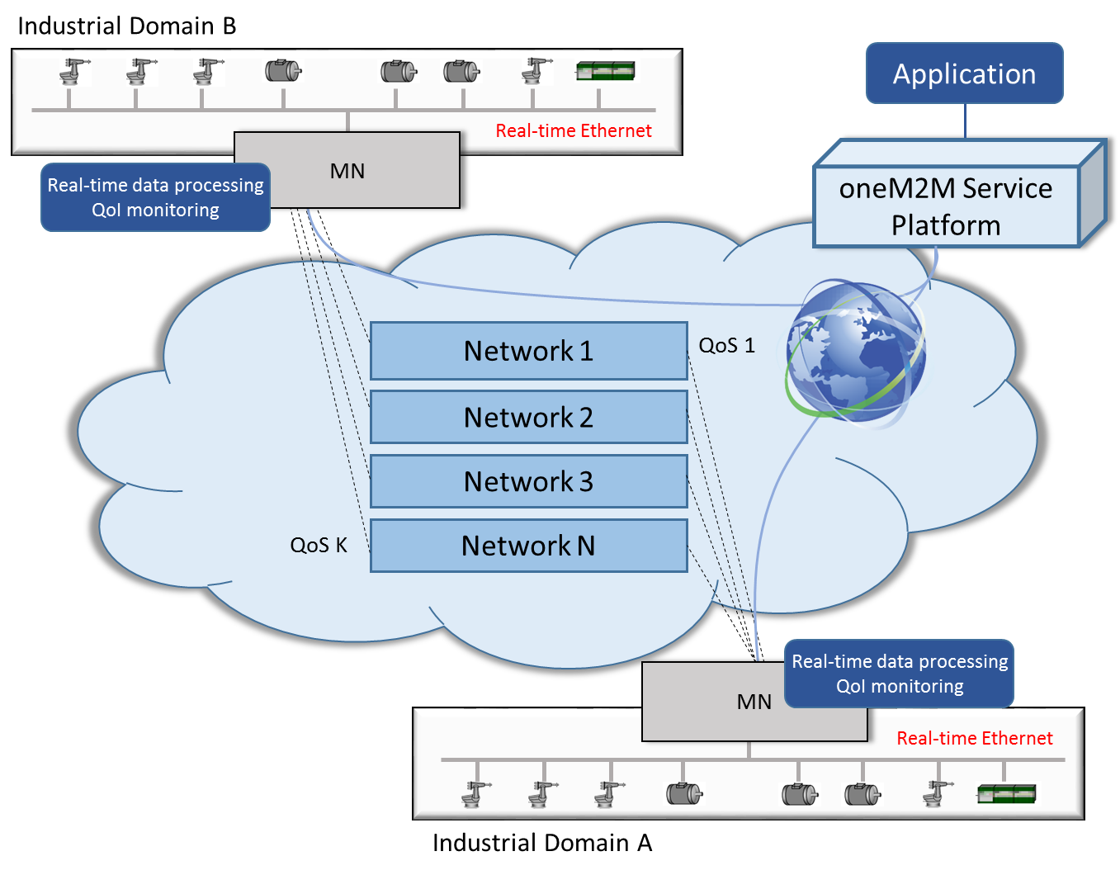

Potential requirements
- The oneM2M System shall support the inclusion of M2M Application’s QoS preference in service requests to Underlying Networks (OSR-038)
- The oneM2M System shall provide the capability for monitoring and describing data streams with associated attributes e.g. data freshness, accuracy, sampling rate, data integrity.

