Input contribution
Use case
Use Case Title:* | Vehicle Management based on Geo-fence
Group Name:* | WG1
Source:* | SK Telecom (TTA)
Contact: | Hongbeom Ahn, SK Telecom, hb.ahn@sk.com
Date:* | 2016-01-08
Abstract:* | This use case describes a Vehicle Management Service based on Geo-fence feature.
Agenda Item:* | <Agenda item reference>
Work item(s): | Vehicular Enablement Domain (WI-0046)
Document(s)  Impacted* | TR-0026 V0.1.0
Intended purpose of  document:* | Decision  Discussion  Information  Other <specify>
Decision requested or recommendation:* | Discuss and make a decision to agree this input contribution
Template Version:23 February 2015 (Dot not modify)

oneM2M Notice
The document to which this cover statement is attached is submitted to oneM2M. Participation in, or attendance at, any activity of oneM2M, constitutes acceptance of and agreement to be bound by terms of the Working Procedures and the Partnership Agreement, including the Intellectual Property Rights (IPR) Principles Governing oneM2M Work found in Annex 1 of the Partnership Agreement.

Vehicle Management based on Geo-Fence

Description
Since vehicle is a nomadic object, localization of vehicles and collecting information for management manner are crucial features for vehicle management.
From the holistic viewpoint, vehicle management is a generic term and it might be all about vehicle and smart car services such as diagnostic, maintenance and so on.
Specifically, in this use case, vehicle management based geo-fence feature is about how to monitor the location and movement of a target vehicle efficiently and judge where the movement is illegal or legal for example.

Source
SK Telecom (TTA)

Actors
- Vehicle:
Vehicle is a nomadic object which is monitored by oneM2M infrastructure node or Location Server and it equips hardware devices for localization (e.g. GPS, Cellular modem)
- oneM2M Infrastructure Node:
A system exposes the service functions for vehicle management such as Location, Device management and so on
- Location Server:
A Location Server can localize the target device(s) using collected measurements (e.g., RSSI, AP ID) and detect Geo-Fence event based on set configurations
- LBS/IoT Application:
An Application requests Geo-Fence based location service toward oneM2M Infrastructure Node

Pre-conditions
N/A

Triggers
- A LBS/IoT Application requires to set Geo-Fence-based Location-Based services depending its demand

Normal Flow

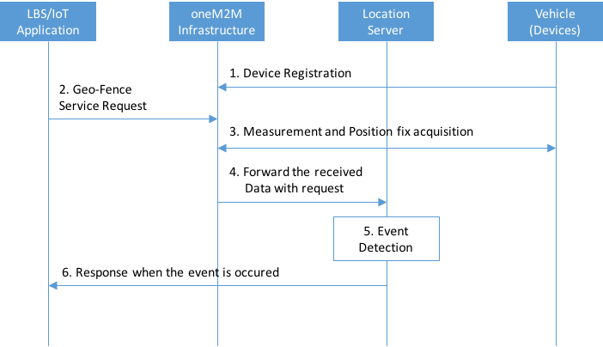

- A vehicle Device registers with oneM2M Infrastructure.
- A LBS/IoT Application requests the Geo-Fence Service to oneM2M Infrastructure. The Application set the configuration regarding Geo-Fence Service such as Geo-Fence area, event criteria, quality of event detection and so on.
- oneM2M Infrastructure acquires Measurement and/or Position fix from the Vehicle devices.
- The Measurement and/or Position fix are/is forwarded to Location Server by oneM2M infrastructure.
- Location Server runs Geo-Fence detection engine and analyzes whether the Geo-Fence event is occurred or not. The detection is operated following the configuration of application.
- When any event is occurred, the event reports to the LBS/IoT Application.

Alternative flow
N/A

Post-conditions
N/A

High Level Illustration
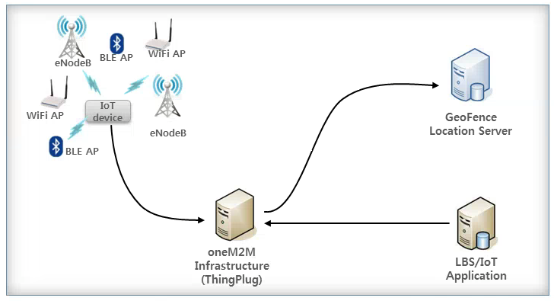
- Vehicle Devices can gather the signal measurement and/or position fix
- The Devices are registered and connected to oneM2M Infrastrucutre
- GeoFence Server can detect any movement event based on the Application’s configuration

Potential requirements
- The M2M System shall support to report Geo-Fence based Location event of the target M2M Device to the M2M Application based on the Application’s configuration.
- The M2M System shall support the M2M Application to set the configuration for Geo-Fence based location service.

