Input contribution
Use case
Use Case Title:* | Use Case on Secure Over-The-Air Firmware Update for Automotive  ECUs
Group Name:* | WG1
Source:* | KDDI
Contact: | Hideaki Kawabata, KDDI, hi-kawabata@kddi.com  Ayumu Kubota, KDDI, ay-kubota@kddi.com  Nick Yamasaki, KDDI, nr-yamasaki@kddi.com
Date:* | <2016-01-07>
Abstract:* | This intends to input Use Case on Secure Over-The-Air Firmware Update Scheme for Automotive ECUs to Chapter 6 in TR-0026 Vehicular Domain Enablement.
Agenda Item:* | REC 21.0
Work item(s): | WI-0046 Vehicular Domain Enablement
Document(s)  Impacted* | TS-0002, TR-0026
Intended purpose of  document:* | Decision  Discussion  Information  Other <specify>
Decision requested or recommendation:*
Template Version:23 February 2015 (Dot not modify)

oneM2M Notice
The document to which this cover statement is attached is submitted to oneM2M. Participation in, or attendance at, any activity of oneM2M, constitutes acceptance of and agreement to be bound by terms of the Working Procedures and the Partnership Agreement, including the Intellectual Property Rights (IPR) Principles Governing oneM2M Work found in Annex 1 of the Partnership Agreement.

Use Case on Secure Over-The-Air Firmware Update for Automotive ECUs
<Secure FOTA for ECUs>

Description
This use case introduces secure remote Over-The-Air (OTA) Firmware Update scheme for M2M Devices such as ECUs (Electronic Control Units) through on-board M2M Gateway in automobiles. An automobile which has on-board M2M GW is called “Smart Vehicle”.
Each M2M Device is connected to on-board M2M Gateway Unit by M2M Area Network such as Controller Area Network (CAN).
M2M Management Server in Infrastructure Domain collects information on version of currently installed firmware in ECUs and distributes updated firmware dedicated for each M2M Device through M2M Gateway using Mobile Network.
Potential Requirements are also described for this use case.

Source
KDDI

Actors
- M2M Device: Electronic Control Unit (ECU) in an automobile is assumed as an M2M Device. There are many kinds of on-board ECUs in automobile, e.g. Power train ECU, Transmission ECU, Brake ECU, etc.
- M2M Gateway (M2M GW): M2M GW is connected with M2M Devices to collect M2M Data and distribute firmware through multiple M2M Area Networks depending on kinds of functionality or security requirements. M2M GW is equipped with a data communication module to communicate with M2M Management Servers and external servers in Infrastructure Domain. Also, it has a display device in order to confirm user’s authorization for the firmware update operation.
- M2M Area Network: CAN (Controller Area Network) or LIN (Local Interconnect Network) is used as wired M2M Area Network in an automobile.
- Mobile Network: Mobile Network is assumed to transfer M2M Data and messages between M2M GW and M2M Management Server.
- M2M Management Server：This server is utilized to conduct firmware update operation and management of version of firmware currently installed in M2M Devices.
- OEM：Original Equipment Manufacturer means automobile manufacturer who is ultimately responsible for the product (e.g. firmware for ECU).
- Firmware Developer: A developer of firmware dedicated for on-board M2M Device (ECU).
- User：A person who makes a decision for conducting firmware update of ECU, when a request for the update is notified from M2M Management Server. This assumes to be an owner of automobile.

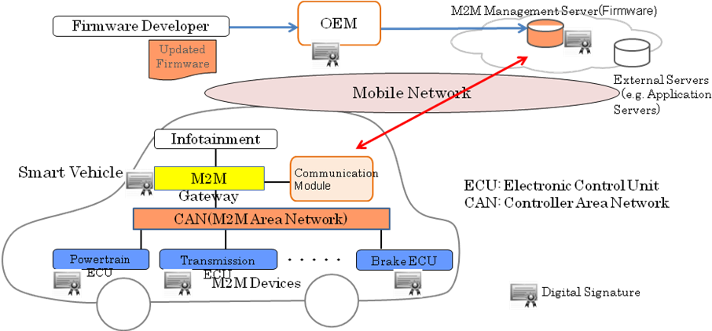
Figure High Level Structure for Over-The-Air Firmware Update for Automotive ECUs

Pre-conditions
- M2M GW is connected to M2M Management Server via Mobile Network.
- M2M GW is connected to M2M Device through CAN.
- M2M GW has capability to manage status of on-board equipments in Smart Vehicle.

Triggers
- Trigger from Server
  - When a new firmware becomes available, M2M Management Server notifies it to M2M GW and M2M GW notifies it to User via a display device of M2M GW.
- Trigger from User
  - User can operate M2M GW to check availability of updated firmware for ECUs in M2M Management Server.

Normal Flow
- A: Generation of updated firmware
- Firmware Developer generates updated firmware for an ECU and submits it to OEM for approval.
- OEM verifies the updated firmware and attaches OEM’s Digital Signature to it as token of approval.
- OEM uploads the updated firmware with the Digital Signature to M2M Management Server.

- B: Authentication
M2M Management Server and M2M GW conduct mutual authentication. It is possible to avoid unintentional outflow of firmware by distributing it to right M2M GW using the authentication mechanism. M2M GW can conduct firmware update operation based on request from the trusted Management Server. Widely used authentication procedures such as Challenge and Response using shared key cryptosystem and public key cryptosystem are applicable.

- C: Establishment of Secure Channel
Encryption of communication channel between M2M Management Server and M2M GW is carried out after the mutual authentication. Encryption procedure such as SSL is applicable.

- D: Verification of current version of Firmware installed in M2M Device
- M2M Management Server sends a request to M2M GW in order to verify version information of firmware currently installed in M2M Device.
- M2M GW transfers the verification request to M2M Device.
- M2M Device sends version information of firmware currently installed back to M2M GW together with its own Digital Signature.
- M2M GW transfers the version information with the Digital Signature of M2M Device to M2M Management Server.
- Management Server verifies the version information with the Digital Signature and checks presence of firmware to be updated for the M2M Device.

- E: Distribution of updated Firmware
- M2M Management Server distributes the updated firmware with OEM’s Digital Signature to M2M GW.
- M2M GW carries out verification of the Digital Signature of the firmware.

- F: User Authorization for Firmware Update
M2M GW sends a message to User in order to confirm permission from the User to conduct firmware update operation, with information regarding firmware update operation.

- G: Firmware Update Implementation
- M2M GW transfers the updated firmware to M2M Device.
- M2M Device verifies Digital Signature of the firmware and gets updated with the firmware if it is the right firmware.
- H: Notification of Firmware Update completion
- M2M Device sends version information of the updated firmware with its Digital Signature when reboot with the updated firmware is completed.
- M2M GW transfers the firmware version information with Digital Signature of M2M Device to M2M Management Server.
- M2M Management Server verifies the Digital Signature of M2M Device and then the operation of Firmware Update is finally completed.

Alternative flow
(1) User Initiated Firmware Update Operation
- Steps A through C are the same as shown in Normal Flow.

- Step D : User Verification of Presence of Firmware to be updated
- User operates Control Display Device of M2M GW in order to check availability of updated firmware for M2M Device.
- M2M GW sends a request to M2M Device in order to verify version information of firmware currently installed in M2M Device..
- M2M Device sends version information of firmware currently installed back to M2M GW together with its own Digital Signature.
- M2M GW transfers the version information with the Digital Signature of M2M Device to M2M Management Server.
- Management Server verifies the version information with the Digital Signature and checks presence of firmware to be updated for the M2M Device.
- If there is firmware to be updated, follow Steps E – H of Normal Flow.
If there is no firmware to be updated, M2M GW notifies User of it on the display.

(2)Constrained Device (ECU)
This alternative flow is provided for Constrained Device which is unable to conduct attachment of its own Digital Signature or verification of Digital Signature of other servers and devices by itself due to limitation of capability. In this case, it is possible to conduct Firmware Update operation by trusting M2M GW on the assumption that M2M GW and M2M Device are mutually trusted.
- Steps A through C are the same as shown in Normal Flow.

- D: Verification of current version of Firmware installed in M2M Device
- M2M Management Server sends a request to M2M GW in order to verify version information of firmware currently installed in M2M Device.
- M2M GW transfers the verification request to M2M Device.
- M2M Device sends version information of firmware currently installed back to M2M GW.
- M2M GW transfers the version information with its Digital Signature to M2M Management Server.
- M2M Management Server verifies the Digital Signature and version information, and checks presence of firmware to be updated for the M2M Device.

- E: Distribution of updated Firmware（same as Step E in Normal Flow）

- F: User Authorization for Firmware Update（same as in Step F in Normal Flow）

- G: Firmware Update Implementation
- M2M GW transfers updated firmware to M2M Device.
- M2M Device gets updated with the firmware trusting M2M GW.

- H: Notification of Firmware Update completion
- M2M Device sends version information of the updated firmware when reboot with the updated firmware is completed.
- M2M GW transfers the firmware version information with its Digital Signature to M2M Management Server.
- M2M Management Server verifies the Digital Signature and then the operation of Firmware Update is finally completed.

Post-conditions
- M2M Management Server has to verify the status of M2M Device (firmware version, number of update failures, error information, etc.) and manage these kinds of information.
- M2M Device has to have rollback function in order to restore to the original state, when the Firmware Update operation fails.

High Level Illustration (Normal Flow)

Potential requirements
- The oneM2M System shall be able to prevent unauthorized modification of the firmware of M2M Device.
- The oneM2M System shall be able to detect unauthorized modification of the firmware of M2M Device.
- The oneM2M System shall be able to stop operation of M2M device when it is updated with wrong firmware.
- The oneM2M System shall be able to support security mechanisms to protect their cryptographic keys and cryptographic operations by using tamper proof devices such as TPM (Trusted Platform Module), HSM (Hardware Security Module) and SIM (Subscriber Identity Module).
- The oneM2M System shall be able to prevent malfunction of M2M Device caused by receiving unsolicited messages or information.

