Input Contribution
Meeting ID* | REQ 22
Title:* | TR-0026-Addition_of_Use_cases_to_Clause_6
Source:* | Hiroyuki Kubo, Hitachi, hiroyuki.kubo.do@hitachi.com  Jiaxin Yin, Huawei, yinjiaxin@huawei.com  Dongjoo Kim, LG Electronics, dongjoo7.kim@lge.com
Uploaded Date:* | 2016-03-14
Document(s)  Impacted* | WI 0046  oneM2M-TR-0018-Vehicular-Domain-Enablement-V0-1-0.DOC
Intended purpose of  document:* | Decision  Discussion  Information  Other <specify>
Decision requested or recommendation:* | Agree for inclusion in TR-0026.
Template Version:23 February 2015 (Dot not modify)

oneM2M Notice
The document to which this cover statement is attached is submitted to oneM2M. Participation in, or attendance at, any activity of oneM2M, constitutes acceptance of and agreement to be bound by terms of the Working Procedures and the Partnership Agreement, including the Intellectual Property Rights (IPR) Principles Governing oneM2M Work found in Annex 1 of the Partnership Agreement.

This contribution moves vehicular domain use cases from Clause 8 of TR0001 to Clause 6 of TR0026.

6.12 Car/Bicycle Sharing Services

6.12.1 Description
As seen clearly, automation already penetrates all aspects of life even in our urban life. The goal of this use case is to describe several automation services which are occurred in different urban space in different life style, bicycle/car sharing services.
Brief Features of Services
- Car Sharing Service
Car Sharing is to offer a new service model for automobile transportation. Simply, Car Sharing is a self-service, on-demand alternative to car ownership; a service that is offered to urban residents (B2C) and businesses (B2B).
This service is mainly designed around a particular user profile – first of all, people who live in cities but do not drive a car every day and secondly tourists who live in cities but do not own a car. Thus, people who need a car at short notice but take an alternative to car ownership.
The brief procedure of this service is 1) joining the membership, 2) unlocking the car door, 3) driving away, 4) parking to any reserved spot provided by the service provider and/or public, and 5) paying as you drive (including gas, insurance, and etc.).
- Bicycle Sharing Service
Bicycle sharing service is also a new service in which bicycle are made available for shared use to individuals who do not own a bicycle. Generally, bicycle sharing service is run by government agencies.
The procedure of this service is similar to the car sharing service, but the different type of services such as healthcare service can be combined.

6.12.2 Source
oneM2M-REQ-2012-0132R01 Use Case: Car/Bicycle Sharing Services

6.12.3 Actors
- User
A user who takes the ownership of the shared things which are car and bicycle.
- Sensors (or Sensor Devices)
Sensor Devices can be various based on its usage, and do not have any direct communication interfaces to the M2M Service Platform.
  - For Car Sharing Service – Door Control Sensor, Tire Pressure Sensor, Fuel Indication Sensor, GPS.
  - For Bicycle Sharing Service – Lock Control Sensor, Accelerometer, Tire Pressure Sensor, Heart-rate Sensor.
- Smartphone
A device which is an intermediate entity and is available to connect from sensors to a M2M Service Platform. The basic role is similar to the general M2M gateway, but it has some sensors and some applications (navigation) itself used by services.
- M2M Service Platform
In charge of providing common functionalities for the M2M services. It is mainly in charge of collecting the status and configuration information of sensors and controlling them via the smartphone and/or M2M gateway.
- M2M Service Providers
Companies which provide its own M2M services for the user through the M2M Service Platform. The M2M Service Providers can be various according to the types of services.
The providers include Car Sharing Service Provider, Insurance Company, Gas Station, Bicycle Sharing Service Provider, and Healthcare Service Provider.

6.12.4 Pre-conditions
See sub-case flows.

6.12.5 Triggers
See sub-case flows.

6.12.6 Normal Flow
Sub use case 1 – Car Sharing Case
Trigger:
A user wants to take an ownership of the car.
Pre-conditions:
The user preliminary joins a membership of the Car Sharing Service.
Sensors built in the car are required to periodically (normal) and non-periodically (urgent) send sensor data to the M2M Service Platform based on the trigger defined by the M2M Service Providers.
The M2M Service Platform collects and manages data and configurations related to the services. Generally, each service has its own data and configuration set, simply called resources.
The M2M Service Providers in the service domain have a service agreement each other for unified services.
The Smartphone has a navigation and car sharing application.

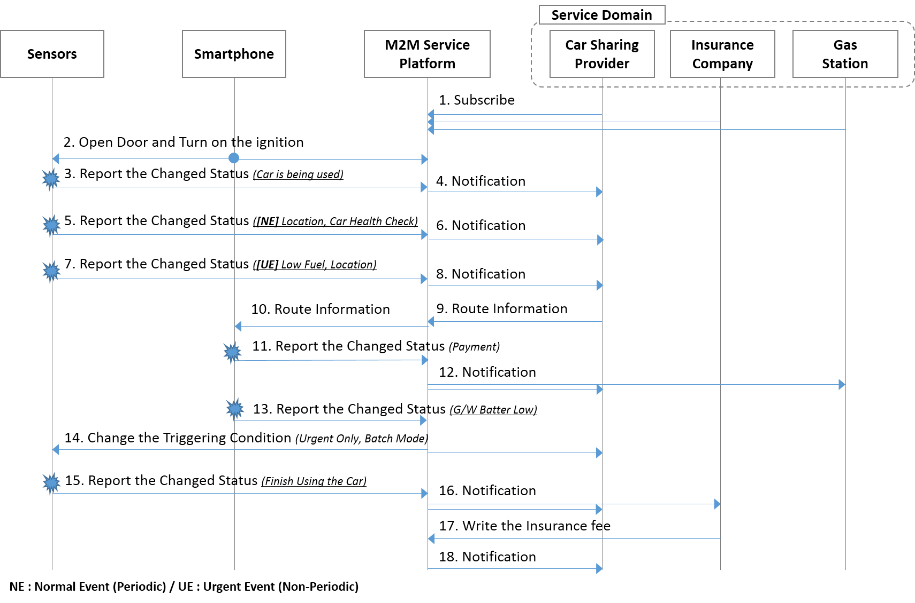
Figure 6.12-1 Car Sharing Normal Flow

Detailed Flow Descriptions:
- The Applications of each Service Provider in the service domain register and subscribe to changes of resources (or information) about the Car Sharing Service in the M2M Service Platform.
- Since each resource in the M2M Service Platform is owned by the Car Sharing Provider, Insurance Company and Gas Station, if an application needs to access another resource, it shall request proper access right of the resources and grant that request if appropriate and based on the service agreement.
- As the user finds a shared car, opens the car door and turns on the ignition using interfaces of the Smartphone such as Bluetooth and NFC, if the user is authorized.
- The Sensors report the changed status to the M2M Service Platform via the Smartphone as a gateway when the specific condition is triggered. (Car is just being used)
- The M2M Service Platform notifies the Car Sharing Service Provider of the changed status. (Note: The Car Sharing Service Provider can update the situation that the car is being used on its website)
- (Normal Reporting Case for managing the Service) The Sensors report the changed status to the M2M Service Platform via the Smartphone when the specific condition is triggered. (Periodic location reporting and car health check for maintenance reasons)
- The M2M Service Platform notifies the Car Sharing Service Provider of the changed status. (Note: Agreement on privacy policy of location is preliminary confirmed)
- (Urgent Reporting Case for handling any emergency) The Sensors report the changed status to the M2M Service Platform via the smartphone as a gateway when the specific condition is triggered. (The fuel is low)
- The M2M Service Platform immediately notifies the Car Sharing Service Provider of the changed status.
- The Car Sharing Service Provider finds out the nearest Gas Station according to the received location information and a service agreement between the Car Sharing Service Provider and the Gas Station, and the Provider sends the route information to M2M Service Platform.
- The M2M Service Platform notifies the Smartphone of the route information.
- After filling the fuel, the user virtually pays the fuel fee by using the Smartphone’s NFC tag. The payment information is reported to the M2M Service Platform.
- The M2M Service Platform notifies the Car Sharing Provider and the Gas Station of the payment information. (Note: This procedure is for the Car Sharing Provider to pay Gas Station the fuel fee instead of the user)
- Afterwards, due to the low battery of the Smartphone (less than 30% remain), the Smartphone reports the changed status to the M2M Service Platform.
- The M2M Service Platform automatically changes the subscription and reporting attributes of the Sensors and the Car Sharing Service Provider. (For example, if the Platform changes the subscription attributes to “only emergency case”, only emergency subscription case will be notified. The others cannot be notified, but at the end of service, batch-mode)
- As the user arrives at the destination, and turns off the ignition, the sensors report the accumulated information, normal event subscription information, to the M2M Service Platform via smartphone.
- The M2M Service Platform notifies the Car Sharing Provides and Insurance Company of the usage of the shared car.
- The Insurance Company stores the insurance fee by writing onto the Car Sharing Service Provider’s resource in the M2M Service Platform, in this case the Insurance Company preliminary acquires proper access right to write.
- The M2M Service Platform notifies the Car Sharing Provides of the insurance fee.

Post-conditions:
- The User will pay as him/her drive according to the recorded data.
- The Car Sharing Service Provider can update the position and status of the car on its website using the recorded data. Thus, next users can make use of the Car Sharing Service.

Sub Use Case 2 – Bicycle Sharing Service
Trigger:
A user wants to take an ownership of the bicycle.
Pre-conditions:
The user preliminary joins a membership of the Bicycle Sharing Service.
The sensors built in the car and in the smartphone are required to periodically (normal) and non-periodically (urgent) send sensor data to the M2M Service Platform based on the trigger defined by the Service Provider.
The M2M Service Platform collects and manages data and configurations related to the services. Generally, each service has its own data and configuration set, simply called resources.
The Smartphone has a navigation and bicycle sharing application.
The M2M Service Providers in the service domain have a service agreement each other for unified services.

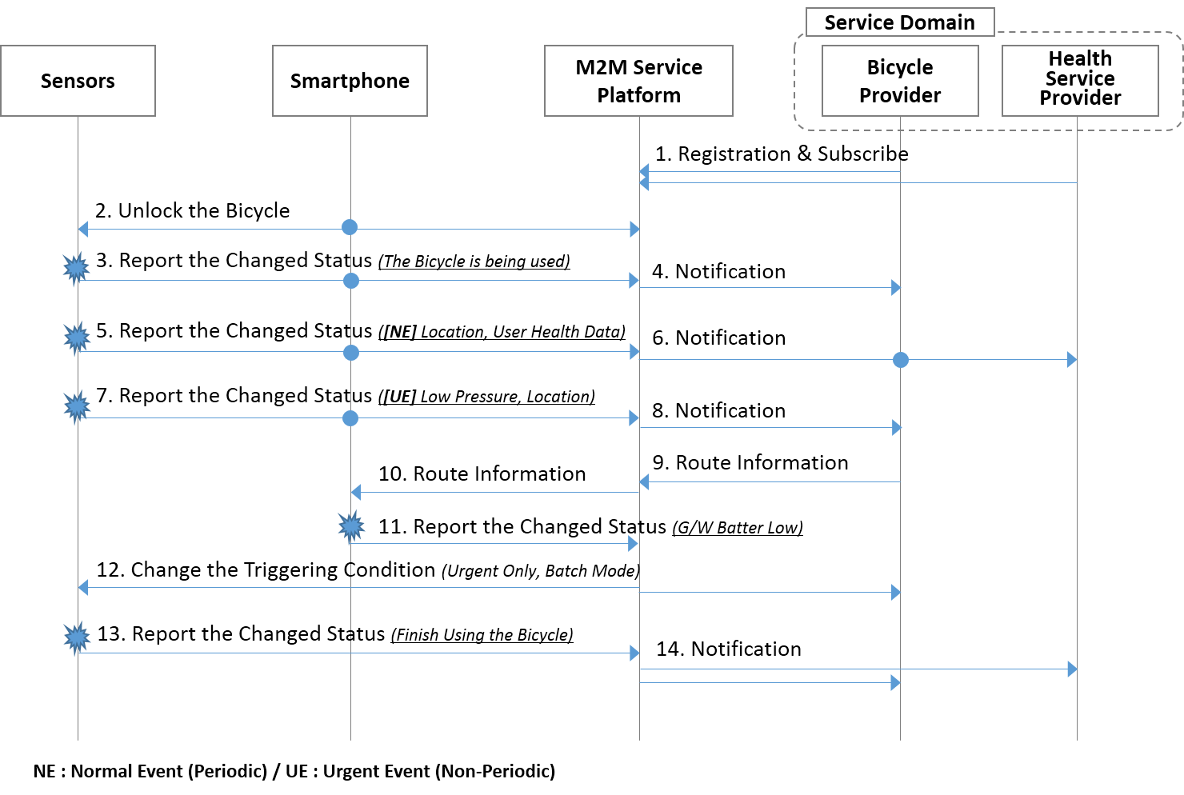
Figure 6.12-2 Bicycle Sharing Normal Flow

Detailed Flow Descriptions:
- The Applications in the service domain register the service and subscribe to changes of information about the Bicycle Sharing Service.
- Since each resource in the M2M Service Platform is owned by the Bicycle Sharing Service Provider and Health Service Provider, if an Application needs to access another resource, it shall request proper access right of the resources and grant that request if appropriate and based on the service agreement.
- To unlock the bicycle, the user tags the locker of the bicycle through the NFC interface.
- The Sensors report the changed status to the M2M Service Platform via the smartphone as a gateway when the specific condition is triggered (for example, the bicycle is being used).
- The M2M Service Platform notifies the Bike Sharing Service Provider of the changed status. (Note: The Bicycle Sharing Service Provider can record the situation on its web-site that the car is being used).
- (Normal Reporting Case for managing the Service) The heart-rate of the user is continuously collected by the heart-rate sensor on the handlebar, and the health-related information such as heart-rate, location, time is reported periodically to the Service Operator.
- The M2M Service Platform notifies the Bicycle Sharing Service Provider and the Health Service Provider of the health Service information.
- (Urgent Reporting Case for handling any emergency) While riding the bicycle, the tire pressure sensor detects the low pressure of the front tire, the information is immediately sent to the M2M Service Platform via the Smartphone with location information.
- The M2M Service Platform notifies the Bicycle Sharing Service Provider of the changed status.
- The Bicycle Sharing Service Provider finds out the nearest bike repair shop according to the received location information, and the Provider sends the route information to M2M Service Platform.
- The M2M Service Platform forwards the route information to the Smartphone which has a navigation application.
- Afterwards, due to the low battery of the Smartphone (less than 30% remain), The Smartphone reports the changed status to the Service Operator. (Low battery indication)
- The M2M Service Platform automatically changes the subscription attributes of sensors and the Bicycle Service Provider such as delay tolerance to reduce battery-consumption. (For example, if the Platform changes the subscription attributes to “only emergency case”, only emergency subscription case will be notified. The others cannot be notified, but at the end of service, batch-mode).
- As the user arrives at the destination and parks to the reserved spot, the Sensor reports the accumulated information and normal event subscription information to the M2M Service Platform via the Smartphone.
- The M2M Service Platform notifies Bicycle Sharing Service Provide and Healthcare Service Provider of the usage of the shared bicycle.
Post-conditions:
- The User may pay as him/her drive according to the recorded data. (not for the public service case)
- The Bicycle Sharing Service Provider can update the position and status of the car on its website using the recorded data. Thus, next users can make use of the Bicycle Sharing Service.

6.12.7 Alternative Flow
None

6.12.8 Post-conditions
See sub-case flows.

6.12.9 High Level Illustration
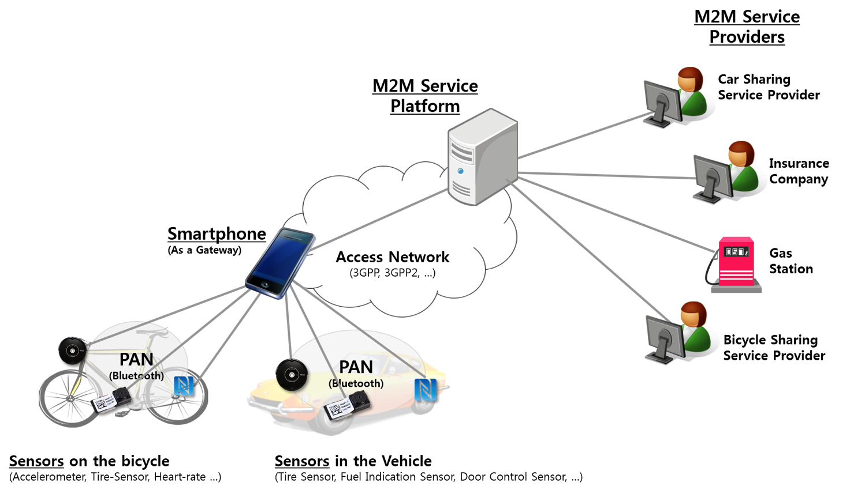
Figure 6.12-3 Car/Bicycle Sharing High Level Illustration

6.12.10 Potential Requirements
- The M2M System shall support mobile/portable M2M Gateway and/or Device.
- The M2M System shall support to distinguish the event levels for reporting and handle it differentially.
- Note: For example, the event levels may be divided into normal and urgent event.
- Based on the condition of the M2M Gateway and/or Device, the M2M System shall change the reporting (or subscription) mechanisms and/or configurations related to a service.
- The M2M System shall support to process access right requests of a resource and grant the requests if the requests

6.13 Smart Parking

6.13.1 Description
Smart parking helps one of the biggest problems on driving in urban areas; finding empty parking spaces and controlling illegal parking. Those parking spaces are wide spread and owned by different providers so that it is not easy to access at one place/time.
With smart parking service, drivers can easily find available parking spaces, pay parking fees and even can make reservations. Making parking reservations would be available for limited people such as VIPs or the disabled, since ordinary parking service needs to satisfy first-come-first-served rule.
In this use case, law enforcement authority is also included as an actor. This implies M2M technologies aims rightness/safety as well as convenience.

6.13.2 Source
oneM2M-REQ-2013-0169R03 Use Case Smart Parking

6.13.3 Actors
- M2M Service Platform
This is a platform that interacts with M2M Gateways/Devices and M2M Application Service Providers.
- Smartphone
This is a M2M Device acts as a car navigator and a wallet to pay parking fee by connecting parking meters.
- On-street Parking Meter
This is a M2M Device installed near parking slots to charge drivers parking fees.
- In-building Parking Sensor
This is a M2M Device with a small camera that can recognize a plate on cars, and is installed near disabled-only parking spaces.
- Parking Provider
This is a M2M Application Service Provider who owns parking lots, in this use case there are two parking providers; in the mall and on street.
- Billing Provider
This is a M2M Application Service Provider (e.g. credit card company) who provides billing service to M2M Users such as parking fee. When it issues a bill, coupons from M2M Application Service Providers are used as tokens for compensation schemes. They also can charge fines issued by police center on their bills.
- Police Center
This is a law enforcement authority, one of M2M Application Service Providers, who charges fine to whom break laws.
- User
This is a M2M service user who drives a car. In the second sub case, dedicated parking space, there are two users. One originally makes a reservation who is handicapped, and the other who illegally parks a car on disabled-only parking area.

6.13.4 Pre-conditions
See sub-case below.

6.13.5 Triggers
See sub-case below.

6.13.6 Normal Flow
- Finding Space, Parking Car & Paying Bill
Pre-condition
User sets a destination as a shopping mall using the smartphone navigator, also checks availability of parking space in the building before or while driving.
Triggers
The car approaches near the destination.
Figure 6.13-1 Normal Flow - Finding Space, Parking Car & Paying Bill
Normal Flow
- Since the user set the mall as the destination before, when the user is near the mall, the navigator sends the location to the mall parking provider automatically.
- The mall parking provider informs the navigator that there’s no empty parking space now.
- Based on the car’s location, which is near the mall, the mall parking provider inquires availability of other parking spaces through M2M service platform.
- There are empty spaces on street, so the mall parking provider recommends that parking space.
- The user touches the smartphone on a parking meter to start parking. Then the street parking provider is noticed, and also the mall parking provider is.
- The mall parking provider offers discount coupon for parking outside as a compensation.
- The user touches the smartphone on the meter to finish parking.
- The street parking provider bills parking fee. The bill with discount coupon is sent to billing provider through M2M service platform.

- Dedicated Parking Space
Pre-condition
Before driving, the user (user A) makes a parking reservation for a slot in a shopping mall, which is especially for the disabled. It is normally assured because there will be fines for illegal parking on this dedicated parking space
Triggers
None
Figure 6.13-2 Normal Flow 1 - Finding Dedicated Parking Space
Normal Flow
- The other user (user B) parks a car on the parking lot, which is already reserved by user A before.
- User B’s illegal parking on the disabled-only parking area is reported to police center.
- Police center charges fine on user B.
- User A approaches the mall and is noticed that reserved parking space is taken and only choice now is normal parking slots.
- User A parks on a normal parking slot instead of the reserved one.
- The parking provider offers parking discount coupon to the user A as a compensation.
- After shopping, user A leaves the building and finish parking.
- The parking provider bills parking fee for user A, adopting the parking coupon.

6.13.7 Alternative Flow
Alternative Flow 1 – Dedicated Parking Space
- Pre-condition
  - Before driving, the user (user A) makes a parking reservation for a slot in a shopping mall, which is especially for the disabled. It is normally assured because there will be fines for illegal parking on this dedicated parking space.
- Triggers
  - None
Figure 6.13-3 Alternative Flow 1 - Finding Dedicated Parking Space
- The other user (user B) parks a car on the parking lot, which is already reserved by user A before.
- The mall parking provider inquires plate number of the car to a CCTV near the parking space.
- User B’s illegal parking on the disabled-only parking area is reported to police center.
- Police center charges fine on user B.
- User A approaches the mall and is noticed that reserved parking space is taken and only choice now is normal parking slots.
- User A parks on a normal parking slot instead of the reserved one.
- The parking provider offers parking discount coupon to the user A as a compensation.
- After shopping, user A leaves the building and finish parking.
- The parking provider bills parking fee for user A, adopting the parking coupon.

6.13.8 Post-conditions
None

6.13.9 High Level Illustration
Figure 6.13-4 High Level Illustration of Smart Parking

6.13.10 Potential Requirements
- The M2M System shall support mechanisms to correlate charging data/records from different M2M Application Service Providers.
- The M2M System shall support triggering M2M Devices to report on-demand regarding collected data from other M2M Devices.

