Input contribution
Use case
Use Case Title:* | Vehicle_BroadCasting_without_Registration
Group Name:* | WG1
Source:* | LG Electronics (TTA)
Contact: | Dongjoo Kim, LG Electronics, dongjoo7.kim@lge.com
Date:* | 2016-03-14
Abstract:* | This use case describes a Vehicle Broadcasting without Registration
Agenda Item:* | <Agenda item reference>
Work item(s): | Vehicular Enablement Domain (WI-0046)
Document(s)  Impacted* | TR-0026 V0.1.0
Intended purpose of  document:* | Decision  Discussion  Information  Other <specify>
Decision requested or recommendation:* | Discuss and make a decision to agree this input contribution
Template Version:23 February 2015 (Dot not modify)

oneM2M Notice
The document to which this cover statement is attached is submitted to oneM2M. Participation in, or attendance at, any activity of oneM2M, constitutes acceptance of and agreement to be bound by terms of the Working Procedures and the Partnership Agreement, including the Intellectual Property Rights (IPR) Principles Governing oneM2M Work found in Annex 1 of the Partnership Agreement.

Vehicle Broadcasting without Registration

Description
This use case consists for any vehicle driving fast to signal its emergency state which can be for example hard braking state or abnormal vehicle state to other following vehicles or infrastructure, such as a road side unit in its vicinity
By broadcasting time limited periodic messages which indicate vehicle’s emergency state triggered by an event, the vehicle can warn unspecified entities of a sudden danger so limiting the risk of collision. The infrastructure can collect those information and relay them to other entities or servers in the distance.
Since a vehicle is a very quick-moving object and the transferred message is a time-critical information, the transmission speed is crucial for this use case.

Source
LG Electronics (TTA)

Actors
- Source Vehicle:
A Source Vehicle is a moving object which provides communications functions necessary to support connected vehicle operations. It can detect its emergency state and send warning message by broadcasting.
- Target Vehicle
A Target Vehicle is a moving object which provides communications functions necessary to support connected vehicle operations for communicating with the Source Vehicle. After receiving warning message, it tries to avoid the potential danger.
- Infrastructure Node:
An Infrastructure Node is located by a road and provides communications functions necessary to support connected vehicle operations. It can collect information generated in a certain area and partially process it. It is also possible to convey it to the server or other vehicles in a far distance.

Pre-conditions
N/A

Triggers
- When a vehicle application detects its emergency state, it should trigger broadcasting specific information

Normal Flow
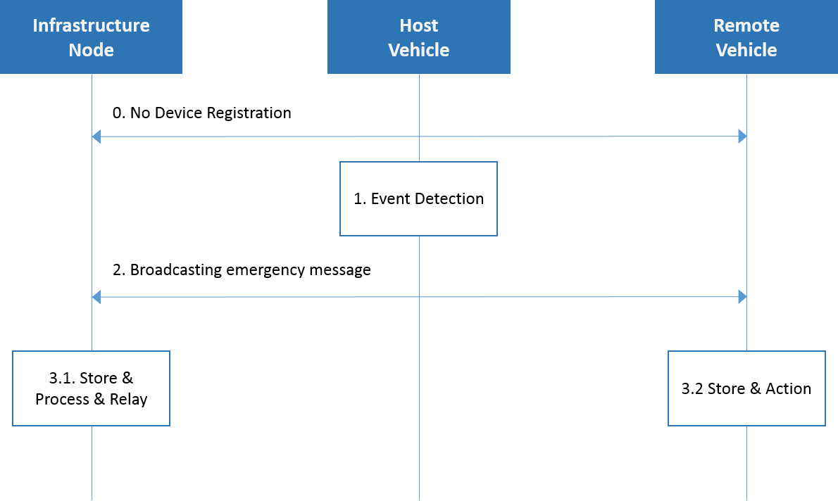

- Each Vehicle and Infrastructure Node do not register with each other.
- Source Vehicle runs event detection engine and analyzes whether the safety-related event has occurred or not.
- Source Vehicle send the safety-related information to unspecified entities by broadcasting
  - Infrastructure Node gathers the broadcasted information and locally processes and relays to other vehicles or servers in a distance if needed
  - Target Vehicle receives the safety-related information and re-acts to avoid the potential collision.

Alternative flow
N/A

Post-conditions
N/A

High Level Illustration
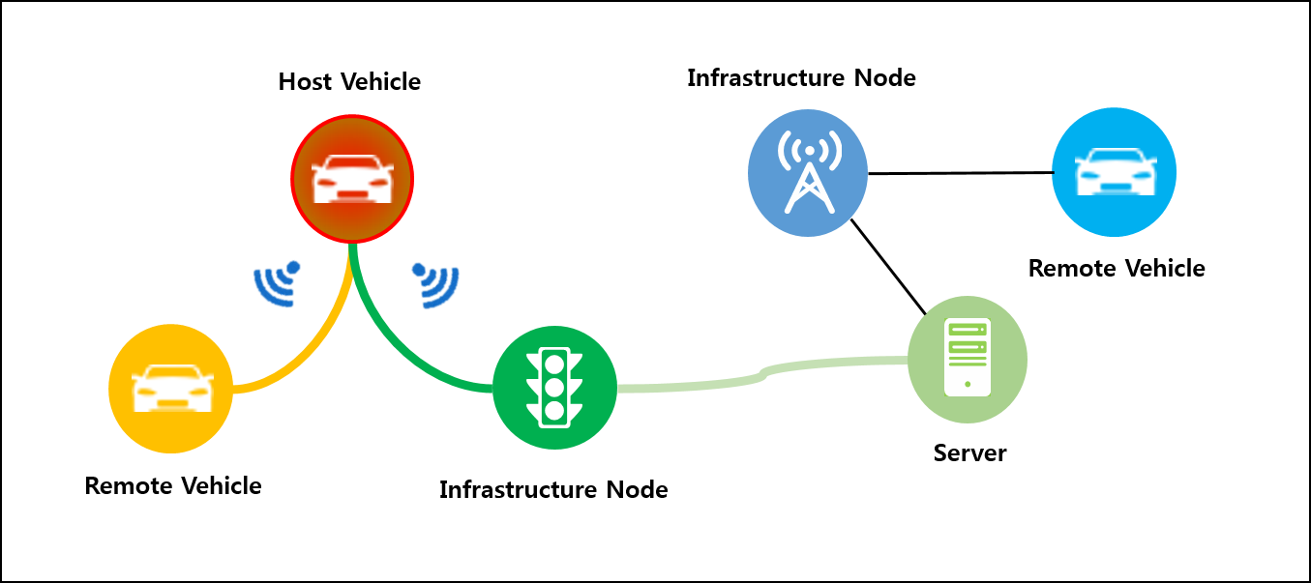
- Source Vehicle can send time-critical information to unspecified entities
- Infrastructure Node can relay this information to the server which can also re-use that information.

Potential requirements

- The oneM2M system shall enable the M2M Infrastructure to facilitate direct communication between two or more different M2M devices without having registered with one another.

