Input contribution
Use case
Use Case Title:* | Vehicle location privacy protection
Group Name:* | REQ
Source:* | Huawei
Contact: | Jessie, Huawei, lijing80@huawei.com
Date:* | 2016-05-06
Abstract:* | This contribution provides a privacy protection scenario where the vehicle enters a specific location area and the location information is not allowed to be accessed by some applications.
Agenda Item:*
Work item(s): | Vehicular Enablement Domain (WI-0046)
Document(s)  Impacted* | TR-0026 0.2.0
Intended purpose of  document:* | Decision  Discussion  Information  Other <specify>
Decision requested or recommendation:* | Discuss and make a decision to agree this input contribution.
Template Version:23 February 2015 (Dot not modify)

oneM2M Notice
The document to which this cover statement is attached is submitted to oneM2M. Participation in, or attendance at, any activity of oneM2M, constitutes acceptance of and agreement to be bound by terms of the Working Procedures and the Partnership Agreement, including the Intellectual Property Rights (IPR) Principles Governing oneM2M Work found in Annex 1 of the Partnership Agreement.

6.x Vehicle location privacy protection

6.x.1 Description
The privacy protection is an issue that must be considered for locating in human to human communications. For example, in 3GPP network, privacy protection is implemented by an independent entity such as a privacy profile register (PPR) or a gateway mobile location center (GMLC). In the vehicle domain, the location information of the vehicle represents the location of the vehicle user. Therefore an issue of privacy protection is also closely related to the vehicle location information. The privacy protection refers to that when a vehicle is connected to the M2M system, the user of the vehicle has permission to specify when and where a third party application is allowed to access to the vehicle location information.
After the M2M platform receives a message from a third part application, requesting for the location information of a certain vehicle, the M2M platform determines the entity that should performs the privacy inspection, according to the source of the location information. For example, if the location information of the vehicle is network based and the underlying network is 3GPP, then the entity that performs the privacy inspection should be the 3GPP location server. On the other hand, if the location information of the vehicle is device based, then it should be the M2M platform that performs the privacy inspection.

6.x.2 Source
Huawei

6.x.3 Actors
- M2M Device: It is embedded in a vehicle, which is used to connecting to the M2M platform.
- Vehicle: Vehicle connects to the M2M platform via the embedded M2M device and it equips hardware devices for localization. (e.g. GPS, Cellular modem)
- Vehicle Owner: The owner of the vehicle. The owner has privacy agreement with the 3GPP network location server or the M2M platform.
- 3GPP network location server: When the vehicle connects to the M2M platform via the 3GPP underlying network, the 3GPP network location server can perform the location service and provide the location information to the M2M platform. In this case the 3GPP network location server also performs the privacy inspection function. The 3GPP network location server is configured with location privacy policies according to the privacy agreement with the vehicle owner and the network operator policy. The location privacy policies refer to when and where a third part application is allowed to access to the vehicle location information.
- M2M Platform: It connects, manages M2M devices and exposes location services to the M2M application. The M2M platform can collect the vehicle location information either from the underlying network, e.g. 3GPP network location server, or from the device itself, e.g. the vehicle is equipped with any location capable modules or technologies (e.g. GPS) and is able to position itself. The M2M platform is configured with location privacy policies according to the privacy agreement with the vehicle owner. The location privacy policies refer to when and where a M2M application is allowed to access to the vehicle location information.
- M2M Application server: The M2M application server requests for the location information of the vehicle for any possible application usage, e.g. fleet management or traffic monitoring.

6.x.4 Pre-conditions
- The vehicle owner already has privacy agreement with the operator of the 3GPP network or the M2M platform.

6.x.5 Triggers
The M2M application server requests to access to the location information of the vehicle.

6.x.6 Normal Flow
Scenario 1: The vehicle No.1 connects to the M2M platform via the 3GPP network and the location information is collected by the 3GPP network location server:
- The M2M application sends message to the M2M platform to request for the location information of vehicle No.1.
- The M2M platform checks the location information source of the vehicle. if the location information of the vehicle comes from the underlying network location server, e.g. 3GPP network location server, the M2M platform sends privacy inspection requests, including the M2M application identifier which can be recognized by the 3GPP network, to 3GPP network location server to verify whether the M2M application is allowed to access to the location information.
- The 3GPP network location server is configured with the privacy policies of vehicle No.1. When the 3GPP network location server receives the access right verify request, it performs the privacy inspection, checking the privacy policies with the M2M application identifier and other information, e.g. the time and the lasted location of the vehicle. The 3GPP network location server returns the checking result to the M2M platform, that is whether the M2M application is allowed to access to the location information.
- If the M2M application is allowed to access to the location information, after the M2M platform receives the responses from 3GPP network location server, it sends the location information request message to the 3GPP network location server.
- The 3GPP network location server performs the location updating procedure inside the 3GPP network and collects the latest location information of the vehicle. Then the 3GPP network location server returns the location information to the M2M platform.
- The M2M platform forwards the location information to the M2M application.

Scenario 2: The vehicle No.2 connects to the M2M platform via the 3GPP network. It is equipped with location capable modules or technologies (e.g. GPS) and is able to position itself. The M2M platform can collect the location information of the vehicle directly without the help of any other location server.
- The M2M application sends message to the M2M platform to request for the location information of vehicle No.2.
- The M2M platform checks the location information source of the vehicle. if the location information of the vehicle is device based and is collected by the M2M platform directly from the vehicle itself, then the M2M platform checks the privacy policies configured in the M2M platform.
- If the M2M application is allowed to access to the location information, then the M2M platform returns the location information to the M2M application. If the M2M application is not allowed to access to the location information, then the M2M platform sends failure response to the M2M application with appropriate error code.

6.x.7 Alternative flow
N/A

6.x.8 Post-conditions
N/A

6.x.9 High Level Illustration
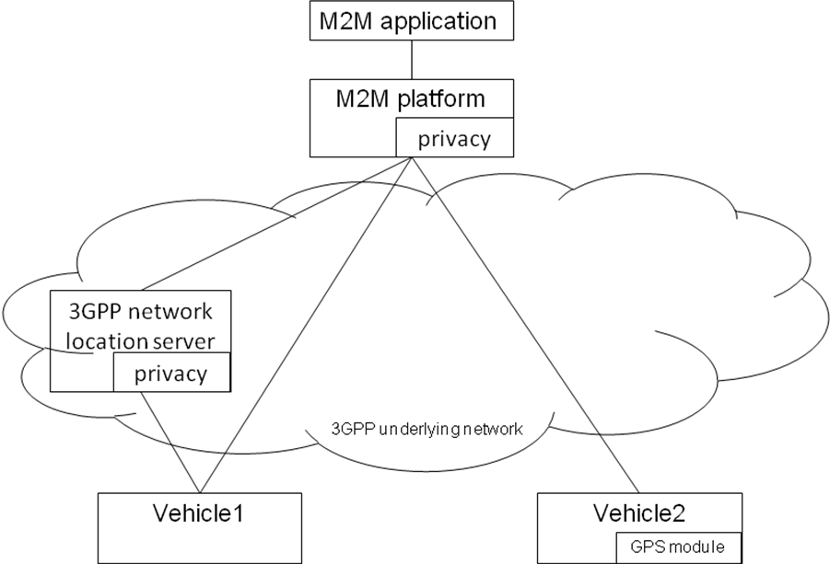

6.x.10 Potential requirements
- The oneM2M System shall able to support the privacy protection to the location information.
- The oneM2M system shall able to distribute the privacy inspection to the location server of the underlying network according to the source of the location information.

