Input Contribution
Meeting ID* | REQ 24
Title:* | TR-0026-Vehicular_Domain_Enablement_Clause_8_High_Level_Architecture
Source:* | Hiroyuki Kubo, Hitachi, hiroyuki.kubo.do@hitachi.com  Jiaxin Yin, Huawei, yinjiaxin@huawei.com  Dongjoo Kim, LG Electronics, dongjoo7.kim@lge.com
Uploaded Date:* | 2016-07-11
Document(s)  Impacted* | WI 0046  oneM2M-TR-0026-Vehicular-Domain-Enablement-V0-1-0.DOC
Intended purpose of  document:* | Decision  Discussion  Information  Other <specify>
Decision requested or recommendation:* | Agree for inclusion in TR-0026.
Template Version:23 February 2015 (Dot not modify)

oneM2M Notice
The document to which this cover statement is attached is submitted to oneM2M. Participation in, or attendance at, any activity of oneM2M, constitutes acceptance of and agreement to be bound by terms of the Working Procedures and the Partnership Agreement, including the Intellectual Property Rights (IPR) Principles Governing oneM2M Work found in Annex 1 of the Partnership Agreement.

This document is the description of Clause 8 “High Level Architecture” in TR-0026

8 High Level Architecture

8.1 Introduction
The fifteen use cases in the vehicular domain discussed in the present document are listed in table 8.1-1.
Table 8.1-1: Use cases in the vehicular domain
Use case No. | Title | Description
1 | Vehicular Diagnostic & Maintenance Report | See clause 6.1
2 | Use Case on Remote Maintenance Services | See clause 6.2
3 | Traffic Accident Information Collection | See clause 6.3
4 | Fleet Management Service using DTG (Digital Tachograph) | See clause 6.4
5 | Use cases for Electronic Toll Collection (ETC) service | See clause 6.5
6 | Use cases for Taxi Advertisement | See clause 6.6
7 | Use Case on Vehicle Data Service | See clause 6.7
8 | Smart Automatic Driving | See clause 6.8
9 | Use Case on Vehicle Data Wipe Service | See clause 6.9
10 | Vehicle Management based on Geo-Fence | See clause 6.10
11 | Use Case on Secure Over-The-Air Firmware Update for Automotive ECUs | See clause 6.11
12 | Car/Bicycle Sharing Services | See clause 6.12
13 | Smart Parking | See clause 6.13
14 | Vehicle Broadcasting without Registration | See clause 6.14
15 | Vehicle location privacy protection | See clause 6.15

Though these use cases are focusing on the vehicular domain, those ways of functional deployment are different. The following clauses provid three types of the high level oneM2M archtecture mapping for these use cases.

8.2 Vehicular Architecture Type 1
Figure 8.2-1 illustrates the first type of high level oneM2M architecture in vehicular domain. In this type, vehicular domain applications and the M2M service platform described in each use case are mapped to the IN (Infrastructure Node). Each vehicle equips a communication module which supports cellular network or other wireless communication technologies, and the vehicle can connect to a service platform via the communication module. Alternatively, an external unit such as the smartphone acts as both a communication module and a GW. In this case, the external unit would connect to in-vehicle network via some network technologies such as Bluetooth.
The GW which provides some functions defined in oneM2M acts as the MN or the ASN. The GW would be the in-vehicle unit such as an ECU (Electronic Control Unit) or the external unit such as the smartphone. The GW is connecting to in-vehicle units and external sensors via an in-vehicle network such as CAN (Controller Area Network) or other communication technology such as Bluetooth.
The in-vehicle units such as ECUs or external sensors don’t act as the oneM2M device node.
The use case 1 to 3, 6 to 11, 13 and 15 are categorized into this type.
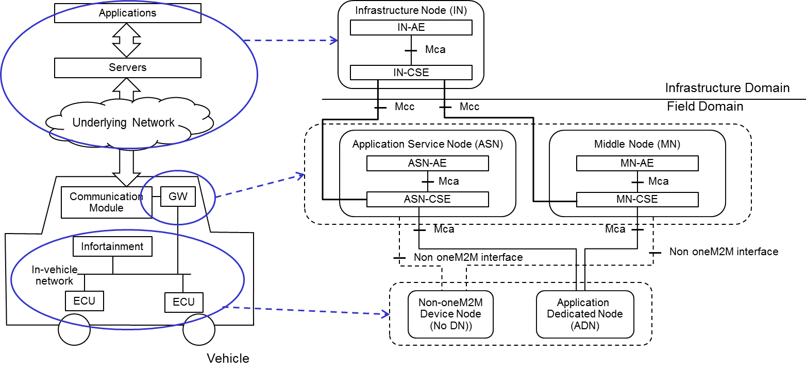
Figure 8.2-1: High Level Architecute Type 1 in Vehicular Domain

8.3 Vehicular Architecture Type 2
Figure 8.3-1illustrates the second type architecture. Same as the first type, vehicular domain applications and the M2M service platform described in each use case are mapped to the IN. Each vehicle equips a communication module to connect to the a road side unit.
The raod side unit which provides some functions defined in oneM2M acts as the MN.
In this type, the GW in vehicle acts as the ASN. The in-vehicle units such as ECUs or external sensors don’tact as the oneM2M device node.
The use case 3 to 5 and 12 are categorized into this type.
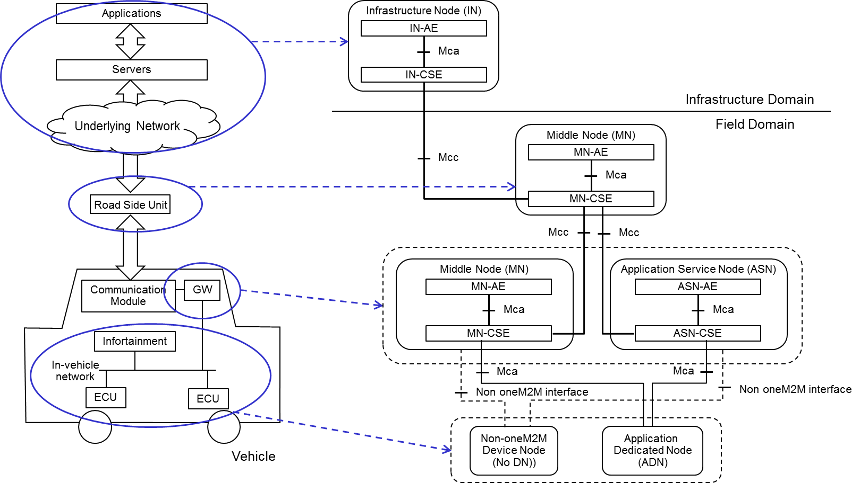
Figure 8.3-1: High Level Architecute Type 2 in Vehicular Domain

8.4 Vehicular Architecture Type 3
Figure 8.4-1 illustrates the third type. In this type, a vehicle to vehicle communication technology is supported in each vehicle. To support the vehicule to vehicle communication in the oneM2M architecture, the GW acts as the MN.
The use case 3 and 14 are categorized into this type.
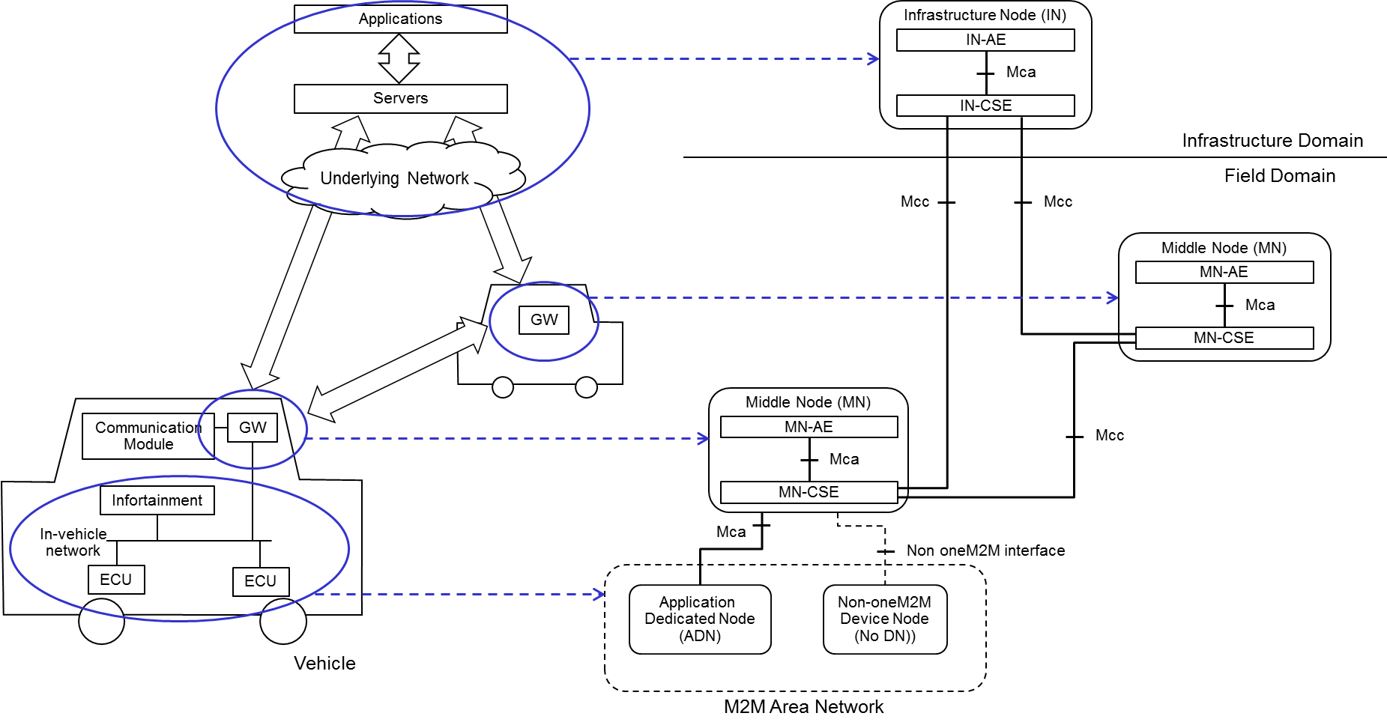
Figure 8.4-1: High Level Architecute Type 3 in Vehicular Domain

