Input contribution
Use case
Use Case Title:* | Use cases for dynamic traffic lights timing
Group Name:* | TP#24
Source:* | CMCC
Contact: | Yawen Niu (niuyawen@chinamobile.com)
Date:* | 2016-7-18
Abstract:* | Propose to add the use case for dynamic traffic lights timing to relief the traffic pressure.
Agenda Item:*
Work item(s):
Document(s)  Impacted* | Technical Specification TR 0026 – Vehicular Domain Enablement Technical Report
Intended purpose of  document:* | Decision  Discussion  Information  Other <specify>
Decision requested or recommendation:* | Approval of the Use Case

oneM2M IPR STATEMENT
“Participation in, or attendance at, any activity of oneM2M, constitutes acceptance of an agreement to be bound by all provisions of IPR policy of the admitting Partner Type 1 and permission that all communications and statements, oral or written, or other information disclosed or presented, and any translation or derivative thereof, may without compensation, and to the extent such participant or attendee may legally and freely grant such copyright rights, be distributed, published, and posted on oneM2M’s web site, in whole or in part, on a non-exclusive basis by oneM2M or oneM2M Partners Type 1 or their licensees or assignees, or as oneM2M SC directs.
  - Title

Use cases for dynamic trffic lights timig.

  - Description

Normally the traffic lights timing is fixed. However, in some situations, vehicle flowrate varies a lot. In this case, dynamic traffic lights timing will be able to relief the traffic pressure and improve the traffic efficiency.

  - Source

CMCC

  - Actors
- Traffic lights (M2M Devices embedded in traffic lights).
- Vehicles (M2M Devices embedded in vehicles)
- Vehicle Service Centre

  - Pre-conditions
- Traffic lights are connected to the Vehicle Service Centre
- Vehicles are connected to the Vehicle Service Centre
  - Triggers

  - Normal Flow
- Vehicles report data (such as location, time, speed, direction…) to vehicle service centre.
- Traffic lights report data (such as location, current traffic lights timing policy) to vehicle service centre.
- The vehicle service centre analyzes the data (such as vehicles flowrate for each direction) periodically. If the current traffic lights timing policy need to be updated according to the policies (policies can be pre-configured in the vehicle service centre, such as maximize flowrate policy), the vehicle service centre re-compute the new traffic lights timing policy. (Noted: as it is not possible for the vehicle service centre to compute all the vehicles data, it should have some query conditions, for example, to compute all the vehicles data within a radius. The radius can be both fixed and dynamically according to the flowrate)
- The vehicle service centre sends the new traffic lights timing policy to traffic lights.
- Traffic lights control the vehicles flowrate according to the new policy.

  - Post-conditions (if any)

NONE.
  - High Level Illustration (as applicable)
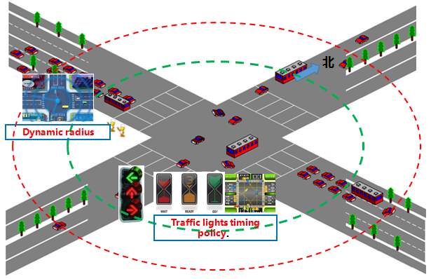

  - Potential requirements (as applicable)
- The M2M service platform shall enable the data exchange between M2M Devices and M2M application with query condition (for example, all the vehicles data within a radius).
- The M2M service platform can real-time monitor the vehicles flowrate and analyze
- The M2M service platform can also self-determine which data will be exchanged according to its analyze result (for example, dynamically determine the radius and report vehicles data within the radius to M2M applications according to vehicles flowrate analyze result)
- The M2M service platform can configure the parameters of the M2M devices (for example, the timing of the traffic lights)

