Input contribution
Use case
Use Case Title:* | Optimal Speed Recommendation
Group Name:* | WG1
Source:* | LG Electronics (TTA)
Contact: | Dongjoo Kim, LG Electronics, dongjoo7.kim@lge.com
Date:* | 2016-10-17
Abstract:* | This input introduces a new use case of vehicular domain
Agenda Item:* | <Agenda item reference>
Work item(s): | Vehicular Enablement Domain (WI-0046)
Document(s)  Impacted* | TR-0026 V0.4.0
Intended purpose of  document:* | Decision  Discussion  Information  Other <specify>
Decision requested or recommendation:* | Discuss and make a decision to agree this input contribution
Template Version:23 February 2015 (Dot not modify)

oneM2M Notice
The document to which this cover statement is attached is submitted to oneM2M. Participation in, or attendance at, any activity of oneM2M, constitutes acceptance of and agreement to be bound by terms of the Working Procedures and the Partnership Agreement, including the Intellectual Property Rights (IPR) Principles Governing oneM2M Work found in Annex 1 of the Partnership Agreement.

Optimal Speed Recommendation

Description
The target vehicle is approaching to the traffic light that is currently displaying red.
The central server connected with vehicles, traffic lights and other entities such as weather server, map server and remote vehicles collects the vehicle's precise location and the traffic light phase schedule as well as additional information such as weather, road shape, emergency situation and etc. of the front road where the vehicle is heading to.
The server then calculates a specific optimal speed for the vehicle based on the collected information to reach the traffic light at the beginning of the next green phase and if necessary to avoid potential dangers.
The result speed is finally delivered to the driver who can avoid the unnecessary stop at the traffic light and unforeseeable hazards.

Source
LG Electronics (TTA)

Actors
- Target Vehicle:
A Target Vehicle is a moving object which periodically provides its movement information such as time, location, velocity, heading, lateral and longitudinal acceleration to the central server so that it can utilize the information to calculate the optimal speed. After the calculation in the server, the Target Vehicle receives back the result directly from the server.
- Traffic Light:
A Traffic Light is located by a road and provides its phase schedule necessary for the server to calculate the optimal speed of the target vehicle.
- Central Server:
A Central Server calculates the optimal speed for the target vehicle based on the gathered necessary information from various sources including the target vehicle, the traffic light, other information servers and remote vehicles.
- Information Servers:
There could be many kinds of additional Information Servers that can be connected with and utilized by the central server. For example, a weather server provides weather data such as time, location, external air temperature, snow, rain and etc. and it is possible to detect potential road hazards via a map server.
- Remote Vehicles:
Remote vehicles automatically or manually report emergency situation to the server.

Pre-conditions
N/A

Triggers
- When the central server detects that the target vehicle has approached a few hundred meters (It should be more than 300 meters in order to safely adjust the current speed) in front of the traffic light, the server calculates the optimal speed and sends it to the target vehicle.

Normal Flow
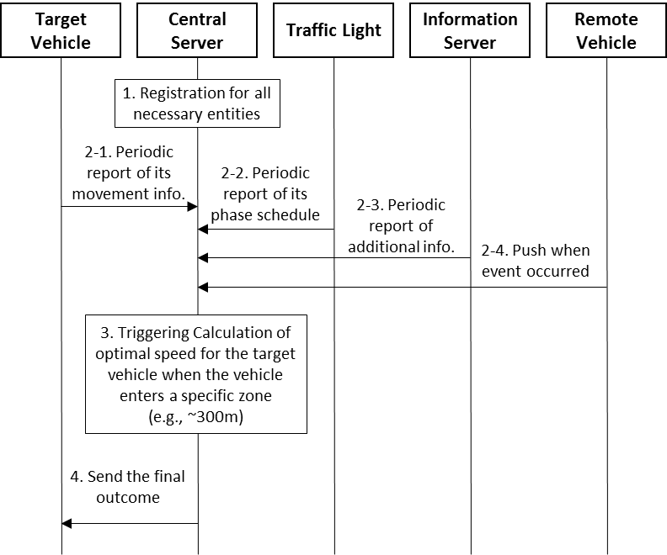

- As the first step, associated entities register to the central server except remote vehicle which does not necessarily need to register because it is moving object and this scenario works based on location information. It is enough to know just the location of the remote vehicle and what happens around it.
- The server gathers information to calculate the optimal speed of the target vehicle.
2.1. The target vehicle periodically provides its movement information including heading, time, location, velocity, lateral and longitudinal acceleration.
2.2. The traffic light periodically provides its phase schedule when to be red, yellow or green.
2.3. Additional information server provides further useful data as requested by the central server. Information such as slippery zone, high accident frequency location, or sharp curve could be examples.
2.4. Remote vehicles can also provide more information to the server in case accident or something dangerous happens. This can be done automatically as programmed or manually by drivers. Note that the server does not subscribe remote vehicles since it’s impossible to predict which vehicles may have necessary information. So remote vehicles should initiate to communicate with the server.
- When the target vehicle has reached a specific area (It could be 300m in front of the traffic light) ahead of the traffic light, the central server starts calculating the optimal speed for the target vehicle to pass through the traffic light with no stop based on the collected information. If any additional information indicates there could be safety risk, the server should consider them as well for the calculation.
- The final outcome from the server is delivered to the target vehicle and shown to the driver who can follow the speed recommendation.

Alternative flow
N/A

Post-conditions
N/A

High Level Illustration
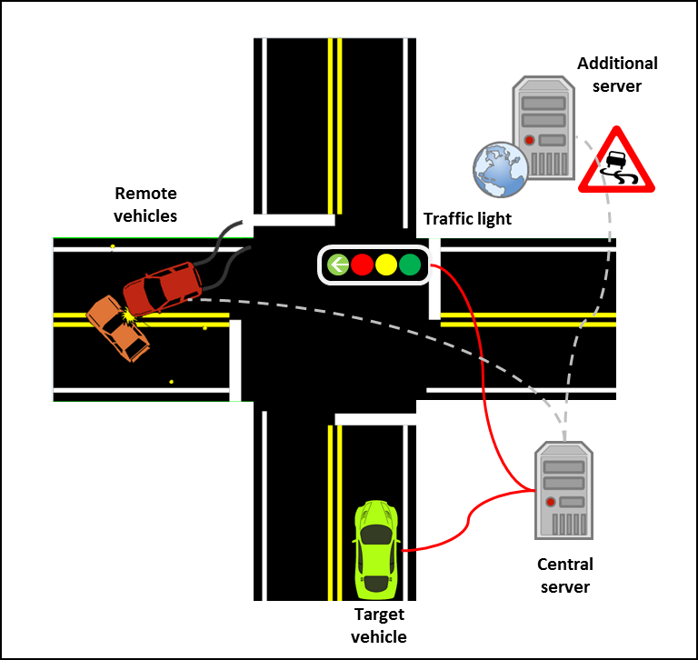
- Solid lines in red are mandatory while dashed lines in gray are optional for this use case.

Potential requirements
- The oneM2M system shall support real time data transmission for moving object to have enough time to react to the received information.
- The oneM2M system shall verify geographical location information from moving objects regardless of information accuracy.
- The oneM2M system shall verify time synchronization among multiple sources that provide inputs for a single output.
- The oneM2M system shall be able to guarantee network stacbility and reliability for applications that are related to safety
- The oneM2M system shall apply high-level security(prevention from malicious hacker) for applications that are related to safety.
- The oneM2M system shall provide privacy protection mechanism at the server.

