Input Contribution
Meeting ID* | REQ 25
Title:* | TR-0026-Vehicular_Domain_Enablement_Clause_9_1_Location
Source:* | Hiroyuki Kubo, Hitachi, hiroyuki.kubo.do@hitachi.com  Jiaxin Yin, Huawei, yinjiaxin@huawei.com  Dongjoo Kim, LG Electronics, dongjoo7.kim@lge.com  Nick Yamasaki, KDDI CORPORATION, nr-yamasaki@kddi.com  Kenichi Yamamoto, KDDI CORPORATION, kc-yamamoto@kddi.com  Ryokichi Onishi, TOYOTA ITC, onishi@jp.toyota-itc.com
Uploaded Date:* | 2016-10-10
Document(s)  Impacted* | WI 0046  oneM2M-TR-0026-Vehicular-Domain-Enablement-V0-4-0.DOC
Intended purpose of  document:* | Decision  Discussion  Information  Other <specify>
Decision requested or recommendation:* | Agree for inclusion in TR-0026.
Template Version:23 February 2015 (Dot not modify)

oneM2M Notice
The document to which this cover statement is attached is submitted to oneM2M. Participation in, or attendance at, any activity of oneM2M, constitutes acceptance of and agreement to be bound by terms of the Working Procedures and the Partnership Agreement, including the Intellectual Property Rights (IPR) Principles Governing oneM2M Work found in Annex 1 of the Partnership Agreement.

This document is the description of Clause 9.1 “Location” in TR-0026

9 oneM2M Release 2 Enablement for Vehicular Domain
The discussions in this clause provide the guideline to utilize oneM2M Release 2 for Vehicular Domain.

9.1 Location
Geographical location information is important in vehicular services, because a node in vehicular domain moves dynamically. As shown in use cases in clause 6, location is the key factor of vehicular services. For instance, the procedures of vehicular services could be triggered by the change of location. In other cases, the vehicular service would provide to the vehicles located in the dedicated area.
In oneM2M Release 2, Location CSF (LOC CSF) gives the following location functions.
- A location server in the Underlying Network
- A GPS module in an M2M device
- Information for inferring location stored in other Nodes
Through the analysis of existing use cases in this technical report, the following descriptions discuss the consideration points in location for vehicular domain.

9.1.1 Position accuracy
In the vehicular domain, each vehicle would generally be equipped with a device to obtain location information. Through the location device, CSE in a vehicle periodically updates its location and forward it to the oneM2M platform. The position accuracies of location and the applicable use cases are depending on the capability of type of the location device. Table 9-1-1 summarizes the required position accuracy of location, and the methods to obtain the required accuracies.
Table 9.1-1: Required position accuracy of location
Title | AREA | ROAD | LANE
Position Accuracy (margin of error) | Less than dozens of meters | Less than a few meters | Less than dozens of centimeters
Method | An Underlying Network (e.g. Cell-ID from 3GPP) | GPS  Assisted GPS  Underlying Network (e. g. Cell-ID from RSUs) | RTK-GPS  Recent GNSS/RNSS
Use cases | 6.8, 6.10 | 6.4, 6.12, 6.13 | TBD

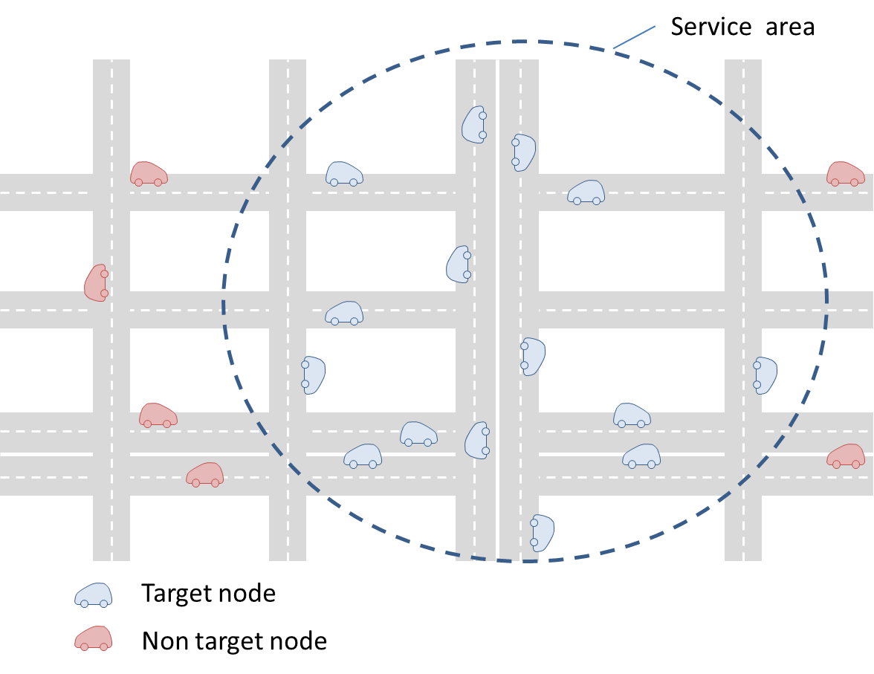
Figure 9.1-2: AREA

To deliver a content to vehicles located in a dedicated area (a few hundred meters), the “AREA level” position accuracy would be required. Figure 9.1-2 illustrates the concept of “AREA” use case. In this case, an acceptable error range should be less than dozens of meters. For instance, an underlying network can provide location information with the required position accuracy based on Cell-ID.
Geo-Fence is also applicable for the AREA level position accuracy. In oneM2M Release 2, Geo-Fence is utilizable as the resource type <locationPolicy>. For instance, in use case 6.8, when a traffic accident occurs, oneM2M platform sets Geo-Fence around the accident point. Then the oneM2M platform can provide the content to the vehicles in the Geo-Fence.
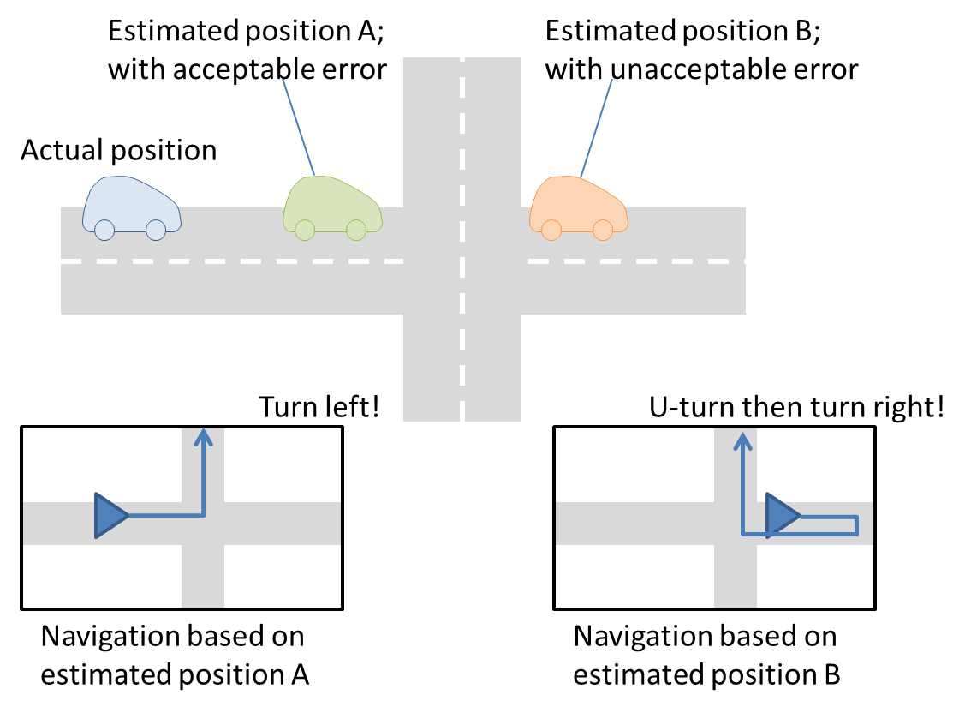
Figure 9.1-3: ROAD

To deliver content to vehicles located in a dedicated road, the “ROAD level” position accuracy would be required. In this case, navigation systems or services can be utilized and its acceptable error range should be less than a few meters. Some use cases provide route navigation for vehicles based on their location. Figure 9.1-3 illustrates the reason why “ROAD” position accuracy is required. As shown in the figure, the service cannot provide accurate route navigation when the location contains larger error. To obtain the location information with the required position accuracy level, GPS (Global Positioning System) or Assisted GPS are applicable. Furthermore, when the underlying network consists of RSUs, if the RSUs are located every a few meters to dozens of meters, the oneM2M platform could obtain ROAD level position accuracy.
To deliver content to vehicles located in a dedicated lane, the “LANE level” position accuracy would be required. At this time, no use case needs the position accuracy level, but the future use cases will require the position accuracy. In this case, an acceptable error range should be less than dozens of centimeters. To obtain the location information with the required position accuracy level, a device in a vehicle and an infrastructure should support the current positioning systems such as RTK-GPS (Real Time Kinematic GPS) or the latest GNSS (Global Navigation Satellite System) /RNSS (RadioNavigation Satellite System).

9.1.2 Latency
Since a node in vehicular domain moves fast and dynamically, the latency (e. g., network latency) causes the difference between the actual vehicle position and the assumed position in application implemented in the center. For instance, one second latency causes dozens of meters difference. Therefore, if the service requires higher position accuracy and time-sensitive operation, the service should take the latency into consideration (for instance, modifying the location considering the latency).

9.1.3 Conclusion
Current oneM2M LOC CSF provide GPS based location function. By analysing existing vehiclular domain use cases, GPS based location function basically satisfies location requirements. However, if the future use cases assume higher position accuracy and time-sensitive location management for the service, current LOC CSF may not satisfy their requirements. To satisfy the future requirements, the other position estimation method and position modification technology should be required for future oneM2M system.

