CHANGE REQUEST
Meeting:* | REQ #26
Source:* | Convida Wireless
Date:* | 2016-11-23
Contact:* | Catalina Mladin, Mladin.Catalina@ConvidaWireless.com
Reason for Change/s:* | Editorial Corrections and Missing text in Section 7 & 8
CR against: Release* | Release 3
CR against: WI* | Active <WI-0046>  MNT Maintenance / < Work Item number(optional)>  STE Small Technical Enhancements / < Work Item number (optional)>  Only ONE of the above shall be ticked
CR against: TS/TR* | TR-0026
Clauses/Sub Clauses* | Section 5.1, 6.15, 6.16, 8, 9
Type of change: * | Editorial change  Bug Fix or Correction  Change to existing feature or functionality  New feature or functionality  Only ONE of the above shall be ticked
Post Freeze checking:* | This CR contains only essential changes and corrections? YES NO  This CR may break backwards compatibility with the last approved version of the TS? YES NO  This CR is a mirror CR? YES if YES, please indicate the document number of the original CR: <Document Number) : NO
Template Version:27 May 2015 (Dot not modify)

oneM2M Notice
The document to which this cover statement is attached is submitted to oneM2M. Participation in, or attendance at, any activity of oneM2M, constitutes acceptance of and agreement to be bound by terms of the Working Procedures and the Partnership Agreement, including the Intellectual Property Rights (IPR) Principles Governing oneM2M Work found in Annex 1 of the Partnership Agreement.
GUIDELINES for Change Requests:
Provide an informative introduction containing the problem(s) being solved, and a summary list of proposals.
Each CR should contain changes related to only one particular issue/problem.
In case of a correction, and the change apply to previous releases, a separated “mirror CR” should be posted at the same time of this CR
Follow the principle of completeness, where all changes related to the issue or problem within a deliverable are simultaneously proposed to be made E.g. A change impacting 5 tables should not only include a proposal to change only 3 tables. Includes any changes to references, definitions, and acronyms in the same deliverable.
Follow the drafting rules.
All pictures must be editable.
Check spelling and grammar to the extent practicable.
Use Change bars for modifications.
The change should include the current and surrounding clauses to clearly show where a change is located and to provide technical context of the proposed change. Additions of complete sections need not show surrounding clauses as long as the proposed section number clearly shows where the new section is proposed to be located.
Multiple changes in a single CR shall be clearly separated by horizontal lines with embedded text such as, start of change 1, end of change 1, start of new clause, end of new clause.
When subsequent changes are made to content of a CR, then the accepted version should not show changes over changes. The accepted version of the CR should only show changes relative to the baseline approved text.

Introduction
TR-0026 has a number of small typographical errors and text omissions. This contribution attempts to perform a minor clean-up throughout the document and to insert the missing text. The following changes/corrections have been made:
- Editorial corrections to Section 5.1 “Vehicle Domain Overview”
- Reducing figure size in Section 6.15.9
- Editorial corrections to Section 6.15 and 6.16 (in heading format)
- Added missing requirements to Section 7 (from use case 6.8, 6.12, 6.13, 6.14, 6.15, 6.16)
- Editorial corrections to section 8
- Added missing architecture to support use case 6.5 and 6.16
R01 includes editorial changes requested for approval during TP#26 session

-----------------------Start of change 1-------------------------------------------

5 Introduction to Vehicular Domain

5.1 Vehicular Domain Overview
Existing ITS (Intelligent Transport Systems) services in automotive industry have been provided through the architecture which is composed of connected vehicles to various infrastructures such as the ETC (Electronic Toll Collection) service, VICS (Vehicle Information and Communication System) or telematics service centers. Those systems have been growing by improving mobility convenience for drivers. However, the infrastructure systems are required to change and become more collaborative , in order to meet rising social demands such as energy saving, traffic congestion resolution and fatal accidents avoidance.
The changing trends are enabled by improvements of IT technologies such as V2V/V2I (Vehicular to Vehicular/ Vehicular to Infrastructure) communication, cloud systems or OSS (Open Source Software). The M2M architecture for vehicle domain described in this TR accelerates wide collaboration between not only auto manufacturers or suppliers but also between telecommunication providers or government, which results in improvement of safety, comfortability and eco-friendliness. Figure 5.1-1 is an example of reference architecture.

Figure 5.1-1 Vehicular Domain Architecture

In this architecture, vehicles can connect to various services via M2M systems. Gateways which collect sensing data could be located both inside (left of figure) and outside of the vehicle (centre of figure). A vehicle may act as a gateway and collect also data generated by sensors located outside of a vehicle (right of figure). Furthermore vehicles may connect to each other and a vehicle may connect to services via other vehicles.
This vehicular domain architecture provides the basic functions for analyzing huge amounts of data collected from large number of vehicles which makes it possible to create future services as a result of collaboration with other industries.
Furthermore, multiple security levels according to features of collected data make it possible to provide critical control and management for vehicles such as remote maintenance or automated driving control via communication networks.

5.2 Technology Trends in Vehicular Domain
In order to develop vehicular domain architecture as ITS platform, many worldwide organizations are discussing technology and standardization related to this field.
ISO (International Organization for Standardization) is an international standard-setting body which standardized technologies for ITS systems through the work of TC (Technical Committee) 204 (ITS) and 22 (Road Vehicles). In recent years, ISO has focused on CITS (Cooperative ITS) using V2V/V2I communication for some new services such as automated driving and Urban ITS which improves mobility in urban area. Furthermore, it has made an effort to develop gateways between in-vehicle area network and nomadic devices like smartphones.
ITU-T (International Telecommunication Union Telecommunication Standardization Sector) is one of the three sectors of the ITU and it coordinates standards for telecommunications. In SG16 (multimedia) of ITU-T, VGP (Vehicle Gateway Platform) has been standardized in terms of telecommunication. In particular, reference architecture and functional architecture based on supposed applications and interface protocol to vehicles or ICT devices are discussed.
ETSI (European Telecommunications Standards Institute) is a standardization organization in the telecommunications industry (equipment makers and network operators) in Europe. In TC (Technical Committee) ITS, standards, specifications and other deliverables to support the development and implementation of ITS Service provision across the network have been developed. The scope includes communication media, and associated physical layer, transport layer, network layer, security, lawful intercept and the provision of generic web services.
The W3C (World Wide Web Consortium) is the main international standards organization for the World Wide Web. In 2013, it has established the Automotive and Web Platform Business Group and prepared a draft of Vehicle Information Access and Vehicle Data Spec. Currently these topics are in discussion to standardize in the Automotive Working Group. Respond to the growing needs of web services for a connected car, the W3C focuses on interfaces for application vendors to accsess vehicle data using a standard and secure method.
In reference to V2V/V2I commnication technologies which support M2M services in vehicular domain, DSRC (Dedicated Short Range Communications) has been discussed in ITU-R (International Telecommunication Union Radiocommunications Sector) and IEEE (The Institute of Electrical and Electronics Engineers). Moreover cellular communication for vehicular domain is also discussed in 3GPP (Third Generation Partnership Project). These wireless communication technologies are expected to resolve some problems such as cost, coverage, latency and power consumption., while an unified communication standard is expected to accelerate the growth of M2M services in business.

Table 5.2-1 Vehicular Domain Standards
No | Organization | Sector | Focus point | Major topics
1 | ISO | TC204, TC22 | ITS services | Cooperative System,  In-vehicular gateway
2 | ITU-T | SG16 | Telecommunication | Vehicle Gateway Platform,  Communication protocol
3 | ETSI | TC ITS | Network system,  Radio Technique | Cooperative ITS, DSRC
4 | W3C | Automotive WG | Web services | Web-API for vehicles
5 | ITU-R | SG5/WP5A | Wireless communication | V2V/V2I communication (DSRC)
6 | IEEE | 802.11p + P1609 | Wireless communication | V2V/V2I communication (DSRC)
7 | 3GPP | - | Wireless communication | V2V/V2I communication (Cellular)

5.3 The focus of oneM2M in Vehicular Domain
In the context of progress achieved through various standardization efforts, oneM2M is continuing to develop a common platform which can be used for information transport functions between vehicles and backend servers to satisfy vehicular domain requirements. The following capabilities are of key importance to the vehicular domain.
- Data management
Since vehicles may move fast, the operation and management in this domain will be dynamic, complex and difficult. For example, if the nodes located on roadside act as gateway, status of a connection between device and gateway is varying frequently. Therefore, management of data (including sensing and device information, data streams) as well as filtering and preprocessing functions (at devices or gateways) are required in order to provide efficient analysis services in the complicated enviroments.
- Communication management
M2M services in vehicular domain need to deal with many and widespread devices. On the other hand, the target devices of the operation are depending on the services. For instance, it is expected that the content is distributed to the vehicles in a specific geographical area. Therefore, the communication management function is needed to select appropriate communication protocols and modes (e.g. unicast, multicast or broadcast), according to features of data, for efficient utilization of network resources.
- Location
Geographical location information is important in vehicular services. To improve safety, up-to-date location information is important for collision avoidance. Therefore, accurate location providing/managing functions are needed in this vehicular domain. Furthermore, the inherent node mobility in the vehicular domain creates greater variability in the services available along the way. Mobility management functionality is required to allow maintaining the vehicular services as the node moves, and to provide means for selection and migration of services between nodes.
- Security
To mitigate the life-threatening risk resulting from malicious control and management of vehicles via network, components of vehicular services should support strict authentication functionality. Furthermore integrity and encryption functionality for communication are required, with consideration for on system scalability and resource constraints at the devices.

-----------------------End of change 1 ------------------------------------------

-----------------------Start of change 2-------------------------------------------

6.15 Vehicle location privacy protection

6.15.1 Description
The privacy protection is an issue that must be considered for locating in human to human communications. For example, in 3GPP network, privacy protection is implemented by an independent entity such as a privacy profile register (PPR) or a gateway mobile location center (GMLC). In the vehicle domain, the location information of the vehicle represents the location of the vehicle user. Therefore an issue of privacy protection is also closely related to the vehicle location information. The privacy protection refers to that when a vehicle is connected to the M2M system, the user of the vehicle has permission to specify when and where a third party application is allowed to access to the vehicle location information.
After the M2M platform receives a message from a third part application, requesting for the location information of a certain vehicle, the M2M platform determines the entity that should performs the privacy inspection, according to the source of the location information. For example, if the location information of the vehicle is network based and the underlying network is 3GPP, then the entity that performs the privacy inspection should be the 3GPP location server. On the other hand, if the location information of the vehicle is device based, then it should be the M2M platform that performs the privacy inspection.

6.15.2 Source
REQ-2016-0040R02-TR-0026-Vehicle_location_privacy_protection

6.15.3 Actors
- M2M Device: It is embedded in a vehicle, which is used to connecting to the M2M platform.
- Vehicle: Vehicle connects to the M2M platform via the embedded M2M device and it equips hardware devices for localization. (e.g. GPS, Cellular modem)
- Vehicle Owner: The owner of the vehicle. The owner has privacy agreement with the 3GPP network location server or the M2M platform.
- 3GPP network location server: When the vehicle connects to the M2M platform via the 3GPP underlying network, the 3GPP network location server can perform the location service and provide the location information to the M2M platform. In this case the 3GPP network location server also performs the privacy inspection function. The 3GPP network location server is configured with location privacy policies according to the privacy agreement with the vehicle owner and the network operator policy. The location privacy policies refer to when and where a third part application is allowed to access to the vehicle location information.
- M2M Platform: It connects, manages M2M devices and exposes location services to the M2M application. The M2M platform can collect the vehicle location information either from the underlying network, e.g. 3GPP network location server, or from the device itself, e.g. the vehicle is equipped with any location capable modules or technologies (e.g. GPS) and is able to position itself. The M2M platform is configured with location privacy policies according to the privacy agreement with the vehicle owner. The location privacy policies refer to when and where a M2M application is allowed to access to the vehicle location information.
- M2M Application server: The M2M application server requests for the location information of the vehicle for any possible application usage, e.g. fleet management or traffic monitoring.

6.15.4 Pre-conditions
- The vehicle owner already has privacy protection agreement with the operator of the 3GPP network or the M2M platform.

6.15.5 Triggers
The M2M application server requests to access to the location information of the vehicle.

6.15.6 Normal Flow
Scenario 1: The vehicle No.1 connects to the M2M platform via the 3GPP network and the location information is collected by the 3GPP network location server:
- The M2M application sends message to the M2M platform to request for the location information of vehicle No.1.
- The M2M platform checks the location information source of the vehicle. if the location information of the vehicle comes from the underlying network location server, e.g. 3GPP network location server, the M2M platform sends privacy inspection requests, including the M2M application identifier which can be recognized by the 3GPP network, to 3GPP network location server to verify whether the M2M application is allowed to access to the location information.
- The 3GPP network location server is configured with the privacy policies of vehicle No.1. When the 3GPP network location server receives the access right verify request, it performs the privacy inspection, checking the privacy policies with the M2M application identifier and other information, e.g. the time and the lasted location of the vehicle. The 3GPP network location server returns the checking result to the M2M platform, that is whether the M2M application is allowed to access to the location information.
- If the M2M application is allowed to access to the location information, after the M2M platform receives the responses from 3GPP network location server, it sends the location information request message to the 3GPP network location server.
- The 3GPP network location server performs the location updating procedure inside the 3GPP network and collects the latest location information of the vehicle. Then the 3GPP network location server returns the location information to the M2M platform.
- The M2M platform forwards the location information to the M2M application.

Scenario 2: The vehicle No.2 connects to the M2M platform via the 3GPP network. It is equipped with location capable modules or technologies (e.g. GPS) and is able to position itself. The M2M platform can collect the location information of the vehicle directly without the help of any other location server.
- The M2M application sends message to the M2M platform to request for the location information of vehicle No.2.
- The M2M platform checks the location information source of the vehicle. if the location information of the vehicle is device based and is collected by the M2M platform directly from the vehicle itself, then the M2M platform checks the privacy policies configured in the M2M platform.
- If the M2M application is allowed to access to the location information, then the M2M platform returns the location information to the M2M application. If the M2M application is not allowed to access to the location information, then the M2M platform sends failure response to the M2M application with appropriate error code.

6.15.7 Alternative flow
N/A

6.15.8 Post-conditions
N/A

6.15.9 High Level Illustration
M2M application
Vehicle1
Vehicle2
GPS module
underlying network
Underlying network location server
privacy
M2M platform
privacy

6.15.10 Potential requirements
1. The oneM2M system shall be able to support the enforcement and management (e.g. update) of the privacy policies for vehicle location information.
2. The oneM2M system shall be able to apply the privacy policies configured in the oneM2M system to those vehicles whose location information is obtained by the oneM2M system itself.
3. The oneM2M system shall be able to request the underlying network to perform, on behalf of the oneM2M system, the privacy policy decision concerning the location information if the location information is obtained by the underlying network location service.

6.16 Vehicle Domain service continuity

6.16.1 Description

Autonomous or self-driving cars have been gaining attention as early versions of such vehicles have become available. A gateway on such a vehicle, may be responsible for movement control (braking, turning, etc.) as well as delivering external services. Such a scenario requires real time monitoring of sensors and fast access to various actuators for accident avoidance. For example, time series data may be gathered which triggers specific actions when data is lost. In such cases service continuity and data transfer of time-critical information are essential.

6.16.2 Source
REQ-2016-0052R02-TR-0026_service_use_case

6.16.3 Actors
- Vehicle:
A Source Vehicle is a moving object which provides support for services necessary for vehicle operations.
- Road-Side Unit (RSU):
A Road–side unit is located along vehicular paths and provides localized support for services necessary for multiple vehicle operations. This support is provided for vehicles within the RSU’s communication range.
- Infrastructure Node:
An Infrastructure Node provides centralized support for services provided by a Services Provider to a large number and variety of devices.

6.16.4 Pre-conditions
- All RSUs are registered to the Infrastructure Node.

6.16.5 Triggers
- When a vehicle moves it loses connectivity to one road-side unit, and then re-connects to different road-side units along the way

6.16.6 Normal Flow
The Normal Flow depicts the case where a moving vehicle receives notifications
Figure 1.1-1 Normal Flow for Vehicular Domain Service Continuity

- Vehicle establishes communication with RSU 1.
- RSU 1 creates a subscription to a resource hosted on the Infrastructure Node on behalf of the Vehicle.
- A notification corresponding to the subscription in step 1 is generated and sent to the Vehicle via RSU 1
- The vehicle moves, and establishes communication with RSU 2.
- Supporting interactions between RSUs and Infrastructure Node.
- A notification corresponding to the subscription in step 1 is generated. The notification is sent to the Vehicle via RSU 2

6.16.7 Alternative flow
The Alternative Flow depicts the case where a moving vehicle reports observed road/traffic conditions (e.g. vehicles in proximity and their speed, distance to curb, etc.) and receives collision avoidance commands. The RSUs collect and store the information from the vehicles, and also exchange information with each other. This allows the RSUs to better identify the trajectory of vehicles and to help predict potential collisions. As collision avoidance decisions are extremely time sensitive, all decisions are made locally at the RSU. This avoids any unnecessary delays incurred with communication to the infrastructure node.

Figure 1.1-2 Alternative Flow for Vehicular Domain Service Continuity
- Vehicle establishes communication with RSU 1.
- Vehicle sends road/traffic data to RSU 1.
- The vehicle moves, and establishes communication with RSU 2.
- RSU 2 retrieves traffic data related to vehicle from RSU 1.
- Vehicle sends road/traffic data to RSU 2.
- Collision avoidance algorithm determines that a collision is imminent (based on vehicle data from RSU 2 and from RSU 1)
- RSU 2 sends a collision avoidance command to the vehicle.

6.16.8 Post-conditions
N/A

6.16.9 High Level Illustration
Figure 1.1-3 High Level Illustration Vehicular Domain Service Continuity

6.16.10 Potential requirements
- The oneM2M system shall enable continuity of services to M2M devices as they move across various geographic points in the oneM2M system.

-----------------------End of change 2 ------------------------------------------

-----------------------Start of change 3-------------------------------------------

7 Overview of Potential Requirements

Potential requirements from all vehicular domain use cases collected in this technical report are summarized as follows,
- The M2M application System shall enable the M2M Devices to exchange M2M application to diagnostic data periodically with the M2M Application in the network domain.
Note: These requirements addresses the use case 6.1 “Vehicle Diagnostic & Maintenance Report”.
- The M2M System shall enable the M2M Application to configure the notification interval in the M2M Devices.
Note: These requirements addresses the use case 6.1.
- The M2M system shall support a mechanism to describe the syntax and semantics format of the M2M application diagnostics data exchanged between the M2M Devices and the M2M Application in the network domain.
Note: These requirements addresses the use case 6.1.
- The M2M service SHALL be able to provide the mechanism for authorization for integrity-checking and installing processes of software/hardware/firmware component(s) on M2M Device(s) (SER-013).
Note: These requirements addresses the use case 6.2 “Use Case on Remote Maintenance Services”.
- The M2M system SHALL be able to support authentication using device key on the integrity check for M2M Device(s).
Note: These requirements addresses the use case 6.2.
- The M2M Device SHALL be able to support HSM (Hardware Security Module) to protect its integrity depending on the security level requirement.
Note: These requirements addresses the use case 6.2.
- A M2M System shall support communication between M2M Platform and a M2M device either directly or via a gateway.
Note: These requirements addresses the use case 6.3 “Traffic Accident Information Collection”.
- A M2M System shall be able to exchange information between M2M applications via M2M Platform.
Note: These requirements addresses the use case 6.3.
- A M2M System shall be able to take actions according to the received service requests from M2M Applications.
Note: These requirements addresses the use case 6.3.
- A M2M system shall be able to support service requests from M2M applications for communication with QoS requirement, such as, higher delivery priority, reliable delivery, etc.
Note: These requirements addresses the use case 6.3.
- A M2M System shall support mutual-authentication among M2M device, M2M gateway, M2M platform and M2M Application (SER-040).
Note: These requirements addresses the use case 6.3.
- The information sent by a M2M device or the M2M platform or a M2M application shall use cryptographic technology to ensure information authentication and information integrity.
Note: These requirements addresses the use case 6.3.
- A M2M system shall permit information being provided in anonymous way.
Note: These requirements addresses the use case 6.3.
- A command issued by a M2M System shall be able to have time expiration or geography restriction.
Note: These requirements addresses the use case 6.3.
- Provisioning, installation, configuration and registration method of terminal system
  - Especially for the case of overlapping two different system for DTG management system (owns and manages the device) and the application system using DTG data (utilising the data from the device).
Note: These requirements addresses the use case 6.4 “Fleet Management Service using DTG (Digital Tachograph)”.
- DTG/FMS data storing method and delivery protocol
  - There is no dominant standard specifying data formats and protocols for vehicle related applications.
Note: These requirements addresses the use case 6.4.
- Vehicle location based service method
  - M2M service platform is expected to provide the service capability supporting location based service.
Note: These requirements addresses the use case 6.4.
- Control, configuration, error logging, and management method for the terminal system Over The Air.
  - M2M service platform is expected to provide the service capability supporting the Over The Air management.
Note: These requirements addresses the use case 6.4.
- The M2M system shall provide the capability for an M2M device to maintain registration with multiple entities simultaneously.
Note: These requirements addresses the use case 6.5 “Use cases for Electronic Toll Collection (ETC) service”.
- The registration shall be able to include information that identify the peer entity, and other information such as its management privilege, subscription etc., that are necessary for the conduct of the respective peer relationships.
Note: These requirements addresses the use case 6.5.
- It shall be possible for some registrations to hold the complete set of information context about the peer entity. This is refereed to as "full registration".
Note: These requirements addresses the use case 6.5.
- It shall be possible for some registrations to hold only a subset of information context about the peer entity. This is referred to as "lightweight registration".
Note: These requirements addresses the use case 6.5.
- It shall be possible for "lightweight registration" at different entities that pertain to a common peer entity, to hold different sets of information, if needed, about the common peer entity.
Note: These requirements addresses the use case 6.5.
- It shall be possible to correlate the "full registration" and the "lightweight registration" that pertain to a common peer entity.
Note: These requirements addresses the use case 6.5.
- It shall be possible to distinguish the "full registrations" and the "lightweight registrations" that pertain to a common peer entity.
Note: These requirements addresses the use case 6.5.
- The M2M service platform shall be able to support the time-based policies to access the Underlying network.
Note: This requirement addresses the use case 6.6 “Use cases for Taxi Advertisement”.
- The oneM2M System shall enable discovery of M2M Application Servers, M2M Management Servers and M2M Devices available to an M2M Gateway for data exchange (OSR-056).
Note: This requirement addresses the use case 6.7 “Use Case on Vehicle Data Service”.
- The oneM2M System shall enable discovery of M2M Gateways available to a M2M Management Server and an M2M Device for data exchange (OSR-057).
Note: This requirement addresses the use case 6.7.
- The oneM2M System shall be able to support the capabilities for data repository (i.e. to collect/store) and for data transfer from one or more M2M Devices or M2M Gateways, for delivery to one or more M2M Gateways via M2M Area Network without any assistance or instruction of M2M Management Servers and M2M Application Servers(OSR-019).
Note: This requirement addresses the use case 6.7.
- Upon request from M2M Application Server, an M2M Gateway shall enable functions that pre-process (e.g. average) M2M data before providing them to the recipient.
Note: This requirement addresses the use case 6.7.
- Upon request, an M2M Gateway shall enable functions that erase M2M data (e.g. that have been sent or could not be sent to the recipient within a certain time) based on criteria from an M2M Application Server.
Note: This requirement addresses the use case 6.7.
- An M2M Gateway and/or an M2M Device shall be able to broadcast to all M2M Devices and/or M2M Gateways in the vicinity its need to receive/deliver specific data.
Note: This requirement addresses the use case 6.7.
- M2M Gateway and/or M2M Device shall be able to establish a connection to each other if it is able to receive/deliver the required specific data.
Note: This requirement addresses the use case 6.7.
- OneM2M System shall be able to send the information to intended vehicles by unicast, multicast and/or broadcast.
Note: This requirement addresses the use case 6.8 “Smart Automatic Driving”.
- OneM2M System shall be able to securely transfer the information by using an appropriate way such as digital signature.
Note: This requirement addresses the use case 6.8.
- OneM2M System shall be able to transfer the information on real-time basis for feeding back current road states to automatic driving control. The feedback time should be less than a few seconds (the distance between vehicles is normally worth of a few seconds) to avoid unnecessary speed down/stop of following vehicles.
Note: This requirement addresses the use case 6.8.
- OneM2M system shall be able to guarantee its reliability in order to receive/feedback massages from/to related vehicles.
Note: This requirement addresses the use case 6.8.
- oneM2M System shall enable sharing of service information between devices/GWs based on proximity.
Note: This requirement addresses the use case 6.8.
- oneM2M System shall enable sending and receiving of service information between devices/GWs with minimized interruption.
Note: This requirement addresses the use case 6.8.
- The oneM2M System shall enable the cancellation of continuous data collection and/or the deletion of collected data when pre-defined conditions are met. (OSR-089)
Note: This requirement addresses the use case 6.9 “Use Case on Vehicle Data Wipe Service”.
- The oneM2M System shall enable pre-defined conditions to be protected from unauthorized modification (SER-050).
Note: This requirement addresses the use case 6.9.
- The oneM2M System shall enable the deletion of M2M data produced/stored by the M2M Devices/Gateways based on request from an authorized entity (SER-051).
Note: This requirement addresses the use case 6.9.
- The oneM2M System shall support reporting of Geo-Fence based Location event of the target M2M Device to the M2M Application based on the Application’s configuration(OSR-047).
Note: This requirement addresses the use case 6.10 “Vehicle Management based on Geo-Fence”.
- The oneM2M System shall support the M2M Application setting the configuration for Geo-Fence based location service.
Note: This requirement addresses the use case 6.10.
- The oneM2M System shall be able to prevent unauthorized modification of the firmware of M2M Device.
Note: This requirement addresses the use case 6.11 “Use Case on Secure Over-The-Air Firmware Update for Automotive ECUs”.
- The oneM2M System shall be able to detect unauthorized modification of the firmware of M2M Device.
Note: This requirement addresses the use case 6.11.
- The oneM2M System shall be able to stop operation of M2M device when it is updated with wrong firmware.
Note: This requirement addresses the use case 6.11.
- The oneM2M System shall be able to support security mechanisms to protect their cryptographic keys and cryptographic operations by using tamper proof devices such as TPM (Trusted Platform Module), HSM (Hardware Security Module) and SIM (Subscriber Identity Module).
Note: This requirement addresses the use case 6.11.
- The oneM2M System shall be able to prevent malfunction of M2M Device caused by receiving unsolicited messages or information.
Note: This requirement addresses the use case 6.11.
- The M2M System shall support mobile/portable M2M Gateway and/or Device.
Note: This requirement addresses the use case 6.12 “Car/Bicycle Sharing Services”
- The M2M System shall support to distinguish the event levels for reporting and handle it differentially.
Note: For example, the event levels may be divided into normal and urgent event.
Note: This requirement addresses the use case 6.12.
- Based on the condition of the M2M Gateway and/or Device, the M2M System shall change the reporting (or subscription) mechanisms and/or configurations related to a service.
Note: This requirement addresses the use case 6.12.
- The M2M System shall support to process access right requests of a resource and grant the requests if the requests
Note: This requirement addresses the use case 6.12.
- The M2M System shall support mechanisms to correlate charging data/records from different M2M Application Service Providers.
Note: This requirement addresses the use case 6.13 “Smart Parking”
- The M2M System shall support triggering M2M Devices to report on-demand regarding collected data from other M2M Devices.
Note: This requirement addresses the use case 6.13
- The oneM2M system shall enable the M2M Infrastructure to facilitate direct communication between two or more different M2M devices without having registered with one another.
Note: This requirement addresses the use case 6.14 “Vehicle Broadcasting without Registration”
- The oneM2M system shall be able to support the enforcement and management (e.g. update) of the privacy policies for vehicle location information.
Note: This requirement addresses the use case 6.15 “Vehicle location privacy protection”
- The oneM2M system shall be able to apply the privacy policies configured in the oneM2M system to those vehicles whose location information is obtained by the oneM2M system itself.
Note: This requirement addresses the use case 6.15
- The oneM2M system shall be able to request the underlying network to perform, on behalf of the oneM2M system, the privacy policy decision concerning the location information if the location information is obtained by the underlying network location service.
Note: This requirement addresses the use case 6.15
- The oneM2M system shall enable continuity of services to M2M devices as they move across various geographic points in the oneM2M system.
Note: This requirement addresses the use case 6.16 “Vehicle Domain service continuity”

-----------------------End of change 3 ------------------------------------------

-----------------------Start of change 4-------------------------------------------

8 High Level Architecture

8.1 Introduction
The use cases in the vehicular domain discussed in the present document are listed in table 8.1-1.
Table 8.1-1: Use cases in the vehicular domain
Use case No. | Title | Description
1 | Vehicular Diagnostic & Maintenance Report | See clause 6.1
2 | Use Case on Remote Maintenance Services | See clause 6.2
3 | Traffic Accident Information Collection | See clause 6.3
4 | Fleet Management Service using DTG (Digital Tachograph) | See clause 6.4
5 | Use cases for Electronic Toll Collection (ETC) service | See clause 6.5
6 | Use cases for Taxi Advertisement | See clause 6.6
7 | Use Case on Vehicle Data Service | See clause 6.7
8 | Smart Automatic Driving | See clause 6.8
9 | Use Case on Vehicle Data Wipe Service | See clause 6.9
10 | Vehicle Management based on Geo-Fence | See clause 6.10
11 | Use Case on Secure Over-The-Air Firmware Update for Automotive ECUs | See clause 6.11
12 | Car/Bicycle Sharing Services | See clause 6.12
13 | Smart Parking | See clause 6.13
14 | Vehicle Broadcasting without Registration | See clause 6.14
15 | Vehicle location privacy protection | See clause 6.15
16 | Vehicle domain Service Continuity | See clause 6.16

Though these use cases are focusing on the vehicular domain, those ways of functional deployment are different. The following clauses provide the types of high level oneM2M architecture mappings for these use cases.

8.2 Vehicular Architecture Type 1
Figure 8.2-1 illustrates the first type of high level oneM2M architecture in vehicular domain. In this type, vehicular domain applications and the M2M service platform described in each use case are mapped to the IN (Infrastructure Node). Each vehicle is equipped with a communication module which supports cellular network or other wireless communication technologies, and the vehicle can connect to a service platform via the communication module. Alternatively, an external unit such as the smartphone acts as both a communication module and a GW. In this case, the external unit would connect to in-vehicle network via some network technologies such as Bluetooth.
The GW which provides some functions defined in oneM2M acts as the MN or the ASN. The GW would be the in-vehicle unit such as an ECU (Electronic Control Unit) or the external unit such as the smartphone. The GW is connecting to in-vehicle units and external sensors via an in-vehicle network such as CAN (Controller Area Network) or other communication technology such as Bluetooth.
The in-vehicle units such as ECUs or external sensors act as the ADN or the non-oneM2M device node.
The use case 1 to 3, 6 to 11, 13 and 15 are categorized into this type.
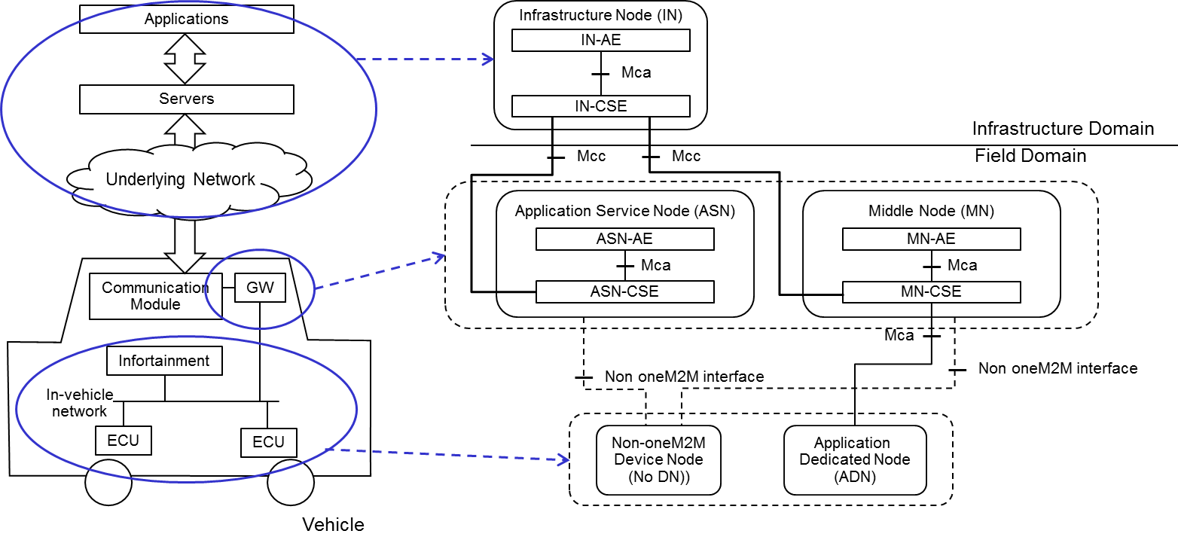
Figure 8.2-1: High Level Architecture Type 1 in Vehicular Domain

8.3 Vehicular Architecture Type 2
Figure 8.3-1illustrates the second type of architecture. Same as the first type, vehicular domain applications and the M2M service platform described in each use case are mapped to the IN. Each vehicle equips a communication module to connect to a road side unit.
The road side unit which provides some functions defined in oneM2M acts as the MN.
In this type, the GW in vehicle acts as the MN or the ASN. The in-vehicle units such as ECUs or external sensors act as the ADN or the non-oneM2M device node.
The use case 3 to 5 and 12 are categorized into this type.
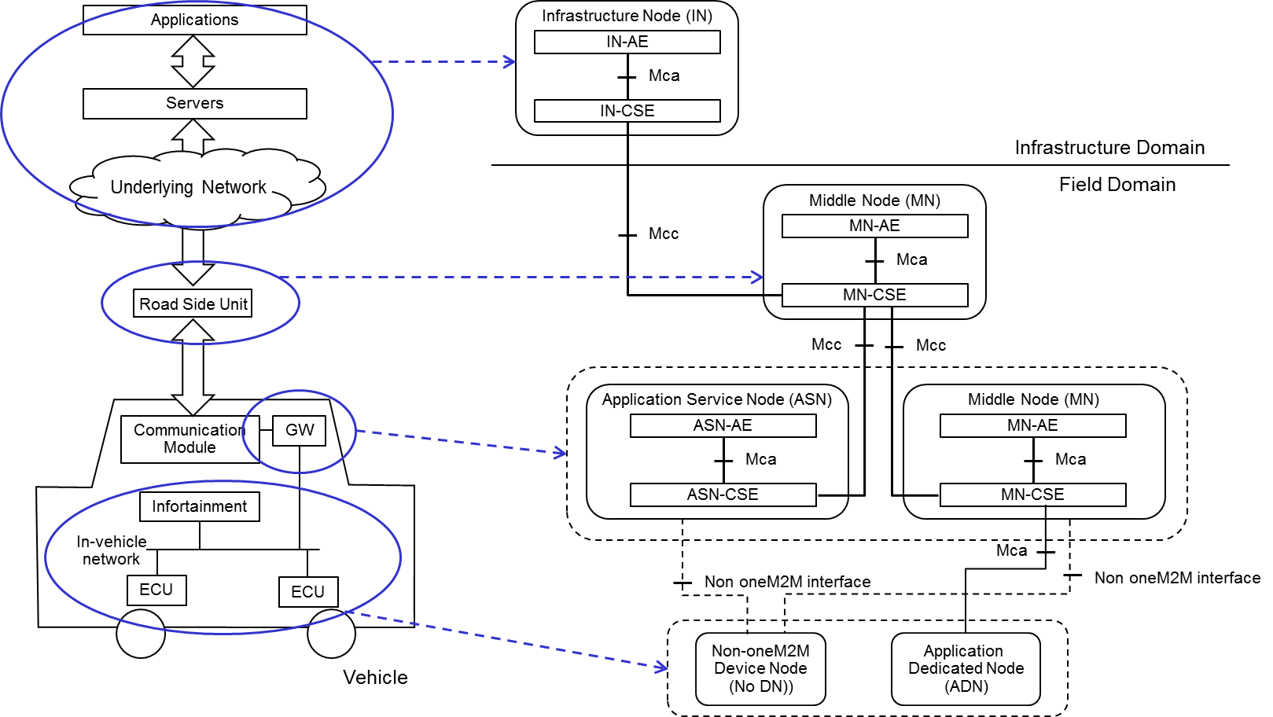
Figure 8.3-1: High Level Architecture Type 2 in Vehicular Domain

8.4 Vehicular Architecture Type 3
Figure 8.4-1 illustrates the third type of architecture. In this type, a vehicle to vehicle communication technology is supported in each vehicle. To support the vehicule to vehicle communication in the oneM2M architecture, the GW acts as the MN.
The use case 3 and 14 are categorized into this type.
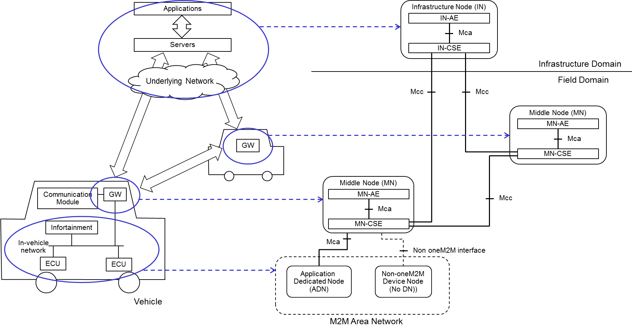
Figure 8.4-1: High Level Architecture Type 3 in Vehicular Domain

8.5 Vehicular Architecture Type 4
Figure 8.5-1 illustrates the fourth type of architecture – which is a variation to Architecture Type 2. The main difference is that the vehicle has no GW functionality providing oneM2M services to the in-vehicle units. However, the vehicle still has a communication module to communicate with RSUs.
In this architecture, the in-vehicle units, such as ECUs or external sensors, act as ADNs or non-oneM2M device nodes. The RSU, which provides functions defined in oneM2M, acts as an MN.
The use case 5 and 16 are categorized into this type.
Figure 8.5-1: High Level Architecture Type 4 in Vehicular Domain

-----------------------End of change 4 ------------------------------------------

CHECK LIST
- Does this change request include an informative introduction containing the problem(s) being solved, and a summary list of proposals?
- Does this CR contain changes related to only one particular issue/problem?
- Have any mirror crs been posted?
- Does this change request make all the changes necessary to address the issue or problem? E.g. A change impacting 5 tables should not only include a proposal to change only 3 tables. Includes any changes to references, definitions, and acronyms in the same deliverable?
- Does this change request follow the drafting rules?
- Are all pictures editable?
- Have you checked the spelling and grammar?
- Have you used change bars for all modifications?
- Does the change include the current and surrounding clauses to clearly show where a change is located and to provide technical context of the proposed change? (Additions of complete sections need not show surrounding clauses as long as the proposed section number clearly shows where the new section is proposed to be located.)
- Are multiple changes in this CR clearly separated by horizontal lines with embedded text such as, start of change 1, end of change 1, start of new clause, end of new clause?

