Input contribution
Use case
Use Case Title:* | Service Grouping
Group Name:* | WG1
Source:* | ETRI (TTA)
Contact: | Yonghwan Choi, ETRI, yhc@etri.re.kr  Jung-soo Park, ETRI, pjs@etri.re.kr
Date:* | 2016-11-28
Abstract:* | This input introduces a new use case of service grouping
Agenda Item:* | <Agenda item reference>
Work item(s):
Document(s)
Impacted*
Intended purpose of  document:* | Decision  Discussion  Information  Other <specify>
Decision requested or recommendation:* | Discuss and make a decision to agree this input contribution
Template Version:23 February 2015 (Dot not modify)

oneM2M Notice
The document to which this cover statement is attached is submitted to oneM2M. Participation in, or attendance at, any activity of oneM2M, constitutes acceptance of and agreement to be bound by terms of the Working Procedures and the Partnership Agreement, including the Intellectual Property Rights (IPR) Principles Governing oneM2M Work found in Annex 1 of the Partnership Agreement.

Service Grouping

Description
In Internet of Things (IoT) environments, thousands of services on heterogeneous resources exist, and each IoT service would be in dependently processed according to the heterogeneous resources.
Furthermore, not only a single IoT service are separately provided, but also a fusion type of various IoT services based on relatively different resources could be provided via interoperability. In other words, service grouping system can be required in IoT. For doing service grouping, identifiers for groups of services and framework for binding and resolution to the services are required.
For example, there is a traffic accident and some injuries suddenly. There are a lot of related services required for those, such as police, emergency call (911), ambulances, family, first aid, hospital reservation and so on. A client can request a one-stop service including all of the services, and then the one-stop service organizes all the services one by one.

Source
ETRI (TTA)

Actors
- Client:
A Client initiates group services and is provided all the specific services when a group services are required. Therefore, A Client requests a group service with a service group ID and information of the Client to a Group Resolution Server.
- Group Resolution Server:
A Group Resolution Server resolves the service group ID and requests specific services registered to the group with an ID of specific service and the information of the Client.
- Service Resolution Sever:
A Service Resolution Server resolves the specific service ID and requests required the specific service to Service Provider with the information of the Client.
- Service Provider:
A Service Provider provides the related service to the Client.

Pre-conditions
N/A

Triggers
- When a client initially requests group services, the servers resolve the request to provide related services of Service Provider.

Normal Flow
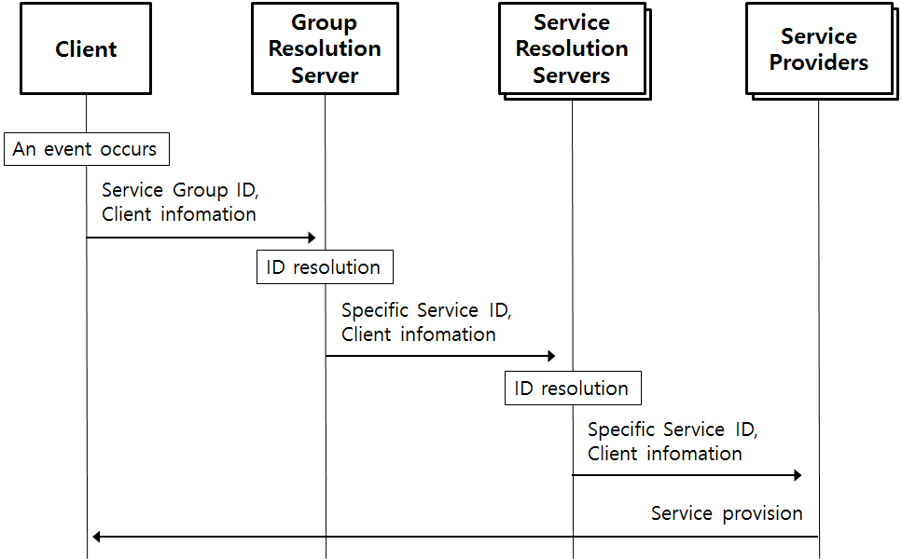

- As the first step, when an event occurs, a client requests group service with group ID and client information to a group resolution server.
- The group resolution server resolves the group ID and sends IDs of specific services and the client information to related service resolution servers.
- The service resolution servers resolve specific service ID and creates information for the specific services. The information is sent to the service providers.
- The service providers offer services to the client.

Alternative flow
N/A

Post-conditions
N/A

High Level Illustration
TBD

Potential requirements
- The oneM2M system shall support service group IDs which is including APP-IDs.
- The oneM2M system shall support resolution and binding for IDs of service grouping.

