Input Contribution
Meeting ID* | REQ34
Title:* | Smart Transportation with Edge/Fog deployment
Source:* | Catalina Mladin, Convida Wireless, Mladin.Catalina@convidawireless.com  Kenichi Yamamoto, KDDI, kc-yamamoto@kddi.com  Chonggang Wang, Convida Wireless, Wang.Chonggang@convidawireless.com
Date:* | 2018-02-15
Input related to* | WI-0080 Edge and Fog Computing  TR-0026 V 0.11.0
Intended purpose of  document:* | Decision  Discussion  Information  Other <specify>
Impacted other TS/TR(s)
Decision requested or recommendation:* | Agree for inclusion in TR-0026.
Template Version: January 2017 (Do not modify)

oneM2M Notice
The document to which this cover statement is attached is submitted to oneM2M. Participation in, or attendance at, any activity of oneM2M, constitutes acceptance of and agreement to be bound by terms of the Working Procedures and the Partnership Agreement, including the Intellectual Property Rights (IPR) Principles Governing oneM2M Work found in Annex 1 of the Partnership Agreement.

Introduction
This contribition provides a use case for Clause 6 “Vehicular Domain Use Cases” of TR-0026.

---------------------- Start of change 1-------------------------------------------

6.x Smart transportation with Edge/Fog computing

6.x.1 Description
Fog/edge computing technologies are very suitable for enabling smart transportation because they enable a dynamic and localized environment for deploying services potentially more closer to the users and/or data sources. Service providers using fog and edgedeployments may actually not instantiate all their available services and in all fog nodes, rather they may do so when there are users who actually require to use the services in the area serviced by the respective fog node.
Smart traffic systems include a multitude of devices and sensors and may provide a variety of services. In this case consider the service of delivering a passenger to a particular destination using a self-driving car. As part of the transportation service, the user may also request other services such as stopping at a particular point of service e.g. coffee shop, finding a parking spot at the destination, and getting notifications about an eminent emergency service (See Figure 6.x.1-1). For example, the passenger in the vehicle is watching a movie using a streaming service. The application provider knows the destination and the route of the vehicle. Since the vehicle remains under one fog node’s area only for a certain period of time, it is unnecessary to have the full movie in one fog node. Instead, the data, in this case video streams, can be prepared across the route of the vehicle up until the destination. The fog nodes in these areas may be requested to instantiate the application ahead of time and also the application may be provided with enough information to predict the time when the vehicle will be under the hosting fog node’s coverage and how much data should be buffered ahead of time for delivery to the vehicle. In this use case, it is assumed that the fog node has roadside units (RSUs) connected to it via which the data is sent to the vehicle.
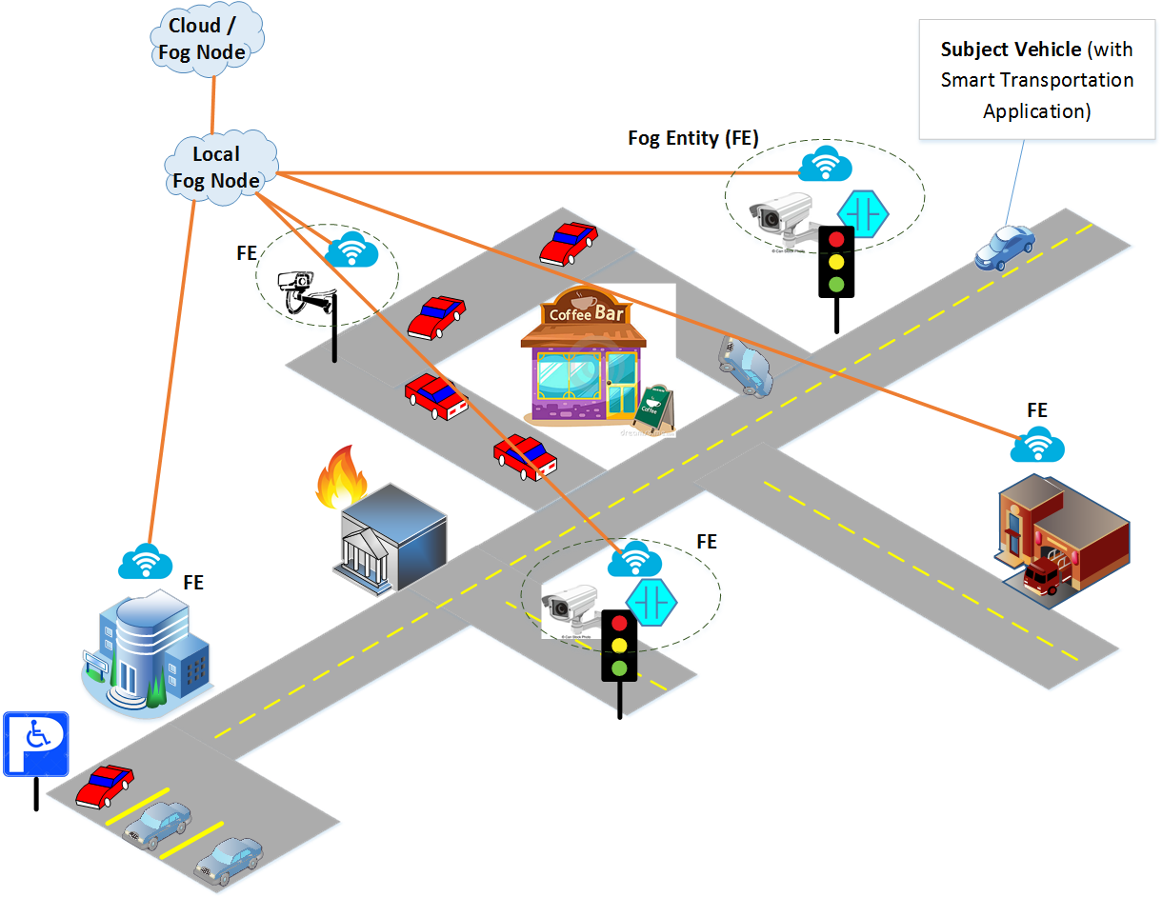

Figure 6.x.1-1 Smart Transportation Use Case

In order to provide this functionality, the platform performs:
- Capability status report, which is used by fog/edge node to report the status of the “things” that are under their control and from which relevant data can be extracted. For example, a camera installed in a particular street intersection for smart transportation service may stop working and other fog nodes or vertical applications on the controlling fog nodes need to be updated about this status so that other data sources can be used to maintain the smart transportation service.
- Fog/Edge capability discovery, which is used by cloud nodes or fog/edge nodes to understand the capabilities of neighboring nodes, other fog/edge nodes, and/or cloud nodes at a different level in the fog/edge deployment hierarchy. This also implies a common understanding of the fog/edge capabilities per service or in aggregate, as a profile.
- Reachability verification, which is used by cloud nodes or fog/edge nodes to verify whether fog/edge nodes of interest are still reachable in order to communicate with them when needed.
- Service migration, which is needed by the fog/edge nodes to interact with each other to provide or receive services, e.g. to request video feed from a camera that is under the control of a neighboring fog node.
- Orchestration of the services provided by fog/edge nodes in a dynamic fashion, in order to satisfy operational requirements for availability, scalability, interoperability, etc.
- Service provisioning, which is used by cloud nodes or fog/edge nodes to provide other fog/edge nodes with the required functionality to instantiate a service.

6.x.2 Source
REQ-2018-00xx: Smart Transportation

6.x.3 Actors
- User: It is the person who drives a vehicle or passengers who ride the vehicle.
- Smart Transportation Application: An application through which the dirver or the passengers in a vehicle can leverage services and capabilities provided by fog/edge deployment.
- Cloud Node: A node with cloud or fog capabilities that manages the operations of other fog nodes lower in the deployment hierarchy. It also interacts with service providers and has service layer agreements and can authorize requests from fog nodes related to applications that are hosted on the fog nodes. Furthermore, the Cloud Node may oversee and manage the interactions between different fog nodes that together enable a fog service layer for applications.
- Fog Node: A node that has any fog resource such as compute, storage, communication, analytics, etc.. For the smart transportation use case, a Fog/Edge Node is assumed to be deployed at one level higher than the level of a Local Fog Node. There may be several levels of Fog Node deployments with the Cloud Node being at the highest level. It also assumed that a Fog/Edge Node connects to at least one Local Fog Node and that the former also manages at least one Local Fog Node.
- Local Fog Node (LFN): A fog node with numerous capabilities and services that together with other LFNs and the cloud create a fog service layer that provides services for authorized applications. Moreover, the Local Fog Node is connected to more than one Fog Entities that are located in the service area of the Local Fog Node. The Local Fog Node, together with other neighboring Local Fog Node, appear as a Fog Service Layer to the applications that are hosted on the Local Fog Node. In the smart transport use case, the Local Fog Node is located between the Fog Entity and the Fog Node or Cloud Node. The Local Fog Node is assumed to be managed by a Fog Node or a Cloud Node that is one level above the Local Fog Node in the fog deployment hierarchy
- Fog Entity (FE): A node that has a sub-set of the capabilities of a Fog Node. Moreover, a Fog Entity connects to a Local Fog Node (see below) and hence becomes a source of data and service for the Local Fog Node. In addition, the Fog Entity may also request and consume data or services from the Local Fog Node. In the smart transport use case, a Fog Entity may be a sensor, a camera, a traffic light, or any IoT device with basic (relatively small) compute and storage resources. Moreover, the Fog Entity is deployed behind or below the Local Fog Node.

6.x.4 Pre-conditions
- Passengers subscribe to Application Provider services
- Fog nodes provide services to the vehicles
- Vehicles are equipped with devices accessing the services

6.x.5 Triggers
- None.

6.x.6 Normal Flow
Figure 6.x.6-1 illusrates the high-level flows of smart transportation use case, which consists of the following steps:
- Step 1: Fog capability status report where capapilities and other context information about a local fog/edge node are reported to or collected by other local fog/edge nodes, fog/edge nodes, and/or cloud nodes.
- Step 2: Fog capability discovery where a cloud node (or a fog node) can discover a local fog node including its capabilities and related context information.
- Step 3: Reachability verification where the reachability between two local fog nodes, between a local fog node and a cloud node (or a fog node) is verified before they statrt to communicate.
- Step 4: Service provisioning and recommendation where fog services on a local fog node is provisioned and some service parameters could be configured or recommended by another local fog node or by a cloud node or a fog node.
- Step 5: Service request where smart transportation application requests fog services directly from a local fog node or indirectly throught a cloud node (or a fog node).
- Step 6: Service orchestration where fog services are orchestrated among local fog nodes, cloud nodes, fog nodes, and/or smart transportation application.
- Step 7: Application instantiation where smart transportation application can be instantiated onto a local fog node with or without the coordination of a cloud node (or a fog node).

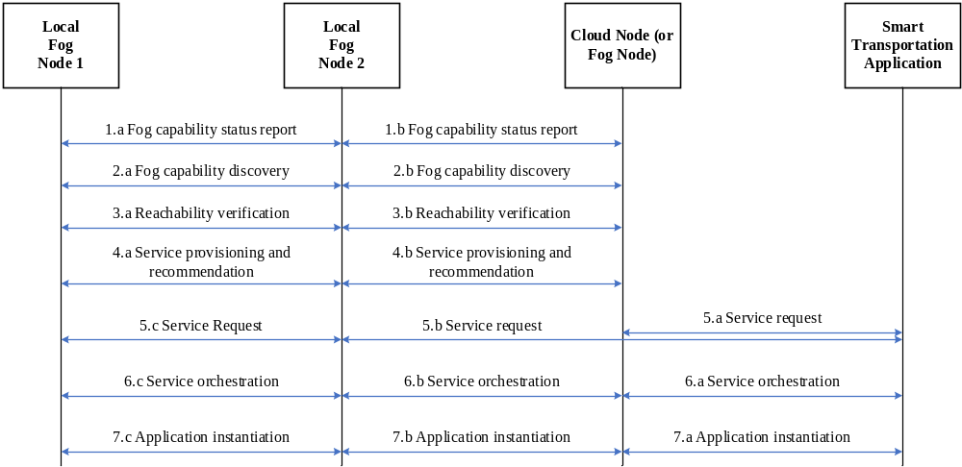

Figure 6.x.6-1: Normal Flow – Smart Transportation System

6.x.7 Alternative Flow
None

6.x.8 Post-conditions
- TBD.

6.x.9 High Level Illustration
At the highest level as shown in Figure 6.x.9-1, there is the Cloud Node (CN) that manages all the fog nodes and is aware of their presence and capabilities. The CN and the Local Fog Nodes (LFNs) interact using the Fog-to-Cloud interface. The CN may be deployed such that it oversees a very large area which is composed of several smaller areas, known as fog areas, each of which is overseen by a LFN. The LFNs together provide a Fog Service Layer that is capable of providing fog services to vertical applications running on the LFNs and to each other using a Fog-to-Fog interface. Services include extracting data from “things”, performing analytics, sharing data, etc. The LFN can be connected to fog entities (FEs) which are nodes with fog capabilities. Their capabilities may be the same as those of the LFNs or they can be smart cameras with fog capabilities (memory, compute, image processing logic, communication that may be wired or wireless, etc) or smart traffic lights, or speed sensors with fog capabilities. In the smart transport use case, the FEs are types of FNs with smaller fog capabilities and may be residing in service points such as a coffee shop and they in turn can control “things” such as cameras, sensors, and can send or receive data to and from these “things”, respectively. FEs can also be nodes residing in other important buildings or departments such as firefighting departments, hospitals, police department, etc. Furthermore, FEs may be basic IoT devices such as sensors, cameras, actuators, etc. As such, these FEs may be aware of reported events and locations to which an ambulance, fire truck, police vehicle, etc, may be dispatched. The FEs can collect such information or data and send it to the LFNs to which they have connections with. The Application Layer running on LFNs interact with the LFNs only and hence are not aware of the FEs with which the LFNs may be connected. The FEs may appear as “things” to the fog application layer. Note that the FEs may also host their local applications. However, for the smart transportation use case, the application layer refers to the application layer that is residing above the LFNs. Although the FE can also host applications, our future reference to application layer below is about the application layer which runs on the LFNs. Finally, it is assumed in our architecture that the LFNs alone are the primary providers of the fog service layer and may use data or services from FEs or IoT devices in a manner that is transparent to the applications that use the fog service layer.

As an example only, Figure 6.x.9-1 shows that LFN 1 is connected to two FEs, 1a and 1b, while LFN 2 is connected to one FE 2a, and LFN 3 connects to FEs 3a and 3b. However, these are just examples that are not intended to limit such connections to the numbers shown. Note that the actual protocol that runs on interfaces between the fog nodes, and between the fog nodes and the cloud, are out of scope of this document.

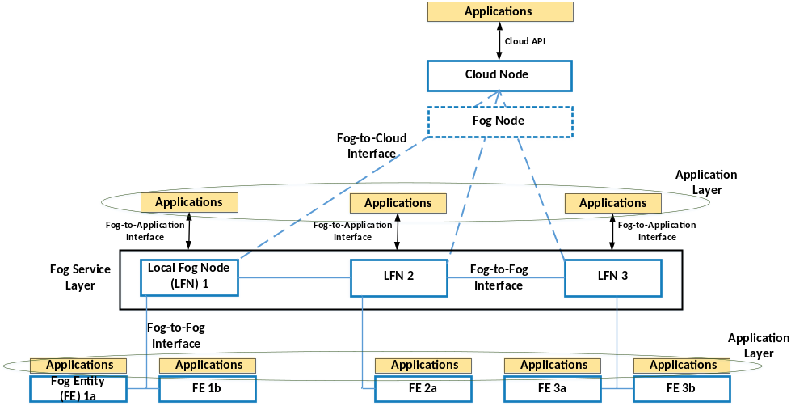

Figure 6.x.9-1 High Level Illustration – Smart Transportation

6.x.10 Potential requirements
- The oneM2M System shall enable the remote instantiation of services across fog/edge networks as well as the remote provisioning of information required to instantiate the services.
- The oneM2M System shall enable the sharing and discovery of service capability information across fog/edge networks.
- The oneM2M System shall enable to request services provided by fog/edge nodes.
- The oneM2M System shall enable service migration among fog/edge nodes.
- The oneM2M System shall enable the orchestration of services provided by Fog/Edge nodes in a dynamic fashion to satisfy operational requirements for availability, scalability, interoperability, etc.

-----------------------End of Change 1 ---------------------------------------------

