Input Contribution
Meeting ID* | REQ36
Title:* | Use case of Smart Factories using Edge/Fog Computing
Source:* | Kenichi Yamamoto, KDDI, kc-yamamoto@kddi.com  Chengsui Lu, Hitachi, cslu@hitachi.cn
Date:* | 2018-07-09
Input related to* | WI-0080 Edge and Fog Computing  TR-0018 Industrial Domain Enablement V 3.0.0
Intended purpose of  document:* | Decision  Discussion  Information  Other <specify>
Impacted other TS/TR(s)
Decision requested or recommendation:* | Agree for inclusion in TR-0018.
Template Version: January 2017 (Do not modify)

oneM2M Notice
The document to which this cover statement is attached is submitted to oneM2M. Participation in, or attendance at, any activity of oneM2M, constitutes acceptance of and agreement to be bound by terms of the Working Procedures and the Partnership Agreement, including the Intellectual Property Rights (IPR) Principles Governing oneM2M Work found in Annex 1 of the Partnership Agreement.

Introduction
This contribution provides new use case on Edge and Fog computing to Clause 6 “Use case” in TR-0018 Industrial Domain Enablement.

---------------------- Start of Change 1-------------------------------------------

2.2 Informative references
[i.a] OpenFog Reference Architecture for Fog Computing, February 2017 (OPFRA001.020817)
[i.b] Broadband Forum TR-369: "User Services Platform (USP)": Issue 1, March 2018.

-----------------------End of Change 1 ---------------------------------------------

---------------------- Start of Change 2-------------------------------------------

6.x Smart Factories using Edge/Fog Computing

6.x.1 Description
This use case introduces Smart Factories Service based on data collected by sensors. Those data are collected by a Local Fog Node in the factory and the Local Fog Node sends them to nearby a Fog Node. The Fog Node analyzes the data, detects system faults in the factory (e.g. component failures, temperature rise and network disconnections), generates the data for some possible causes of failures, and discovers the recovery method for the system faults. The Fog Node executes the recovery method autonomously by its own decision making and centralized decision-making in the cloud is no longer the only option. If the factory can’t recover from the system fault, the Fog Node takes alternative measure autonomously and finally leads to recover the system faults. The autonomy is the one of the core principles as pillars in OpenFog Reference Architecture [i.a].
Application Provider would like to recover them as soon as possible in order to minimize the impact of the production line, and keep high reliability, availability and serviceability (RAS). Therefore, the most of operations for fault recovery need to be performed autonomously.

6.x.2 Source
REQ-2018-0043: Use case of Smart Factories using Edge/Fog Computing.

6.x.3 Actors
- Application Provider: It provides its own services for factories.
- Cloud Node: It is the Node which manages Fog Nodes, maintains database of Fog Nodes and interacts with Application Provider.
- Fog Node (FN): It is the Node which computes, stores and analyzes data collected by sensors in a factory. It supports operational autonomy in order to executes recovery methods in case of system faults in a factory. It is located between Cloud Node and Local Fog Node. It is assumed to be deployed at higher levels than the level of a Local Fog Node. It is also assumed that a Fog Node connects to at least one Local Fog Node.
- Local Fog Node (LFN): It is the gateway which collects sensor data in a Factory. It is also connected to one or more sensors in a Factory.
- Maintenance Center: It manages and operates Factories remotely or on-site for trouble shooting.

6.x.4 Pre-conditions
- Factory 1 and Factory 2 subscribe to Factory Automation Service of Application Provider.
- Factory 2 has alternative production line of Factories. In this use case, Factory 1 and Factory 2 have the same production line and supplies.
- All of sensor data in Factory 1 are sent to FN 1 periodically via LFN 1 in Factory 1.
- FN 1 monitors production lines in Factory 1 remotely by using those sensor data.

6.x.5 Triggers
- FN 1 detects a system fault from the sensor data of Factory 1.

6.x.6 Normal Flow
Figure 6.x.6-1 illustrates the high-level flows of the use case, which consists of the following steps:
- FN 1 confirms that one of the production lines doesn’t work properly.
- FN 1 tries to discover the recovery method from its own database, however it can’t find the appropriate method in its database. Therefore, it sends the data for some possible causes of failures to Cloud Node.
- Cloud Node analyzes the data, then sends the data of a recovery method to FN 1.
- FN 1 executes the recovery method autonomously by the data of a recovery method to Factory 1.
- FN 1 sends the data which contains possible causes of failure and the recovery method to FN 2.
- FN 2 stores the data in its database for future trouble shooting of Factory 2.
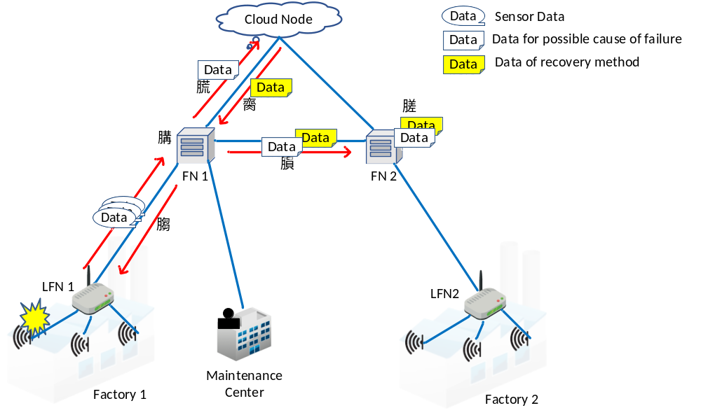

Figure 6.x.6-1: Normal Flow – Fault Recovery for Factories

6.x.7 Alternative Flow
This alternative flow may occur as Figure 6.x.7-1 if Factory 1 can’t recover from the system fault by the Fog Node operation (see 6.x.6-1 Normal Flow), and the production line in Factory 1 still doesn’t work properly.
- FN 1 confirms that the production line in Factory 1 still doesn’t work properly and decides to take alternative measure autonomously without centralized decision-making in the cloud.
- FN 1 orders FN 2 to operate alternative production line of factories in FN2 coverage area in order to compensate for lack of production capability.
- FN 2 orders Factory 2 to operate a production line, and Factory 2 starts to operate the production line.
- FN 1 sends Maintenance Center to the data for possible cause of failure and the data of the recovery method in Factory 1, which are used for the initial trouble shooting described clause 6.x.6.
- Operators in the Maintenance Center check the system in Factory 1 via FN 1 by remote management technologies (e.g. BBF TR-369 [i.b]) and fix the system fault (remotely or on-site).
- FN 1 confirms the system recovery, starts to operate the production line in Factory 1, and informs FN 2 to stop operating the alternative production line.
- FN 2 orders Factory 2 to stop operating the production line, and Factory 2 does it.
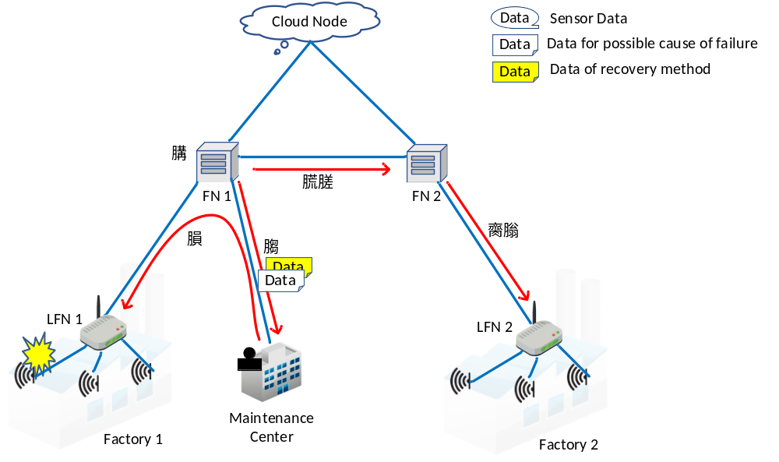

Figure 6.x.7-1: Alternative Flow – Fault Recovery for Factories

6.x.8 Post-conditions
- The production line in Factory 1 is recovered, and it starts to work properly.

6.x.9 High Level Illustration
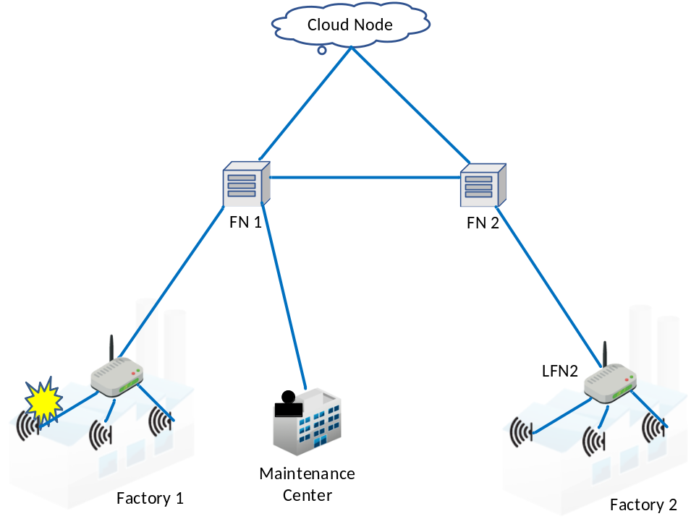

Figure 6.x.9-1 High Level Illustration – Smart Factories service by Fog Nodes

6.x.10 Potential requirements
- The oneM2M system shall enable Edge/Fog Nodes to support operational autonomy in order to keep high reliability, availability and serviceability (RAS).
- The oneM2M System shall enable Edge/Fog Nodes to provide the capability for monitoring and diagnostics of M2M Applications.
- The oneM2M System shall enable Edge/Fog Nodes to support management and configuration of M2M Gateways/ Devices (e.g. using BBF TR-369).
- The oneM2M System shall enable Edge/Fog Nodes to provide the capability for data sharing between Edge/Fog Nodes.

-----------------------End of Change 2 ---------------------------------------------

