Input contribution
Use case
Use Case Title:* | Use cases for automatic ontology mapping
Group Name:* | REQ#36
Source:* | CMCC, Huawei
Contact: | Yawen Niu (niuyawen@chinamobile.com)  Yongjing Zhang (zhangyongjing@huawei.com)
Date:* | 2018-06-13
Abstract:* | Propose to add the use case illustrates that, since the manual creation of mappings is often too labour-intensive for large ontologies, oneM2M system need to automatically discover, create and save the mappings between semantically related ontology entities. This is kind of abilities just like automatic ontology mapping.
Agenda Item:*
Work item(s): | WI 0015 - oneM2M Use Case Continuation
Document(s)  Impacted* | Technical Specification TR 0001 - oneM2M Use Case Technical Report
Intended purpose of  document:* | Decision  Discussion  Information  Other <specify>
Decision requested or recommendation:* | Approval of the Use Case

oneM2M IPR STATEMENT
“Participation in, or attendance at, any activity of oneM2M, constitutes acceptance of an agreement to be bound by all provisions of IPR policy of the admitting Partner Type 1 and permission that all communications and statements, oral or written, or other information disclosed or presented, and any translation or derivative thereof, may without compensation, and to the extent such participant or attendee may legally and freely grant such copyright rights, be distributed, published, and posted on oneM2M’s web site, in whole or in part, on a non-exclusive basis by oneM2M or oneM2M Partners Type 1 or their licensees or assignees, or as oneM2M SC directs.
  - Title

Use cases for automatic ontology mapping.

  - Description

In M2M applications, reusing of common ontologies (e.g. location, time ontologies, etc.) plays an important role in developing cost effective and high quality ontologies. It could save the cost and time required for the ontology construction of specific domains.

For example, a user wants to build ontology to provide syntactic and semantic interoperability of the smart home System. He could reuse some existing ontologies (e.g. the oneM2M Base Ontology, sensor ontologies, environment ontologies) and build his own ontology by mapping them.

Ontology mapping is to find the mapping relationships between different ontologies to reuse ontologies. Ontology mapping can be implemented either by manual approaches or automatic approaches. However, discovering manually mappings is often too labour-intensive, error-prone, and impractical for large heterogeneous ontologies. Therefore, oneM2M system needs to automatically discover, create and save the mappings (equivalent or inherited relationships) between semantically related ontology entities by using industry-proven mapping algorithms, e.g. the edit distance, language-based similarity, structural-based similarity, or external- resources-based similarity etc.

  - Source

CMCC, Huawei
  - Actors
- End User: the user who wants to build his own ontology by mapping existing ontologies.
- The ontology is a vocabulary with a structure. It could capture a shared understanding of a domain of interests and provide a formal and machine interpretable model of the domain. It may be mapped to others with the help of ontology mapping function.
- Ontology Mapping Function is responsible for discovering, creating and saving mappings between the ontologies defined in the context of the oneM2M System and/or other external ontologies. It’s a service layer functionality provided by the oneM2M System.
- The ontology mapping file is a RDF document including the mappings between ontologies. It can be saved and managed in the oneM2M System as a resource.

  - Pre-conditions
- NONE
  - Triggers
- An ontology is required to be mapped to other ontologies automatically.

  - Normal Flow

The normal message flow is described as follows:
AE

Ontology mapping function hosting CSE

1. request to mapping ontology A and ontology B
2. loading ontology A
4. computing the similarity
5. discovering mapping relationship
6. saving mapping file
Ontology A hosting CSE

Ontology B hosting CSE

3. loading ontology B
Establish mapping according to mapping method based on description information of ontology mapping function
7. return successful response
Figure 1: Message flow for automatic ontology mapping operation
- An application (representing the End User) sends a request for mapping ontology A and ontology B to the ontology mapping function in the oneM2M platform (e.g. IN-CSE).
- An ontology A is loaded into the ontology mapping function.
- Another ontology B is is loaded into the ontology mapping function.
- The similarities between entities (classes, properties, instances.) of ontologies are computed by the ontology mapping function.
- Mapping discovery is performed based on similarity between entities and other helpful information like synonyms, hypernym-hyponym relations from external knowledge bases by the ontology mapping function.
- The mapping result between Ontology A and Ontology B is saved as an ontology mapping resource by ontology mapping function.
- The mapping result (e.g. resource id) is return to the application.

  - Post-conditions (if any)
- NONE.
  - High Level Illustration (as applicable)
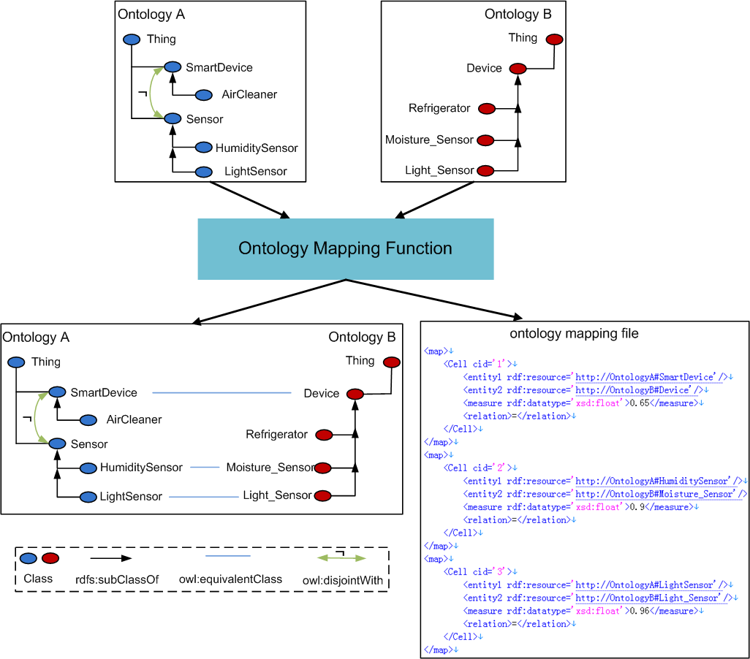
  - Potential requirements (as applicable)
- The oneM2M system shall be able to automatically discover, create and save semantic mappings between ontologies.

