Input contribution
Use case
Use Case Title:* | Use cases for ontology mapping conflict detection
Group Name:* | REQ#36
Source:* | CMCC, Huawei
Contact: | Yawen Niu (niuyawen@chinamobile.com)  Yongjing Zhang (zhangyongjing@huawei.com)
Date:* | 2018-06-13
Abstract:* | Propose to add the use case for ontology mapping conflict detection of TR 0001. For ontology mapping tasks, it is required to detect conflicts leading to logical errors among semantic mappings between ontologies.
Agenda Item:*
Work item(s): | WI 0015 - oneM2M Use Case Continuation
Document(s)  Impacted* | Technical Specification TR 0001 - oneM2M Use Case Technical Report
Intended purpose of  document:* | Decision  Discussion  Information  Other <specify>
Decision requested or recommendation:* | Approval of the Use Case

oneM2M IPR STATEMENT
“Participation in, or attendance at, any activity of oneM2M, constitutes acceptance of an agreement to be bound by all provisions of IPR policy of the admitting Partner Type 1 and permission that all communications and statements, oral or written, or other information disclosed or presented, and any translation or derivative thereof, may without compensation, and to the extent such participant or attendee may legally and freely grant such copyright rights, be distributed, published, and posted on oneM2M’s web site, in whole or in part, on a non-exclusive basis by oneM2M or oneM2M Partners Type 1 or their licensees or assignees, or as oneM2M SC directs.
  - Title

Use cases for ontology mapping conflict detection.

  - Description

Ontology mapping is an effective way to reuse existing ontologies to provide semantic support for M2M applications . Whether ontology mapping is implemented by manual approaches or automatic approaches, there are often semantic conflicts among candidate mappings. These conflicts will make the mapped ontology becoming incoherent. So the oneM2M system shall be able to detect these conflicts among mappings for further repair.

  - Source

CMCC, Huawei
  - Actors
- End User: the user who wants to detect the conflicts among mapping relationships between ontologies.
- The ontology is a vocabulary with a structure. It could capture a shared understanding of a domain of interest and provide a formal and machine interpretable model of the domain. It may be mapped to others with the help of ontology mapping function.
- Ontology Mapping Function is responsible for discovering, creating and saving mappings between the ontologies defined in the context of the oneM2M System and/or other external ontologies. It’s a service layer functionality provided by the oneM2M System.
- The ontology mapping file is a RDF document including the mappings between ontologies. It can be saved and managed in the oneM2M System as a resource.
- Ontology Mapping Conflict Detection Function is responsible for detecting and saving conflicts among the mappings between the ontologies defined in the context of the M2M System and/or other external ontologies. It’s a service layer functionality provided by the oneM2M System.
- The ontology mapping conflict file is a RDF document including the conflicts among mappings between ontologies. It can be saved and managed in the oneM2M System as a resource.

  - Pre-conditions
- The conflict among mappings is a kind of logical coherence.
  - Triggers
- There is logical inconsistency in the mapped ontology according to the existing mappings.

  - Normal Flow

The normal message flow is described as follows:
Figure 1: Message flow for ontology mapping conflict detection operation

- An application (representing the End User) sends a request for detecting the conflicts among mappings between ontology A and ontology B to the ontology mapping conflict detection function in the oneM2M platform (e.g. IN-CSE).
- An ontology A is loaded into the ontology mapping conflict detection function.
- Another ontology B is loaded into the ontology mapping conflict detection function.
- The ontology mapping file including the mappings between ontology A and ontology B is loaded into the ontology conflict detection function.
- Conflicts detection is performed from the mappings by the ontology conflict detection function through conflict pattern matching or semantic reasoning techniques.
- The mapping conflicts result among the mappings between Ontology A and Ontology B is saved as an ontology mapping conflict resource by ontology mapping conflict detection function.
- The mapping conflicts result (e.g. resource id) is return to the application.

  - Post-conditions (if any)

NONE.
  - High Level Illustration (as applicable)
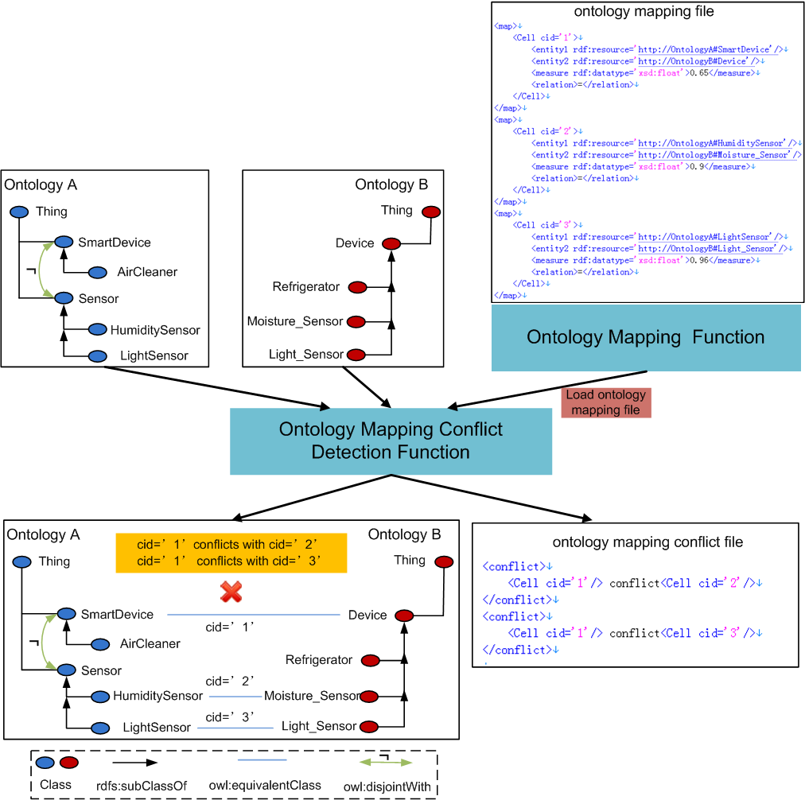

  - Potential requirements (as applicable)
- The oneM2M system shall be able to detect and save conflicts among semantic mappings between ontologies.

