Input contribution
Use case
Use Case Title:* | Use cases for ontology mapping conflict repair
Group Name:* | REQ#36
Source:* | CMCC, Huawei
Contact: | Yawen Niu (niuyawen@chinamobile.com)  Yongjing Zhang (zhangyongjing@huawei.com)
Date:* | 2018-06-13
Abstract:* | Propose to add the use case for ontology mapping conflict repair of TR 0001. For ontology mapping tasks, it is required to repair conflicts among the mappings to ensure the logical coherence of the mapped ontology.
Agenda Item:*
Work item(s): | WI 0015 - oneM2M Use Case Continuation
Document(s)  Impacted* | Technical Specification TR 0001 - oneM2M Use Case Technical Report
Intended purpose of  document:* | Decision  Discussion  Information  Other <specify>
Decision requested or recommendation:* | Approval of the Use Case

oneM2M IPR STATEMENT
“Participation in, or attendance at, any activity of oneM2M, constitutes acceptance of an agreement to be bound by all provisions of IPR policy of the admitting Partner Type 1 and permission that all communications and statements, oral or written, or other information disclosed or presented, and any translation or derivative thereof, may without compensation, and to the extent such participant or attendee may legally and freely grant such copyright rights, be distributed, published, and posted on oneM2M’s web site, in whole or in part, on a non-exclusive basis by oneM2M or oneM2M Partners Type 1 or their licensees or assignees, or as oneM2M SC directs.
  - Title

Use cases for ontology mapping conflict repair.

  - Description
- For the detected conflicts among the mappings between ontologies, it is required to remove a part of mappings to ensure the logical coherence of the mapped ontology. There are generally two main principles of repair: remove as few mappings as possible and try to remove the mappings with low confidence (confidence is the similarity between two ontology entities).

  - Source

CMCC, Huawei

  - Actors
- End User: the user who wants to repair the conflicts among mapping relationships between ontologies.
- The ontology is a vocabulary with a structure. It could capture a shared understanding of a domain of interests and provide a formal and machine interpretable model of the domain. It may be mapped to others with the help of ontology mapping function.
- Ontology Mapping Function is responsible for discovering, creating and saving mappings between the ontologies defined in the context of the oneM2M System and/or other external ontologies. It’s a service layer functionality provided by the oneM2M System.
- The ontology mapping file is a RDF document including the mappings between ontologies. It can be saved and managed in the oneM2M System as a resource.
- Ontology Mapping Conflict Detection Function is responsible for detecting and saving conflicts among the mappings between the ontologies defined in the context of the M2M System and/or other external ontologies. It’s a service layer functionality provided by the oneM2M System.
- The ontology mapping conflict file is a RDF document including the conflicts among mappings between ontologies. It can be saved and managed in the oneM2M System as a resource.
- Ontology Mapping Conflict Repair Function is responsible for removing conflicts among the mappings between the ontologies defined in the context of the M2M System and/or other external ontologies to ensure the logical coherence of the mappings and saving the repaired mappings.
- The repaired ontology mapping file is a RDF document including the mappings without conflicts between ontologies. It can be saved and managed in the oneM2M System as a resource.

  - Pre-conditions
- The conflict among mappings is a kind of logical coherence.
  - Triggers
- Some conflicts are detected from the mappings between different ontologies.

  - Normal Flow

The normal message flow is described as follows:
Figure 1: Message flow for ontology mapping conflict repair operation

- An application (representing the End User) sends a request for repairing the conflicts among mappings between ontology A and ontology B to the ontology mapping conflict repair function in the oneM2M platform (e.g. IN-CSE).
- An ontology A is loaded into the ontology mapping conflict repair function.
- Another ontology B is is loaded into the ontology mapping conflict repair function.
- The ontology mapping file including the mappings between ontology A and ontology B is loaded into the ontology mapping conflict repair function.
- The ontology mapping conflict file including the detected conflicts among mappings between ontology A and ontology B is loaded into the ontology mapping conflict repair function.
- Conflicts repair is performed by the ontology mapping conflict detection function through removing some mappings until the mapped ontology passes the consistency check.
- The repaired mapping result between Ontology A and Ontology B is saved to a repaired ontology mapping resource by the ontology mapping conflict repair function.
- The repaired mapping result (e.g. resource id) is return to the application.

  - Post-conditions (if any)
- NONE.
  - High Level Illustration (as applicable)
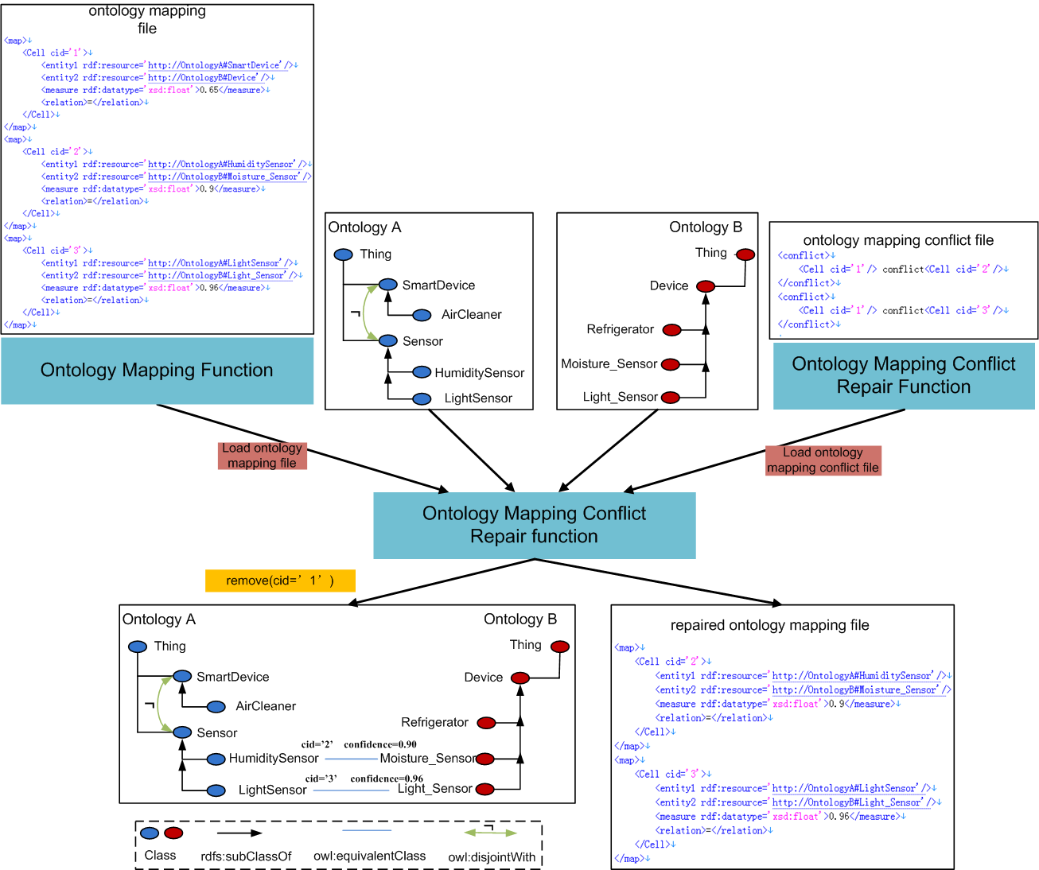
  - Potential requirements (as applicable)
- The oneM2M System shall be able to remove conflicts among semantic mappings between ontologies and save the repaired mappings.

