Input Contribution
Meeting ID* | REQ#36
Title:* | Case study input for KEPCO and K-Water in Korea
Source:* | SeungMyeong Jeong, KETI, sm.jeong@keti.re.kr
Date:* | 2018-07-17
Input related to* | TR-0036
Intended purpose of  document:* | Decision  Discussion  Information  Other <specify>
Impacted other TS/TR(s) | n/a
Decision requested or recommendation:* | Incorporate this use case into TR-0036
Template Version: January 2017 (Do not modify)

oneM2M Notice
The document to which this cover statement is attached is submitted to oneM2M. Participation in, or attendance at, any activity of oneM2M, constitutes acceptance of and agreement to be bound by terms of the Working Procedures and the Partnership Agreement, including the Intellectual Property Rights (IPR) Principles Governing oneM2M Work found in Annex 1 of the Partnership Agreement.

Introduction
This contribution proposes oneM2M based smart city case studies of KEPCO and K-Water in Korea.
KEPCO: Korea Electric Power Corporation (http://www.kepco.co.kr/eng)
K-Water: Korea Water Resources Corporation (http://english.kwater.or.kr)

=== Start of input text ===

6.X Utility services in South Korea

6.x.1 Electricity
KEPCO (Korea Electric Power Corporation) [i.x] is the public corporation for national electric power supply in South Korea. Starting from testbeds for pilot services, it also offers commercial IoT services over oneM2M based platforms. The below illustrates some of the deployed services. Those deployments runs oneM2M certified platforms of KEPCO and vendor companies.
Electric power monitoring system monitors with the sensors directly attached to power equipments (e.g. transformer, switch, insulator). For example, switch monitoring sensor reports vibration, slope, external temperature, telluric current and ultrasonic waves to the IoT platform. With data analysis and prediction, this monitoring system lowers the maintenance cost for deployed equipments. This has been depoyed in Daegu, Gwangju, Ansan with 2,200 sensors and 200 gateways. Daejeon will have another deployement by the end of 2018 with 2,400 sensors and 70 gateways.
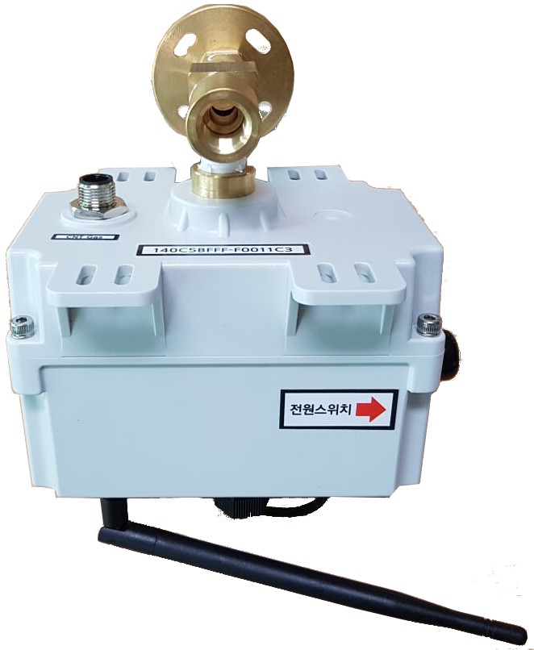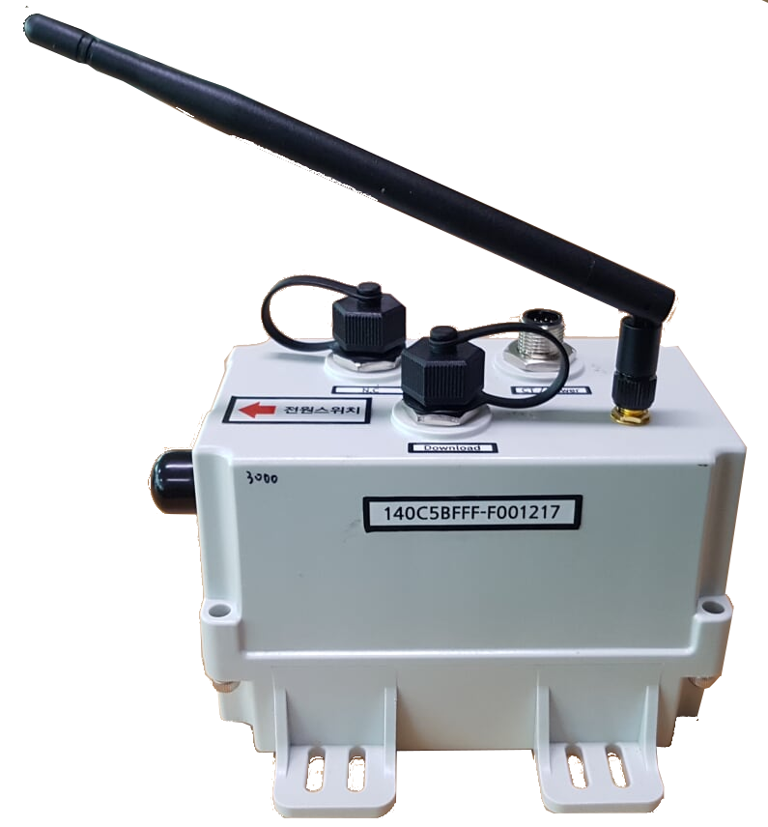
Figure 6.x.1-1. Pad mount electric transformer sensor (left) and ground switch sensor (right)
In Uijeongbu city, the pad mount sensors are operating over 2 years by 2018. 100 sensors reports data over LoRa and 30 gateways forward the data to the e-IoT platform, which is the oneM2M certified IoT platform of KEPCO. A set of proprietary information models for this service has been defined.
Diagnosis of power transmission line has been done by human or robot on premises so far. It gets really difficult to do the inspection on transmission towers in mountain areas. There is the testbed having remote sensors reporting diagnosis data to the IoT platform. The testbed consists of 3 transmission towers with 11 sensors and 2 gateways in Naju city. This guarantees the power grid system are up and running.
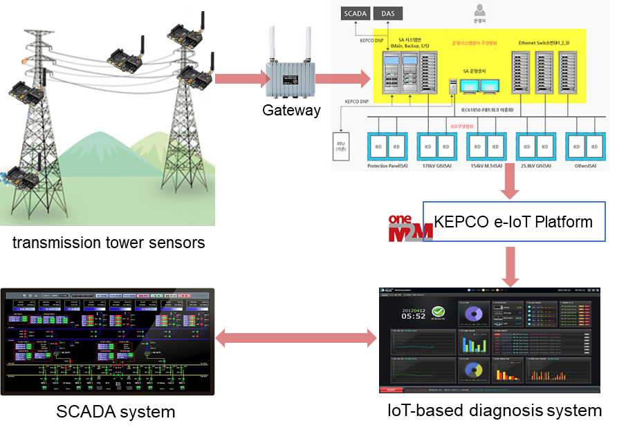
Figure 6.x.1-2. Electric transmission monitoring system
In islands far from the land, electricity is produced and supplied locally. As a plot service, KEPCO is running 1 electric generator diesel engine with 12 sensors in the monitoring system.
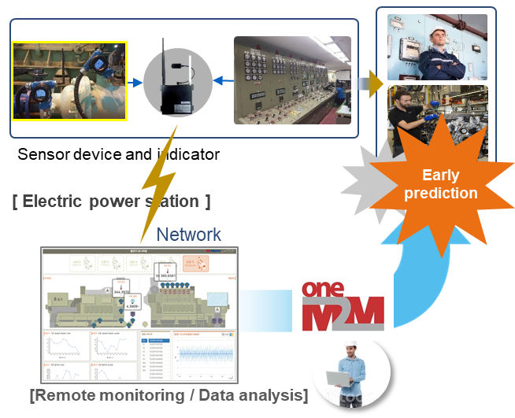
Figure 6.x.1-3. Electric generator monitoring system

6.x.2 Water
K-Water (Korea Water Resources Corporation) [i.y] as public corporation for water utility services in south Korea now adopting IoT to its legacy system and services. The below deployments are already commercialized services.
Multi-unit water quality information system is deployed in Paju, Seoul, Huaseong and Geoje city in South Korea. On premises, the oneM2M enabled platform is gatering data from sensors. The sensors provide data on DO (Dissolved Oxygen), Cl (Chlorine), pH (Hydrogen Ion Concentration) and turbidity.
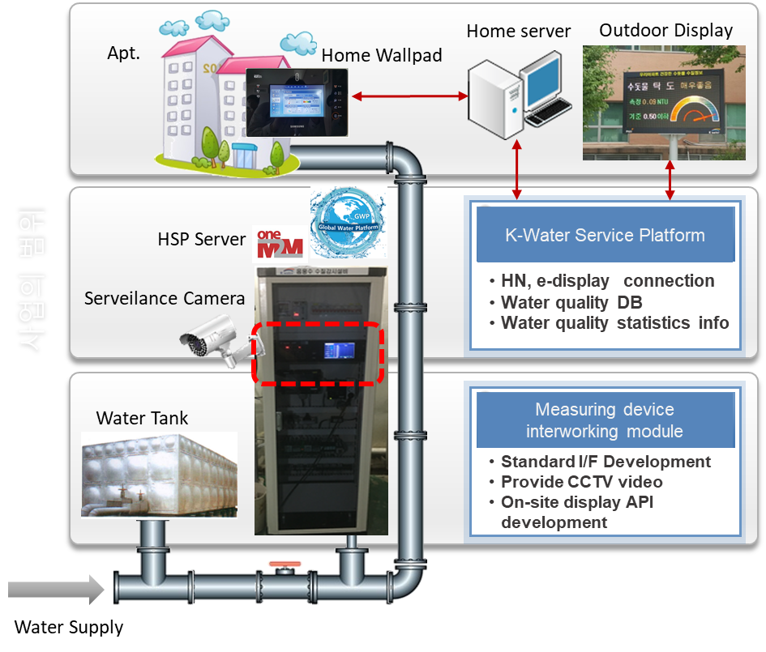
Figure 6.x.2-1. Multi-unit water quality information system
As a water grid, smart water grid management system collects a set of data on water meter, flow, gauge, quality and etc. All the sensor data are collected to oneM2M platform. This system integrated the legacy i-Water platform with the oneM2M based plaform.
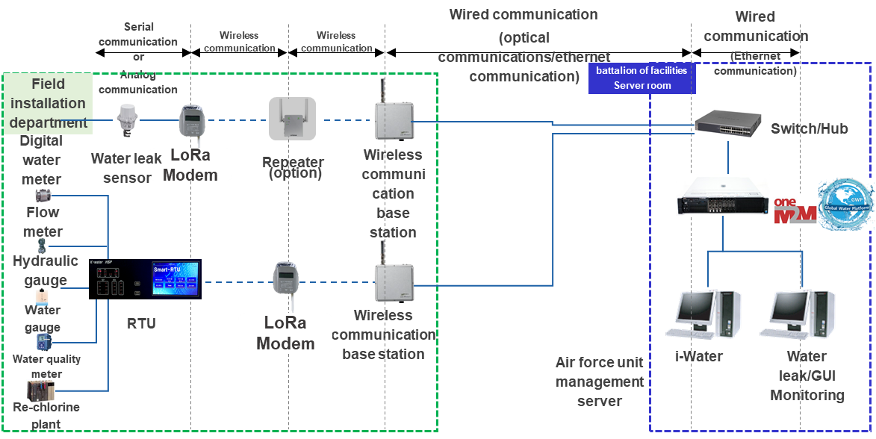
Figure 6.x.2-2. Smart water grid management system
=== End of input text ===
=== Start of change 1 ===

2.2 Informative references
The following referenced documents are not necessary for the application of the present document but they assist the user with regard to a particular subject area.
[i.x] Korea Electric Power Corporation (http://www.kepco.co.kr/eng)
[i.y] Korea Water Resources Corporation (http://english.kwater.or.kr)
=== End of change 1 ===

